Problem 6.25

Find V_{C}(t) for t > 0 in the network in Fig. 6.25 using the step-by-step method.

Suggested Solution

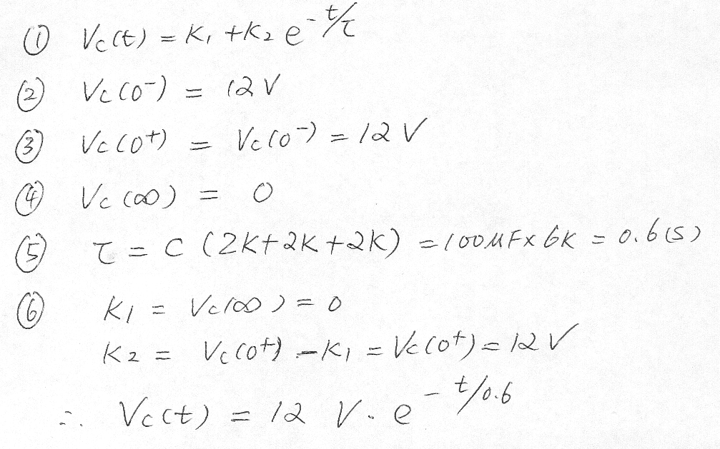

Problem 6.33

Find i₀(t) for t > 0 in the network in Fig. P6.33 using the step-by-step method.

Suggested Solution

