ECE 210 Mini Design Project

The Resonance Circuit



Vladi Gergov
Monday, December 03, 2001

I have neither given nor received aid in completion of this report.

_________________________
I. Abstract

Since all values in the circuit ( Figure 1 ) except one are known, the resistor value can easily be found with the given equations. To find R, we use the equation R = Req – Rout – Rd. I can easily measure Rd which, is the internal resistance of the inductor using the digital multi meter, and I get Rd to be around 67 Ohms. Rout is the internal resistance of the function generator which is given to be 15 Ohms. Now I can use the following equations to find Req.
Req = |Zc| / X ; | Zc | = 1 / (Wr C) and Wr = 1 / √(L*C). Since L and C are given, finding Req is as matter of turning the crank on the equation and I get Req to be equal to 133.01 Ohms. Now all I have to do is plug everything back into the following equation
R = Req – Rout – Rd to find R which comes out to 50.91 Ohms. Now, I have to find a resistor that is close to our calculated value. After which I use that resistor in my circuit. To find that I achieve a gain of 7.5 I connect the oscilloscope across Vin and Vout to see that the input is in fact amplified from 0.2v to 1.5v and therefore my mini design meets the required specifications.
FIGURE 1: RLC Circuit

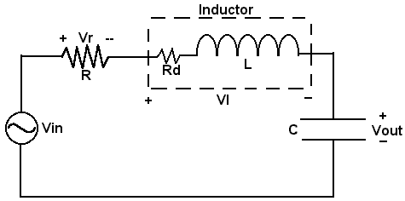
II. Design Criteria

Design an RCL circuit to input a voltage of value Vin ( t ) = 0.2 cos ( Wr t ) and output a voltage of value Vout ( t ) = 1.5 cos ( Wr t + θ ). The values for the capacitor and inductor are given as 0.1uF and 100mH respectively.
III. Theoretical Solution

Attached at the end of this report.
IV. Experimental Verification

After I found the resistor value for my circuit, I connected the resistor in series with the inductor and capacitor. I set the digital multi-meter to measure alternating current voltage and proceeded to measure the required voltage values.

The following steps will describe how I measured the current and voltage values.

i. I connected the DMM across the voltage source to find Vrms and got 0.1413 volts.
ii. I connected the DMM across the resistor to find Vr and got ~57.7 mV.
iii. I connected the DMM across the inductor to find VL and got ~1.07 volts.
iv. I connected the DMM across the capacitor to find Vc and got ~1.07 volts
v. To find the current ( IRMS ) however I connected the DMM in series with the circuit and got IRMS equal to 1.07 mA.

V. Conclusion

In doing the midi design and writing the report I learned that I can amplify the input of the RLC circuit by changing the denominator in equation Req = |Zc| / X. When the denominator is equal to one, there is no amplification and therefore the input is the same as the output. I also learned that the DMM measures root mean square values, so the measurements I receive will have to be divided by the square root of two because the nature of the sinusoidal wave.

