Vladi Gergov
Stephanie Hayes
Experiment Number Two
Commutative, Associative, De Morgan’s, and Distributive Laws
September 26, 2000



We have neither received nor given aid in the presentation of this report

________________________ ________________________

I. Objective(s)

- To verify the Commutative property of the AND operation using the NAND gate DIP package.
- To prove the Associative properties of the AND operation using the NAND gate DIP package.
- To prove De Morgan’s Law using the NAND gate DIP package (for the OR version) and to also verify the Law using the NOR gate DIP package (for the AND version)
- To prove the Distributive property of the AND operation using NAND gates only.

II. Theory

To prove the Commutative, Associative, De Morgan’s, and Distributive laws using digital logic.

II. Materials Required

Hardware Implementation using DDS:

- DDS
- 7400 –quad 2 input NAND
7402 – quad 2 input NOR
- Wires

Win Bread Board Simulation:

- Win breadboard Simulation package

III. Procedure and Results

NAND Gate:

A | B | Output  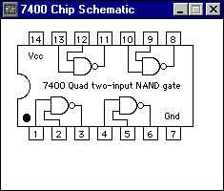
0 | 0 | 1
0 | 1 | 1
1 | 0 | 1
1 | 1 | 0

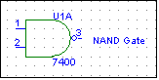

NOR Gate:

A | B | Output  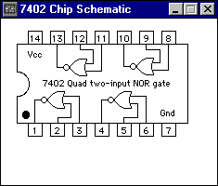
0 | 0 | 1
0 | 1 | 1
1 | 0 | 1
1 | 1 | 0

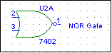

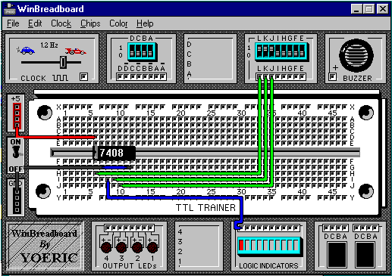

The above objectives were carried out using the Digital Design Station. First we gathered the appropriate chips and wires necessary. Second we proceeded to wire according to chip diagrams and derived schematics. Third we concluded logic table outputs from digital design stations output LED’s. Fourth we proceeded to the computer lab where we simulated the laws and previously derived circuit diagrams.

IV. Conclusions and Precautions

In these series of experiments we experienced how the above laws work in a real life environment and also how to manipulate such laws to suit a particular goal. We also learned how Boolean algebra simplifications make resulting circuits cost efficient and more optimized.

