Objective: To individually implement a quad two-input NAND, NOR, AND and OR gate using the respective DIP’s and to also familarize you with the use of the Hex Inverter or the NOT gate.

Theory: To verify the implementation of the NAND, NOR, AND and OR gates. This experiment also verifies basic theoretical relationships.

Materials Required (Equipment):
Hardware Implementation using DDS:

- DDS
- 7400 –quad 2 input NAND
7402 – quad 2 input NOR
7404 – hex inverter
7408 – quad 2 input AND
7432 – quad 2 input OR
- Wires

Winbreadboard Simulation:

- Winbreadboard Simulation package

NAND Gate:

A | B | Output  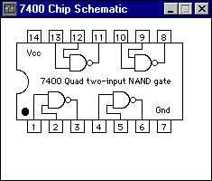
0 | 0 | 1
0 | 1 | 1
1 | 0 | 1
1 | 1 | 0

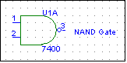

NOR Gate:

A | B | Output  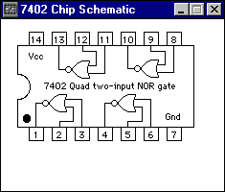
0 | 0 | 1
0 | 1 | 1
1 | 0 | 1
1 | 1 | 0

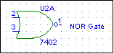

AND Gate:

A | B | Output  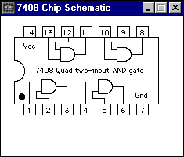
0 | 0 | 0
0 | 1 | 0
1 | 0 | 0
1 | 1 | 1

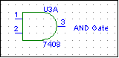

OR Gate:

A | B | Output  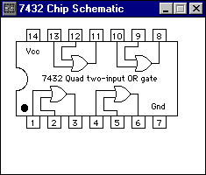
0 | 0 | 0
0 | 1 | 1
1 | 0 | 1
1 | 1 | 1

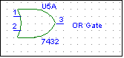

HEX Inverter:
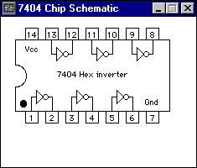
A | Output
0 | 1
1 | 0

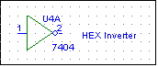

The purpose of this experiment was to familiarize students with the Digital Design Station (DDS), experiemental procedures and simulation using the Winbreadboard and the DDS. Using the Winbreadboard we showed an example of the AND gate and its wiring.
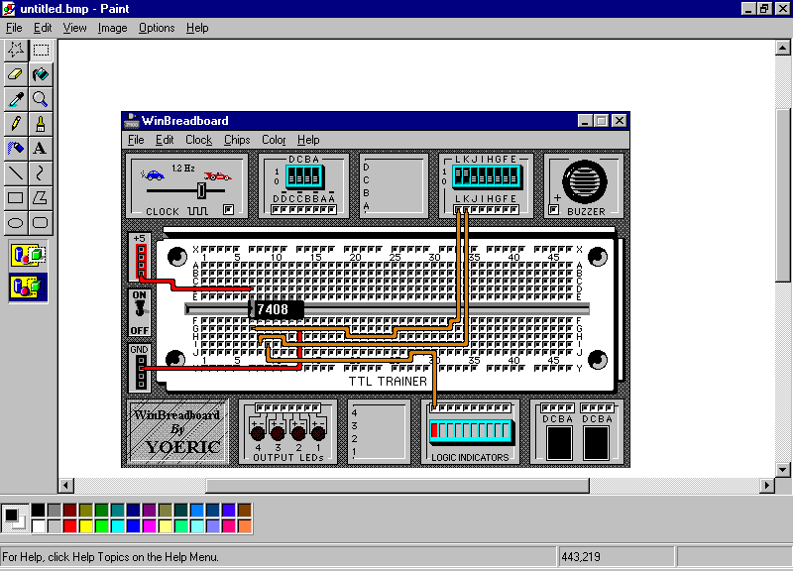

Conclusions and Precautions: In this lab assignment we were to understand the basic schematics, Boolean expressions and truth tables of the NOR, NOT, NAND, OR, and AND gates using the DDS and Winbreadboard Stations. The only precautions or a difficulty encountered was the wiring using the Winbreadboard (too small). The assignment was fairly easy and enjoyable.

