Vladi Gergov
Stephanie Hayes
Project I
Seven Segment Display And Combinational Circuit Design



We have neither received nor given aid in the presentation of this report

________________________ ________________________

I. Objective(s)

- To implement the Data Distribution (Multiplexing) operation using a simple Multiplexer.
- To implement the Data Distribution (DeMultiplexing) operation using a simple DeMultiplexer circuit.
- To combine the MUX and DMUX circuit in order to realize the application of the Multiplexer and DeMultiplexer.
- To implement the parallel to serial conversion of data using 1 of 8 Multiplexer.

II. Theory

To prove the Multiplexing and Demultiplexing operations using data distribution, successful combination of MUX and DMUX, and the implementation of the parallel to serial conversion using an 1 of 8 MUX.

II. Materials Required

Hardware Implementation using DDS:

- DDS
- 7 Segment Display Circuit
7404 – Hex Inverter
7432 – Quad 2 Input OR
7408 – Quad 2 Input AND
- Wires

Win Bread Board Simulation:

- Win breadboard Simulation package

III. Procedure and Results

Experiment 4a:
A | B | C | Output
0 | 0 | 0 | 0
0 | 0 | 1 | 0
0 | 1 | 0 | 1
0 | 1 | 1 | 0
1 | 0 | 0 | 0
1 | 0 | 1 | 1
1 | 1 | 0 | 1
1 | 1 | 1 | 1

We used a 7400 NAND gate to simulate a multiplexer.
The results we received are to the right.

Experiment 4b:
A | LED 1 | LED 2
0 | 1 | X
1 | X | 1

We used a 7400 NAND gate with a 1Hz Clock on the DDS to simulate the demultiplexer, and also with the windows bread board.

Experiment 4c:

We combined the two circuits for the multiplexer and demultiplexer to simulate a “communications channel”.

Experiment 4d:

We used the reduced equation to find the inputs of the multiplexer and simulated the circuit using a 74193 4 bit counter, 7404 Hex inverter, and a 74151 1 of 8 MUX on the DDS.

IV. Conclusions and Precautions

In these series of experiments we experienced how multiplexers and demultiplexers work and their applications in real life like the communications channel. We also learned that how to duplicate a MUX and DMUX using NAND gates.
Windows Bread Board Simulation Screen Shots:

Experiment 4b
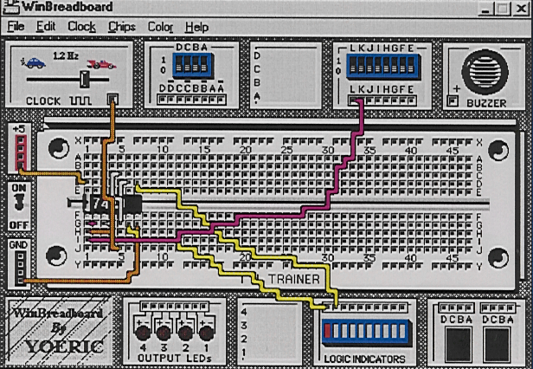
Experiment 4c
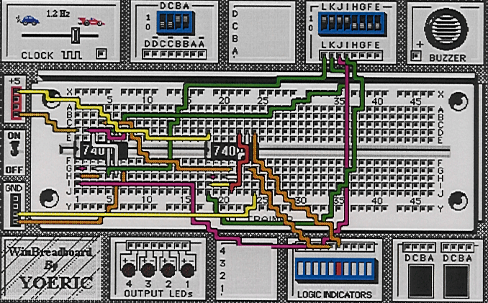
Experiment 4d
