Ray’s Design

I began the design project with a Class B Power Amplifier. I designed a basic schematic from information from class lecture. I used a voltage source of 20V for the rail voltages and an op amp to create Vcc/2. I then assumed R1 to be 1K and solved for the gain of the 1st op amp which I knew from lecture was 6V. Unsure of how to calculate the gain of an op amp with inputs at both the inverting and non-inverting terminals I first tried to calculate Rf one input at a time.

Rp Vo = -Rf
V3

Solving for Rf I got 2795. Though I believed this was incorrect and thought I needed superposition to calculate Rf this proved to work.

I then calculated the capacitors at the inputs using the equation

ω = 1 = 1.59E-7 = 159nF
2π Rf

this was too low and I wasn’t getting enough gain so I tried Rp and the result was 318nF. This was still too low so I experimented until 430nF gave me a nice sine wave that was near 6V.

I then preceded to calculate the output of the second op amp U2. Already having calculated the final voltage using the equation V²/R, I knew the output voltage needed to be 5.65V. This meant that R10 would have to be a lower value than R9. So I assumed R10 to be 1K. I used superposition for this op amp and the resulting resistance was too low to get the needed gain. I again experimented until I got an unclipped sine wave.

I assembled the schematic in figure 1 and began testing. Finding I needed more gain I changed several resistor and eventually the op amp passed all tests. Figure 2 shows the output of the op amp U1, figure 3 shows the output of the op amp U2 and figure 4 shows the final output of the Class B power amplifier. Figure 5 is the AC analysis.

Figure 1

Figure 2
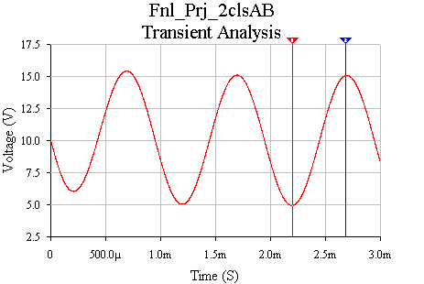
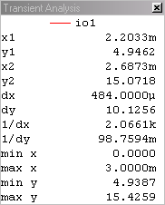

Figure 3

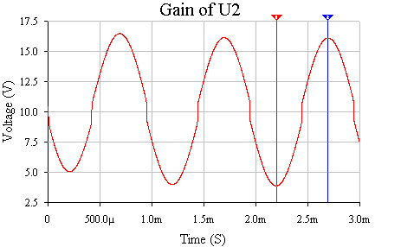

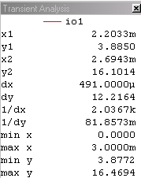

Figure 4

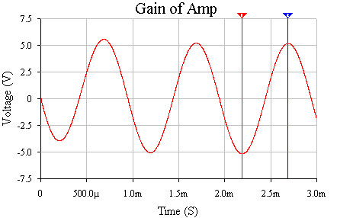

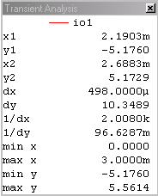

Figure 5
