ECE 311 Lab 15:
[ Common-Mode Rejection ]

Professor Miller



We have nor given or received any aid on this project.

Ray Eggers: _______________________________________

Vladi Gergov: _______________________________________

Brandon Harris: _______________________________________
Objectives

- To asses the concepts of differential and common-mode signals.
- To evaluate the various voltage gains as they apply to differential and common-mode signals.
- To determine the common-mode rejection ratio by signal measurement in a differential amplifier.
- To measure the effectiveness of employing current source drive to improve common-mode rejection ratio.
- To evaluate the operation a differential amplifier used to amplify a small DC differential signal.
- To simulate the AC conditions of various differential amplifier circuits using Electronics Workbench.

Equipment

11 Resistors: 1 kΩ (3), 22kΩ, 39kΩ, 47kΩ (3), 56 kΩ 220kΩ, 470 kΩ
2 2N5210 NPN Transistors
1 1.5 V Battery

Oscilloscope
Function Generator
Triple Power Supply
Electronics Workbench
Schematics
Figure 15-3a
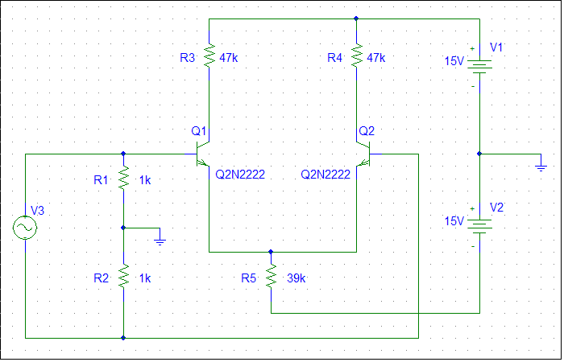
Figure 15-3b
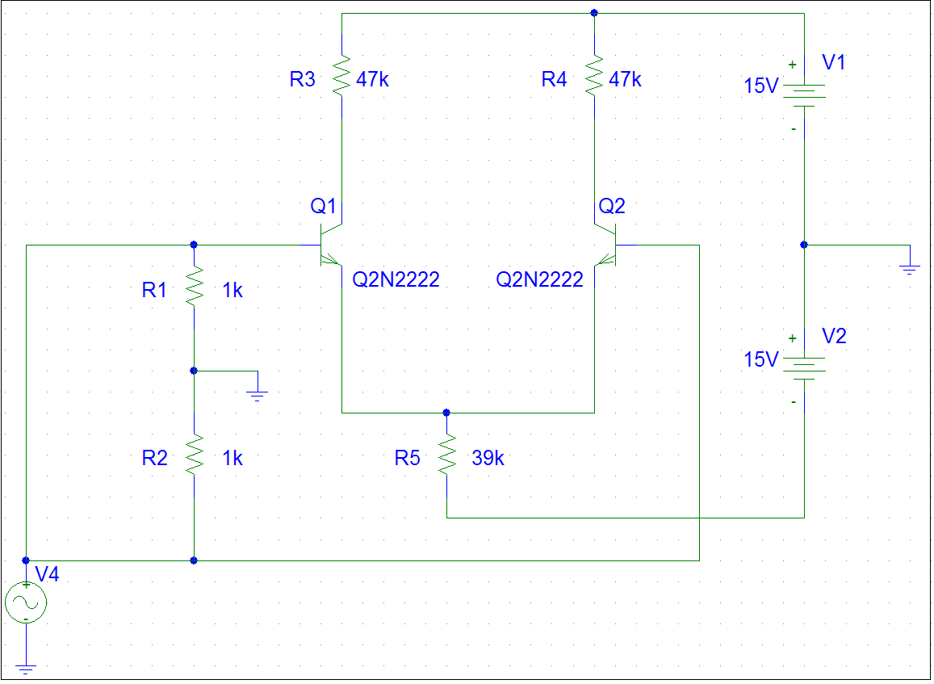
Simlulation Results

Differential Input |  |  |  | Common-Mode Input
Measured |  | Calculated |  | Measured |  | Calculated
Vi₁ | -1.387mV | Av_{DS1} |  | Vi₁ | 0 | Av_{CS1}
Vi₂ | -1.387mV | Av_{DS2} |  | Vi₂ | 0 | Av_{CS2}
Vi_{D} | 0v | Av_{DD} | ∞ | Vi_{C} | 0 | Av_{CD} | ∞
Vo₁ | 6.389v |  |  | Vo₁ | 6.388v | CMRS₁
Vo₂ | 6.389v |  |  | Vo₂ | 6.388v | CMRS₂
Vo_{D} | 0v |  |  | Vo_{C} | 0 | CMRD | 1

Lab Results

Differential Input |  |  |  | Common-Mode Input
Measured |  | Calculated |  | Measured |  | Calculated
Vi₁ | .858v | Av_{DS1} |  | Vi₁ | 1.568v | Av_{CS1}
Vi₂ | .808v | Av_{DS2} |  | Vi₂ | 1.568v | Av_{CS2}
Vi_{D} | .05v | Av_{DD} | 95.5 | Vi_{D} | 1.568v | Av_{CD} | .406
Vo₁ | 6.889v |  |  | Vo₁ | .777v | CMRS₁
Vo₂ | 2.114v |  |  | Vo₂ | .141v | CMRS₂
Vo_{D} | 4.775v |  |  | Vo_{D} | .636v | CMRD | 235.22
Conclusion

In this lab we were thought how to use a differential signal in order to isolate common-mode line noise. This is accomplished by the ability of the circuit to amplify only the differential signal and reject the common-mode signal. This circuit is very useful for a signal that has to travel long distances and the lines are exposed to the same kind of noise usually 60 Hz from power lines.

