ECE 311
Lab 7 Switching Circuits



We have nor given or received help on this lab.

Ray Eggers ______________________________________________

Vladi Gergov ______________________________________________

Brandon Harris ______________________________________________

Objectives

- To compare voltages and currents at saturation with those at cut-off.
- To represent the conditions of a load line.
- To explain specifications relating to saturation and cut-off regions of transistor operation.
- To test a transistor to determine specifications relating to cut-off and saturation.
- To evaluate the switching speed of a transistor.
- To simulate switching circuits using Electronics Workbench.

Equipment

Resistors: 680kΩ, 1kΩ, 39kΩ, 180kΩ

NPN Transistor: 2N5210

LED

Oscilloscope
Triple Power Supply
Electronics Workbench

Schematics

Figure 7-3 Figure 7-4
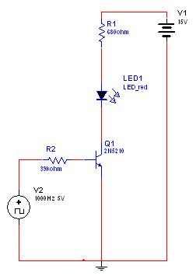

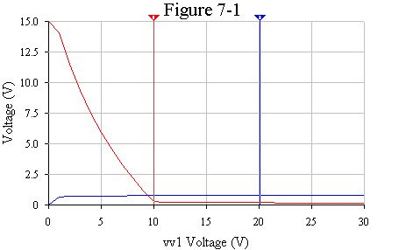
Results

Table 7-1

Variable  Supply | Measured |  |  |  | Calculated
Variable  Supply | V_{B} | V_{C} | I_{C} | I_{B} | β
0V | 0 | 15V | 0 | 0
1V | 0.662V | 14.09V | .879 mA | 1.00 µA | 496
2V | 0.701V | 11.53V | 3.45mA | 7.11 µA | 485
5V | 0.735V | 5.95V | 9.03mA | 23.54 µA | 383.6
10V | 0.757V | 0.298V | 14.7mA | 51.18 µA | 287.2
15V | 0.758V | 0.198V | 14.81mA | 79.05 µA | 187.4
20V | 0.758V | 0.181V | 14.82mA | 106.8 µA | 138.8
25V | 0.758V | 0.170V | 14.83mA | 134.6 µA | 110.2
30V | 0.759V | 0.163V | 14.83mA | 162.3 µA | 91.37

Table 7-3

 | Measured
 | V_{G} | V_{B} | V_{X} | V_{C}
ON |  | 835.5 mV | 7.73 V | 7.02 V
OFF |  | .5762 µV | 15 V | 14.63 V

Question

- From table 7-2 as the 0-30V supply was increased at what value of this supply did the transistor just start to saturate, that is, when Ic stopped increasing.

It occurs at about 15V because the change from 15 – 20 volts was only .1 mA change, which is insignificant.

- How would circuit performance change if the 39 K ohm resistor in figure 7-4 were increased?

It affects Ib, which therefore changes the current in Ic and it would not produce enough current to switch the LED off and on if the resistance value got too high.

- What change would you make to the circuit Figure 7-4 if you were switching an LED which had a maximum current rating of 10 mA?

You would adjust Rc and Rb given β to calculate a new Ic and Ib thus limiting current flowing into the LED so that the desired current of 10mA is achieved.

Conclusion

In this lab we learned about transistors and their three states ( cut-off , active, and saturation ). In the first circuit simulation we learned how to calculate β by using the equation β = Ic / Ib ( β is the current gain at the emitter ). We noticed in our lab that at 5 V, β is the highest, meaning it has the highest gain ratio. We also learned about some practical applications of a transistor such as how it can be used as a switching circuit. The switching circuit can be used to turn off and on an LED or any other type of device that requires a larger current than the signal can provide. When you have a square wave generator source for the switching circuit, the transistor alternates between saturation and cut-off. Active mode is used to amplify current, but was not used in this lab.

