ECE 311: LAB 16 REPORT

Partners:
Ray Eggers
Vladi Gergov
Brandon Harris

Title:

Op-Amp Characteristics

Objectives:

The purpose of this lab is to evaluate op-amp specifications such as open-loop gain, output voltage swing, common mode rejection ratio, and bandwidth. To compare measured op-amp specifications with manufacturer’s data tables. The op-amp will be simulated on Multisim to evaluate maximum output swing characteristics.

Equipment:

2 10KΩ resistor
1 LM741 Op-Amp

Circuit Diagram Fig. 16 - 3:

Simulation Results Table 16 - 2:

Waveform  Condition | Voltage | Waveform
Maximum  Unclipped | 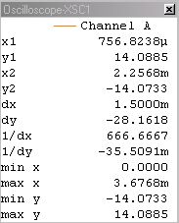 | 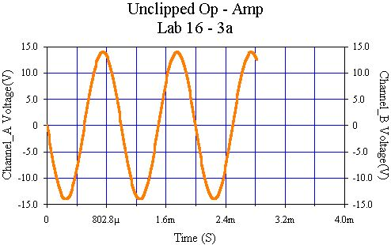
Maximum  Clipped | 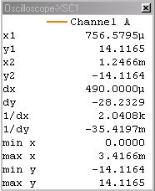 | 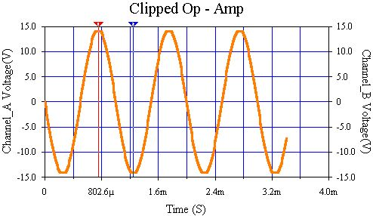

Lab Test Results Table 16 - 3:

Waveform  Condition | Voltage |  | Waveform
Maximum  Unclipped |  | 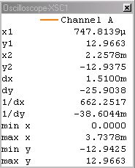 |  | 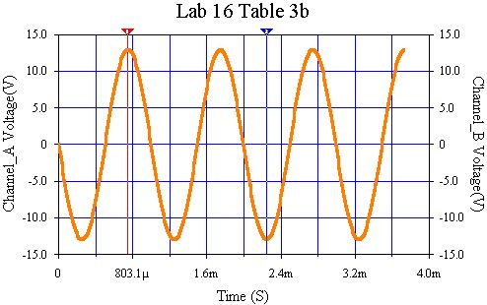
Maximum  Clipped |  | 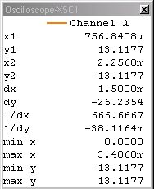 |  | 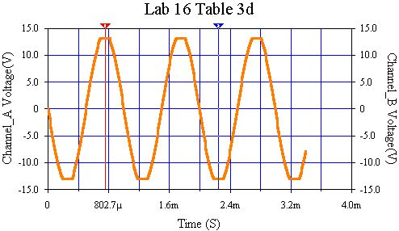

Conclusion:

This lab introduced us to op-amps and their characteristics. We wired up a negative feedback inverting op-amp after which we adjusted the amplitude of the input wave until the op-amp started to clip the sinusoidal wave due to the rail voltages being ±15 volts this was at around ±13 volts.

The function generator for the simulation in fig. 16 – 2 was set at 1KHz, 1V and clipping occurred at ±14.1175V. It was then set to 500mV and no clipping was observed, and the maximum output voltage was approximately ±10V. The amplitude was then re-adjusted to 600mV and again there was no clipping at ±12V. Setting the amplitude to 705mV yielded an output of ±4.0885V. The first viewed clipped sine wave at ±14.1165 V was observed when the input voltage was 720mV. When the input voltage was adjusted to 710mV the output voltage just barely began clipping at ±14.1154V.

The lab experiment began by setting up the circuit in fig. 16 – 3. The function generator was set to a 1 kHz sine wave and rail voltages were set to ±15V. An oscilloscope was connected to the output of the circuit. A sin wave was then viewed and the amplitude of the function generator was lowered until an unclipped sine wave which was approximately ±13V, then documented in fig 16 - 3. The amplitude was raised until the sine wave began clipping at just above ±13V and this was also documented in fig 16 - 3.

