ECE 311: LAB 17 REPORT

Partners:
Ray Eggers
Vladi Gergov
Brandon Harris

Title:
Comparators and Multi-vibrators

Objectives:

The purpose of this lab is to evaluate a simple op-amp comparator circuit and assess the characteristics of op-amp Multi-vibrators. Also to simulate these circuits using Electronics Workbench.

Equipment:

100Ω, 3.3kΩ, 10kΩ, 100kΩ, 10ΜΩ resistors
10nF, 100nF capacitors
1N5233 6.0V zener diode
LM741 Op-Amp

Simulation Circuit Diagrams:
Fig. 17 – 3 Comparator: Fig. 17 – 4 Inverting Comparator:

Fig 17 – 5 Multivibrator

Simulation Results Table 17 - 1:

Circuit
Non-Inverting  Comparator | 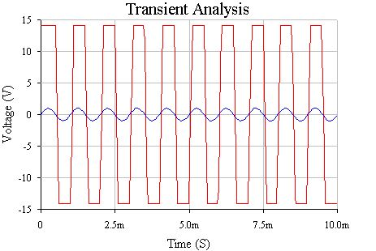
Inverting  Comparator | 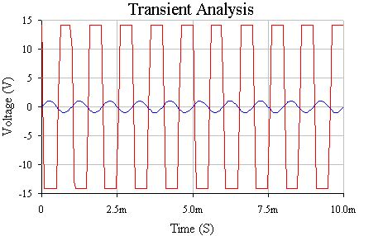

Simulation Results Table 17 - 1:

Circuit
Non-Inverting  Comparator | 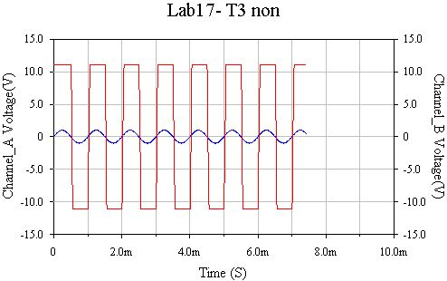
Inverting  Comparator | 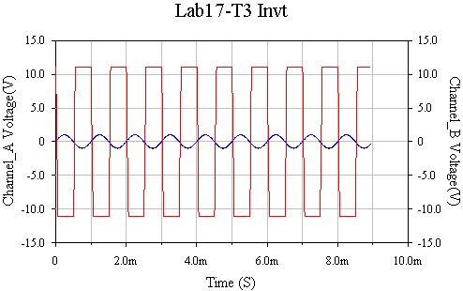

Simulation Results Table 17 - 3:

Step | Voltage | Frequency | Waveforms
6 | 8.1V | 1.64 kHz | 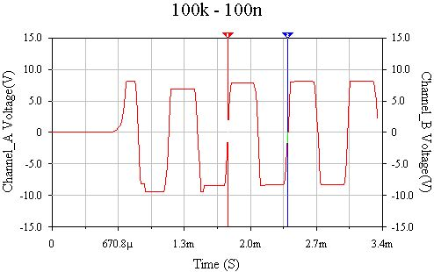
7 | 6.7V | 6.024 kHz | 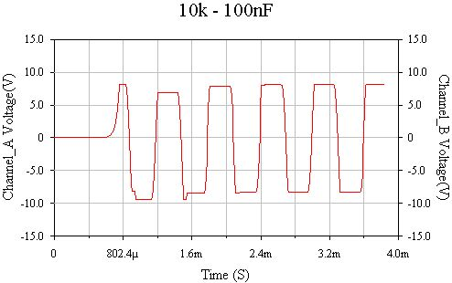
8 | 8.1V | 6.134 kHz | 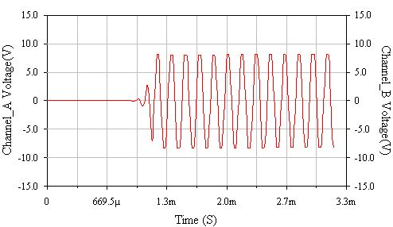
9 | 9.7V | 238 Hz | 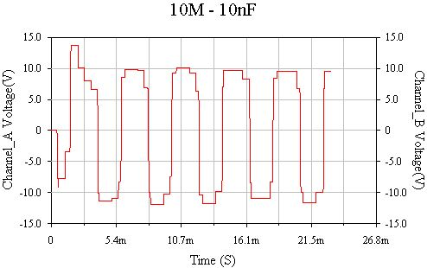
10 | 16.8V | 26.32 Hz | 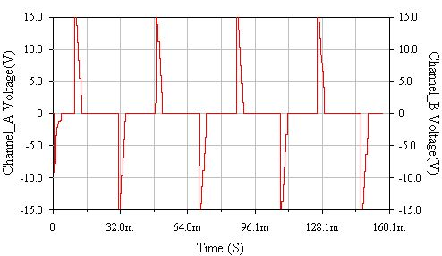

Conclusion:

In this lab we learned how an inverting and non-inverting comparator circuits work also how a multi vibrator works. We simulated both of these circuits in workbench and the results were similar to the results yielded in lab. The inverting and non inverting comparators outputs were 180 degrees offset with each other which meant that the output waveforms changed state when the input wave passed through zero. In the multi-vibrator circuit which is basically an op-amp with positive feedback whose voltage is controlled by the values of R1 and R2 and the capacitor which, uses R2 to charge to the trigger voltage. Then the circuit generates a clipped sine wave with some capacitor characteristics.

Questions:

- Yes. The waves were 180 degrees out of phase with each other.
- Yes. The output waveforms changed state from hi to low when the input passed through zero volts.
- Our theoretical frequency calculated by 1/(2*100k*1e-7*ln((1+.0099)/(1-.0099)) was 2525.2Hz. The frequency acquired form our lab is 1.25 which is theoretically incorrect.

