311 Project One:
[ Shunt Regulator ]

Professor Miller



We have nor given or received any aid on this project.

Ray Eggers: _______________________________________

Vladi Gergov: _______________________________________

Brandon Harris: _______________________________________
Objectives

- Design a voltage regulator to produce a nominal voltage of six volts plus or minus two hundred Mila-volts. The input voltage can vary from ten to sixteen volts and the load can vary from two hundred twenty ohms to one hundred kilo-ohms. Under these conditions, the output must not change by more than five Mila-volts. Note that only a single voltage source may be used.

Equipment

- Zener Diodes ( 2 ): D1N750
- Capacitors ( 2 ): .1 μF
- Op Amps ( 2 ): uA741
- Resistors ( 7 ): 2x500, 2x1000, 290, 3030, Variable from 220 to 100,000
- Oscilloscope
- Varying Power Supply: 10v – 16v
Theory

- The shunt regulator uses zener diodes to bring a varying voltage down to a constant by taking advantage of the zener’s reverse break down affect. It is also critical to get a good amount of current going through the zener diode to improve regulation by surpassing the knee. Then after sufficient amount of regulation an op-amp is used to amplify the signal without drawing little to no current from the circuit due to its infinite impedance at the inputs property. Once the proper ratio of resistors yields the correct gain to amplify the regulated voltage to an desired value the process is repeated again to achieve further regulation until it falls within the five mila volt output variance specs. Then the need of an transistor becomes apparent when the load resistance is varied from 220 Ohms to 100K Ohms for further stabilization of the current draw aspect of such a variation. With that final addition to the circuit is made and the shunt regulator is complete.
Final Design Schematic

Conclusion

- While going through the design process of this project we learned a lot about the properties of zener diodes, op-amps, and transistors. We also learned that there is a big difference between a computer simulation and the actual hardware implementation of the circuit, op-amps performed no where near ideal and the zener diodes and transistors dissipated a lot of power which threw off predicted resistance values and other pspice calculations. We also got some oscillation in our first stage but quickly fixed it by putting some .1 μF capacitors across the rails ( pins 4 and 7 ).
Vladi’s Pspice Simulation

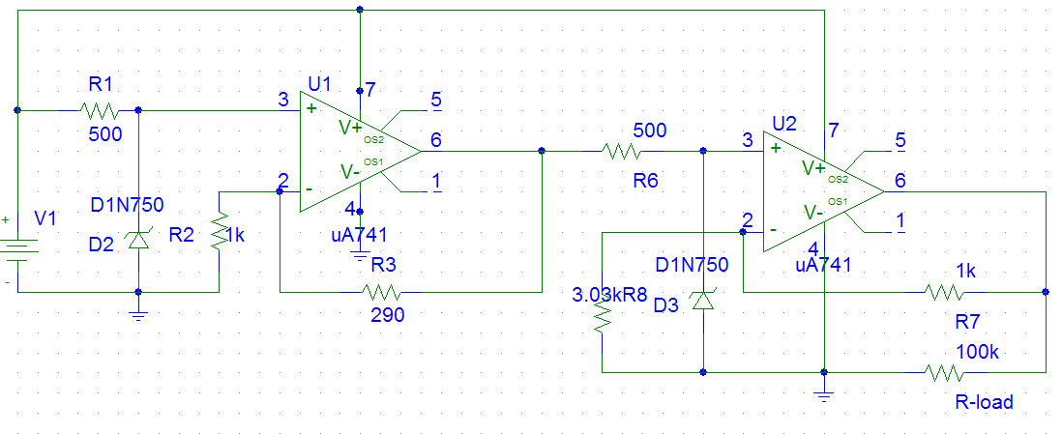

- For my pspice simulation I started by using the sample circuit provided in our notes which gave me the general layout and basic understanding of the circuit. Using two op-amps and two zener diodes arranged in the matter described in our notes. From that point on I used the non-inverting gain equation from which I had Vo and Vin and solved

