311 Project One:
[ Shunt Regulator ]

Professor Miller



We have nor given or received any aid on this project.

Ray Eggers: _______________________________________

Vladi Gergov: _______________________________________

Brandon Harris: _______________________________________
Objectives

- Design a voltage regulator to produce a nominal voltage of six volts plus or minus two hundred Mila-volts. The input voltage can vary from ten to sixteen volts and the load can vary from two hundred twenty ohms to one hundred kilo-ohms. Under these conditions, the output must not change by more than five Mila-volts. Note that only a single voltage source may be used.

Equipment

- Zener Diodes ( 2 ): D1N750
- Capacitors ( 2 ): .1 μF
- Op Amps ( 2 ): uA741
- Resistors ( 7 ): 2x500, 2x1000, 290, 3030, Variable from 220 to 100,000
- Oscilloscope
- Varying Power Supply: 10v – 16v
Theory

- The shunt regulator uses zener diodes to bring a varying voltage down to a constant by taking advantage of the zener’s reverse break down affect. It is also critical to get a good amount of current going through the zener diode to improve regulation by surpassing the knee. Then after sufficient amount of regulation an op-amp is used to amplify the signal without drawing little to no current from the circuit due to its infinite impedance at the inputs property. Once the proper ratio of resistors yields the correct gain to amplify the regulated voltage to an desired value the process is repeated again to achieve further regulation until it falls within the five mila volt output variance specs. Then the need of an transistor becomes apparent when the load resistance is varied from 220 Ohms to 100K Ohms for further stabilization of the current draw aspect of such a variation. With that final addition to the circuit is made and the shunt regulator is complete.

Procedure

- We used the schematic of the partner that worked the best in pspice. We also went and bought some quality parts from an electronics store. We got some .2 tolerance resistors, some op-amps and some ~6 v zener’s. After which we wired up the first stage of the circuit and assuming R1 = 1K then R2 = 66.85. At this point we had a ratio and a starting point. But the tolerance was 23.5mV (figure 1) and it appeared that the wattage in R2 would be too high. We then increased and decreased R1 and R2 noticing an increase in R1 and a decrease in R2 would tighten the tolerance. We tried using Zeners with smaller voltages and raising and lowering Rs. We knew at this point a second stage would be needed.

[ Figure 1 ]
- We added the second stage to the first going back to the original design (figure 2). We then used the same Rs diode combination and solved R1 and R2 just as we did for the single stage. This worked very well and we had a tolerance of about 1.4mV. Problem was when the load resistance was dropped to 51 Ω the output voltage dropped 1.2309V.

[ Figure 2 ]

- We then added the 2N5210 transistor that was suggested in class. At this time we also didn’t know about the single voltage source. The transistor solved the problem of being over  0.2V from the nominal. I then took ammeter readings and calculated the power dissipated through each resistor using the power formula

- P = I²R

- All the wattage’s were below 0.5 watts, but I decided to increase the diode resistors to 1K mainly for easier calculation (Figure 3).
[ Figure 3 ]

- After wiring the circuit we discovered there was to be only one voltage source. On paper the regulator worked fine, but when we got to the lab it oscillated. We blamed the new voltage source configuration and started swapping resistors in both EWB and on the board. This was mistake for most of the original information was lost. We finally realized that we were missing Rs2 on the board. Replaceing it we found that the 1st stage had too much gain. We raised the value of R1 and ended with a new configuration (Figure 4). This is the shunt regulator we demoed.
[ Figure 4 ]
Conclusion

- While going through the design process of this project we learned a lot about the properties of zener diodes, op-amps, and transistors. We also learned that there is a big difference between a computer simulation and the actual hardware implementation of the circuit, op-amps performed no where near ideal and the zener diodes and transistors dissipated a lot of power which threw off predicted resistance values and other pspice calculations. We also got some oscillation in our first stage but quickly fixed it by putting some .1 μF capacitors across the rails ( pins 4 and 7 ).

Ray’s Pspice Design

- I began the shunt regulator design project with a single stage. It had a 5.624V Zener diode and an LM741 op amp. I calculated Rs_{min} using the formula

- P = (Vs_{max} – Vz)²
- Rs_{min} and solving for Rs_{min} . I tried calculating Rs_{max} using the formula from the book but my diodes didn’t have specs for Rz or Iz.

- I then attempted to calculate R1 and R2. I knew that V- at the op amp inverting input terminal equaled V+ at the non- inverting input. This was also the voltage Vz. Using two equations I used were:

- Vo = 1 + R2 * V₋
- R1

- 0 = V- + V- - Vo
- R1 R2 R2
Vladi’s Pspice Simulation

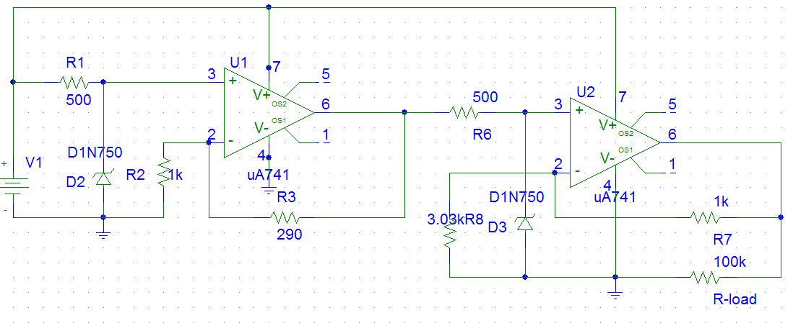
Procedure

- For my pspice simulation I started by using the sample circuit provided in our notes, which gave me the general layout and basic understanding of the circuit. Using two op-amps, two zener diodes, and seven resistors arranged in the matter described in our notes I got a starting point to work from. I then used the non-inverting gain equation from which I knew Vo and Vin and solved for the ratio of R2/R1 then I chose an R1 or R2 and solved for the other. This will give me the proper resistor ratio for the op amp to get the regulated zener voltage at the input to a desired six volts at the output. As I progressed along the circuit I realized that if I put more current through the diodes it will improve my regulation which is what I finally did to get a variance of +/- 3 mV at the output. In theory and in pspice my design regulates within specs but if actually implemented I believe that I will have problems with power dissipation of resistors and zeners. Will also need to include a transistor to help with the lower values of Rload.

Brandon Pspice Simulation

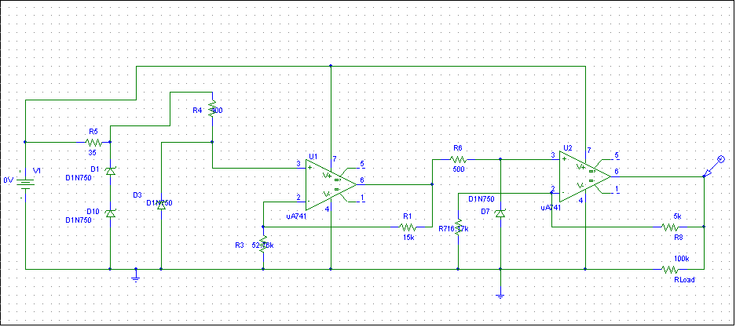

Theory:

Two of the most important components needed in this design were the op-amps and the zener diodes. The zener diode works in reverse bias mode. What it does essentially is stabilize voltage. After a certain amount of current is driven through the zener diode, the voltage becomes stable. You need to use a resistor to restrict current flow into the zener diode. I tried different values until I found the resistor value that produced saturation current through the diode. When enough current is driven through zener diode, there is approximately 4.7 V that flows into the input of the op-amp. You then need to calculate the gain needed to amplify the 4.7 V signal to 6 V. This is done using the equation:

Vo/Vin= 1 +(R2/R1)

I was able to trace the input voltage emitted by the diode using PSPICE. I also knew that I wanted the output to be 6V. You then choose a resistor value for R2 or R1 and solve for the remaining resistance value. This will give you the correct gain to get 6 V.
I originally tried to use only one op-amp by using multiple zener diodes in parallel. By adding more zener diodes in parallel you can stabilize the voltage even further. This however was not sufficient. I realized that another stage was needed if the output voltage was to fall within the 5mV variance range. For the second stage I used only one zener diode to regulate the voltage. I again calculated the gain and set up the load resistor. I simulated it with values ranging from 220 ohms to 100k ohms. The variance was approximately 1.3 mV, which is well within the allowed range. In real life, my circuit may not be appropriate because of the high current flowing through the very small resistance values. It does however work nicely in PSPICE.

