Nick Sitarski
Vladi Gergov
ECE 317
Professor Awad
Winter 2003
Lab 5


We have neither given nor received any unauthorized aid in this graded assignment.

____________________________________________________________________

_____________________________________________________________________

Problem 1:

C = 1
10Kπ *25KΩ

R1 = 10KΩ
R2 = 25KΩ
C = 1.27324 nf

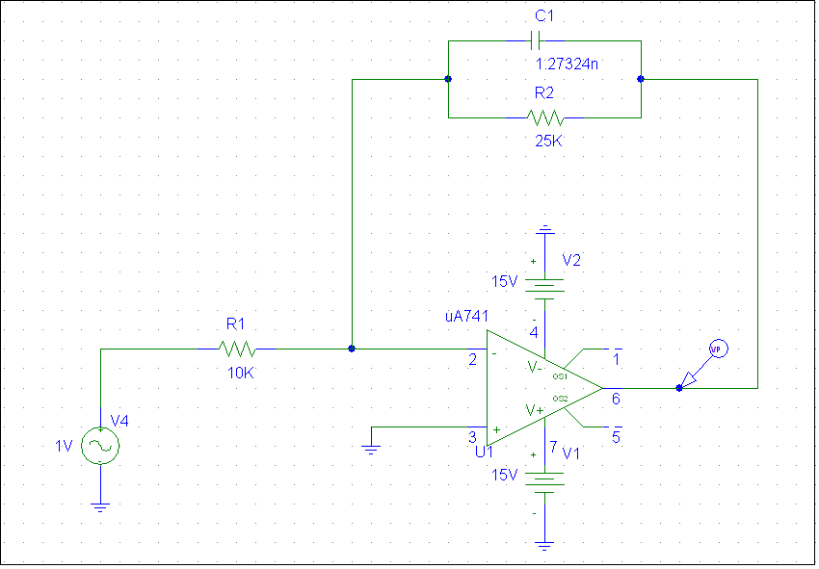
Above is the circuit used for problem #1.

Magnitude Response
Phase Response

From the above graphs at 15 KHz the magnitude response is down about 10 db.

Problem 2:

Below is the equation to figure out ω_{c}

1 = 10 log {1 + (10Kπ)⁶}
ω_{c}

ω_{c =} 39350.8 rad / sec

The cut off frequency works out to be about 6.0199 Hz. At this frequency the magnitude response should be down about 3 db and at 5KHz it should be down about 1 db. The cut off frequency was calculated using the formula for a 3rd order butterworth method.

C = 1
39350 *1KΩ

C = 29.41 nf
R = 1K

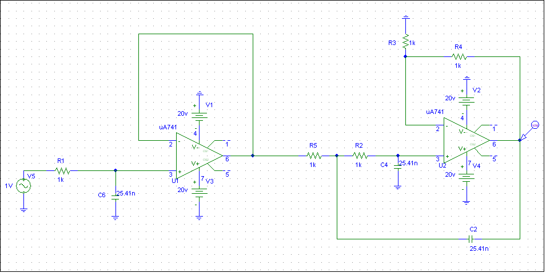

The above is the circuit used in problem #2

Magnitude Response
From above you can see at 5KHz the magnitude is down 1 db and at about 6.02KHz it is down about 3 db.

Phase Response
Problem 3:
Through the equations for a butterworth filter is was determined that a 6th order filter was need for problem 3. Also it was determined that the cutoff frequency for this filter was about 19450.5 rad / sec. Resistor and capacitor values can be seen on the below circuit.

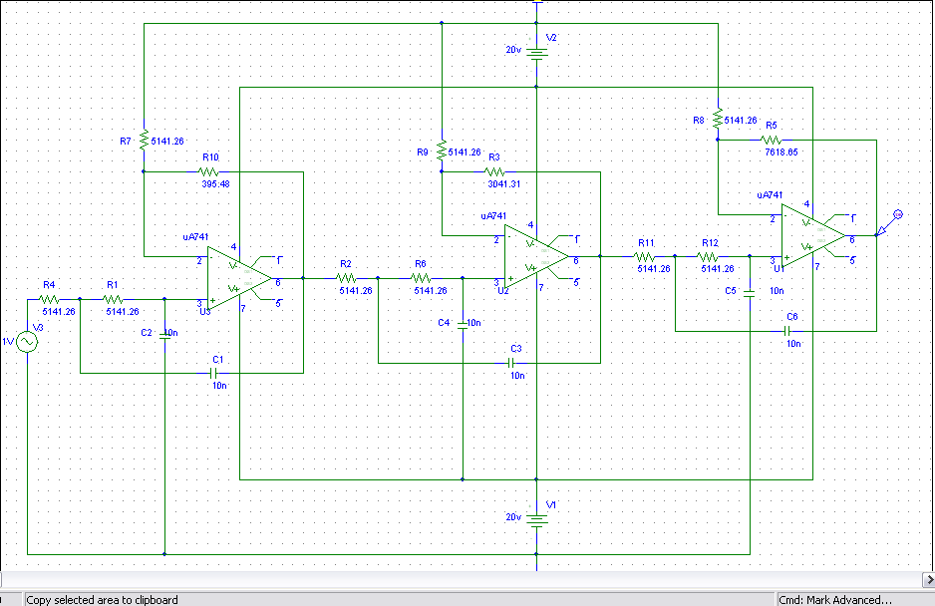

Magnitude Response
Notice that this magnitude response meets the requirements for this filter. At 2.5KHz the response is down less than .5 db. At 5 KHz the response is down about 25 KHz.

Phase Response
Conclusion:
The results for all parts of this lab came out to be what was expected. We learned how make filters other than first or second order.

