ECE 317 |  |  | 5 November 2002
Lab 3:
LTI Systems in MatLab


Fall 2002

Professor Awad

“We have neither given nor received aid in the preparation of this lab report.”
 | Prepared by
Tan Nyugen  tannguyen_79@yahoo.com |  | ____________________________
Jason Smith  jasonmsm@umd.umich.edu |  | ____________________________

Objectives
• | To become more familiar with the concepts of phase response and magnitude response of LTI systems using Matlab.
• | To produce graphical data, which describes the input and output of first and second, order LTI systems.
• | To learn to distinguish between different kinds of filters, and to gather data using Matlab which describes their characteristics (e.g. bandwidth, cutoff, peak value, phase response).

Theory
This assignment focuses on how to find the step-response, steady state value, time, amplitude, phase angle, phase response, peak value and final value of LTI systems described by first and second order of differential equations using Matlab. Part I deals with a lowpass filter, and is primarily focused on gathering data through inspection. Part II involves a lowpass, as well as a bandpass filter.

Procedure
- Consider an LTI system described by a first order differential equation given by:

a_{o} $\frac{\text{dy}(t)}{\text{dt}}$ + y(t) = x(t), with zero initial conditions.
  - Find the step-response, the steady-state value and the time the system reaches steady –state (also end of transient period) for the following cases:

a_{o} =0.2,0.5,1 and 2.

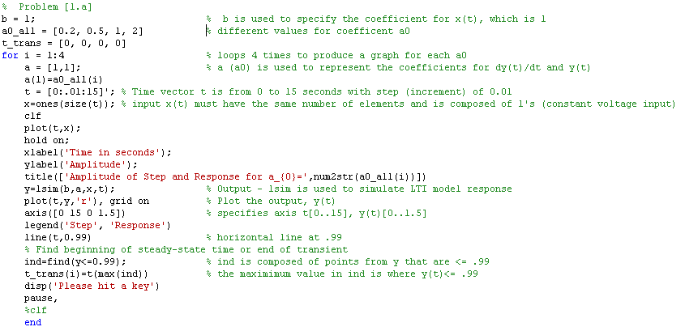
Program Listing 1.a. Matlab code used to implement problem 1.a.
See Results section of this report for graphs.
Full program listing is attached.

  - If the input to the system is x(t)=M cos(2πft)u(t) and a_{o} =1/20π:

i) Find the output response y(t) for the following cases:
M=2 and f=2,4,6,8,10 and 12 Hz.
j) For each frequency, determine amplitude and phase of the output signal at steady-state.
k) From the above information, plot the magnitude (B/M versus frequency) and phase responses of the system (θ versus frequency).

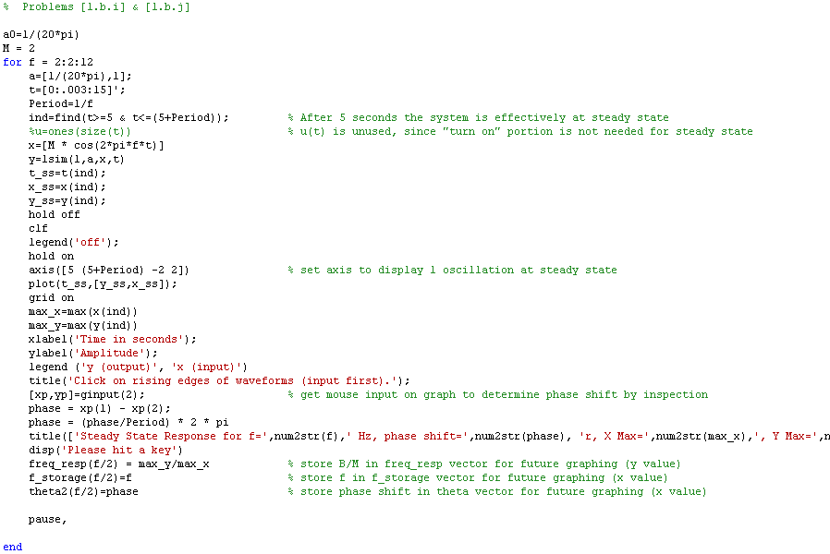
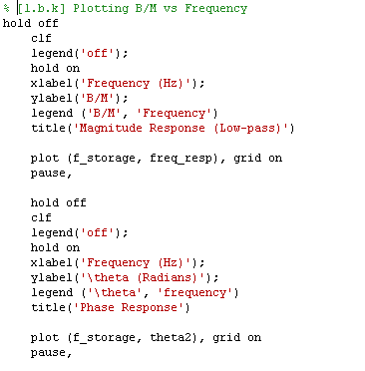

Program Listing 1.b. MatLab code used to implement part 1.b.
See Results section of this report for graphs.
Full program listing is attached.

- A second order LTI system is described by the following differential equation:

a_{o} $\text{dy}\frac{\begin{matrix}2 \\ (t)\end{matrix}}{\text{dt}\begin{matrix}2 \\ \end{matrix}}$+ a₁ $\frac{\text{dy}(t)}{\text{dt}}$²+ a₂ y(t)= b_{o} $\text{dx}\frac{\begin{matrix}2 \\ (t)\end{matrix}}{\text{dx}\begin{matrix}2 \\ \end{matrix}}$+ b₁ $\frac{\text{dx}(t)}{\text{dt}}$+ b₂ x(t).
  - Find the step-respsonse, peak value and final value (steady-state-value) for the following cases:

- $\frac{\text{dy}(t)}{\text{dt}}$=1, a₁=√2, a₂=1, b_{o} = b₁=0, and b₂=1.
ii) Same values as part I) except that a₁=0.5. Did the peak value change in comparison to part (i)? Explain.

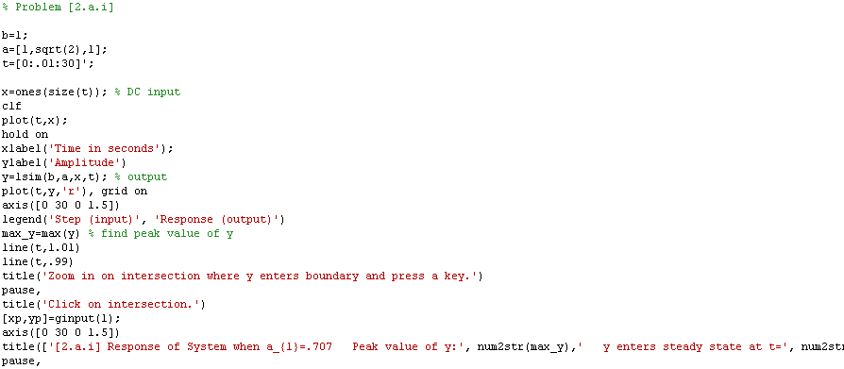
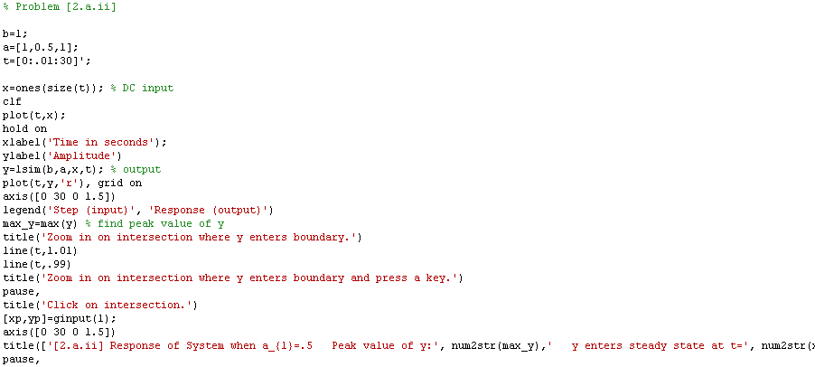

Program Listing 2.a. Matlab code used to implement problem 2.a.
See Results section of this report for graph. Full program listing is attached.

  - Plot the magnitude and phase responses for the following cases:

- a_{o}=1, a₁=20π/0.707, a₂=(20π)², b_{o}=b₁=0, and b₂=a₂. Hence, find the frequency at which the magnitude response drops to 0.707 from its dc value.

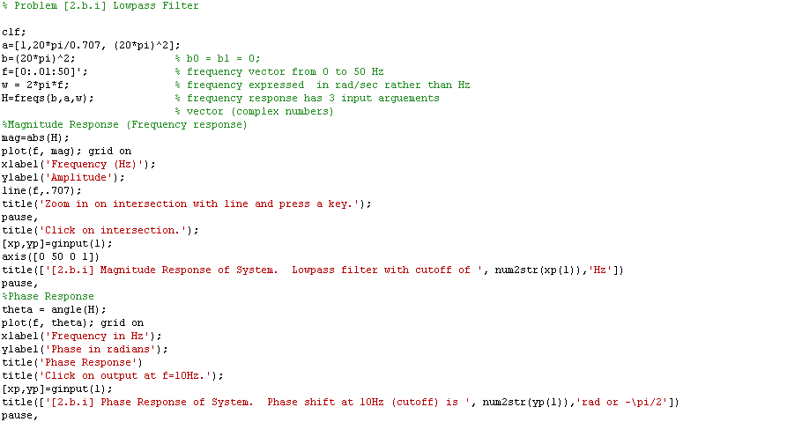

Program Listing 2.b-1. Matlab code used to implement problem 2.b.i
See Results section of this report for graph. Full program listing is attached.
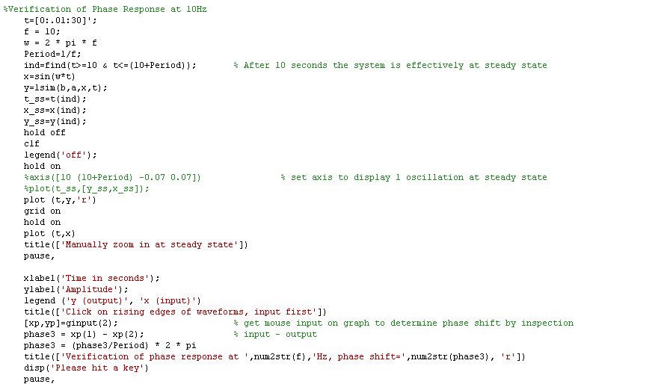

Program Listing 2.b.i-2. Matlab code used to verify problem 2.b.i
See Results section of this report for graph. Full program listing is attached.

ii) a_{o}=1, a₁=4π, a₂=(20π)², b_{o} = b2= 0, b₁=a₁.
What is the type of this filter? Determine the center frequency and bandwidth in Hz.

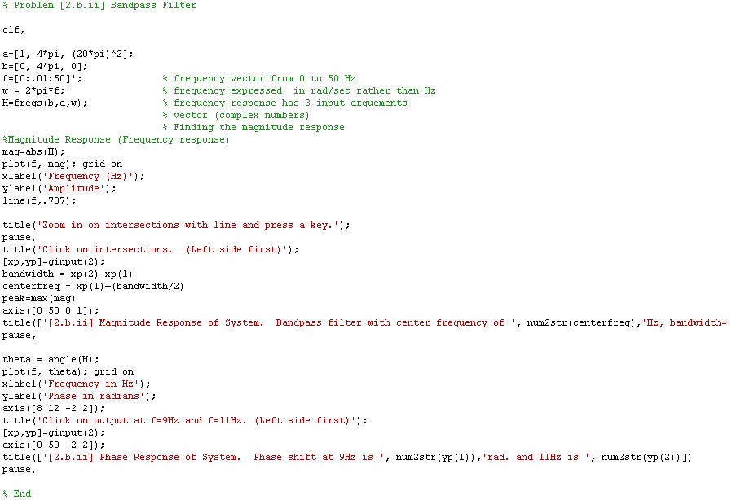

Program Listing 2.b.ii. Matlab code used to solve problem 2.ii.
See Results section of this report for graph. Full program listing is attached.

Results

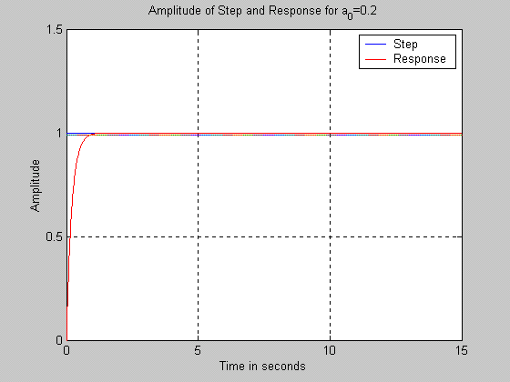
Figure 1. Step response of y for a₀ = 0.2.

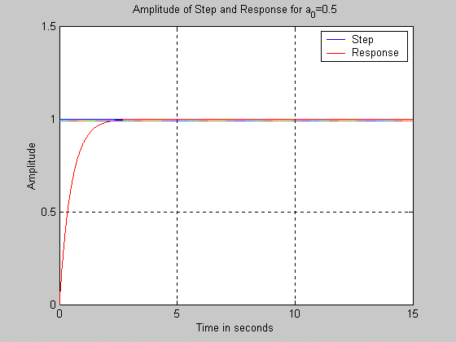
Figure 2. Step response for a₀ = 0.5. As a₀ is increased,
the system takes longer to go to steady state.

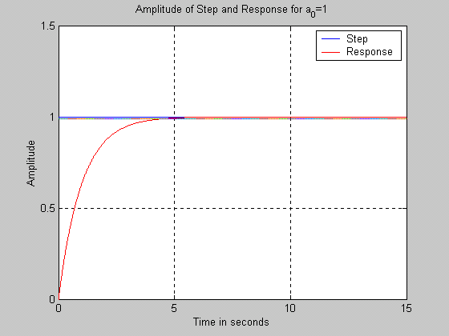
Figure 3. Step response for a₀ = 1 As a₀ is increased,
the system takes longer to go to steady state.

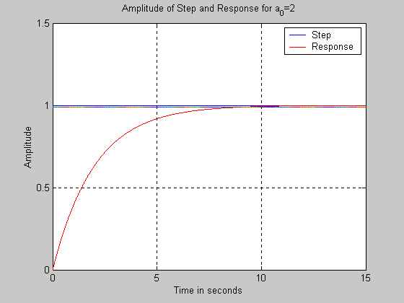
Figure 4. Step response for a₀ = 1. At this value, a₀ takes
approximately 10 seconds to go to steady state.

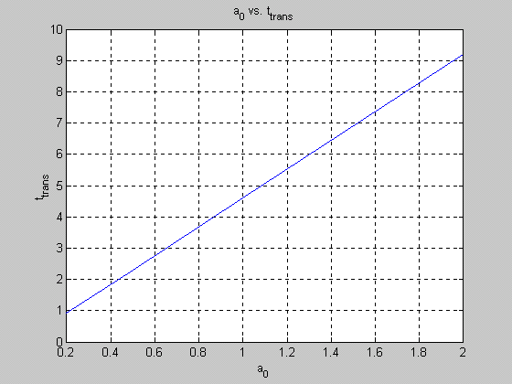
Figure 5. As suggested in the tutorial, a0 vs t_trans was graphed.
As the coefficient a0 is increased, the transient phase of the response
is also increased. That is, a larger value of a0 causes the system to
take longer to go to steady state.

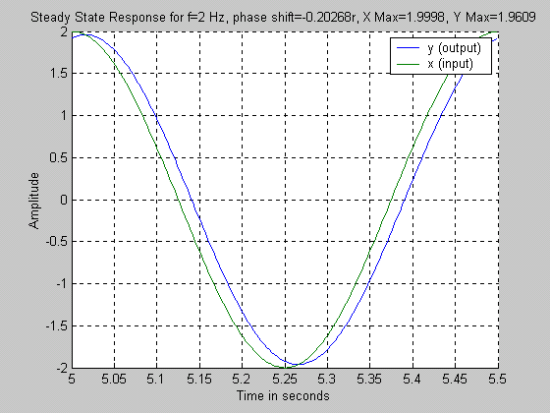
Figure 6. Input and output waveforms of the system for 2Hz. This
graph is used to realize the phase shift for this frequency through
inspection (using the ginput function in MatLab), as well as peak values.
In this case the output is lagging the input. Computed values are
contained within graph.

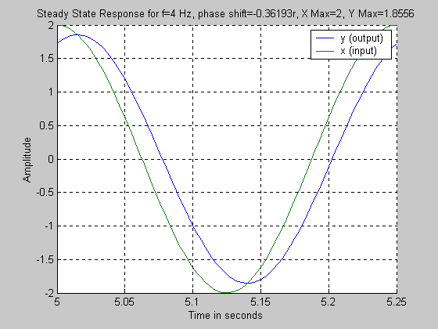
Figure 7. Input and output waveforms of the system for 4Hz. This
graph is used to realize the phase shift for this frequency through
inspection (using the ginput function in MatLab), as well as peak values.
In this case the output is lagging the input. Computed values are
contained within graph. As frequency is increased, there is a larger
magnitude of phase shift.

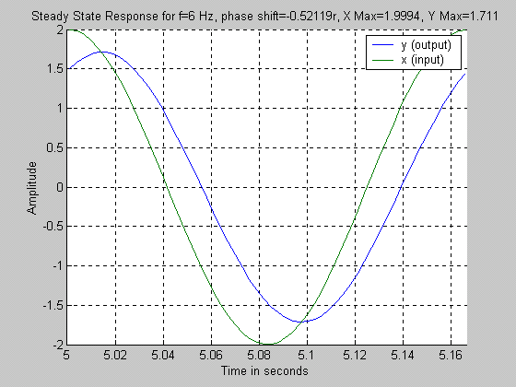
Figure 8. Input and output waveforms of the system for 6Hz. This
graph is used to realize the phase shift for this frequency through
inspection (using the ginput function in MatLab), as well as peak values.
In this case the output is lagging the input. Computed values are
contained within graph. As frequency is increased, there is a larger
magnitude of phase shift.

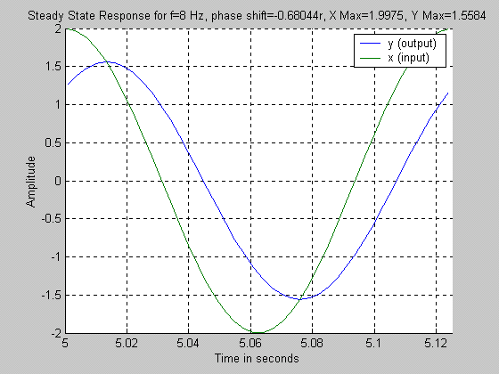
Figure 9. Input and output waveforms of the system for 8Hz. This
graph is used to realize the phase shift for this frequency through
inspection (using the ginput function in MatLab), as well as peak values.
In this case the output is lagging the input. Computed values are
contained within graph. As frequency is increased, there is a larger
magnitude of phase shift.

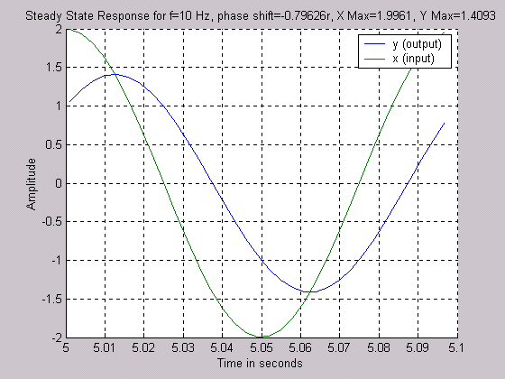
Figure 10. Input and output waveforms of the system for 10Hz. This
graph is used to realize the phase shift for this frequency through
inspection (using the ginput function in MatLab), as well as peak values.
In this case the output is lagging the input. Computed values are
contained within graph. As frequency is increased, there is a larger
magnitude of phase shift.

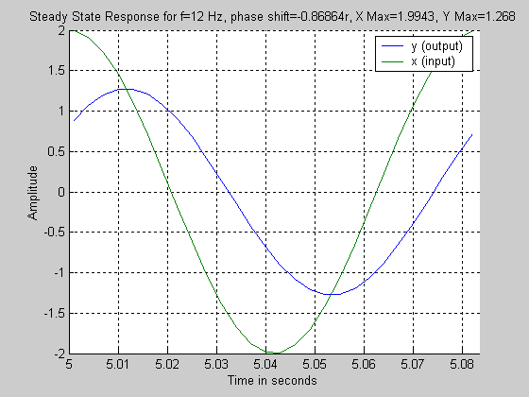
Figure 11. Input and output waveforms of the system for 12Hz. This
graph is used to realize the phase shift for this frequency through
inspection (using the ginput function in MatLab), as well as peak values.
In this case the output is lagging the input. Computed values are
contained within graph. As frequency is increased, there is a larger
magnitude of phase shift.

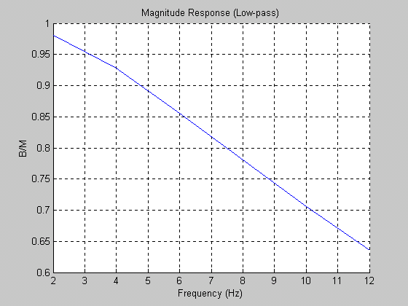
Figure 12. Frequency response of the system described in problem 1.b,
which corresponds to a lowpass filter.

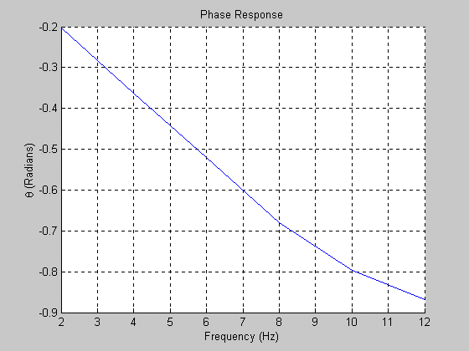
Figure 13. Phase response of the system described in problem 1.b.
As the frequency is increased, the phase shift is increased in magnitude.

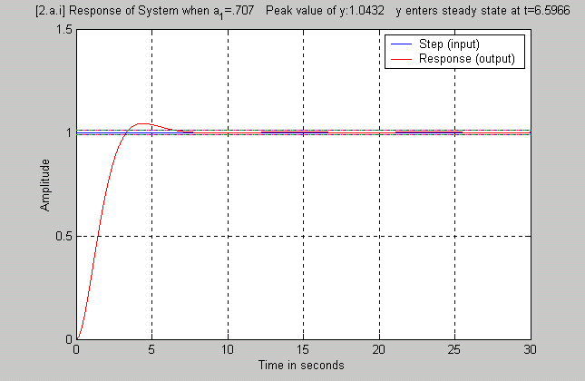
Figure 14. Step response of the system describe by problem 2.b. In this case, the coefficient a₀ is .707.

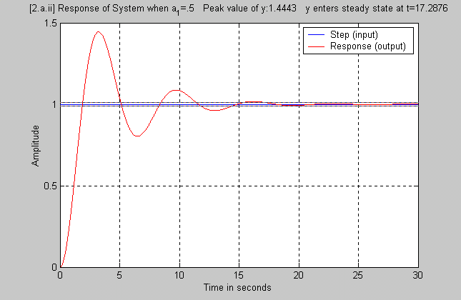
Figure 15. Step response of the system describe by problem 2.b. In this case, the coefficient a₀ is .5

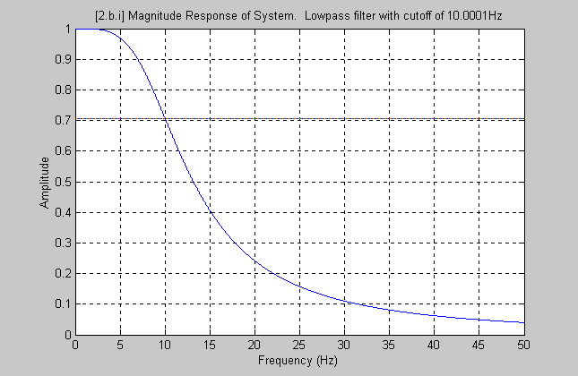
Figure 16. Magnitude Response of the system. A horizontal line was plotted at 0.707. Then the intersection with the magnitude response curve was zoomed in on. The ginput matlab function was then utilized to obtain the cutoff frequency. Since the ginput function is not precise, a value of 10.0001 Hz was yielded. For practical purposes this value is rounded to 10 Hz. This frequency response curve corresponds to a lowpass filter.
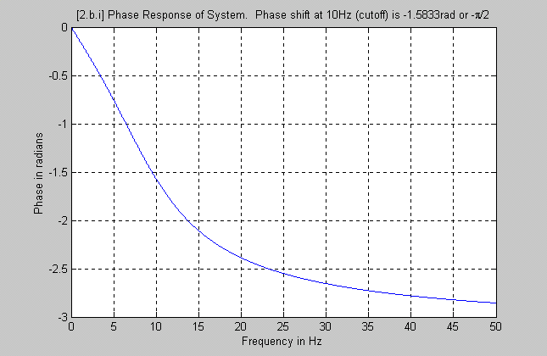
Figure 17. Phase response of the system in problem 2.b.i. Built in Matlab functions were
used to obtain a precise curve for the phase response (which is verified through inspection
in Figure 17). As the frequency is increased, the phase shift is increased in magnitude.

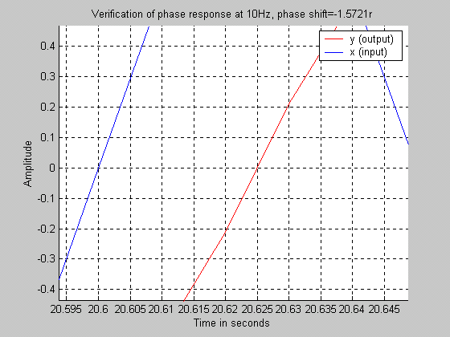
Figure 18. Verification of phase shift through inspection of the input
and output curves. Rising edges were blown up using zoom then points
were inspected using ginput function.

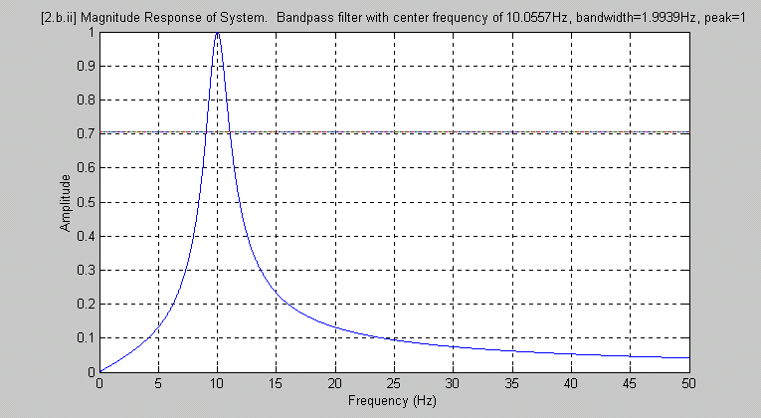

Figure 19. Magnitude response of the system described by problem 2.b.ii. Corresponds to a bandpass
filter with a bandwidth of approximately 2Hz, centered around 10Hz.

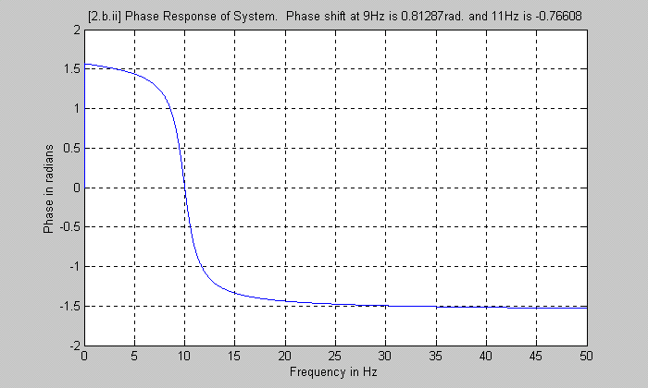
Figure 20. Phase response of the system described by problem 2.b.ii. For input frequencies below 10Hz,
there is a positive phase shift, which decreases in magnitude. For input frequencies above 10Hz, there is a negative phase shift, which increases in magnitude. Since the bandwidth is 2Hz, centered around 10Hz, specific values for the phase shift were gathered for 9Hz and 11Hz and are contained within the graph.

Conclusion

This assignment was an in-depth exploration of first and second order LTI systems simulated in Matlab. For the lowpass filter in part 1, it was realized that as the input frequency is increased, the magnitude response of the system will decrease. Also, as this input frequency is increased, so does the phase shift. The lowpass filter in the first section of part 2 also possessed these characteristics. However, the bandpass filter in part 2 responded with a magnitude of .707 or higher for frequencies in the range of 9 to 11Hz. For input frequencies above 10Hz, there is a negative phase shift, which increases in magnitude. Through this experiment, we had learned the concept of first and second order LTI systems using Matlab and the various types of filters design application.

