ECE 317 |  |  | 26 November 2002
Lab 4:
Simple passive first order & second order filters


Fall 2002

Professor Awad

“We have neither given nor received aid in the preparation of this lab report.”
 | Prepared by
Tan Nguyen  tannguyen_79@yahoo.com |  | ____________________________
Jason Smith  jasonmsm@umd.umich.edu |  | ____________________________

Objective:

- To design first order lowpass filter with a cutoff frequency of 10kHz.
- To design a second order highpass filter to filter out the signal x1(t) and pass the signal x2(t) and x3(t).
- To design a filter to pass the frequency band described by 95kHz ≤ f ≤ 105kHz and filter out the rest bands.

Procedure/Results:

- Design a first order lowpass filter with a cutoff frequency of 10kHz. The available capacitor value is 10nF.

Part ( a )
Verity your design using Pspice by plotting the magnitude (in dB) and phase responses.

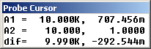
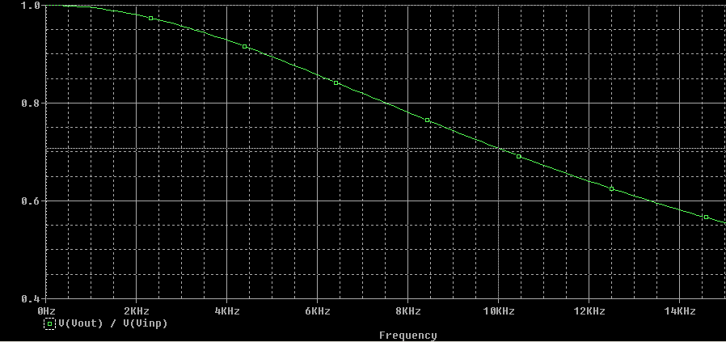
Figure I: Frequency Response
By using the cursor, we have verified that the cutoff frequency at 10kHz we have ( .707). Indeed the cut off frequency is 10kHz, which verified the design

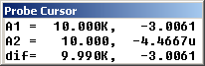
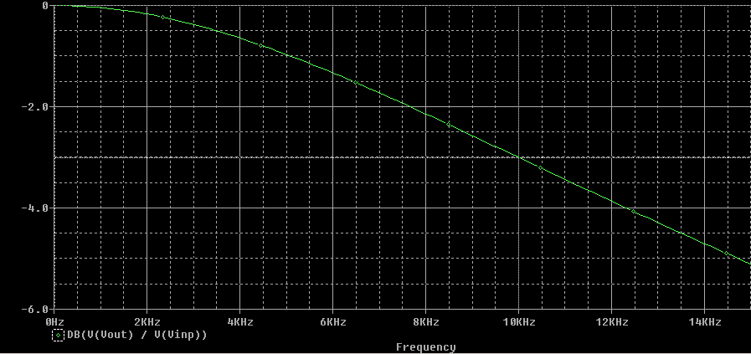
Figure II: Magnitude Response (in dB)
From the prode cursor results, we see that at 10kHz we have –3dB which verify the design.

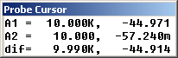
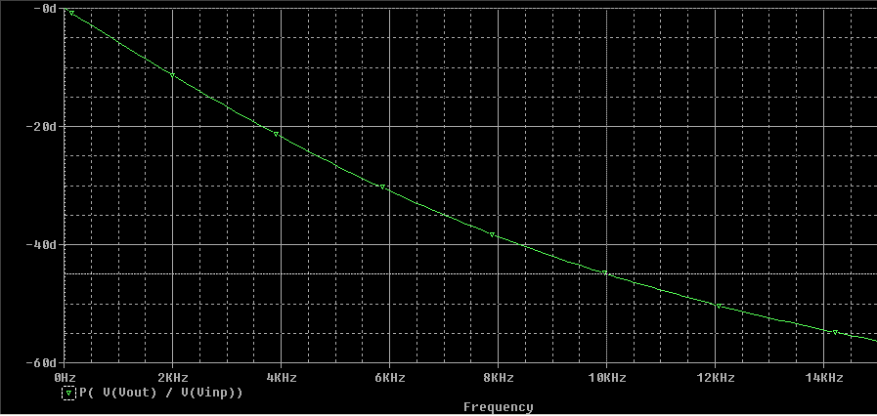
Figure III: Phase Response
Again we used the cursor to find the phase response at –44.971≈–45 degrees we get 10kHz. This verified our design completely in term of phase response.

Part ( b )
What is the frequency where the magnitude response is –10dB?
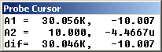
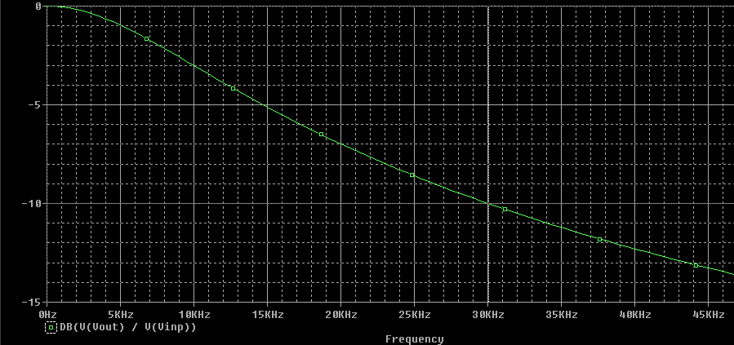
Figure IV: Magnitude response in dB
From the prode cursor results, we see that at magnitude response of –10dB we have 30kHz of frequency.

Part ( c )
Find the frequency where the phase response is –45°.
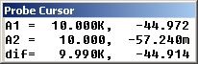
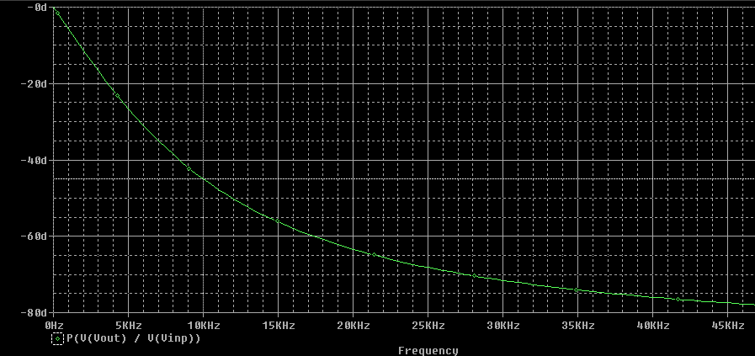
Figure V: Phase response
From the prode cursor results, we see that at the phase response of –45 degrees happens at 10kHz.

II.
- It is required to design a second order highpass filter to filter out the signal x1(t) and pass the signal x2(t) and x3(t) from the composite signal x(t)= x1(t)+x2(t)+x3(t), where
X1(t)=0.1cos(2000πt+π/3), x2(t)=cos(10,000πt) and x3(t)=1.1cos(20,000πt+π/4).
Part ( a ):
What values of cutoff frequency and Q values do you choose? Give reasons

We chose the cutoff frequency to be fo= 1 kHz because if we chose the cutoff frequency to be less than 1kHz, it only filter out a portion of that band and if we chose the cutoff frequency to be 1kHz, it will filter more than half of the band, which is good for the design.

We chose Q=0.707. Because if we are designing a HPF to filter out low frequency and pass high frequency we don’t need the peak. So, the best design will have values of k = 0.707. Thus, the quality factor Q=0.707

Part ( b ):
From part a), calculate the values of the circuit elements needed, assuming the capacitor value available is in the nano Farad range.

We choose C=100nF
Now we need to find the L and R parameters:
By using the following equation we will get the value for Inductor (L) and value for resistor ( R ).
⇒ fo=1/2π√LC ⇒1000^2=1/4π^2LC
⇒L(1000^2*100nF*4π^2)=1, ⇒L=0.2533H

R=1/Q√(L/C) ⇒1/0.707√(0.2533/100E-9)
Therefore, R=2.25kΩ

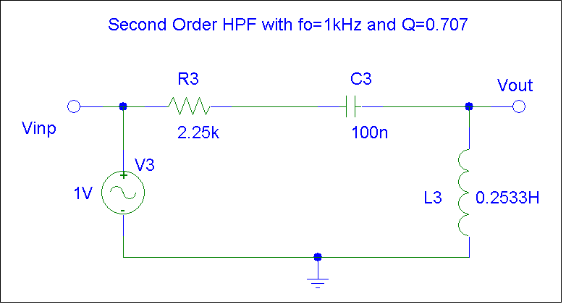
Figure VI: Second Order High Pass Filter with cutoff frequency fo=1kHz and quality factor Q=0.707

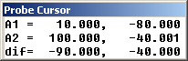
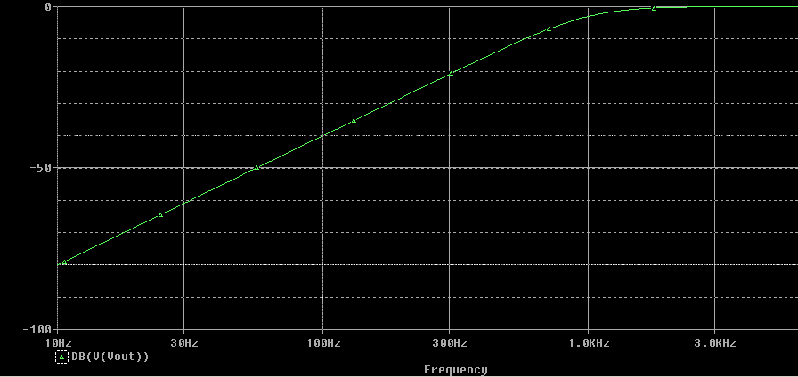
Figure VII: Frequency response in dB
By using the cursor to choose 2 points (one at 10Hz is –80dB & 100Hz is –40dB). From the Probe cursor results, we see that the slope of the line is 40dB/decade but positive. This is consistent for second order HPF. If we used 1st order, the slope will be 20dB/decade.

Part ( c):
Give an expression of the output of the filter at steady state (y_{ss}(t)).
We have 3 input signals:
For the input signal x1(t), amplitude is a1=0.1 with a frequency of 1kHz and phase shift is θ1=π/3
For the input signal x2(t), amplitude is a2=1 with a frequency of 5kHz and no phase shift.
For the input signal x3(t), amplitude is a3=1.1 with a frequency of 10kHz and phase shift is θ3=π/4

Therefore,
⇒yss(t)=0.1|H(j2000π)|cos(2000πt+π/3 + ∠H(j2000π)) + 1|H(j10000π)|cos(10000πt +∠H(j10000π)) ) + 1.1|H(j20000π)|cos(20000πt + π/4 + ∠H(j20000π)),

where |H(j2000π)| & ∠H(j2000π)) are the magnitude and phase response of the 1st signal
and |H(j10000π)| & ∠H(j10000π)) are the magnitude and phase response of the 2nd signal
and |H(j20000π)| & ∠H(j20000π)) are the magnitude and phase response or 3rd signal.

III.
- It is required to design a filter to pass the frequency band described by 95 kHz ≤f≤ 105kHz and filter out the rest bands. Assume that the capacitor used is 100pF

Part ( a )
Calculate an appropriate center frequency and quality factor.
Center Frequency:
⇒fo=$\sqrt{\text{fl}∗\text{fu}}$ ⇒fo=$\sqrt{\text{95}∗\text{105}}$≈100kHz
Quality Factor:
⇒Q=$\frac{\text{fo}}{\text{fu}−\text{fl}}$=$\frac{\text{100}}{\text{105}−\text{95}}$≈ 10
Inductor Value:
Using the following equation fo=$\frac{1}{2π\sqrt{\text{LC}}}$⇒L=0.02533H
Resistor Value:
R=$\frac{1}{Q}$$\sqrt{\frac{L}{C}}$⇒R=1.59kΩ

Part ( b )
Give the complete design of the filter. Hence, verify the frequency response through simulation
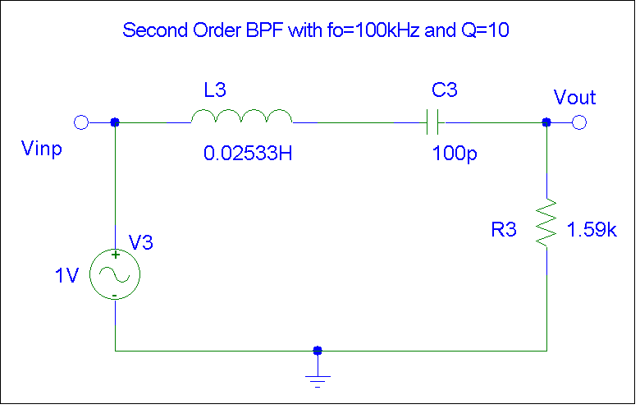
Figure VIII: Second Order Band Pass Filter with center frequency fo=100kHz and quality factor is Q=10.

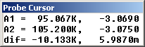
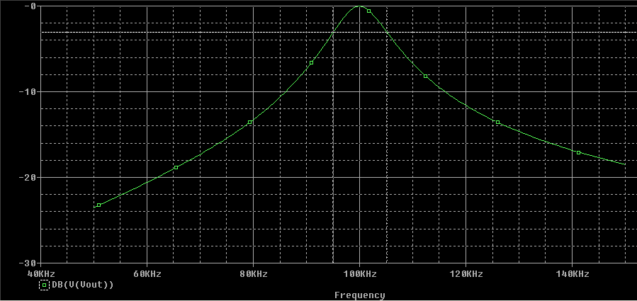
Figure IX: Frequency Response in dB
From the Prode Cursor results, we have –3 dB at lower frequency of 95kHz and –3 dB at the upper frequency of 105kHz and the different is 10kHz and also the center frequency on the graph is 100kHz. Therefore, we met all of the design requirements for a Band Pass Filter described by 95kHz≤ f ≤105kHz.

Part ( c)
If the value of the capacitor c is changed by ±5%, ±10% and ±20% of its nominal value, find the corresponding percentage change in the center frequency (fo) and quality factor (Q). Hence, plot the percentage change in fo and Q versus percentage change in the value of C.
- C is changed by ±5%
C= +5%
C₅=C(1+ΔC/C) = 105pF
⇒f’o=$\frac{1}{2π\sqrt{{\text{LC}}_{5}}}$=97kHz
⇒Q’=$\frac{1}{R}$$\sqrt{\frac{L}{C_{5}}}$=9.7
Therefore, the percentage change in center frequency and quality factor are:
⇒$\frac{f'o−\text{fo}}{\text{fo}}$x 100 = -3%
⇒$\frac{Q'−Q}{Q}$x 100 = -3%
C=-5%
C₅=C(1-ΔC/C) = 95pF
⇒f’o=$\frac{1}{2π\sqrt{{\text{LC}}_{5}}}$=103kHz
⇒Q’=$\frac{1}{R}$$\sqrt{\frac{L}{C_{5}}}$=10.3
Therefore, the percentage change in center frequency and quality factor are:
⇒$\frac{f'o−\text{fo}}{\text{fo}}$x 100 = 3%
⇒$\frac{Q'−Q}{Q}$x 100 = 3%
- C is changed by ±10%
C = +10%
C₁₀=C(1+ΔC/C) = 110pF
⇒f’o=$\frac{1}{2π\sqrt{{\text{LC}}_{\text{10}}}}$=95kHz
⇒Q’=$\frac{1}{R}$$\sqrt{\frac{L}{C_{\text{10}}}}$=9.5
Therefore, the percentage change in center frequency and quality factor are:
⇒$\frac{f'o−\text{fo}}{\text{fo}}$x 100 = -5%
⇒$\frac{Q'−Q}{Q}$x 100 =-5%
C=-10%
C₁₀=C(1-ΔC/C) = 90pF
⇒f’o=$\frac{1}{2π\sqrt{{\text{LC}}_{\text{10}}}}$=105kHz
⇒Q’=$\frac{1}{R}$$\sqrt{\frac{L}{C_{\text{10}}}}$=10.5
Therefore, the percentage change in center frequency and quality factor are:
⇒$\frac{f'o−\text{fo}}{\text{fo}}$x 100 = 5%
⇒$\frac{Q'−Q}{Q}$x 100 = 5%

- C is changed by ±20%
C= +20%
C₂₀=C(1+ΔC/C) = 120pF
⇒f’o=$\frac{1}{2π\sqrt{{\text{LC}}_{\text{20}}}}$=91kHz
⇒Q’=$\frac{1}{R}$$\sqrt{\frac{L}{C_{\text{20}}}}$=9.1
Therefore, the percentage change in center frequency and quality factor are:
⇒$\frac{f'o−\text{fo}}{\text{fo}}$x 100 = -9%
⇒$\frac{Q'−Q}{Q}$x 100 = -9%
C = -20%
C₂₀=C(1-ΔC/C) = 80pF
⇒f’o=$\frac{1}{2π\sqrt{{\text{LC}}_{\text{20}}}}$=112kHz
⇒Q’=$\frac{1}{R}$$\sqrt{\frac{L}{C_{\text{20}}}}$=11.2
Therefore, the percentage change in center frequency and quality factor are:
⇒$\frac{f'o−\text{fo}}{\text{fo}}$x 100 = 12%
⇒$\frac{Q'−Q}{Q}$x 100 = 12%
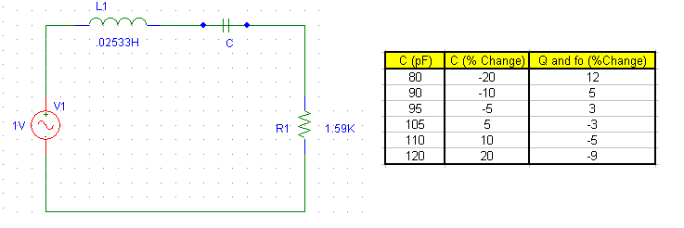
Conclusion:
This assignment was an in-depth exploration of first and second order passive filter simulated in Pspice. Through this experiment, we had learned the concept of first and second order passive filters using Pspice and the various types of filters design application.

