Abstract—This project deals with the design and implementation of a biased common drain amplifier by using jFETs. The specifications for this design are that: (1) the voltage difference between gate and source at DC is -6V and (-1V to –1.5V) at AC; (2) the jFET model parameters are k_{n}(W/L) = 1.778 mA/V²; (3) the threshold voltage is -3V. According to these specifications the DC and AC analysis was performed. Then the theoretical results were compared to the PSpice simulation.
Biased Common Drain Amplifier
Tan Nguyen, tannguyen_79@yahoo.com
Eudora Gunarta, egunarta@umd.umich.edu
Trang Pham, Anna_V21@yahoo.com

introduction
The junction field effect transistor (JFET) is a high-input impedance, low noise and high input impedance, voltage controlled device used primarily at the input of amplifiers to take advantage of its low noise and high input impedance characteristics. JFETs are voltage depletion majority carrier type devices, where the PN junction of the gate-to-source is reversed biased in controlling the amount of current flow through the device when no reverse biasing (zero volts) exist across the gate-to-source junction. Then, as reverse gate-to-source bias voltage is increased, the current through the device is reduced, (ideally) to a zero current flow condition.
-The purpose of this project is to design a biased common drain amplifier which satisfy the following requirements: V_{gs(off)} = -6 V and V_{gs}=(-1V to -1.5V) with a sinusoidal input of 3V peak-to-peak, k_{n}(W/L) = 1.778 mA/V² and V_{t}=-3V. Since Vgs is negative the n-channel jFET will operate in the depletion mode (see figure 1).
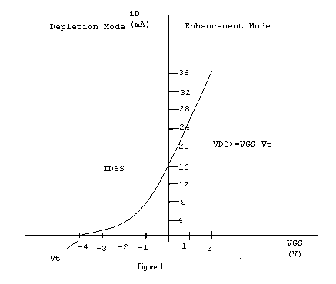
To analyze this design some new factors must be introduced:

DC factors in the linear operation of the n-channel JFET (including the square law analysis).

AC considerations in the linear operation of JFET (which include alternating current parameters: transconductance gm and transresistance r's).
These factors are discussed in detail in the theoretical implementation.

specifications of design
The requirements of this design are: (1) sinusoidal input voltage of 3 volts peak to peak with frequency of 1kHz; (2) voltage source at the drain is 24 volts; (3) k_{n}(W/L) = 1.778 mA/V² ; (4) V_{GS(off)} = -6 volts at DC analysis, and V_{GS} = -1.5 volts for AC analysis; (5) V_{t}=-3V

theoretical implementation

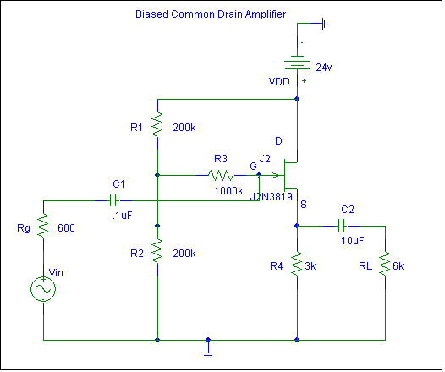

Theory

DC factors in the linear operation of the n-channel JFET (including the square law analysis).
Maximum current flows through the JFET channel when zero volts are applied across the gate-to-source junction VGS and the drain-to-source voltage VDS is increased beyond the pinch-off voltage Vp (as shown in figure 2). The maximum saturation current is labeled as IDSS.
The minimum drain current (theoretically) occurs when the reverse gate-to-source voltage equals the pinch-off voltage, or Vp= |VGS(off)|. Theoretically, the minimum current is 0.0mA, but practically the current flow through the JFET is considered to be “pinched off” when the current through the device has been reduced to about 1% of the maximum current (IDSS) condition.
As shown in the JFET out characteristic of Figure 2, the curve is broken into two distinct regions. One is the operating region between the pinch off voltage line & the breakdown region and the other is ohmic region before the pinch off voltage line.

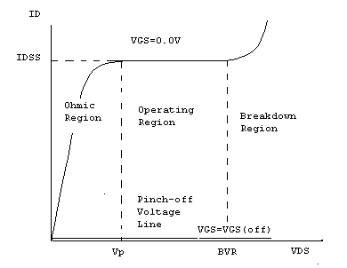
FIGURE 2

In theory JFETs are square law devices and the drain current can be solved for any value of V_{GS} between 0 volt and V_{GS(off)} using the formula:

I_{D} = I_{DSS} [1- V_{GS} / V_{GS} (off)]²

Therefore, once saturation current IDSS and the VGS (Off) of the device are known, ID, can be solved. See Figure 3.
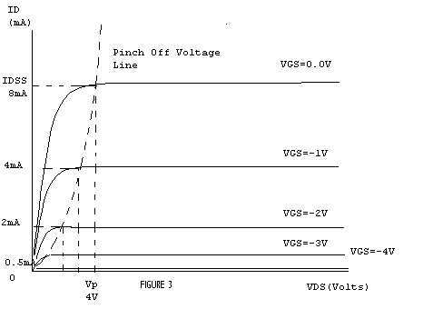
In practice, the device rarely follows square wave principles exactly, and the only reasonably accurate calculated to measured results are achieved by using the actual characteristic curves of the device. A curve tracer can be used to measure both the output characteristic curve and transfer curve, and both sets of curves can be used to find the drain current at every condition of VGS. However, the transfer curve is generally more useful than the output characteristic curves because the ID and VGS conditions of the circuit are easily solved using the transfer curve and the inverse slope line of the source resistor. The transfer curve, with the output characteristic curves at each of the VGS and corresponding ID conditions, is shown in Figure 4.
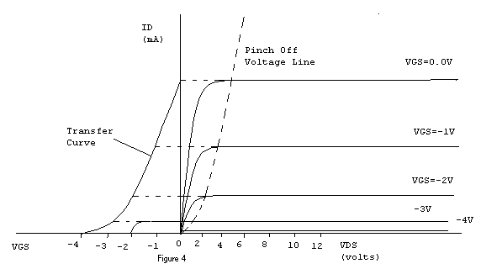

AC Considerations in the Linear operation of JFETS

In the AC analysis we will be solved for the device parameters, which include transconductance (gm). Mathematically, the transconductance of a FET with ideal square law characteristics, as we introduced in the above section, can be solved from:
^{gm=2/V}_{GS}^{(off)} $\sqrt{I_{D}∗I_{\text{DSS}}}$. Another transconductane formula that provides the transconductance (gm) for every condition of VGS is:
gm=gmo[1-VGS/VGS(off)]
where gmo=2/VGS(off) $\sqrt{I_{D}∗I_{\text{DSS}}}$
Next we will determined the transresistance by using the following mathematically formula:
^{r’s = VGS(off) / 2}$\sqrt{I_{D}∗I_{\text{DSS}}}$

Design and Parameters Calculation

The DC analysis of the biased common drain circuit is solved in conjunction with the equivalent circuit of Figure 5.

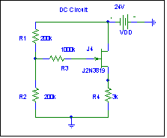
Figure 5

IDSS=1/2k’nW/LVt^2
IDSS=1/2(1.778mA/V^2)(-3)^2
Therefore, IDSS=8mA

By substitute IDSS into ID equation we get:
I_{D} = I_{DSS} [1- V_{GS} / V_{GS(off)} ] ²
=8mA(1-1.5V/6V) ²
= 4.5 mA

V_{R2}=$\frac{V_{\text{DD}}∗R2}{R1+R2}=\frac{\text{24}V∗\text{200}kΩ}{\text{200}kΩ+\text{200}kΩ}=\text{12}$V
Vs=V_{R4}=I_{D}R4=4.5mA * 3k$Ω$=13.5V
V_{D} = V_{DD} =24V
V_{DS} = V_{D} - V_{R5}=24V-13.5=10.5V
V_{G} V_{R5} =12V
V_{GS}= V_{G} – V_{S}12V-13.5V=-1.5V

2) The AC analysis of the universal biased common drain amplifier circuit is assumed the characteristics of the JFET follow square law principles and (knowing V_{GS(off)} and I_{D}) will be used to solve the transconductance g_{m} and the transresistance r_{s}’. The calculations for these parameters are shown in conjunction with the equivalent circuit of Figure 6.

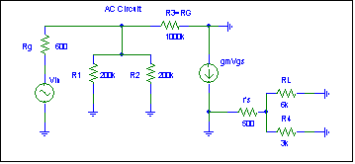
FIGURE 6

g_{m}=(2/Vp) $\sqrt{I_{D}∗I_{\text{DSS}}}$
=(2/6V) $\sqrt{4\text{.}5\text{mA}∗8\text{mA}}$
=2000$μ$S
r_{s}’= 1/ g_{m} = 1/2000$μ$S =500$Ω$
A_{V}=$\frac{g_{m}r_{L}}{1+(g_{m}r_{L})}=\frac{g_{m}(R4||R_{L})}{1+[g_{m}(R4||R_{L})]}$
=$\frac{2\text{mS}(3kΩ||6kΩ)}{1+[2\text{mS}(3kΩ||6kΩ)]}=\frac{4}{1+4}=0\text{.}8$
A_{V}=$\frac{r_{L}}{r_{S}'+r_{L}}=\frac{(R4||R_{L})}{r_{S}'+R_{L}}=\frac{3kΩ||6kΩ}{\text{500}Ω+2kΩ}=0\text{.}8$
V_{o}= A_{v}V_{in}= 0.8 * 3 V_{pp}=2.4 V_{pp}
Z_{in}R_{in}=R3 + (R1||R2) =1M$Ω$+$(\text{200}kΩ||\text{200}kΩ)$
=1M$Ω$+ $($100k$Ω)$ =1.1M$Ω$
Z_{in}$=$R_{in}=r_{gs}=$1\text{.}1MΩ||\text{100}MΩ=1\text{.}\text{088}MΩ$
Z_{o} = r_{s}’||R4 = 500$Ω$ ||3k$Ω$ = 428.6$Ω$
A_{p}=A_{v}² $\frac{Z_{\text{in}}}{R_{L}}=0\text{.}8^{2}$$\frac{1\text{.}\text{088}MΩ}{6KΩ}=\text{116}\text{.}1$
A_{p}(dB) = 10log116.1 = 20.6dB

DISCUSSION OF PSPICE &
THEORETICAL ANALYIS

From the PSPICE simulation we have a VGS=-1.18V instead of –1.5V compare to the theoretical analysis. This is because of the properties of the Non-ideal N-channel JFET from the simulation. Also, it is affected by the two input capacitance CGD= 1.6E^-12 & CGS = 2.414E-12 are very small which can be neglect when performing the DC analysis. If we were to build the physically circuit and used the ideal N-channel JFET, we could have the same or almost result as the theoretical value of VGS=-1.5V. We have tried to test the circuit, by increasing the resistance of R3 to 4kΩ, we get Vs=13.5 and VG=12, implies VGS=-.15V, which is satisfy the requirement. However, we have used the 4kΩ to calculated Vs =18V, which is way off from the requirement. Therefore, we have to keep R3 = 3kΩ, which will lead to a difference of 0.32V due to the non-ideal N-channel JFET from PSPICE.

We then used a BJT transistor to test the circuit to see if there is any major difference from what we had. From the Simulation, we have VG=4.222V and Vs=3.558, VGS=0.664V. Thus, if we used a BJT transistor we will have to changes the parameter and work in either triode or saturation regions (enhancement mode). This transistor acted as a current gain. The input impedance drove the voltage at the Emitter, and the collector voltage source or Vin supplied the majority of the current. (Refer to Apendix B for a simulation circuit diagram).

INPUT IMPEDANCE DISSCUSSION

When 3Vp-p of input is applied to the circuit the input signal current is approximately 2.757uAp-p. Thus, Zin equals 1.008 MΩ. Essentially, since R3 +(R1//R2) is 1.1MΩ and the gate-to-source rgs input impedance of the JFET is considered to be about 100MΩ. IR3=2727nA and irgs=30nA. Therefore, Zin can be approximated at 1.1MΩ, but if the rgs of the JFET at approximately 100MΩ is included in the calculations, Zin=1.088MΩ from:
Zin=Vin/iin = Vin/iR3+irgs=3Vp-p/(2727nAp-p+30nAp-p) = 1.088MΩ, where iR3=Vin/R3+(R1//R2)=3Vp-p/1.1MΩ=2727nAp-p and irgs=3Vp-p/100MΩ=30nAp-p, so iin=2757nAp-p.

EXPERIMENT RESULTS
We were able to design a Biased Common Drain Amplifier with a nominal output of VGS=-1V to –1.5V for an input voltage of 24V, a 3 Vp-p of input signal is applied at the gate, and for a load of 6kΩ at the source.
The theoretical calculations were used to implement the circuit. The voltage gain can be solved from known values of r’s and R4//RL and using the voltage divider equations.
Av=rL/r’s+rL=R4//RL/r’s+(R4//RL)=(3kΩ//6kΩ)/500Ω+(3kΩ//6kΩ) = 0.8
The current gain is can be solved using the standard current gain formula. Thus:
Ai=Av*Zin/RL=0.8*(1.088MV)/6kΩ = 145.1
Multiplying the voltage gain by the current gain can solve the power gain. The power gain in dB are shown solved
Ap=Av*Ai=0.8*145.1=116.1
Ap(dB) = 10log (116.1) 20.6 dB
Finally, the output signal voltage swing for 3 Vp-p of input signal is solved by multiplying the input voltage by the voltage gain
Vo=Vin*Av=3Vp-p*0.8=2.4 Vp-p.

CONCLUSION
Through the Biased Common Drain Amplifier designed, we had learned that in the signal process analysis a signal applied to the input is multiplied by the transcondcutance of the JFET to provide the output drain current ID, (when developed across the effective source resistance) provides the output signal voltage across the load. Taking the ratio of the output signal voltage to the input signal voltage can then solve the voltage gain. More important, we have learned that the Non-ideal and Ideal N-channel JFET are so tricky. In reality, we deal with the non-ideal one, but theoretically we deal with the ideal. So, we have to be more careful and taking these factors into considerations for further designs projects. Also, a N-channel JFET give a deeper understand of signal process analysis.
APPENDIXES:
A) Theoretical Circuit Diagram
B) Theoretical Circuit Diagram with BJT
C) Output Signal Voltage Graph
REFERENCES:
[1] Micro-electronics circuits/ Adel S. Sedra, Kenneth C. Smith. – 4 th ed., New York Oxford, 1998
[2] Bipolar and MOS analog integrated circuit design / Alan B. Grebene, New York: J. Wiley, c1984
[3] Characteristics and limitations of transistors [by] Richard D. Thornton [and others], New York, 1966
[4] Practical design with transistors, Sam – 2nd ed. Indianapolis, H.W., 1971

 

