Abstract—This project deals with the design and implementation of a capacitively coupled common-source amplifier by using a MOSFET. JFET was chosen from the different existing commercial MOSFETs. The specifications for this design are: (1) a mid-band gain of 28dB and (2) lower 3dB frequency of 100Hz and upper 3dB frequency of 5MHz. Based on these specifications the values of the resistors and capacitors were designed. Then the DC and AC analysis were performed to verify if the requirements were fulfilled. Finally, the low and high frequency responses were done to verify if the amplifier does have a mid-band gain of 28dB between 100Hz and 5MHz. All the calculations were also verified in the PSpice simulation.
Series-Shunt Feedback Control
Tan Nguyen, tannguyen_79@yahoo.com
Trang Pham, Anna_V21@yahoo.com
Eudora Gunarta, egunarta@umd.umich.edu

introduction
As part of the design a n-channel JFET with model parameters k_{n}(W/L) = 52.4 uA/V² was chosen from the different existing commercial MOSFETs. The reason for using JFET is due to its high input impedance and low noise characteristics. These characteristics are important for the performance of an amplifier.

The junction field effect transistor (JFET) is a high-input impedance, low noise and high input impedance, voltage controlled device used primarily at the input of amplifiers to take advantage of its low noise and high input impedance characteristics. JFETs are voltage depletion majority carrier type devices, where the PN junction of the gate-to-source is reversed biased in controlling the amount of current flow through the device when no reverse biasing (zero volts) exist across the gate-to-source junction. Then, as reverse gate-to-source bias voltage is increased, the current through the device is reduced, (ideally) to a zero current flow condition.

Although JFETs operate in the depletion mode it can be used as an amplifier by making the JET operate in the saturation mode.
The design of this amplifier circuit was done based on the following requirements:

mid-band gain of 28dB.

lower and upper 3dB frequencies of 100Hz and 5MHz.

model parameters k_{n}(W/L) = 52.4 uA/V²

threshold voltage V_{t}=2V

specifications of design
The requirements of this design are:

mid-band gain of 28dB.

lower and upper 3dB frequencies of 100Hz and 5MHz.

model parameters k_{n}(W/L) = 52.4 uA/V²

threshold voltage V_{t}=2V

III. THEORETICAL IMPLEMENTATION
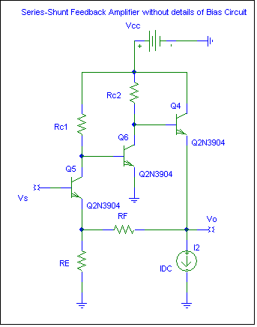
Figure I: Series-Shunt Feedback Amplifier

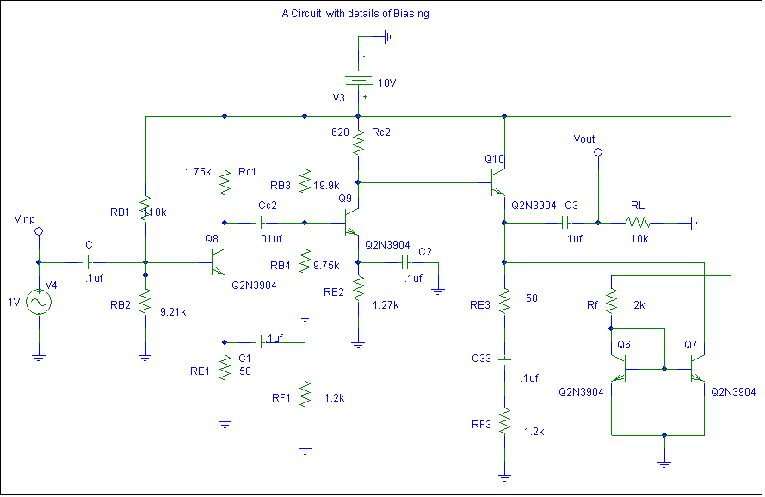
Figure II: A circuit with details of Biasing (see attachment for more details)

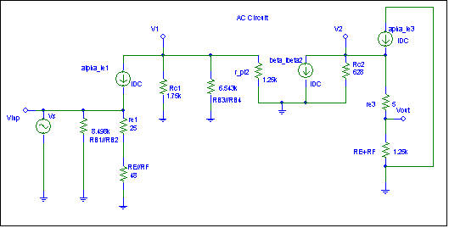

Figure III: AC Circuit Model

Part 3) Verity Af, Rif, Rof, and open gain using PSPICE
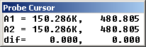
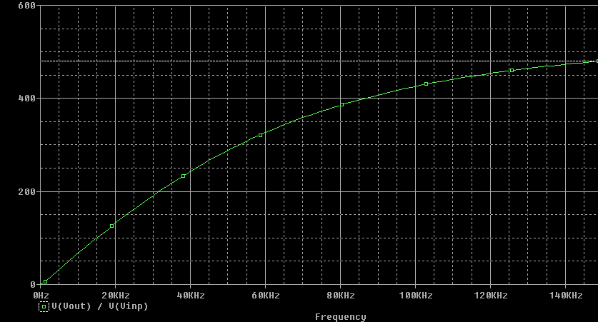

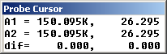
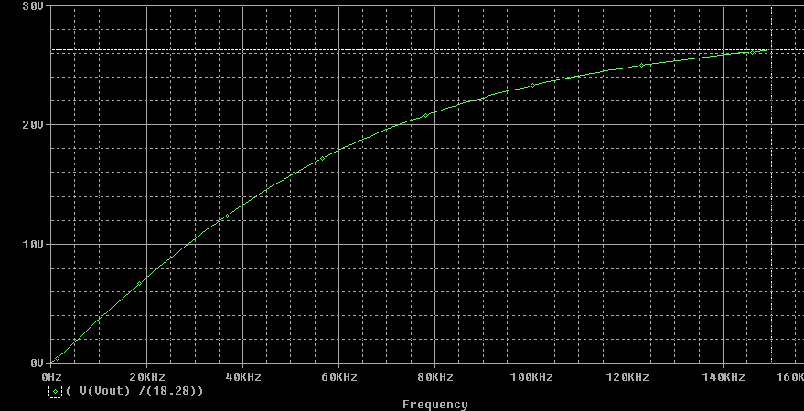

Design and Parameters Calculation

DC analysis

Figure 2

V_{G}=$\frac{R_{G2}∗V_{\text{DD}}}{R_{G1}+R_{G2}}=\frac{\text{40}kΩ∗\text{20}V}{\text{200}kΩ+\text{40}kΩ}=3\text{.}\text{3333}$V
For a MOSFET to operate in saturation mode:
V_{t}=2V, $\frac{W}{L}=\text{200}$, $μ_{n}C_{\text{ox}}=0\text{.}\text{262}{μA}/{V^{2}}$
$I_{D}=\frac{1}{2}μ_{n}C_{\text{ox}}\frac{W}{L}(V_{\text{GS}}−V_{t})^{2},\text{where}→V_{\text{GS}}=V_{G}−V_{S}$
and $V_{S}=\text{11}\text{.}4kΩ(I_{D})$
$∴I_{D}=\frac{1}{2}(0\text{.}\text{262}{μA}/{V^{2}})\text{200}[3\text{.}\text{333}V−\text{11}\text{.}4kΩ(I_{D})−2]^{2}$
$∴I_{D}=0\text{.}5\text{mA}$ and $I_{D}=2\text{.}\text{73}x{\text{10}}^{−5}A$
For the DC circuit to operate in saturation mode
$$I_{D}=0\text{.}5\text{mA}$$
then $V_{D}=\text{20}V−\text{21}kΩ(0\text{.}5\text{mA})=9\text{.}5V$
and $V_{\text{GS}}=3\text{.}\text{333}V−\text{11}\text{.}4kΩ(0\text{.}5\text{mA})=−2\text{.}\text{367}$

AC analysis

figure 3

I_{DSS}=8mA, I_{D}=0.5mA, and V_{p}=-2V

At this operating point the transconductance is
g_{m}= $\frac{2I_{\text{DSS}}}{−V_{p}}\sqrt{\frac{I_{D}}{I_{\text{DSS}}}}=\frac{2(8\text{mA})}{2}\sqrt{\frac{0\text{.}5\text{mA}}{8\text{mA}}}=2{\text{mA}}/V$
The midband voltage gain can be determined as follows: The input resistance Rin is given by
$R_{\text{in}}=\frac{R_{G1}R_{G2}}{R_{G1}+R_{G2}}=\frac{\text{200}kΩ∗\text{40}kΩ}{\text{200}kΩ+\text{40}kΩ}=\text{33}\text{.}\text{33}kΩ$
and the midband voltage gain A_{m} can be written
$A_{m}=\frac{R_{\text{in}}}{R_{\text{in}}+R}∗−g_{m}(R_{D}||R_{L})=\frac{\text{33}\text{.}\text{33}kΩ}{\text{33}\text{.}\text{33}kΩ+\text{600}Ω}∗(−2)[\frac{\text{21}x\text{33}}{\text{54}}]$$A_{m}=−\text{25}\text{.}2V/V]$

Thus the amplifier has a midband voltage gain of
20log|Am|=28dB

To find which of the three capacitors, C_{C1}, C_{S}, and C_{C2}, should be made to cause the dominant low frequency pole at 100Hz
R_{CC1}=R + R_{in}=33.93k$Ω$
R_{CS}=R_{S} ||(1/g_{m})=0.479k$Ω$
R_{CC2}=R_{D}+R_{L}=54k$Ω$
As expected R_{CS} is the smallest and thus should be the one to form the highest-frequency(and thus dominant) pole. Thus,

$$C_{S}=\frac{1}{2{πf}_{L}R_{\text{CS}}}=\frac{1}{2πx\text{100}x(0\text{.}\text{479}k)}=3\text{.}\text{32}μF$$

$$F_{Z}=\frac{1}{2{πC}_{s}R_{S}}=\frac{1}{2π(3\text{.}\text{32}μF)(\text{11}\text{.}4k)}=4\text{.}2\text{Hz}$$

To place the two other poles, due to C_{C1} and C_{C2}, at least a decade away from f_{L} (that is equal to or lower than 10Hz) we select the capacitors as follows:
$$C_{C1}≥\frac{1}{2πx\text{10}x\text{33930}}=0\text{.}\text{47}\text{uF}$$
$$C_{C2}≥\frac{1}{2πx\text{10}x\text{54000}}=0\text{.}\text{295}μF$$

Low Frequency Response
$$V_{g}(s)=V_{i}(s)\frac{R_{\text{in}}}{R_{\text{in}}+R+1{\text{SC}}_{C1}}$$

The transfer function can be express as

$$\frac{V_{g}(s)}{V_{i}(s)}=\frac{R_{\text{in}}}{R_{\text{in}}+R_{S}}∗\frac{1}{S+1/{C_{C1}}(R_{\text{in}}+R)}$$
$$W_{P1}=\frac{1}{C_{C1}(R_{\text{in}}+R)}=\frac{1}{(0\text{.}\text{47}μF)(\text{33930})}=\text{63}\text{rad}\text{/sec}$$
$I_{d}(s)=I_{S}(s)\frac{V_{g}(s)}{1g_{m}+Z_{S}}$$=g_{m}V_{g}(s)\frac{Y(s)}{1g_{m}+Y_{S}}$

$$Y_{s}=\frac{1}{Z_{s}}=\frac{1}{R_{s}}+{\text{sC}}_{s}$$
$I_{d}(s)=g_{m}V_{g}(s)\frac{1/R_{s}+{\text{sC}}_{s}}{g_{m}+1/R_{s}+{\text{sC}}_{s}}$

$$∴I_{d}(s)=g_{m}V_{g}(s)\frac{s+1/C_{s}R_{s}}{s+(g_{m}+1/R_{s}+)/{C_{s}}}$$
$$W_{z}=\frac{1}{C_{s}R_{s}}=\frac{1}{\left(3\text{.}\text{32}\text{uF}\right)\left(\text{11}\text{.}4kΩ\right)}=\text{26}\text{rad}\text{/sec}$$
$$W_{p2}=\frac{g_{m}+1/R_{s}}{C_{s}}=\frac{1}{C_{s}\left(R_{s}\text{//}1g_{m}\right)}$$
$$\begin{aligned}W_{p2}=\frac{1}{\left(3\text{.}\text{32}\text{uF}\right)[{\left(\text{11400}∗\text{500}\right)}/{\left(\text{11400}+\text{500}\right)}]} \\ W_{p2}=\text{628}\text{rad}\text{/sec}\end{aligned}$$

figure 4

$$V_{0}(s)=−I_{d}(s)(R_{D}\text{//}r_{o}\text{//}R_{L})\frac{s}{s+1/C_{C2}\left[R_{L}+\left(R_{d}\text{//}r_{o}\right)\right]}$$
$$W_{p3}=\frac{1}{C_{C2}\left[R_{L}+(R_{D}\text{//}r_{o})\right]}$$

$$\begin{aligned}r_{o}\text{>>}R_{D}{\text{andR}}_{L} \\ ∴r_{o}≈∞\end{aligned}$$
so we can neglect r_{o}.

$$∴W_{p3}=\frac{1}{(0\text{.}\text{295}\text{uF})(\text{21000}+\text{33000})}$$
$$W_{p3}=\text{63}\text{rad}\text{/sec}$$

$$A_{L}(s)=\frac{V_{o}(s)}{V_{i}(s)}=A_{m}\frac{s}{s+W_{p1}}∗\frac{s+W_{Z}}{s+W_{p2}}∗\frac{s}{s+W_{p3}}$$

$$⇒A_{L}=−\text{25}\text{.}2\frac{s}{s+\text{60}}∗\frac{s+\text{26}}{s+\text{628}}∗\frac{s}{s+\text{63}}$$

By looking at this low frequency amplifier gain AL(s) we find that the low frequency response is dominated by the pole at s=Wp2 and the lower 3dB frequency is approximated to Wp2:

$$\begin{aligned}W_{L}≃W_{p2}=\text{628}\text{rad}\text{/sec} \\ \underline{⇒f_{l}={\text{628}}/2π=\text{100}\text{Hz}}\end{aligned}$$

High Frequency Response

figure 5

There are a number of ways to analyze the high frequency equivalent circuit above. There is an approximate method that yields considerable insight into high frequency limitations. It involves the application of Miller’s theorem to replace Cgd by an equivalent input capacitance between the gate and ground. This method is based on the observation that since Cgd is small, the current through it will be much smaller than that of the voltage controlled current source gmVgs. Thus, neglecting the current through Cgd in determining the output voltage Vo, we can say that:
$$V_{o}≃−g_{m}V_{\text{gs}}R'_{L}$$
where R’L = R’_{L} //r_{o =} R_{L}

The ration of the voltages at both sides of Cgd enable us to replace Cgd at the input (gate) side with the equivalent Miller capacitance:
$$C_{\text{eq}}=C_{\text{gd}}\left(1+g_{m}R'_{L}\right)$$
as shown in the figure above.

The input side (gate) of the circuit is a first-order low –pass filter where the time constant is determined by the total input resistance:
$$C_{τ}=C_{\text{gs}}+C_{\text{gd}}\left(1+g_{m}R'_{L}\right)$$
and the signal-source resistance Rs.

Now, we use the approximate method based on Miller’s effect to find the upper 3dB frequency . Since Cgs & Cgd are so small we chose Cgs=Cgd=.041pF we have the following:
$\begin{aligned}C_{T}=C_{\text{gs}}+C_{\text{gs}}\left(1+g_{m}R'_{L}\right) \\ C_{T}=\text{.}\text{041}+\text{.}\text{041}(1+2∗\text{33}))=2\text{.}\text{79}\text{pF}\end{aligned}$
$$W_{H}=\frac{1}{C_{τ}R_{S}}=\frac{1}{\left(2\text{.}\text{79}\text{pF}\right)\left(\text{11}\text{.}4KΩ\right)}$$

$$W_{H}=\text{31440608}\text{rad}\text{/sec}$$

The high frequency gain can be expressed as:
$$A_{H}(s)=A_{M}\frac{1}{1+sW_{H}}$$
Thus,
$$⇒F_{H}={W_{H}}/2π≃5\text{MHz}$$
This is the dominant high frequency response

DISCUSSION OF PSPICE &
THEORETICAL ANALYIS

From the DC analysis, it shows that the MOSFET does operate in the saturation region: VDS=9.5V, VGS=-2.367V, and Vt=2V implies that VDS>=VGS-Vt, which shows that it does operate in the saturation region.
The requirements if this amplifier were: (1)mid-band gain of 28dB; and (2) lower and upper 3dB frequencies of 100Hz and 5MHz.
From the parameter calculation, fL=99.94930426Hz and fH=5.003928.17Hz. The calculated values of fL and fH are very close to the required values.
The bandwidth of this amplifier is the frequency range over which the gain remains within 3dB of the value at midband. The limits of the bandwidth are the frequencies fL and fH (for a DC amplifier, only fH applies).
The amplifier is said to have a dominant pole in the low-frequency band if the nearest pole or zero is at least two octaves lower in frequency (100Hz). A dominant pole in the high-frequency band exists if the nearest pole or zero is at least two octaves higher in frequency (5MHz).
The high-frequency response of this design limited by the Miller effect, which multiplies the feedback capacitance Cgd(Cu) and forms a dominant pole at the input. The bandwidth can be extended by reducing the generator resistance and/or the load resistance. The latter action reduces the gain.
Using the parameter calculations, the circuit was built in the PSPICE and then simulated. The bode plot from the simulation shows that the mid-band gain is approximately 26dB, which is very close to the required mid-band gain (28dB). This difference in the mid-band gain is because in the theoretical calculation we assumed no current through RG1 and so all the current ID goes through the load. However, in the simulation part it shows that there is some small amount of current going through RG1 (83.33uA) and therefore reducing the current ID going through the load. This decrease in ID causes a decrease of the voltage drop at the load and therefore, decreasing the mid-band gain.
By looking at the bode plot generated from the simulation we can see that the low frequency band involves coupling capacitors and bypass capacitors in effect, while mid-band has no capacitors in effect. The high frequency band shows that it has in the internal capacitors in effect.
When performing the simulation the circuit was tested with different inputs. The output shows that they are all the same for different inputs, which is a satisfactory result. Thus, the design shows satisfactory results and fulfills the requirements specified before.

CONCLUSION
Through the Capacitively Coupled Common Source Amplifier designed, we had learned that in the signal process analysis a signal applied to the input is multiplied by the transcondcutance of the JFET to provide the output drain current ID, (when developed across the effective source resistance) provides the output signal voltage across the load. In addition, we have learned how to perform low and high frequency analysis to design a circuit with a given midband gain. Taking the ratio of the output signal voltage to the input signal voltage can then solve the voltage gain. More important, we have learned that the Non-ideal and Ideal N-channel JFET are so tricky. In reality, we deal with the non-ideal one, but theoretically we deal with the ideal. So, we have to be more careful and taking these factors into considerations for further designs projects. Also, a N-channel JFET give a deeper understand of signal process analysis.
APPENDIXES:
A) Theoretical Circuit Diagram
B) Bode Plot
C) Output Signal Voltage Graph
REFERENCES:
[1] Micro-electronics circuits/ Adel S. Sedra, Kenneth C. Smith. – 4 th ed., New York Oxford, 1998

 

