ECE414 Fall 2003  Course Competence Quiz (CCQ)  Passing mark is 85% | Name
 | Mark | / 100

- For the MOS amplifier shown below, Vt=1.5V, k(W/L)=0.25mA/V^2, Va=50V. Find ID, Vd, , gm and small signal gain Vo/Vgs. (20 points) (course outcome 1, ECE I, j, h)

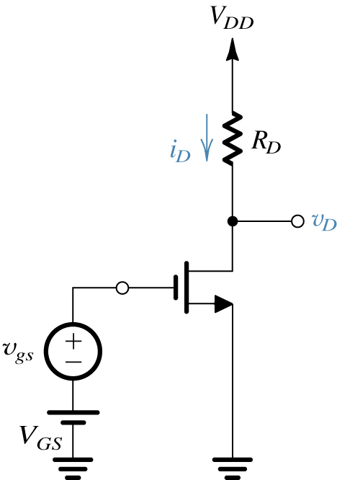

- For the multistage differential amplifier shown below: (20 points)
- Perform an approximate DC analysis, assume beta>>100 and |Vbe|=0.7V, calculate the DC voltage and currents everywhere in the circuit.
- Calculate the quiescent power dissipation in this circuit
- Calculate the common mode range
- Draw the small equivalent circuit for the purpose of calculating the voltage gain. (you do not have to calculate the gain) (course outcome 1, 3, ECE outcome I, j, h e)

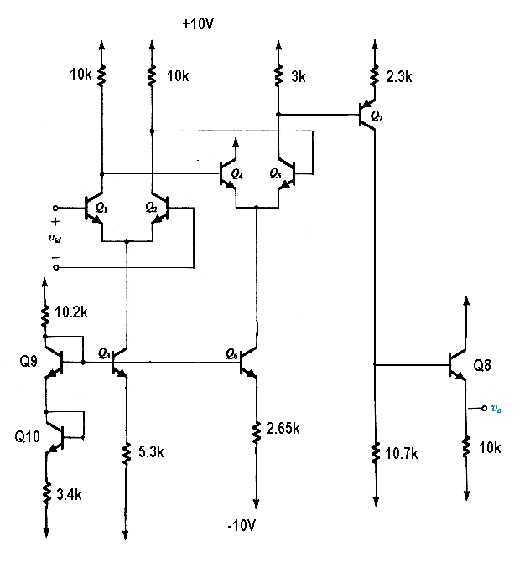

- For the circuit below, draw small signal equivalent for low frequency response and high frequency response respectively. (20 points) (course outcome 1, 3, ECE outcome I, j, h, e)

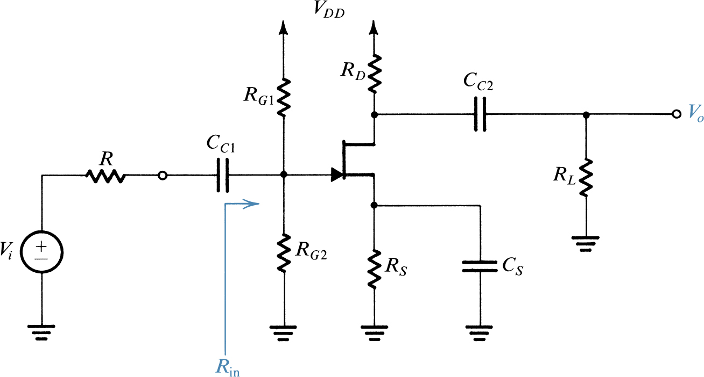

- For the non-ideal op-amp below, neglect Rs, (1) Draw A and β circuit; find A and β; (2). Find Af, Rif, Rof (20 points) (course outcome 1, 3, ECE outcome I, j, h e)

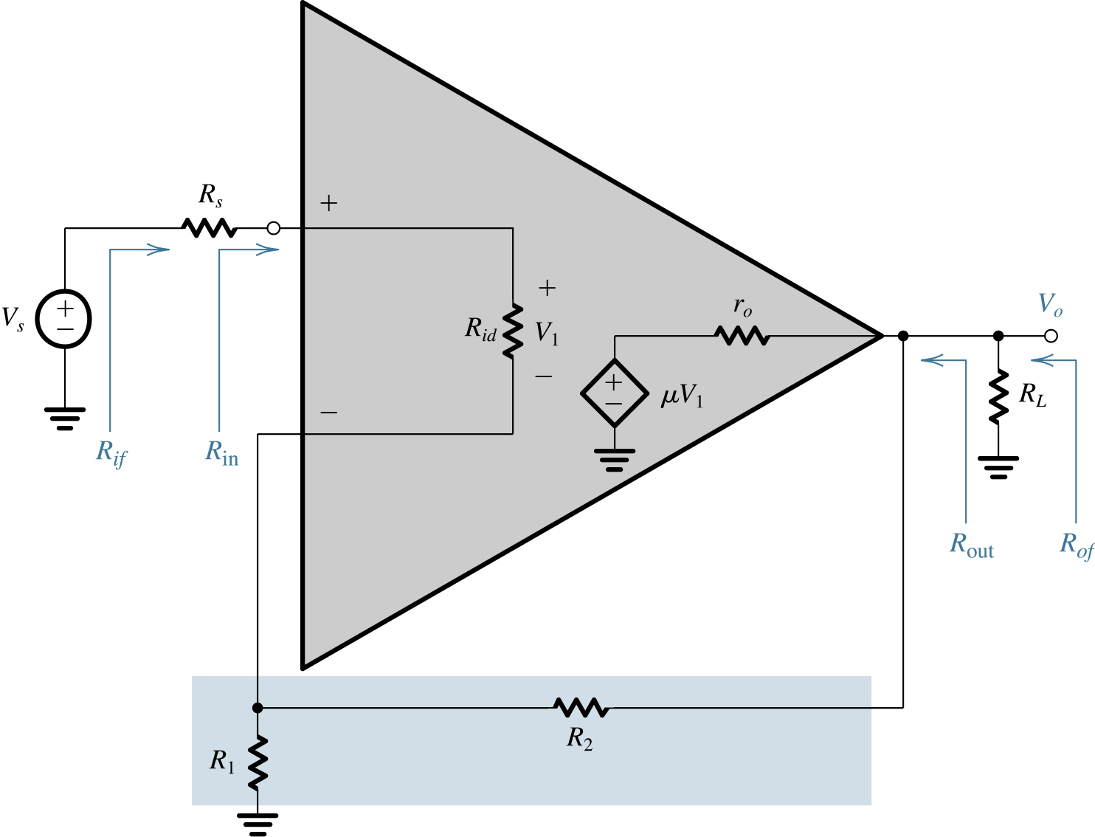
5. An analog signal in the range of 1~15V is to be digitized. The required quantization error is 0.5%. of full scale. How many bits are needed? What is the conversion resolution? (10 points) (course outcome 1, ECE outcome I, j, h)

6. Suppose you are asked to simulate the circuit of Problem 3 in this quiz in PSPICE. Describe the steps that you will need to do. What kind of simulation can you do in PSPICE for this particular circuit (DC Sweep, AC sweep, etc, describe what result of each simulation will give you. (10 points) (course outcome 2, ECE outcome h)

