ECE414 Fall 2003  Quiz 1 Solutions | Name
ECE414 Fall 2003  Quiz 1 Solutions | Mark | Total 25 points

For the multistage differential amplifier shown below:
- Perform an approximate DC analysis, assume beta>>1 and |Vbe|=0.7V, calculate the DC voltage and currents everywhere in the circuit. (10 points)
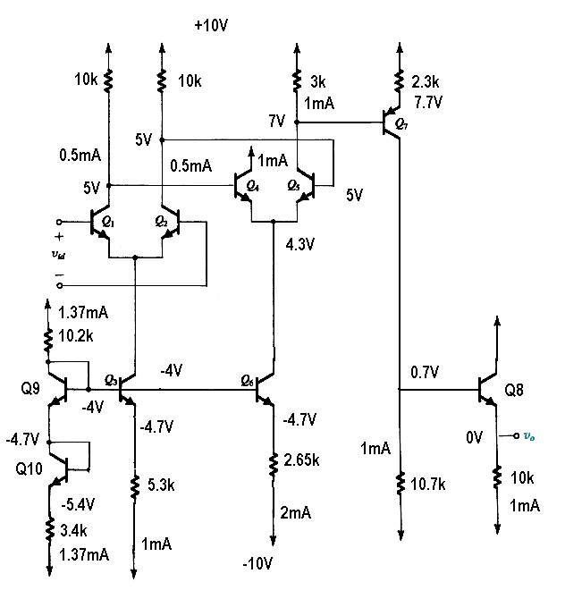
Key: Ic9=Ic10=[10-(-10)-0.7-0.7]/(10.2+3.4)=1.37mA
VB3=10-Ic9*10.2=-4V
Ve3=Vb3-0.7=-4.7V
Ie3=Ic3=[-4.7-(-10))=1mA, similarly, Ic6=Ie6=(-4.7+10)/2.65=2mA

- P⁺ =10V*(1.37+0.5+0.5+1+1+1+1)=63.7W
P⁻ =10V*(1.37+1+2+1+1)=63.7mW
P_total= P⁺ + P⁻ =127.4W (5 points)
- Common mode range: upper limit: Q1 and Q2 leaves active mode, e,g. Vin=5V
Lower level, Q3 leaves active. -4+0.7= -3.3V (5 points)
- Differential gain: (5 points)
Refer to page 553-555 in the textbook

Stage 1: you need to determine the resistance between the collectors of Q1 and Q2:
Re1=re2=25mV/0.5mA=50 Ohms;
rπ1=rπ2=101*50=5.05k
Rid=rπ1+rπ2=10.1k

Re3=re4=25mV/1mA=25 Ohms;
Rπ3=rπ4=101*25=2.525k
Ri2=rπ1+rπ2=5.05k

A1=(Total resistance in collector circuit)/(total resistance in emitter circuit)
=[Ri2//(R1+R2)/[re1+re2]=(5.05//20k)/100=40.3

Stage 2: you need to determine the resistance at the collector of Q5
Re7=25/1=25 Ohm
Ri3=(beta+1)*(R4+re7)=101*(2.3k+25)=234.8k
A2=(Total resistance in collector circuit)/(total resistance in emitter circuit)
=(R3//Ri3)/(re4+re5)=234.8/50=-59.2

Stage 3: you need to determine the resistance at the collector of Q7

Re8=25/1=25 ohms
Ri4=(beta+1)*(re8+R6)=101*(25+10k)=1013k
A3=(R5//Ri4)/(re7+R4)=(10.7//1013)/(2.3+25)=-4.55

Stage 4
A4=R6/(R6+re8)=10k/(10k+25)=1

A=A1*A2*A3*A4=40.3*59.2*10.6*1=11,100 V/V

