ECE414 Fall 2002  Quiz 2 (open book) | Name
ECE414 Fall 2002  Quiz 2 (open book) | Mark | / 25

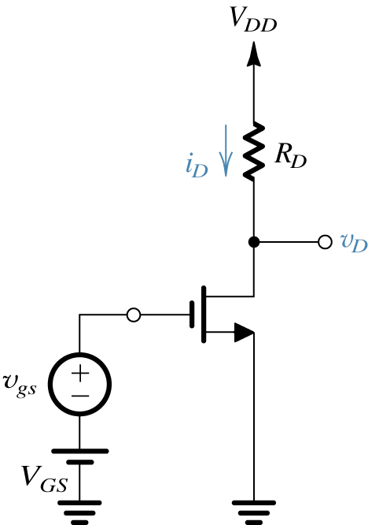
1. For the circuit shown below, Vt=2V, kn(W/L)=1mA/V², V_{DD}=10V, v_{gs}=0, Find V_{GS} for a DC biasing current of I_{D}=2mA. What’s the maximum resistance R_{D} to keep the MOS as amplifier? (10 points)

$\begin{aligned}\text{use} I_{D}=\frac{1}{2}k_{n}^{1}\frac{W}{L}(V_{\text{GS}}−V_{t})^{2} \\ 2\text{mA}=\frac{1}{2}∗1∗(V_{\text{GS}}−2)^{2} \\ V_{\text{GS}}=4V(e\text{lim}\text{inate} V_{\text{GS}}=0V) \\ V_{D}=V_{\text{DD}}−I_{D}R_{D}>V_{\text{GS}}−V_{t}=4−2=2V \\ R_{D}<(V_{\text{DD}}−2)/{I_{D}}=(\text{10}−2)/2 \\ R_{D}\text{<=}4kΩ\end{aligned}$

2. For the same circuit above, assume R_{D}=2k, Vt=1V, kn =20uA/V², L=10um, V_{GS}=2V, neglect ro, find channel Width W that results voltage gain of 2V/V. Also find required I_{D}. (10 points)

$$\begin{aligned}\text{gain}=g_{m}∗R_{D} \\ ∴ g_{m}={\text{gain}}/{R_{D}}=2(V/V)/2k=1{\text{ma}}/V \\ g_{m}=k_{n}^{1}\frac{W}{L}(V_{\text{GS}}−V_{t}) \\ 1\text{mA}=\text{20}×{\text{10}}^{−3}∗\frac{W}{\text{10}}∗(2−1)=2×{\text{10}}^{−3}W \\ W=\text{500}\text{um} \\ I_{D}=\frac{1}{2}k_{n}^{1}\frac{W}{L}(V_{\text{GS}}−V_{t})^{2}=0\text{.}5×\text{20}×{\text{10}}^{−3}\frac{\text{500}}{\text{10}}×(2−1)^{2}=0\text{.}5\text{mA}\end{aligned}$$

3. For the circuit below, Iref=100uA, (W/L)₁=10, (W/L)₂=20, find Io. Further assume kn’=20uA/V², find V_{GS}. If V_{t}=1V, what is the minimum Vo? (5 points)
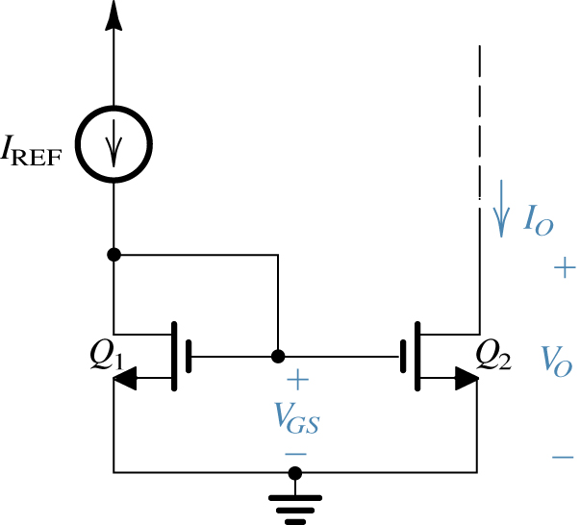
$$\begin{aligned}I_{D}=\frac{1}{2}k_{n}^{1}\frac{W}{L}(V_{\text{GS}}−V_{t})^{2}(1) \\ I_{o}=I_{\text{ref}}=\text{100}∗\frac{(W/L)_{1}}{(W/L)_{2}}=\text{200}\text{uA} \\ \text{For} Q_{1}, \text{use} (1), V_{\text{GS}}=2V \\ \text{For} Q_{2}, \text{use} (1), V_{\text{GS}}=2V \\ \text{min}\text{imum} V_{o}: V_{o}=V_{\text{GD}}>V_{\text{GS}}−V_{t} \\ ∴ V_{o}\text{>=}1V\end{aligned}$$

