Assignment 4:

ECE 450
Electronic Communications
Spring/Summer 2003
7/29/26

Tatha (Tat) Lohachitkul rattatatat@hotmail.com

Honor Code: I have neither given nor received aid in the preparation of this report.

Tatha (Tat) Lohachitkul



Introduction:

In this assignment, the first part, we are to build the envelope detector based. It has a modulator using the “ sum and squaring” approach. We will analyze the relationship between the FFT on the left side of the diode and the FFT on the right side.
In the second part of this assignment we are to convert the receiver to a superheterdyne receiver.

Results:

For part 1, we are to build an envelope detector circuit. The purpose of this circuit is to familiarize ourselves with the parts and operations of an envelope detector circuit. We will start with the components of the circuit from the left to right. As you can see in the following schematic , I used a DC bias, that ensures that the sum of the carrier plus the baseband signal never goes negative. I used Vsin for the baseband and carrier signals. The next components will consist of PWR, which does the squaring, band pass filters, gains, limits, a resistor, and ground.

Envelope Dectection Circuit:
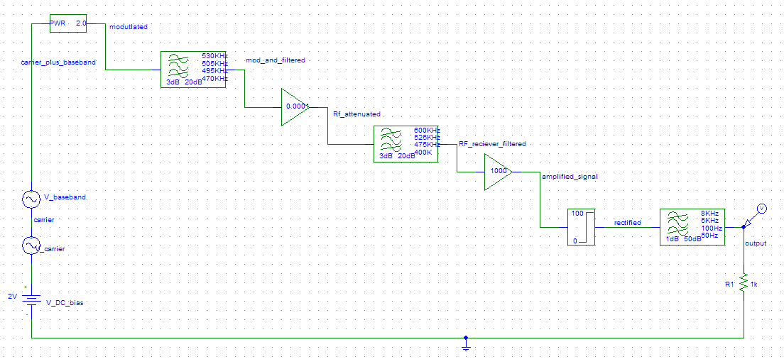

Now that we have the schematic lets test it to learn how it works. The following plot is the input signal in time domain:

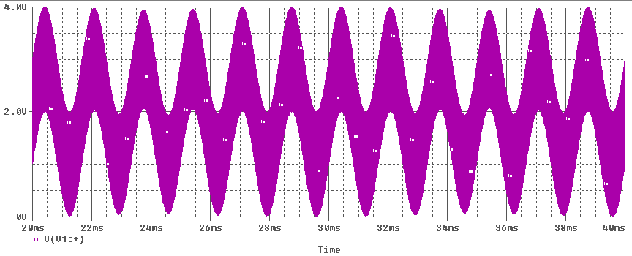
input

The following plot is the output of the system:

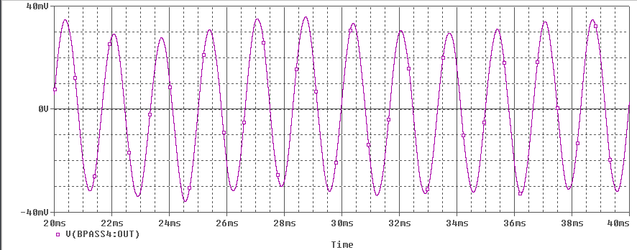
output

We can see from the previous two plots that the input and output line up perfectly. I tried plotting the two input signal plots on the same graph to show a better comparison but the simulation gave didn’t give me what I wanted. I will figure it out for the next assignment.

By examining the frequency spectrum of the two signals we can see they are very similar expect for their amplitude. The next two plots are of inputs and outputs in the frequency domain:

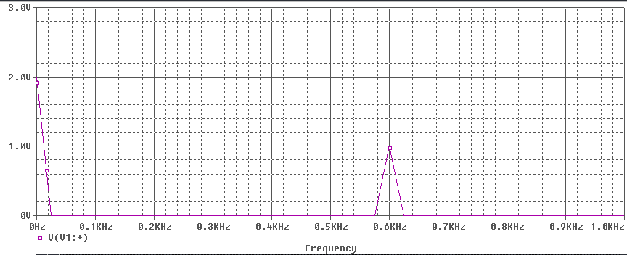
input

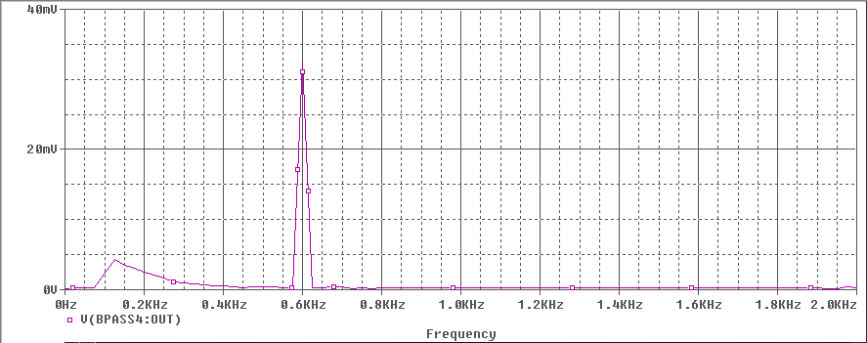
output

I notice that each signal has the same harmonic at 0.6KHz. This means that each signal is a sine wave with a frequency of 0.6KHz. However the output signal in the frequency domain has a little hump between 0.09KHz to 0.4KHz, which the input doesn’t have.

The second part, the circuit is similar. In the envelop detection with superheterodyne circuit, the difference is you add a multiplier, another band pass filter, and another Vsin. The following schematic is the circuit:

Envelope Dectection with Superheterodyne:
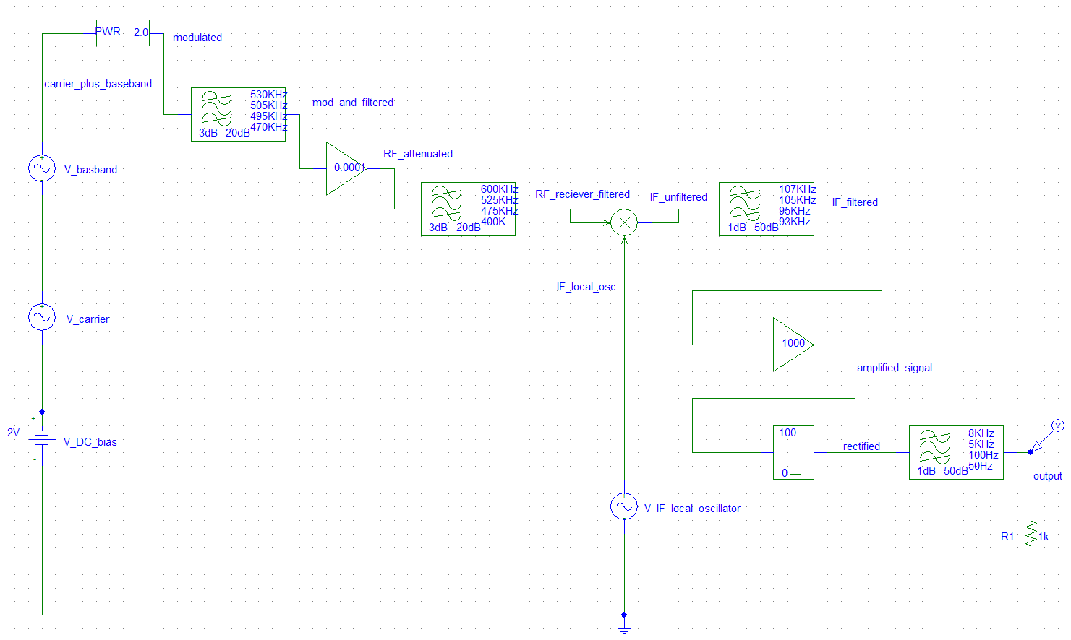

Let’s see how this circuit works by simulating it. The following plot is of the input signal of the circuit in time domain:

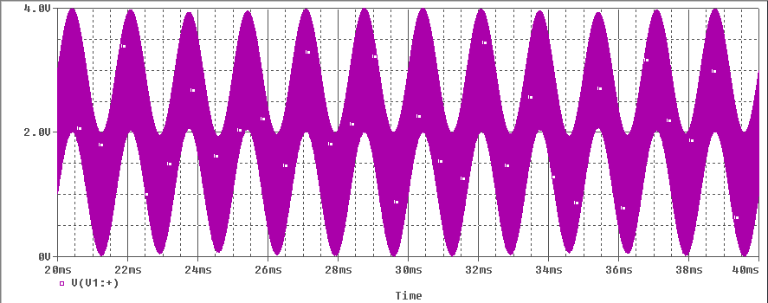

input

The following is the output signal of the system in time domain:
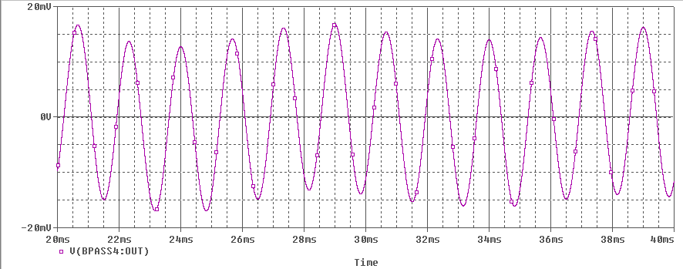output

We can see from the previous two plots that the input and output line up perfectly.

By examining the frequency spectrum of the two signals we can see they are very similar expect for their amplitude. The next two plots are of inputs and outputs in the frequency domain:
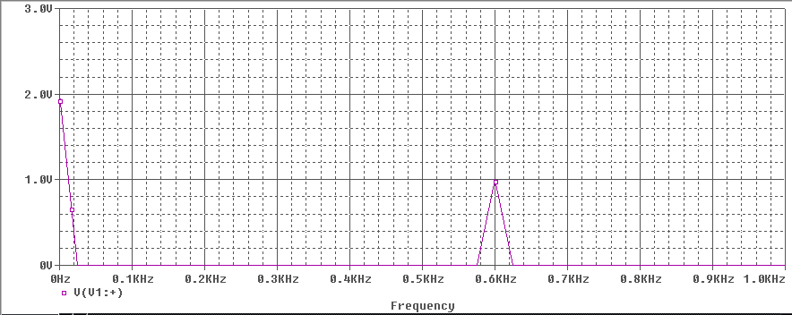input

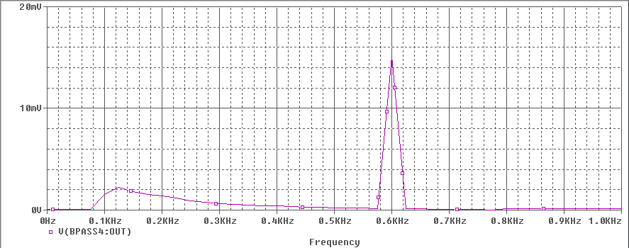
output

I notice that each signal has the same harmonic at 0.6KHz. This means that each signal is a sine wave with a frequency of 0.6KHz. However the output signal in the frequency domain has a steep inclining slope and slow declining slop between 0.09KHz to 0.5KHz, which the input doesn’t have.

Conclusion:

This assignment has taught me how to design envelope detection and envelope detection with superheterodyne circuits using Pspice. I looked at the basic operations and how these circuits passes a signal through filters, harmonics, and amplifiers. It has shown me how waveforms of a envelope detection and envelope detection with superheterodyne circuits would look like under frequency and time domains. In addition I have gotten to use Pspice more productively during this assignment. Overall, this assignment is a great introduction to start of Electronic Communications. It has acquainted me to many new concepts.

