Assignment 5:

ECE 450
Electronic Communications
Spring/Summer 2003
7/31/26

Tatha (Tat) Lohachitkul rattatatat@hotmail.com

Honor Code: I have neither given nor received aid in the preparation of this report.

Tatha (Tat) Lohachitkul



Introduction:

In this assignment, we will build an AM super heterodyne circuit and also tune into a particular station with a noisy environment. It is known that superheterodyne makes AM receivers easier to operate and build. With a superheterodyne receiver, there is only one knob to turn in order to tune in a particular radio station. This was popular because it took away the need for all of those dials that were very difficult to set correctly.

Part 1:
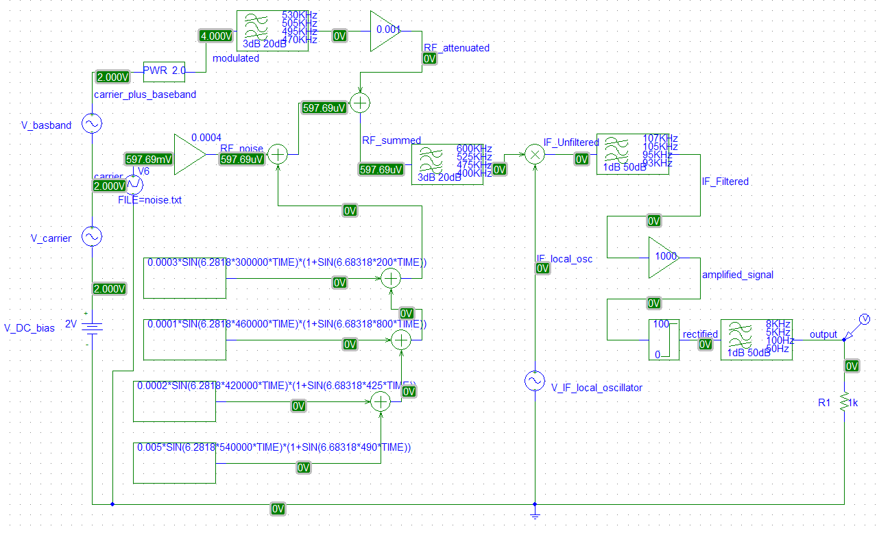

Figure 1a. Design of an AM superheterodyne receiver with a noisy environment and ability to tune. The gain for the noise portion is 0.0004.

The above circuit look similar to the superheterodyne circuit in assignment 4. In order to tune into one particular station with a noisy environment, we add 4 alternate stations using the ABM part name, a AWGN file with 1000 entries of increments of 0.000001 seconds using the VPWL_F_RE_FOREVER part name, a part name gain of 0.0004, and summers. This circuit has a local oscillator which is variable and is used to modulate the signal so that the modulated signal will have the same center frequency as the fixed high-order filter that follows the multiplier. In an AM radio, the variable local oscillator and the bandpass filter are linked so that one know controls both.

Results: Part 1

Now that we have the schematic lets test it to learn how it works. The following plots were created by using Pspice simulator.

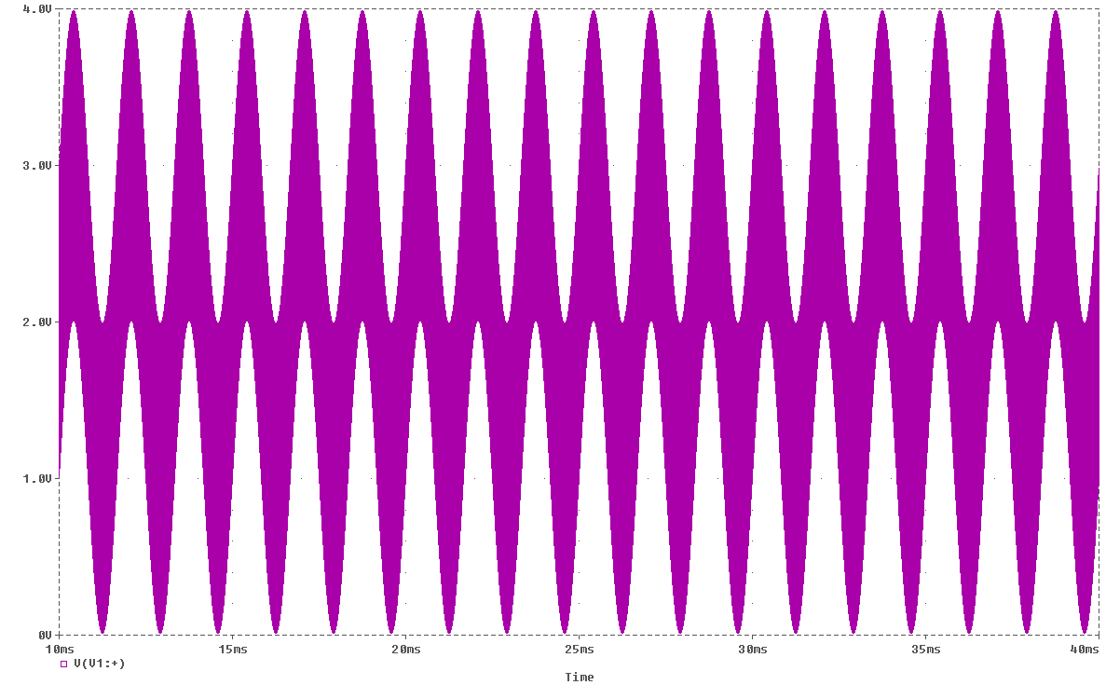
Figure 1b: Input waveform in time domain of the AM superheterodyne receiver with a noisy environment and ability to tune. Run time of 10 to 40ms and Maximum step size of 0.0001ms.

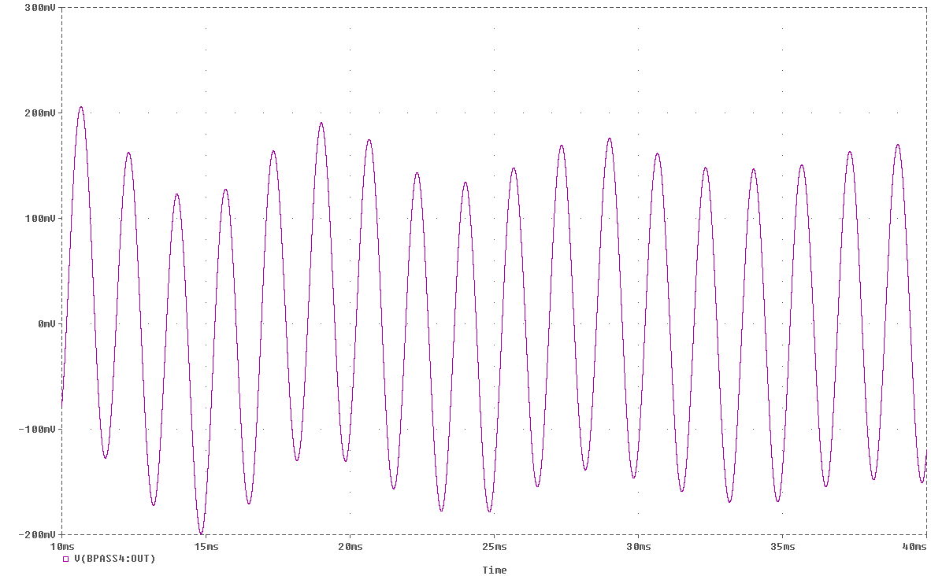
Figure 1c. Output waveform in time domain of the the AM superheterodyne receiver with a noisy environment and ability to tune. Run time of 10 to 40ms and Maximum step size of 0.0001ms.

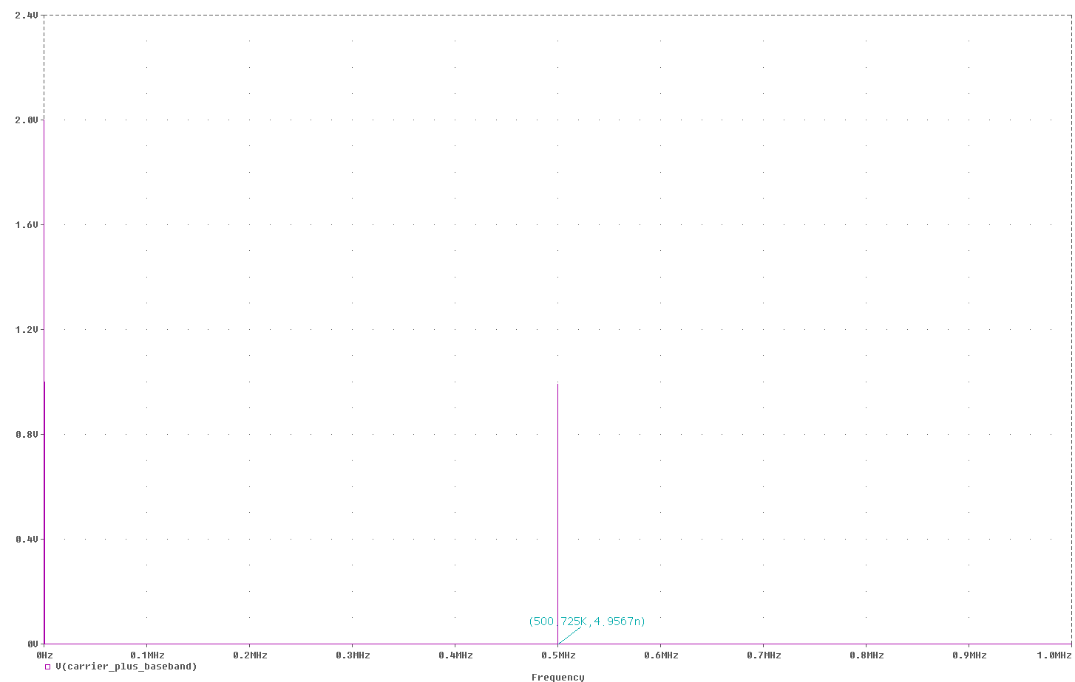
Figure 1d. Input in frequency domain of the the AM superheterodyne receiver with a noisy environment and ability to tune. This is zoomed at 0 to 1MHZ. The frequency component is at 500KHz and amplitude of .
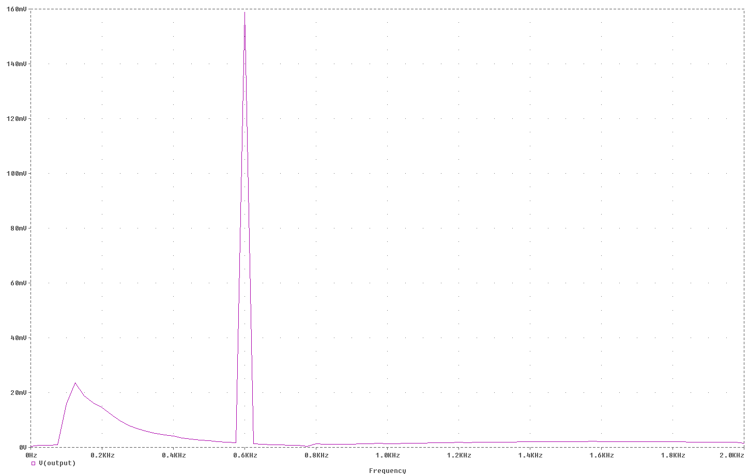
Figure 1e. Output in frequency domain of the AM superheterodyne receiver with a noisy environment and ability to tune. . This is zoomed at 0 to 1kHZ. The frequency component is at 0.6KHz and amplitude of 160mV. The lower frequency component that was not originally in the basband signal appears to ahave a grequency near 125Hz and an amplitude near 23mV.

Conlustion Part 1

The AM superheterodyne receiver with a noisy environment and ability to tune appears to work wee, however an unwanted signal with a frequency near 125Hz and an amplitude near 23mV is present. This may be because of multiplication operations that cause a many signals and some are what we want. We might have to spend more time on tweaking the filters to get rid of this unwanted signal.

Part 2

In part 2 we are do crank up the noise level such that we can see it in the output. So for the gain in the noise portion of the circuit I change the 0.0004 value to 0.1. Hopefully we will see a change in the output.

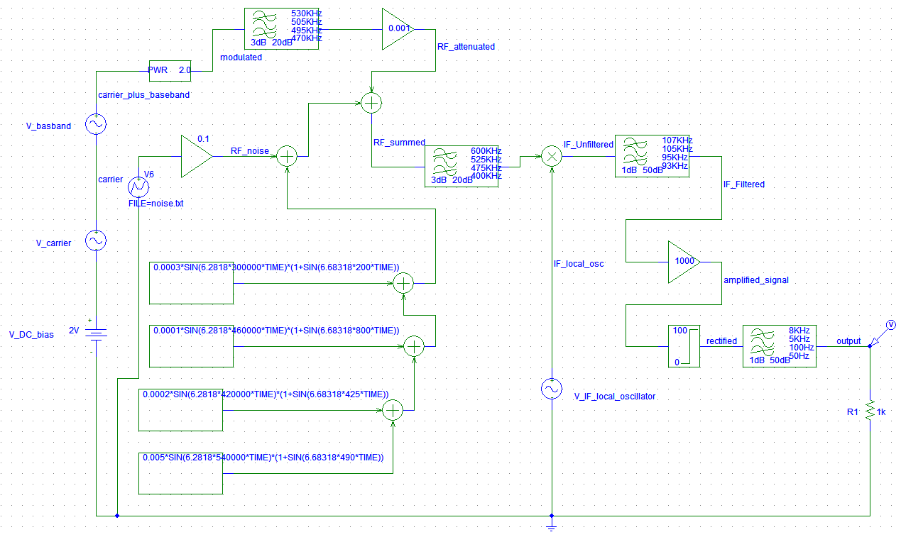Figure 2a. Design of an AM superheterodyne receiver with a noisy environment and ability to tune. The gain for the noise portion is 0.1.

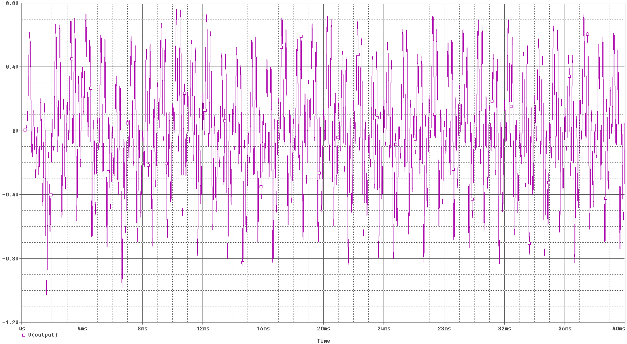
Figure 2b. Output waveform in time domain of the the AM superheterodyne receiver with a noisy environment and ability to tune. Run time of 0 to 40ms and Maximum step size of 0.0001ms. After cranking up the gain of the noise to 0.1, you can see here that the output waveform has changed. There is more oscillations and more noise.

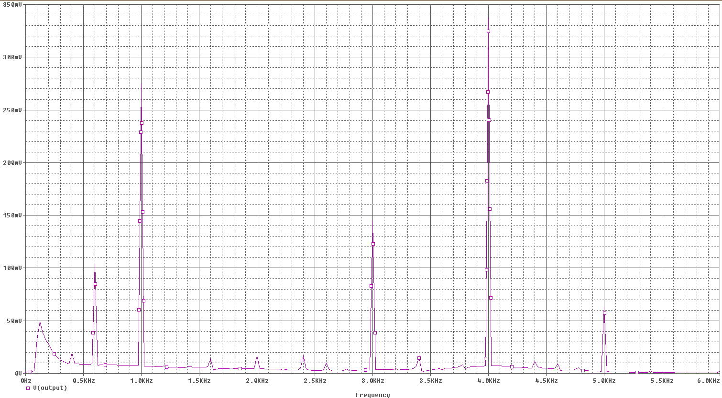
Figure 2c. Output in frequency domain of the AM superheterodyne receiver with a noisy environment and ability to tune. This is zoomed at 0 to 7kHZ. There are more frequency components compared to the signals from part 1.

Conclusion Part 2

. After cranking up the noise there are more frequency components present, which was predicted after seeing the waveform in the time domain.

Part 3
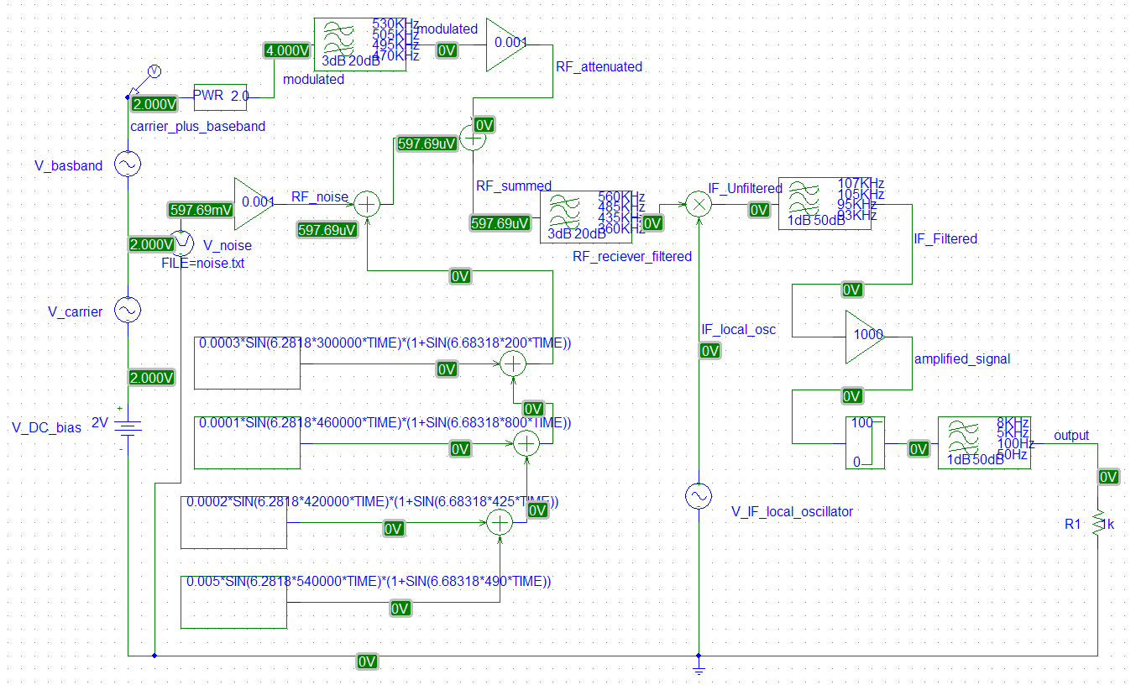

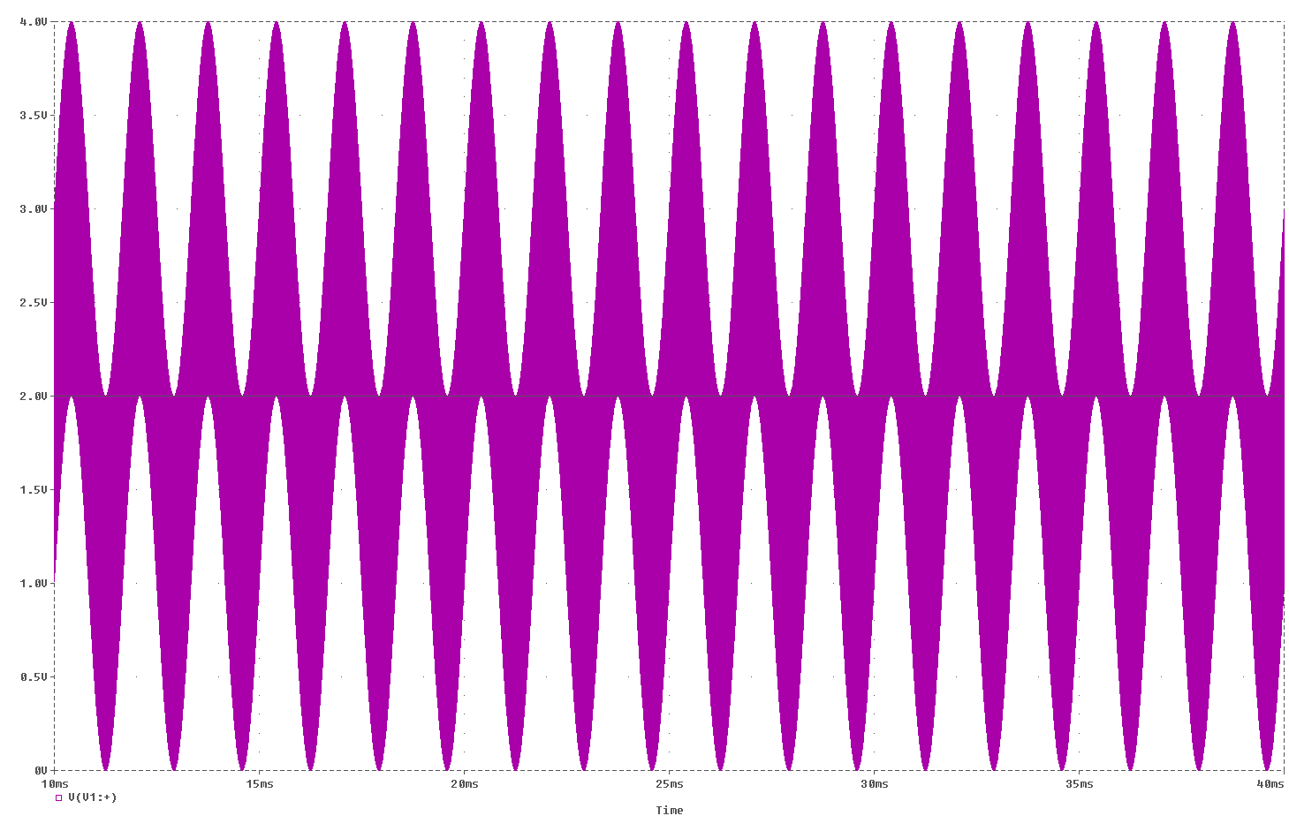

input

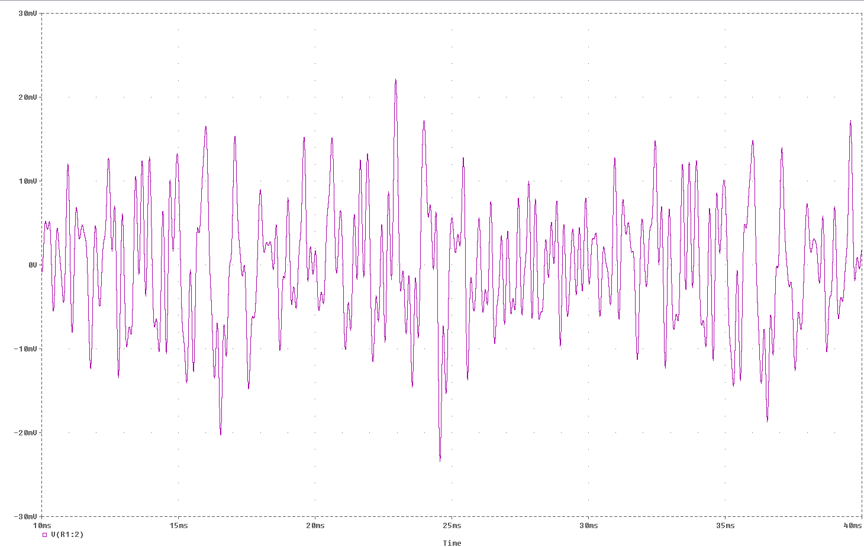
output

Frequency
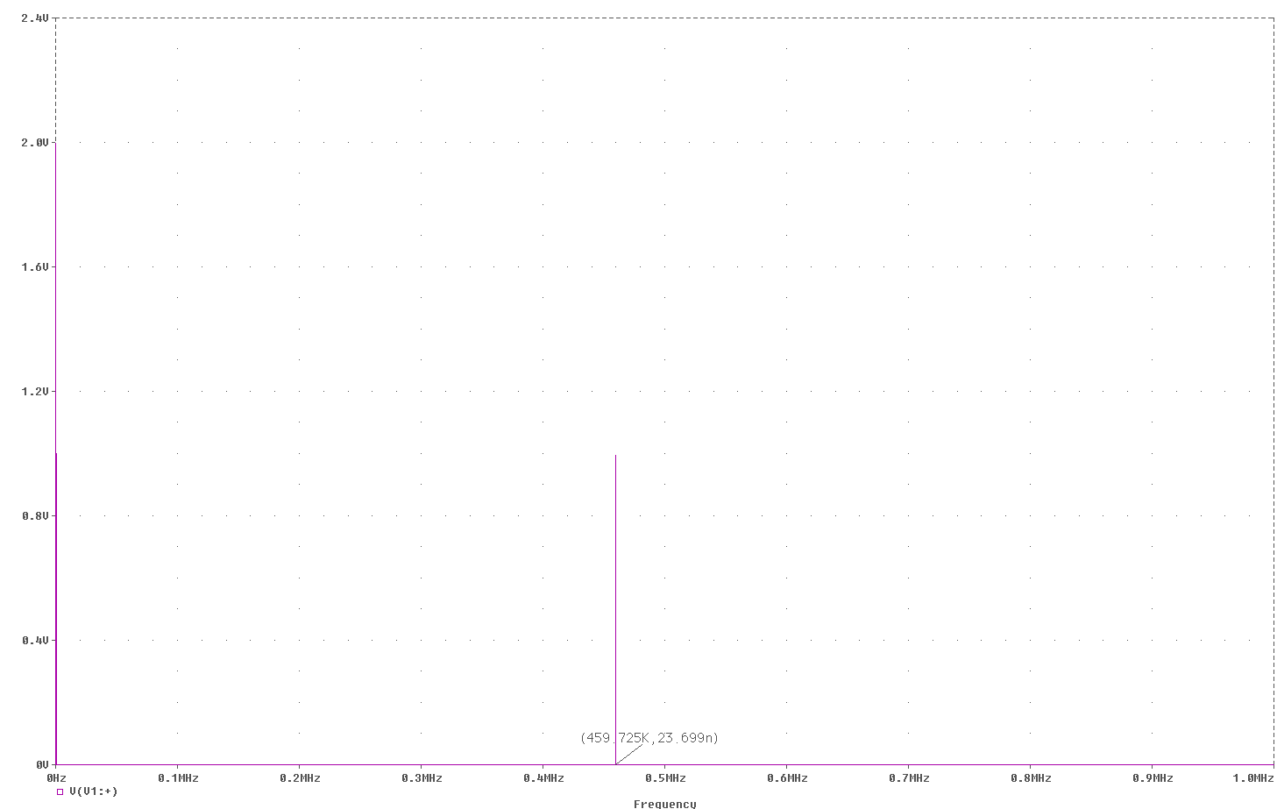

input

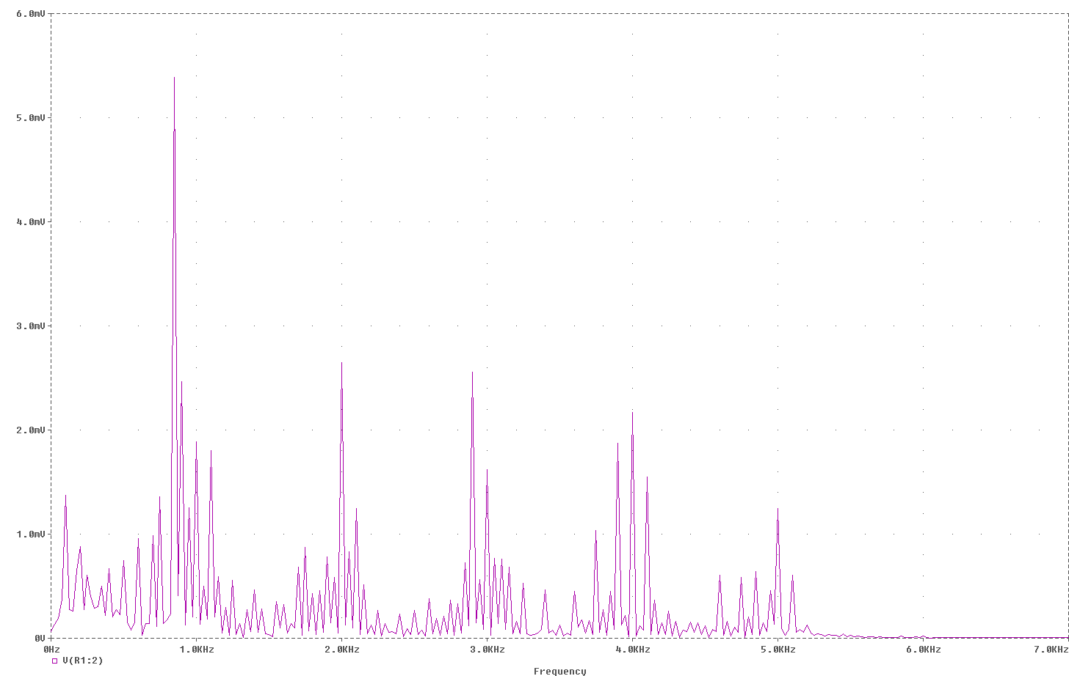
output

Part4
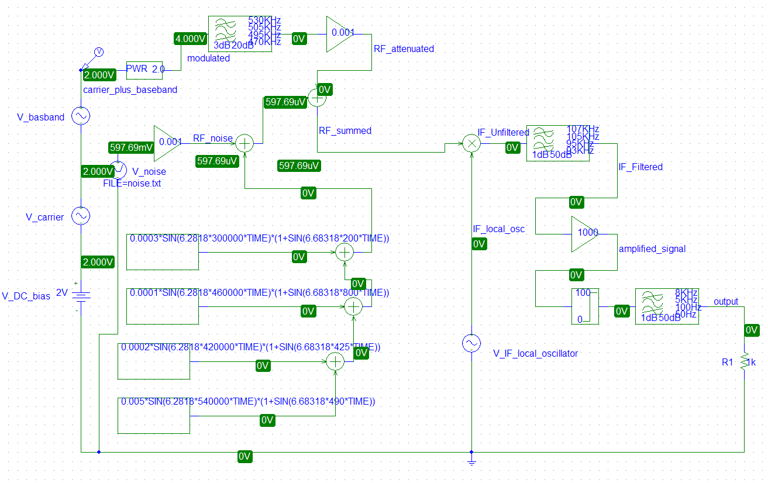

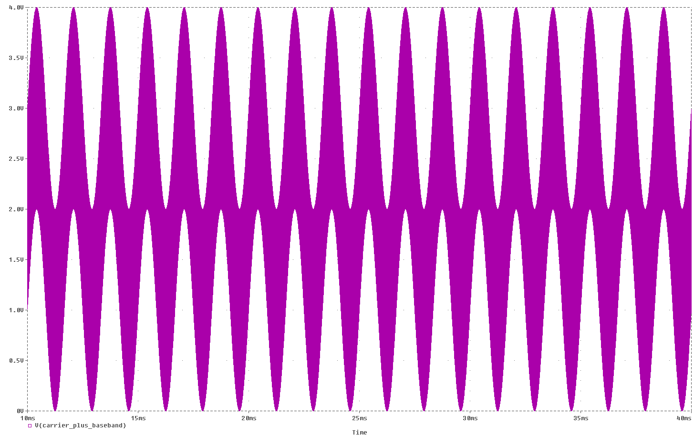
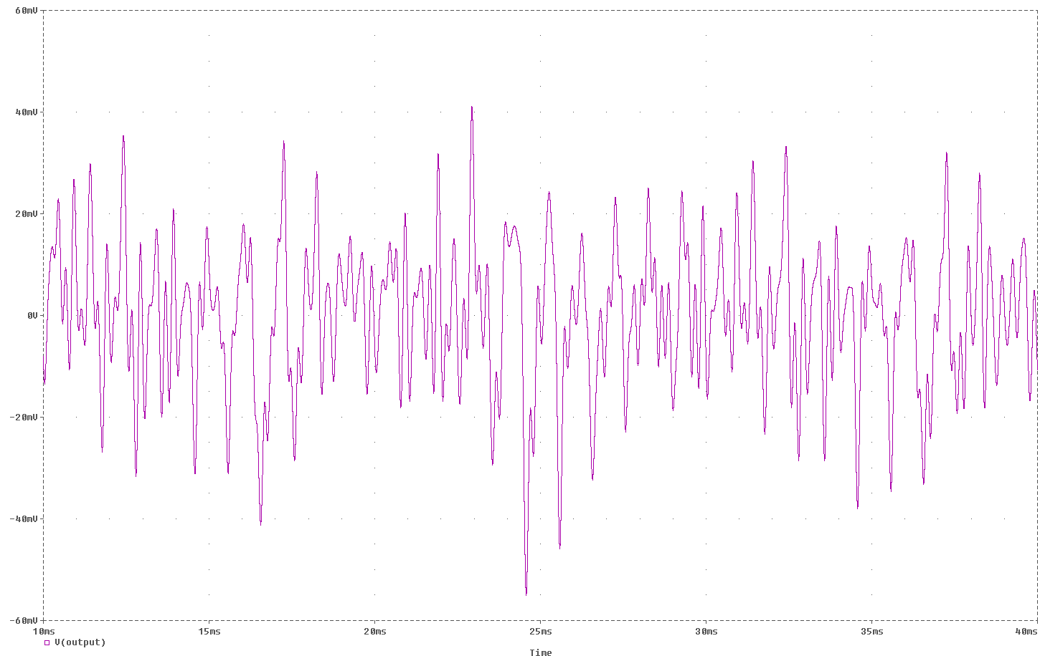

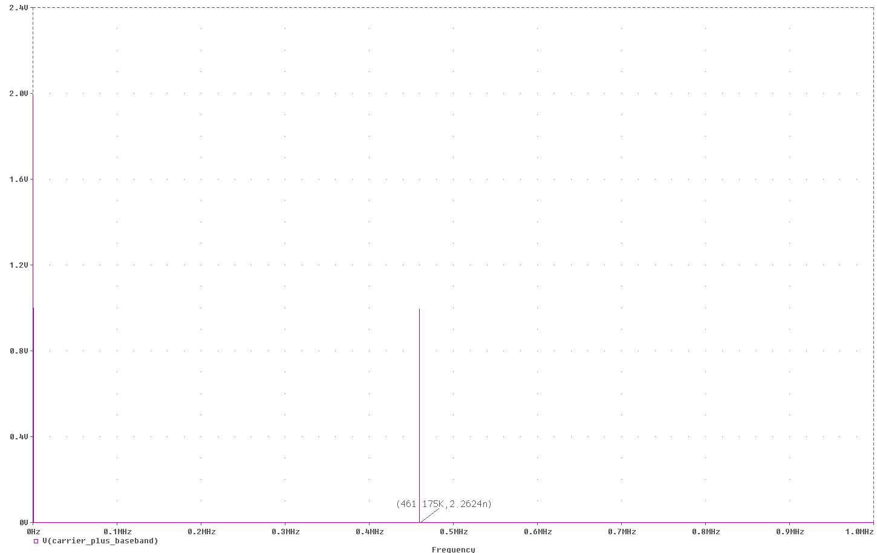

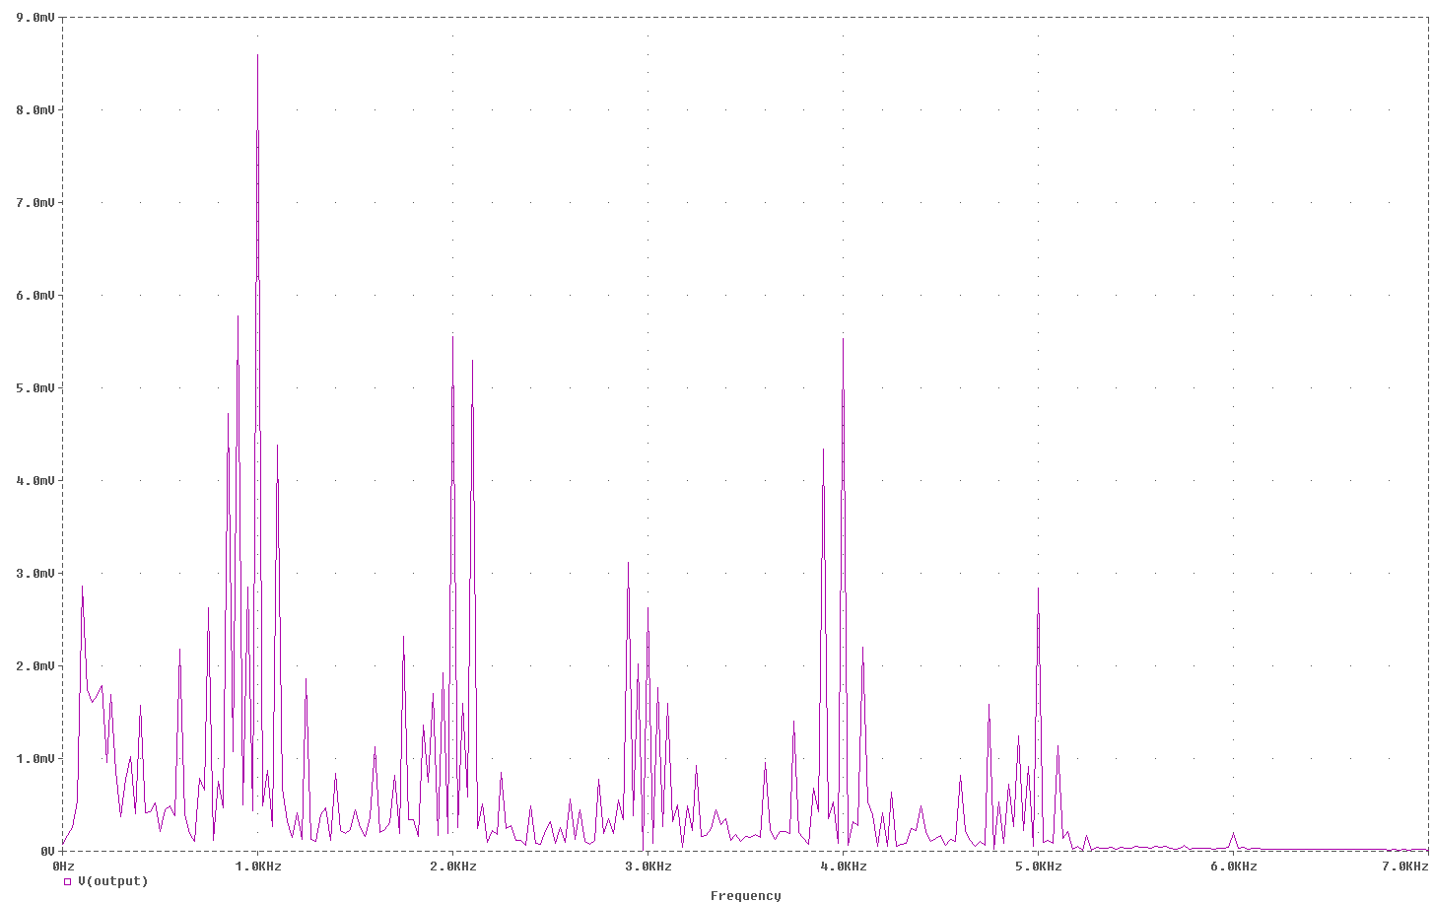

Conclusion:

This assignment has taught me how to design envelope detection and envelope detection with superheterodyne circuits using Pspice. I looked at the basic operations and how these circuits passes a signal through filters, harmonics, and amplifiers. It has shown me how waveforms of a envelope detection and envelope detection with superheterodyne circuits would look like under frequency and time domains. In addition I have gotten to use Pspice more productively during this assignment. Overall, this assignment is a great introduction to start of Electronic Communications. It has acquainted me to many new concepts.

