Assignment 6:

ECE 450
Electronic Communications
Spring/Summer 2003
7/29/26

Tatha (Tat) Lohachitkul rattatatat@hotmail.com

Honor Code: I have neither given nor received aid in the preparation of this report.

Tatha (Tat) Lohachitkul



Part 1: Introduction:

In this assignment, we will build the FM modulator with a 100KHz carrier and a kf of 10000Hz/V. We will feed in DC voltages of 0, +-1, and +-2 volts as baseband signals.

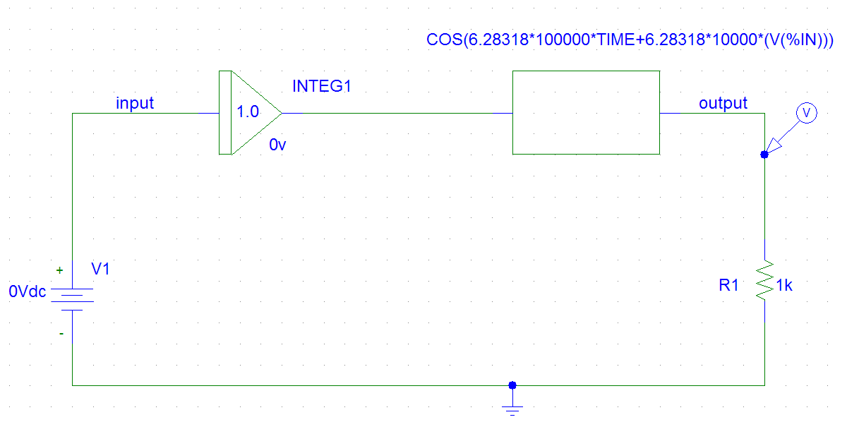
Figure 1a. Design of a FM modulator with a 100KHz carrier and a kf of 10000Hz/V. This circuit has an integrator and an AMB block that forms the FM modulator.

Results: Part 1

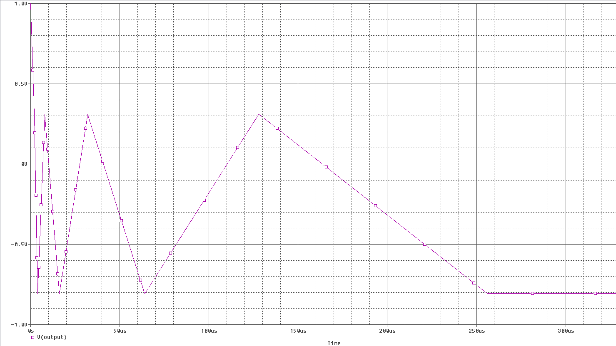
Figure 1b: Input waveform in time domain of the AM superheterodyne receiver with a noisy environment and ability to tune. Run time of 10 to 40ms and Maximum step size of 0.0001ms.

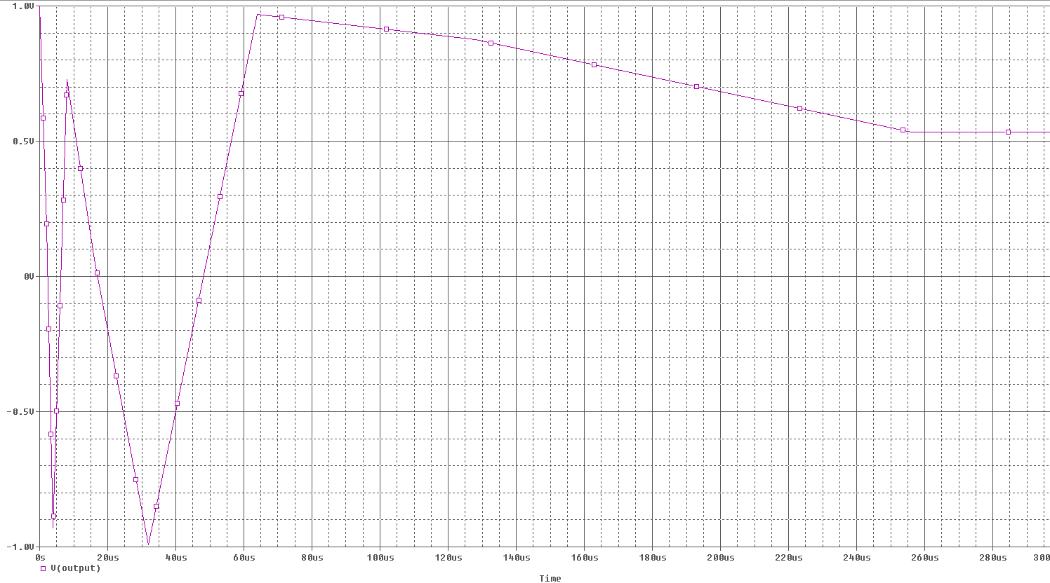
Figure 1c. Output waveform in time domain of the the AM superheterodyne receiver with a noisy environment and ability to tune. Run time of 10 to 40ms and Maximum step size of 0.0001ms.

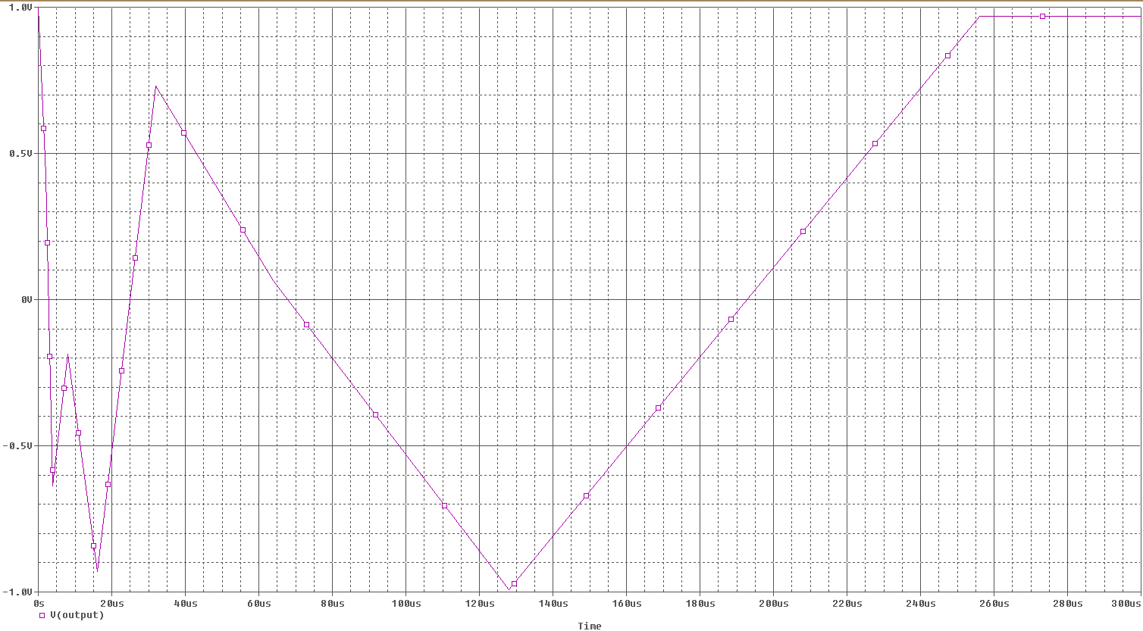
Figure 1d. Input in frequency domain of the AM superheterodyne receiver with a noisy environment and ability to tune. This is zoomed at 0 to 1MHZ. The frequency component is at 500KHz.
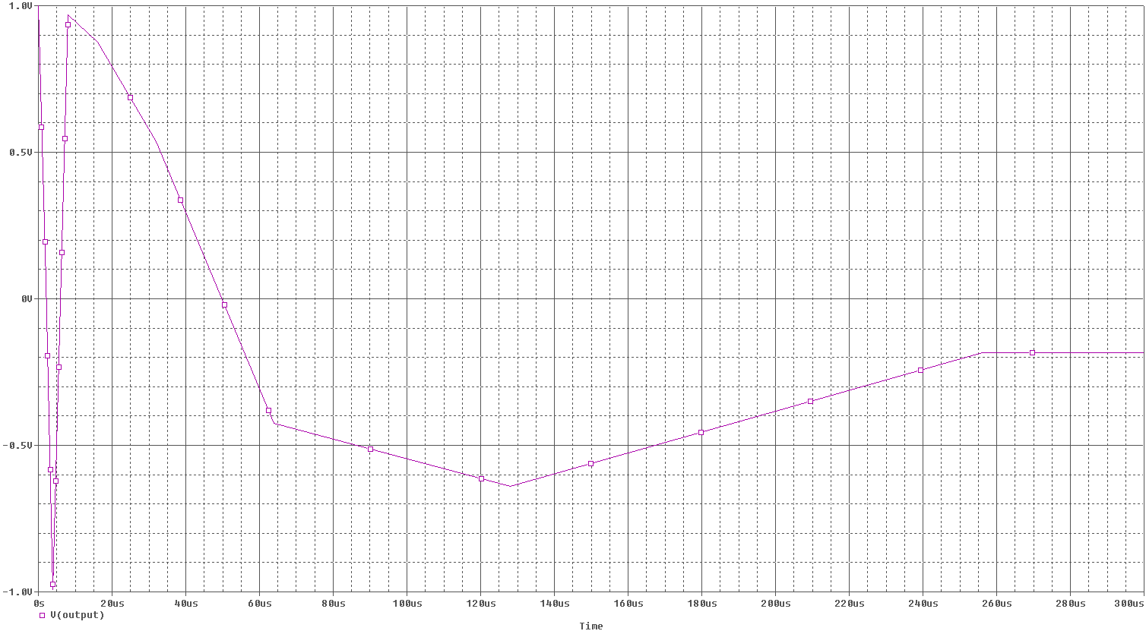
Figure 1e. Output in frequency domain of the AM superheterodyne receiver with a noisy environment and ability to tune. . This is zoomed at 0 to 1kHZ. The frequency component is at 0.6KHz and amplitude of 160mV. The lower frequency component that was not originally in the baseband signal appears to have a frequency near 125Hz and amplitude near 23mV.

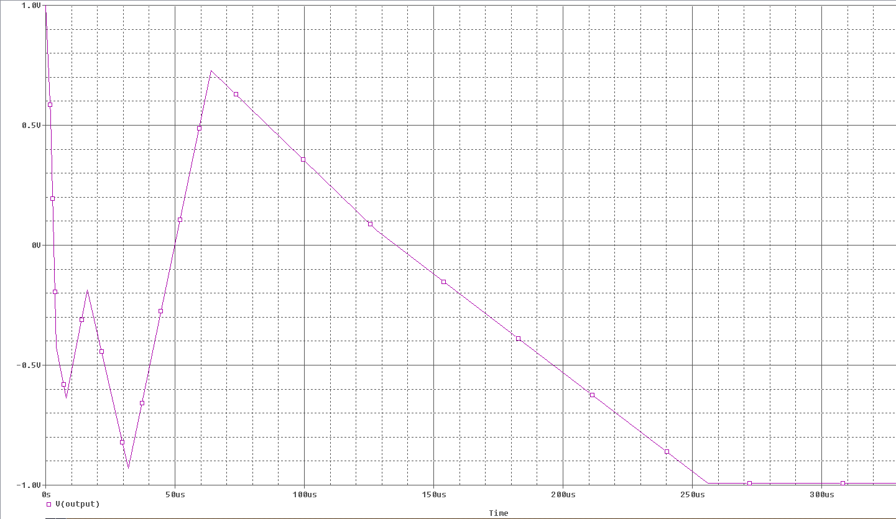

Figure 1f.

Conclusion Part 1

The AM superheterodyne receiver with a noisy environment and ability to tune appears to work wee, however an unwanted signal with a frequency near 125Hz and amplitude near 23mV is present. This may be because of multiplication operations that cause a many signals and some are what we want. We might have to spend more time on tweaking the filters to get rid of this unwanted signal.

Part 2-Introduction

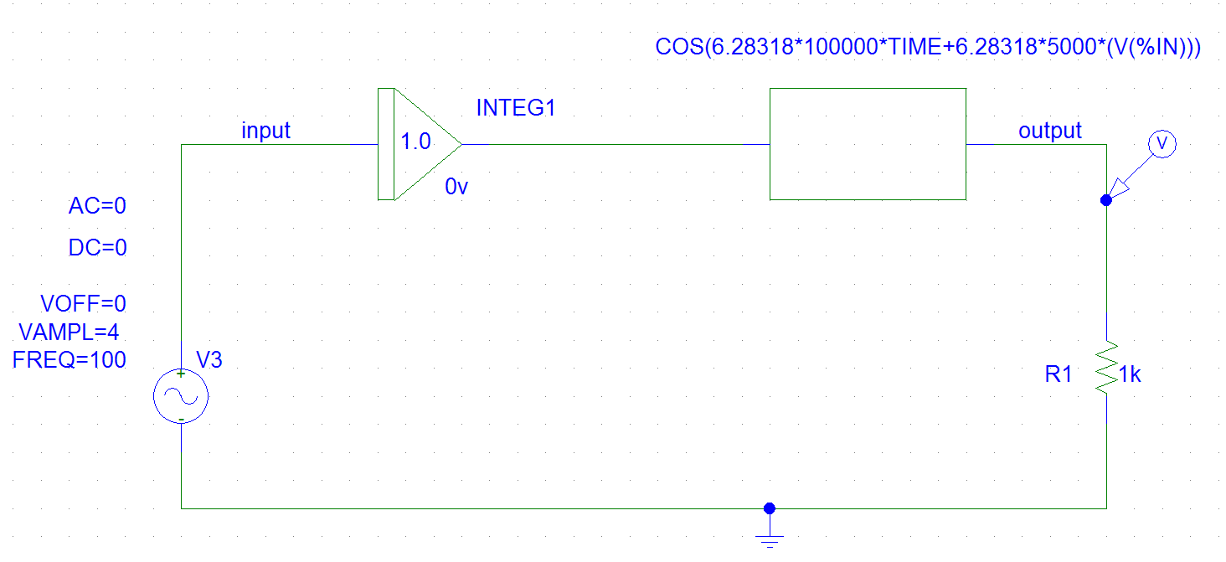
Figure 1a. Design of a FM modulator with a 100KHz carrier and a kf of 10000Hz/V.

Results-Part 2

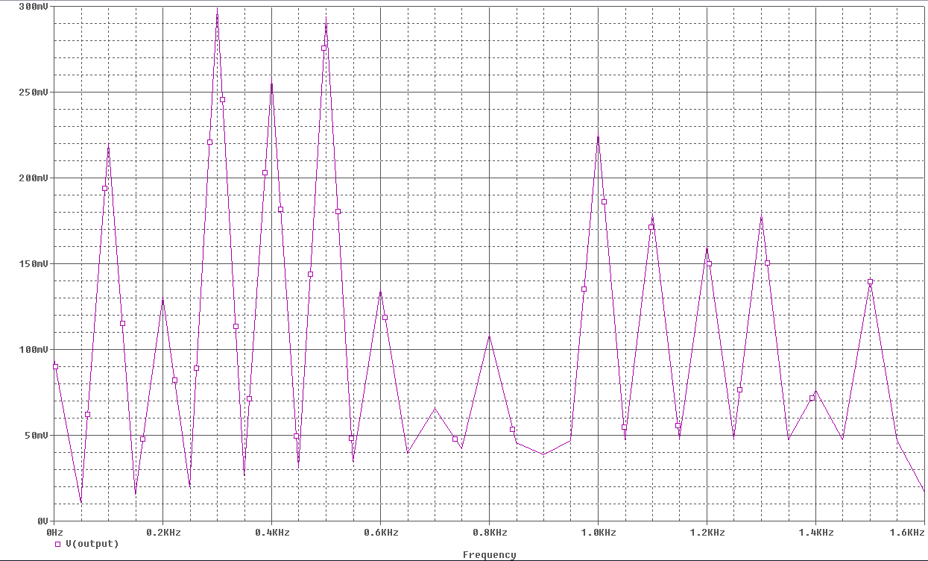
Figure 2a. 100,5000
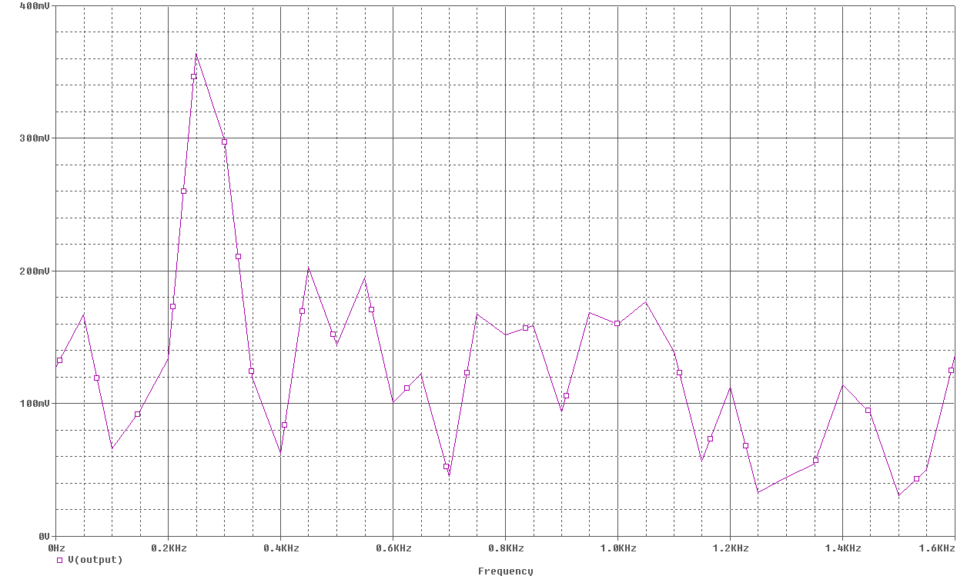
Figure 2a. 200,5000
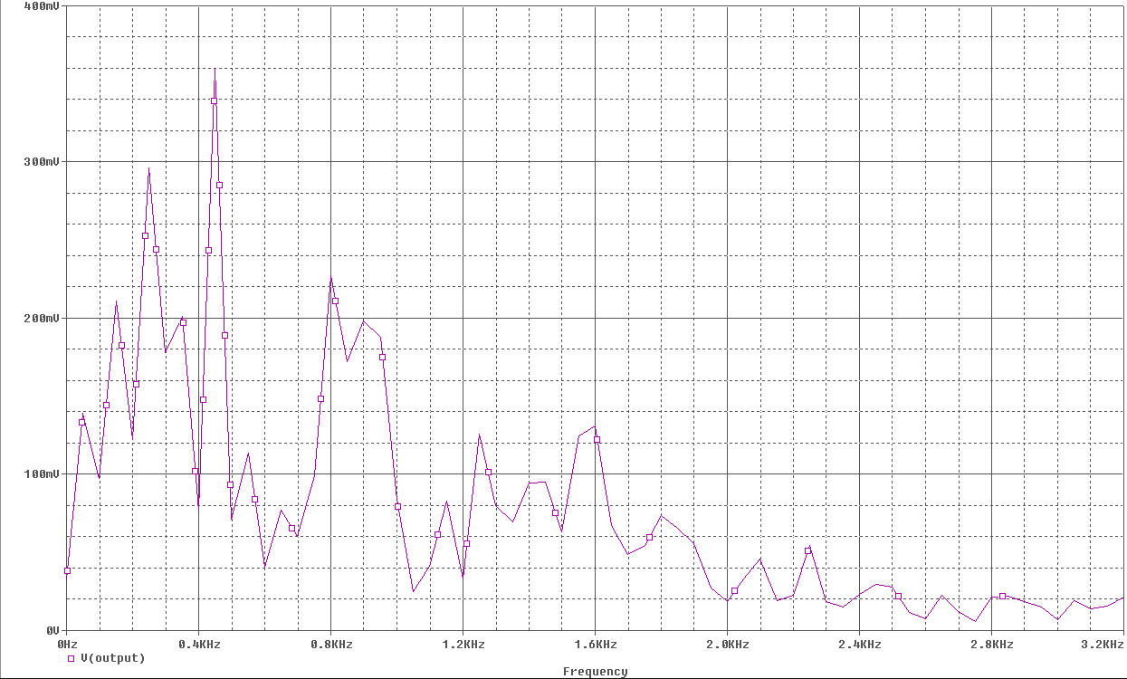
Figure 2a. 400,5000

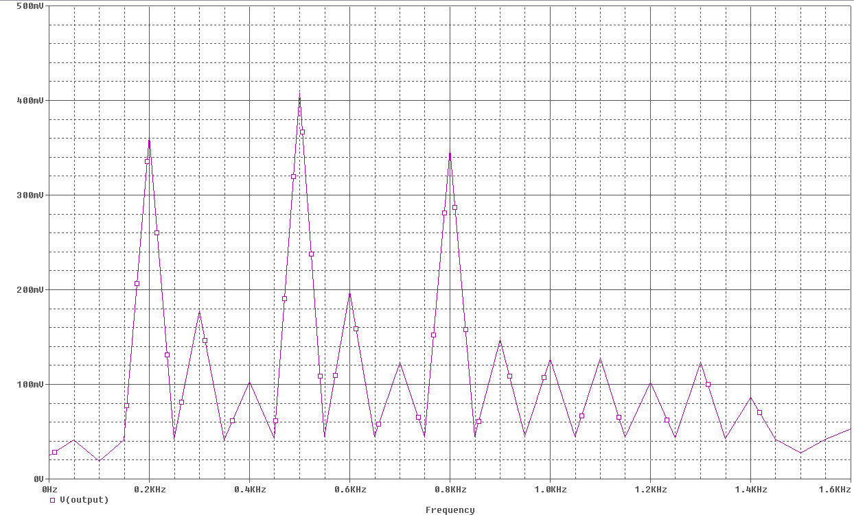
Figure 2b. 100,10000

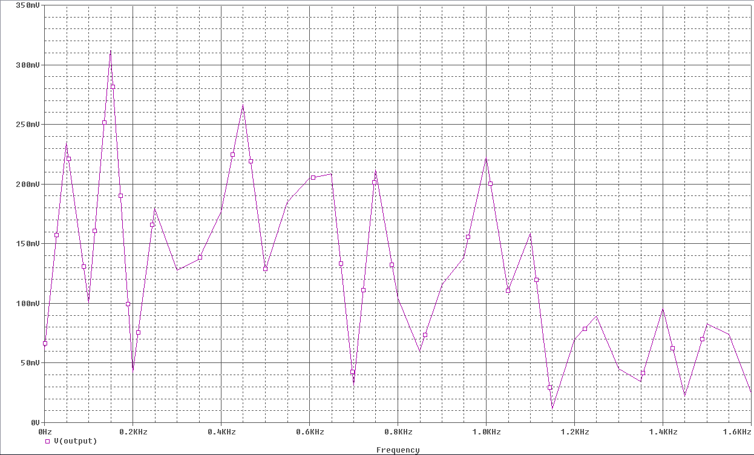
Figure 2b. 200,10000

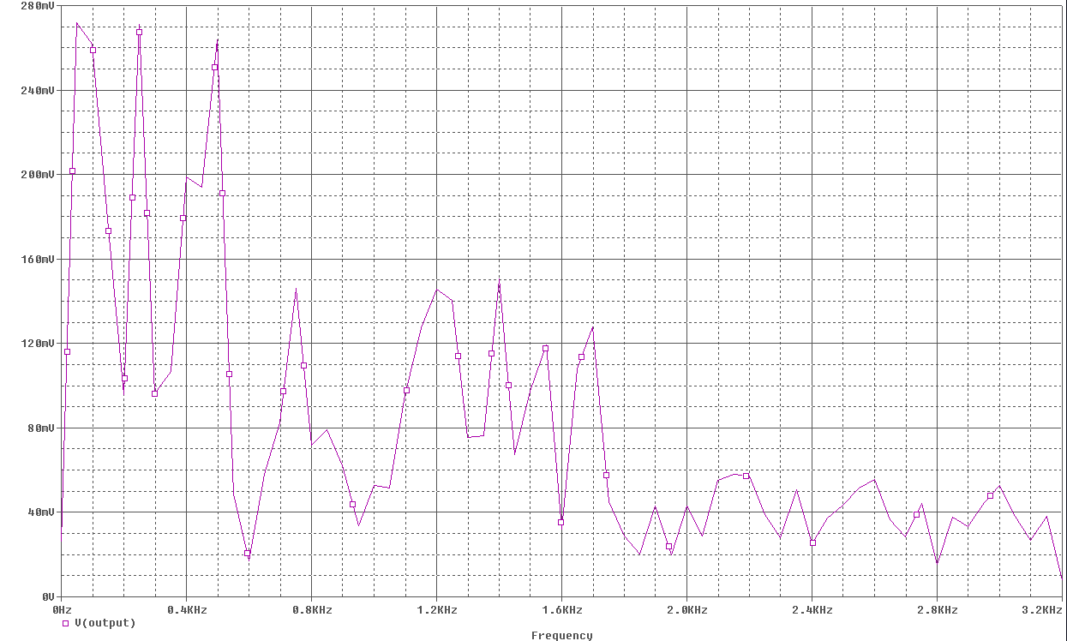
Figure 2b. 400,10000
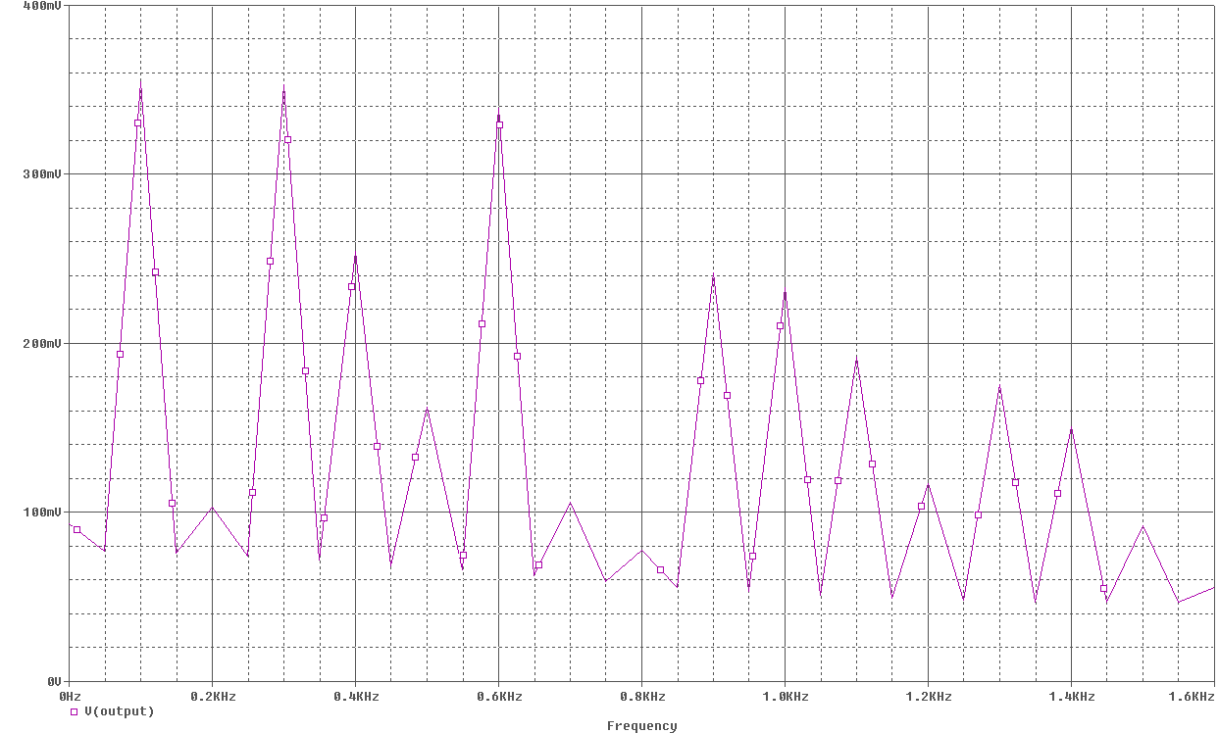
Figure 2b. 100,20000

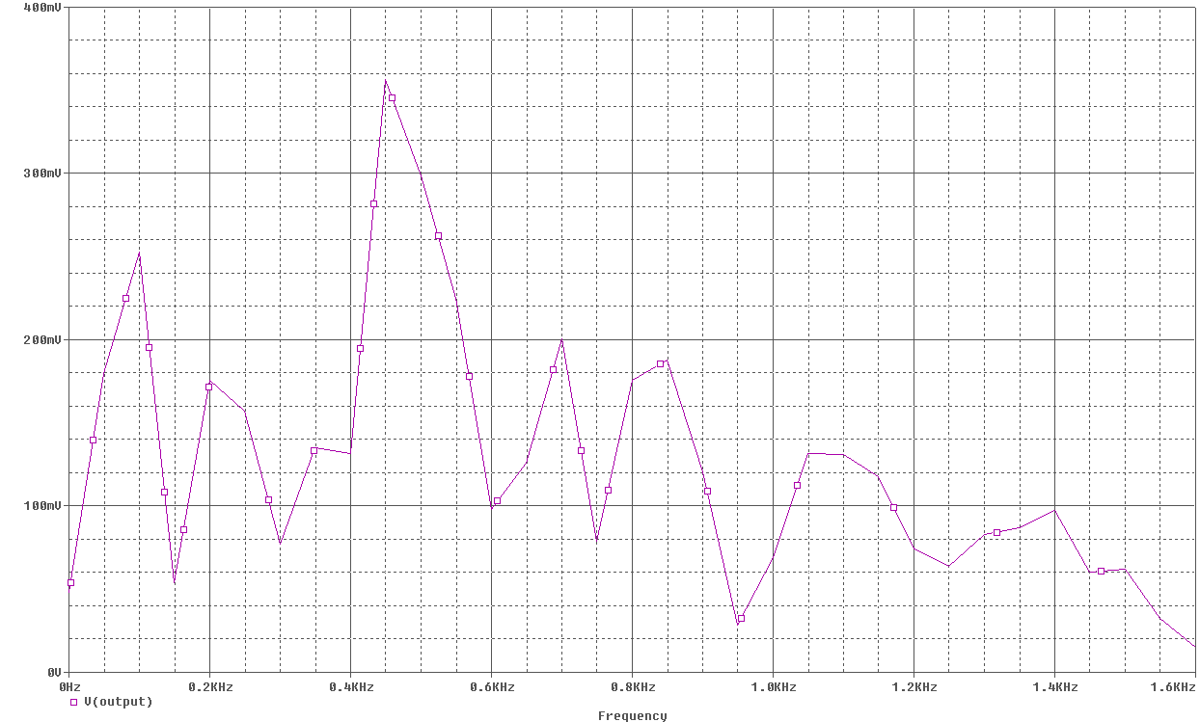
Figure 2b. 200,20000

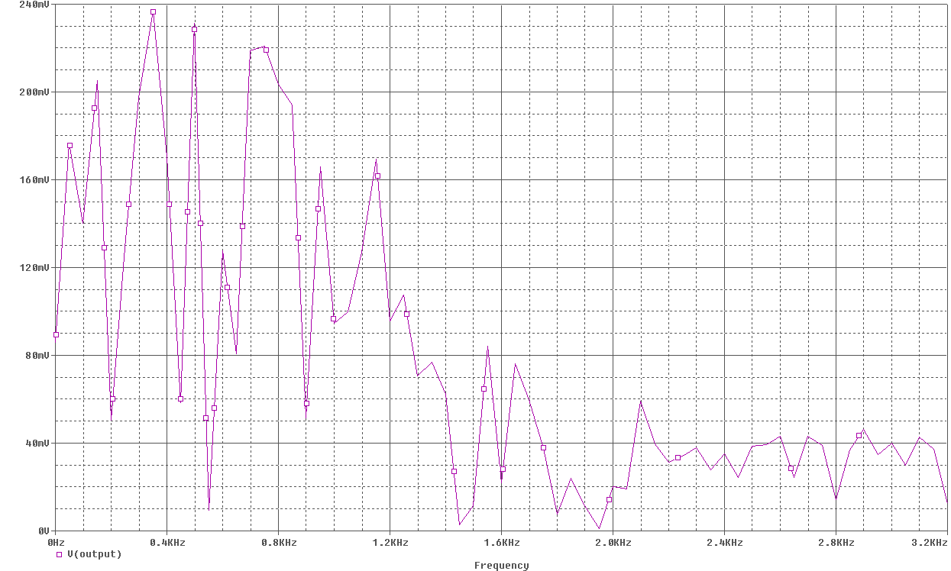
Figure 2b. 400,20000

Conclusion-Part 2

Part 3-Introduction

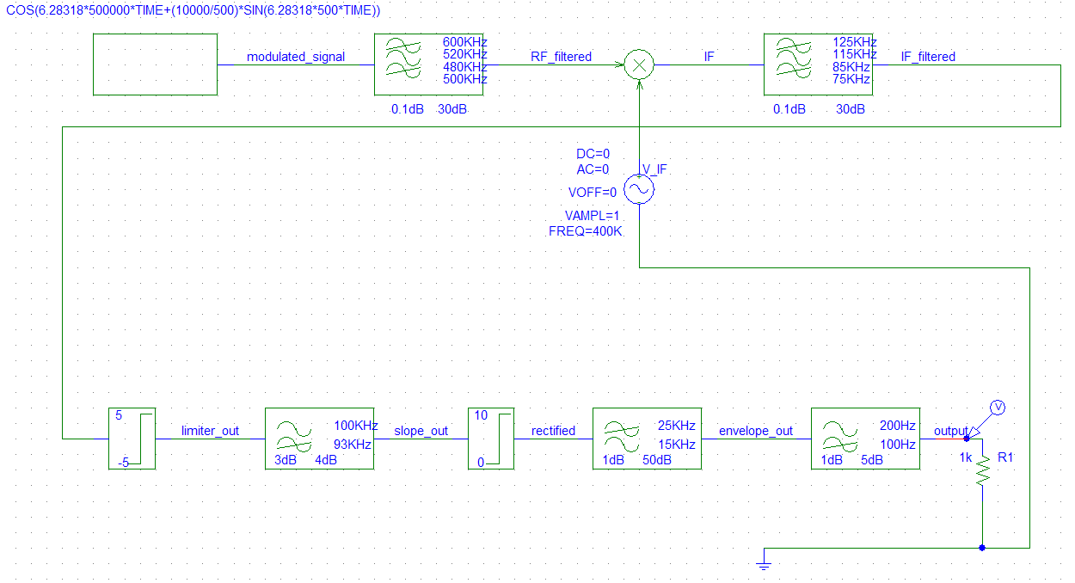

Results-Part 3
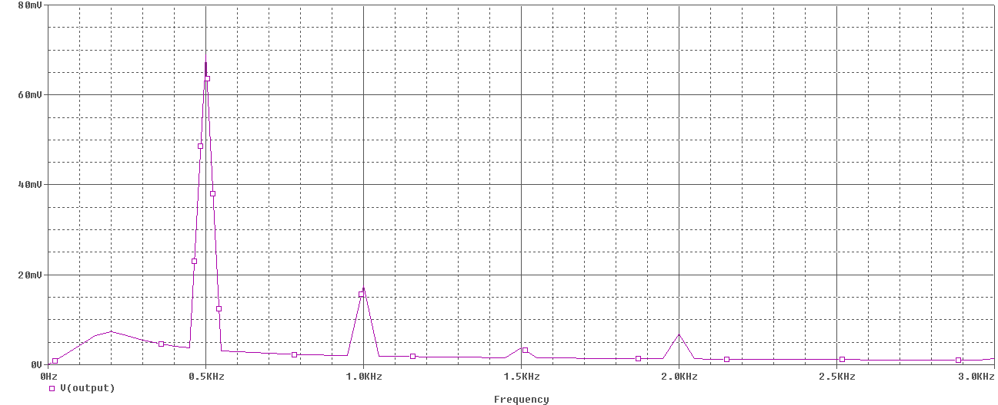
Conclusion-Part 3

Part 4-Introduction
Results-Part 4
Conclusion-Part 4

Conclusion:

This assignment has taught me how to design envelope detection and envelope detection with superheterodyne circuits using Pspice. I looked at the basic operations and how these circuits pass a signal through filters, harmonics, rectifiers and amplifiers. It has shown me how waveforms of envelope detection and envelope detection with superheterodyne circuits would look like under frequency and time domains. I gained experience on how these waveforms will look like with noise and reduced noise once tuning in stations. In addition I have gotten to use Pspice more productively during this assignment. Overall, this assignment is a great introduction to start of Electronic Communications. It has acquainted me to many new concepts.

