Assignment 8:

ECE 450
Electronic Communications
Spring/Summer 2003
7/29/26

Tatha (Tat) Lohachitkul rattatatat@hotmail.com

Honor Code: I have neither given nor received aid in the preparation of this report.

Tatha (Tat) Lohachitkul



Introduction:

We are going to understand the concept of PSK or Phase Shift Keying. Phase Shift keying is a method of transmitting and receiving digital signals in which the phase of a transmitted signal is varied to convey information.
There are several schemes that can be used to accomplish PSK. The simplest method uses only two signal phases: 0 degrees and 180 degrees. The digital signal is broken up time wise into individual bits (binary digits). The state of each bit is determined according to the state of the preceding bit. If the phase of the wave does not change, then the signal state stays the same (low or high). If the phase of the wave changes by 180 degrees (reverses) then the signal state changes (from low to high, or from high to low). Because there are two possible wave phases, this form of PSK is sometimes called biphase modulation or BPSK (Binary Phase Shift Keying). It is a digital frequency modulation technique used for sending data over a coaxial cable network. This type of modulation is less efficient, but also less susceptible to noise, than similar modulation techniques such as QPSK. We will be using BPSK in this assignment.

Below is the figure of the circuit that we will be analyzing.
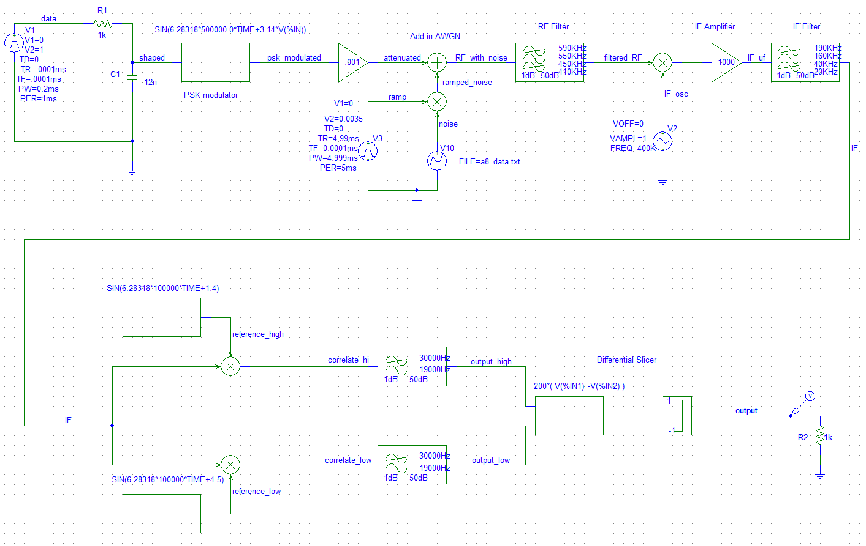
Figure 1a. Design of Superheterodyne BPSK System. A simulated Data Source will be pulse shaped and put through a PSK modulator. The PSK modulated signal will have attenuation due to distance and have noise. Next, the RF signal with noise will be filtered by a RF filter. The filtered RF signal is then put through an IF oscillator, then amplified, and then IF filtered. Then the IF signal will go in two directions to be correlated. The IF signal will be correlated with a signal reference of 1 (or high) and a signal reference of 0 (or low). Once the 2 signals are through the LPFs to smooth the correlation, they are put through a differential slicer to produce the output.

Under phase modulation, the transmitter end, will we be a reference signal. The phase of this reference signal is varied based on the baseband input. In digital signals, under phase modulation, we are varying the input from one extreme to another extreme, so the phase of the output is going from one phase to another phase. In this case, we shift from low to high, or high to low. This can mean we shift 180 degrees. It doesn’t have to be exactly 180 degrees but what is important is that the phase shifts from one value to another (0 to 1, 1to 0).
At the receiver end, their can be a local oscillator that has the same phase as the reference signal (for example a 1) and another with the same phase as the reference ( for example a 0). What we can do is correlate the incoming signal with each of the two references to see what we will get. Then we feed the two output signals to a differential slicer that makes its output a 1 if the input is above a certain threshold and a 0 if it is below it. For example, if the output is a -1V it is equivalent to a logical “0” and if the output is 1V it is equivalent to a logical “1”.

Results:
Next we will take a look at the input and output waveforms of the signals going through parts of the circuit.
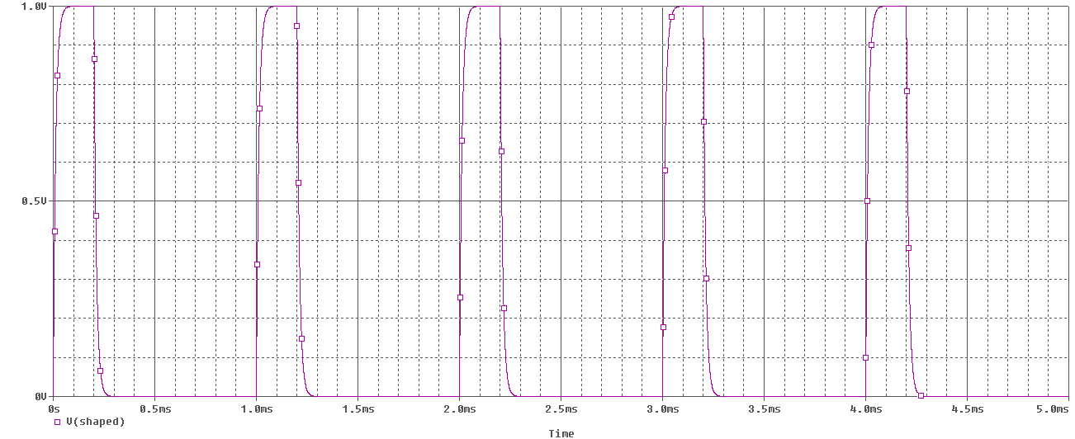
Figure 1b. Input waveform in time domain of the simulated data source. The VPulse part name is used for the simulated data source with attributes: V1=0, V2=1, TD=0, TR=0.0001ms, TF=0.0001ms, PW=0.2ms, PER=1ms.

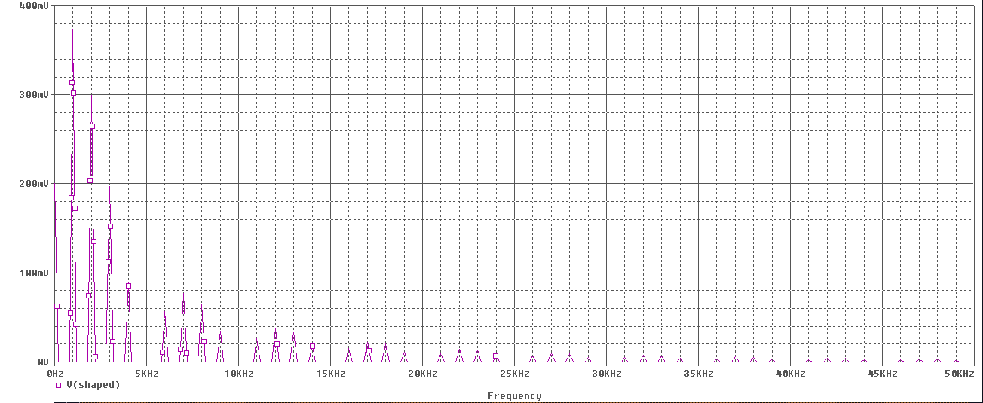
Figure 1c. Input waveform in frequency domain of the simulated data source. Here you can see the waveform’s voltage decrease as frequency increases.
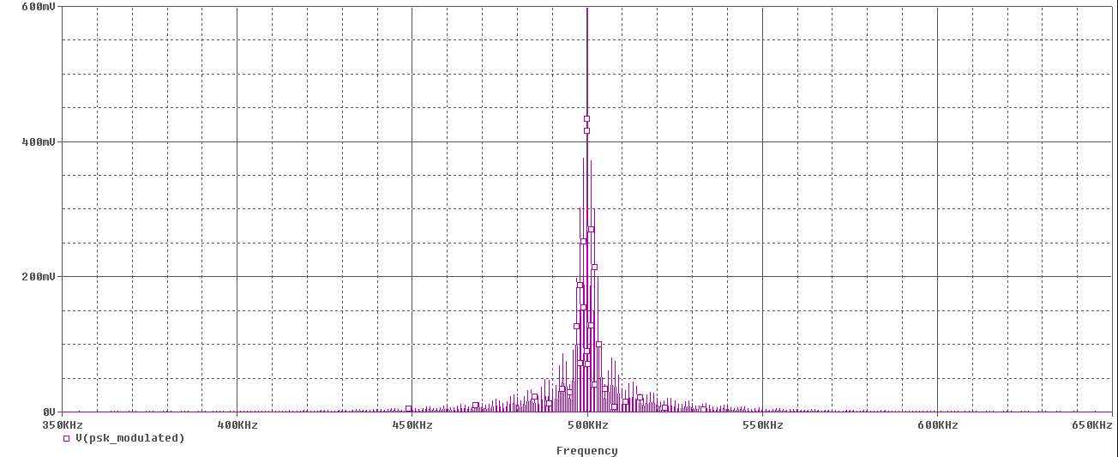
Figure 1d. Output waveform in frequency domain after the signal goes through the PSK modulator which I used ABM part name for. I predicted to see a center frequency of 500Khz from fc being 500000 in the equation of the PSK modulator.

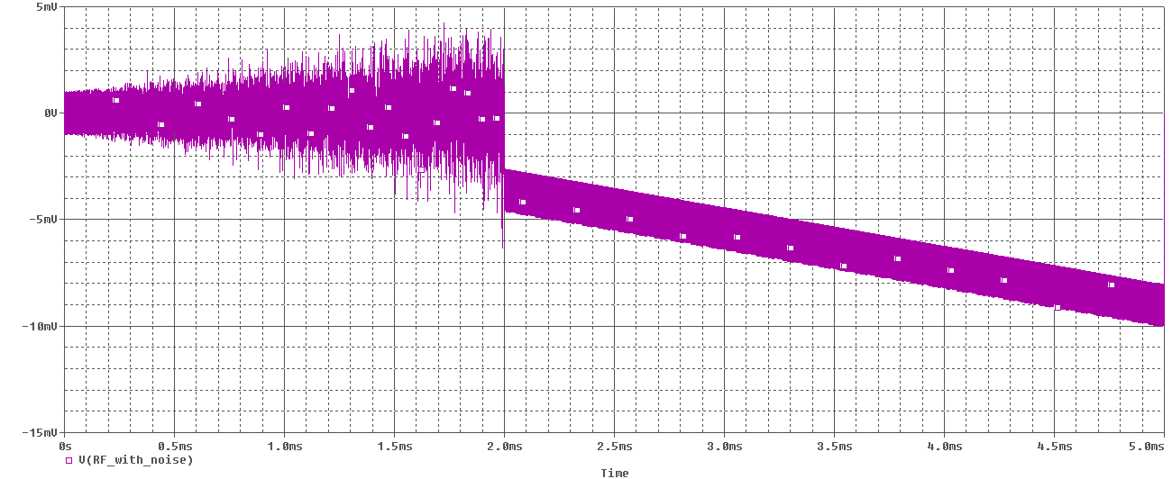
Figure 1e. The RF signal with noise in frequency domain after the signal meets with noise by adding in AWGN. Here it looks like the waveform started constantly increasing voltage on both positive and negative sides, but at 2ms the waveform just quit and just keeps drop into the negative region of voltage as time went by.

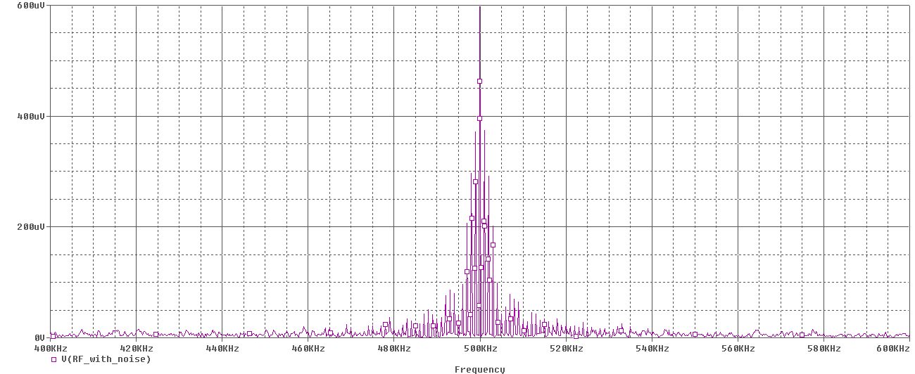
Figure 1f. The RF signal with noise in frequency domain after the signal meets with noise by adding AWGN. We can see here that the center frequency is still at 500Khz
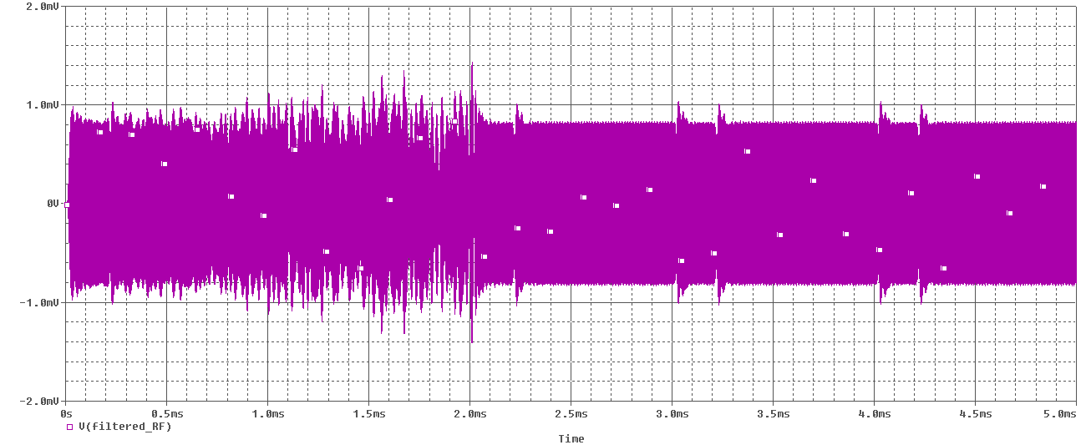
Figure 1g. RF filtered waveform in time domain. Here you can see the waveform averages right between about 1mV and 1mV as time increases. At 2ms the waveform’s edges seems to be smooth at after going through the RF filter which is by using a Band Pass Filter.

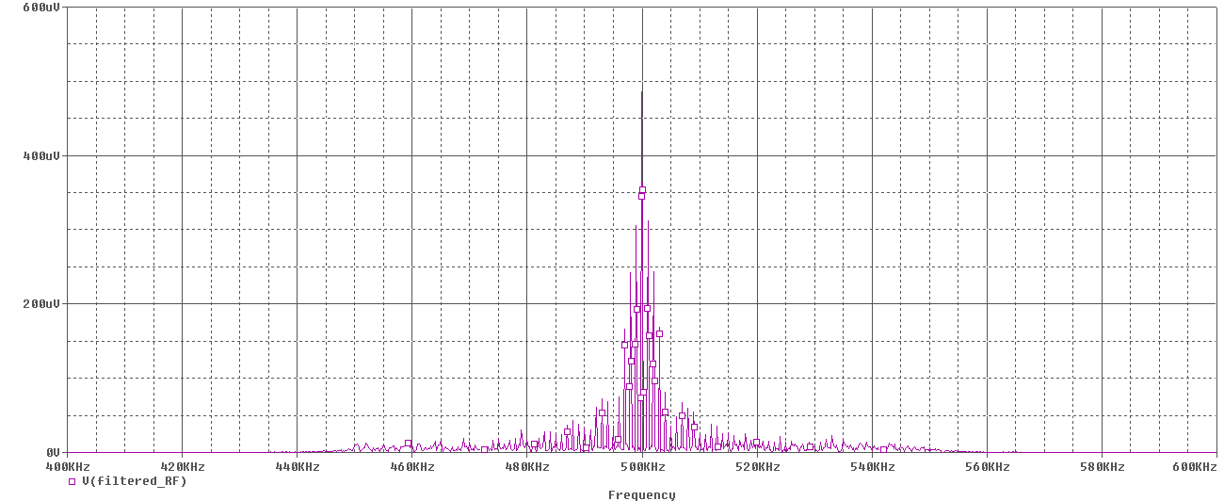
Figure 1h. The RF filtered waveform in frequency domain after going through the RF filter which is by using a Band Pass Filter. We can see here that the center frequency is still at 500Khz.

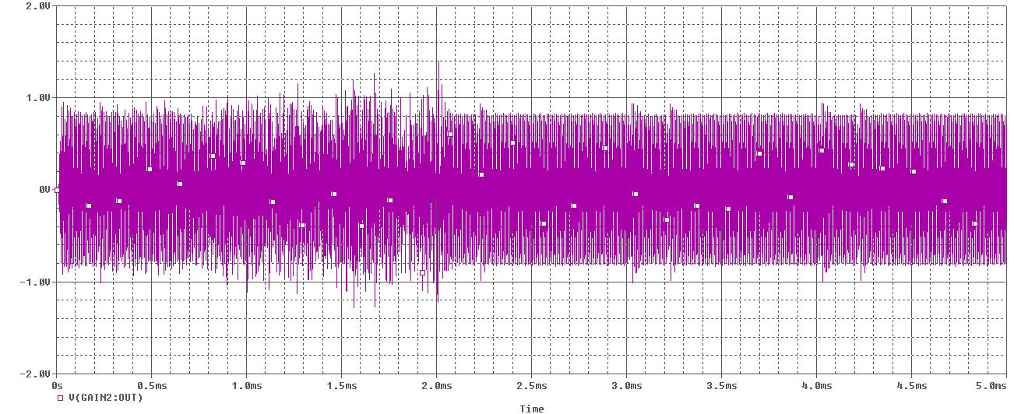Figure 1i. RF filtered waveform in time domain after being amplified. Here you can see the waveform averages right between about 1mV and 1mV as time increases also. At 2ms the waveform’s edges seems to be smooth at after going through the RF filter which is by using a Band Pass Filter.
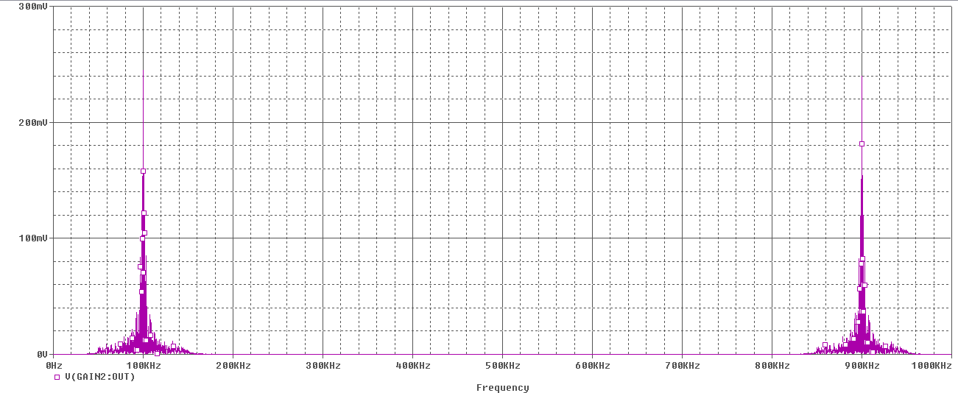
Figure 1j. The RF filtered waveform in frequency domain after being amplified. It seems like there are two frequency components here. One at 100Khz and the other at 900KHz from going through the IF oscillator with amplitude of 1 and frequency of 400KHz.

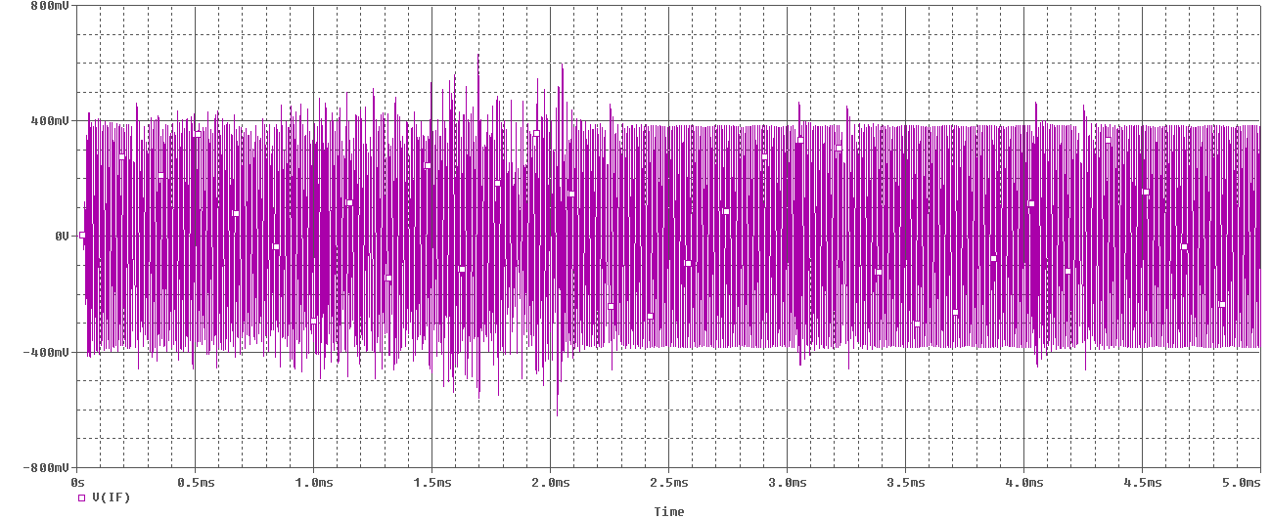
Figure 1k. IF signal after it is filtered in time domain. Here you can see the waveform averages right between about 1mV and 1mV as time increases also. At 2ms the waveform’s edges seems to be smooth at after going through the IF filter which is by using a Band Pass Filter.

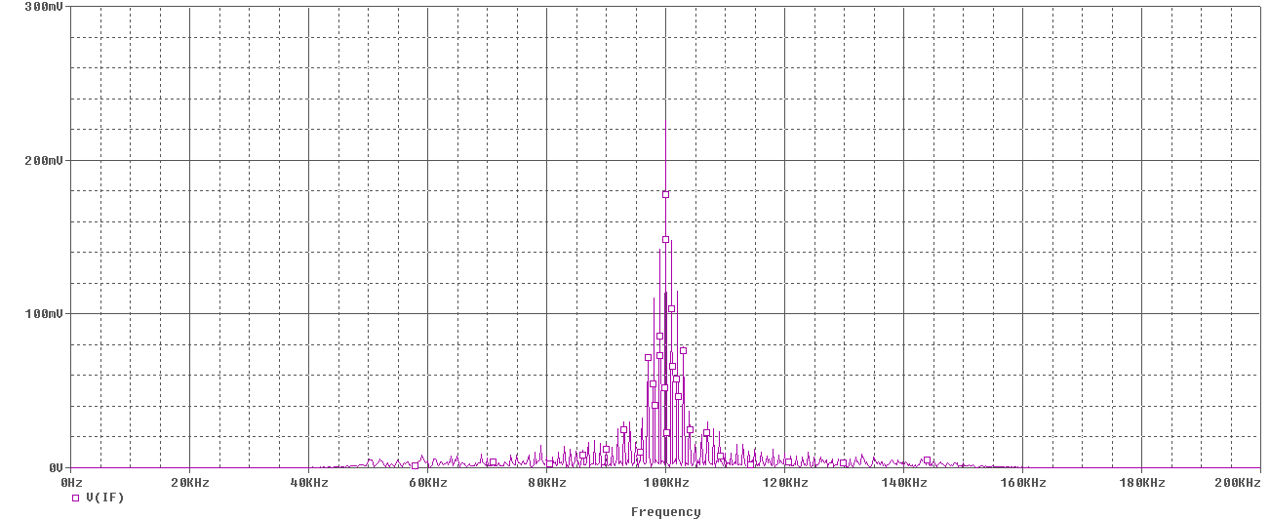
Figure 1l. The IF filtered waveform in frequency domain after going through the IF filter which is by using a Band Pass Filter. We can see here that the center frequency is still at 100Khz.
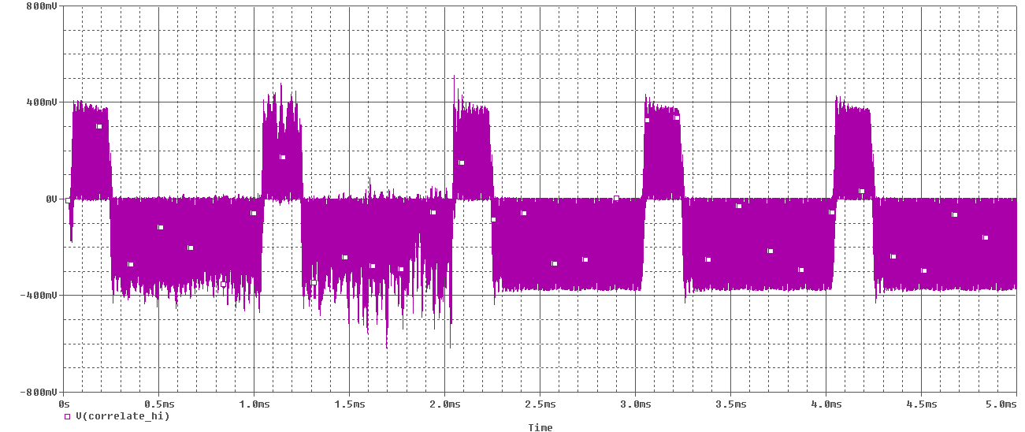
Figure 1m. IF signal waveform correlated with high reference signal in time domain. The IF filtered signal will be incoming and correlated with each of 2 reference signals, here it is with reference signal high (or 1). You can see the waveform ranges between 400mV and -400mV as time increases.
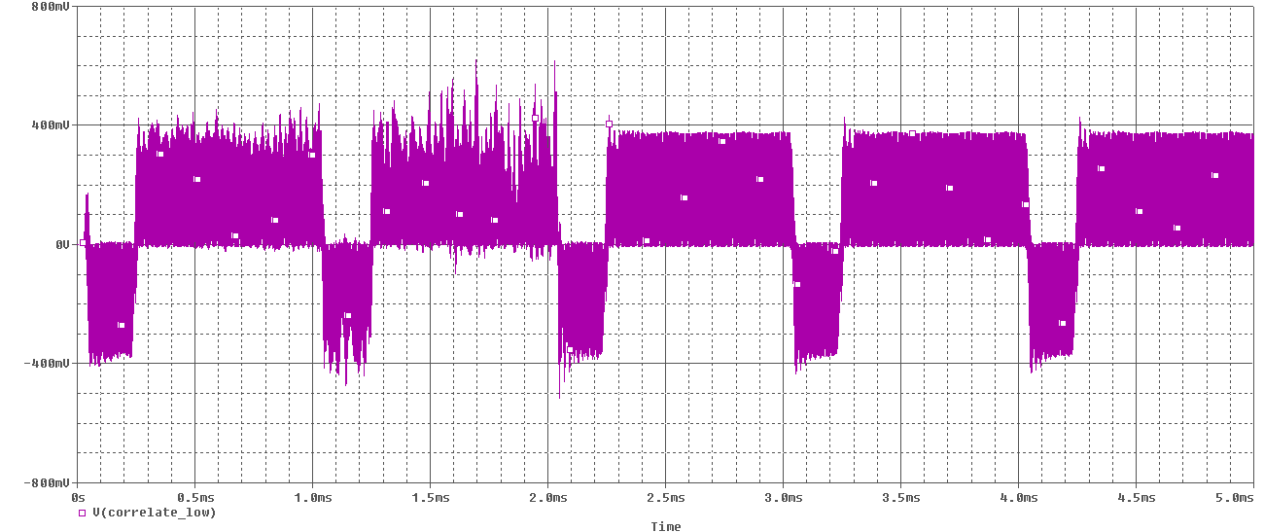
Figure 1n. IF signal waveform correlated with low reference signal in time domain. The IF filtered signal will be incoming and correlated with each of 2 reference signals, here it is with reference signal low (or 0). You can see the waveform ranges between 400mV and -400mV as time increases. You can see hear that the waveform is the reverse of the waveform found when the incoming signal correlated with reference high. This is where you can see the BPSK happening which is normally 180 degrees apart.

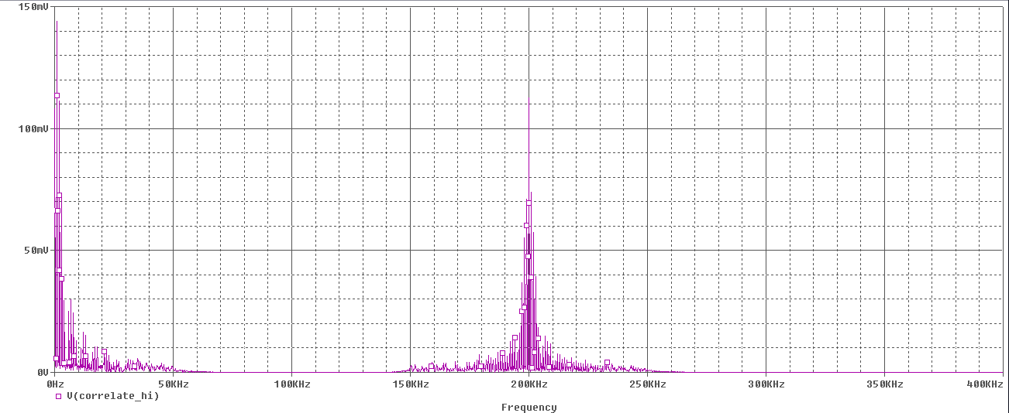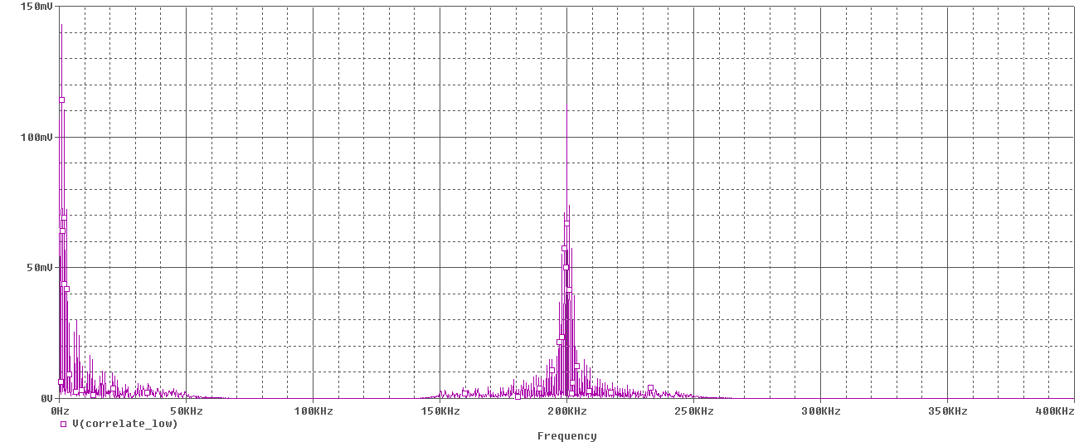
Figure 1o. IF signal waveform correlated with high reference signal in frequency domain on the left. IF signal waveform correlated with low reference signal in frequency domain on the right. They both have frequency components at near 1HZ and 200Hz.

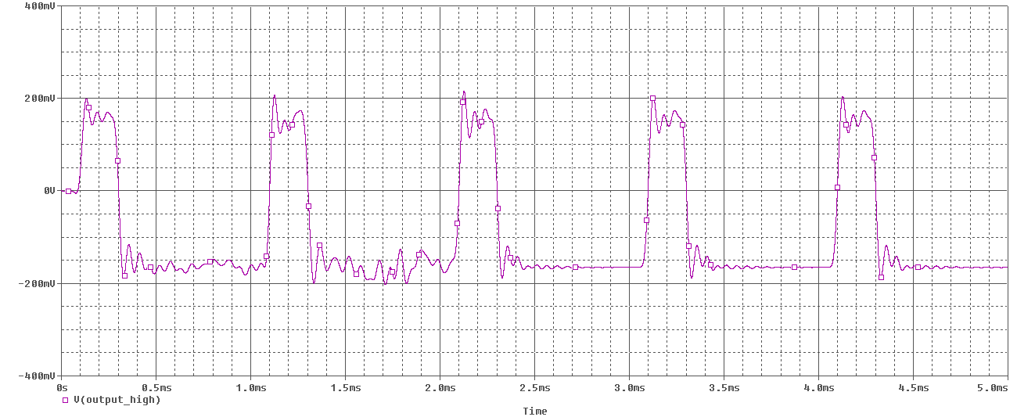
Figure 1p. Output waveform in time domain of the high reference signal and IF incoming signal after going through the Low Pass Filter. You can see the waveform ranges between 200mV and -200mV as time increases.

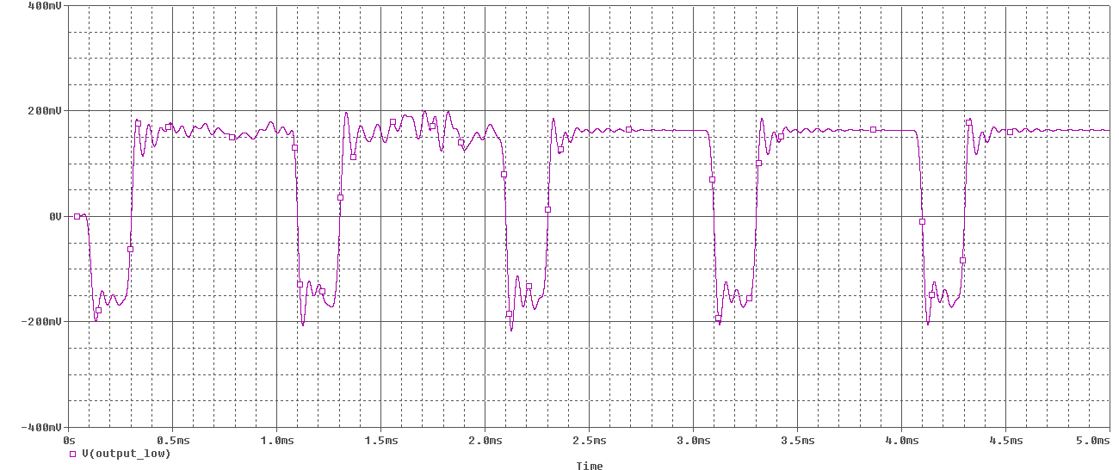
Figure 1q. Output waveform in time domain of the low reference signal and IF incoming signal after going trough the Low Pass Filter. You can see the waveform ranges between 200mV and -200mV as time increases. Here the waveform is the reversal of the pervious figure because this the incoming signal is correlated with the low reference signal. Here you can see BPSK again which is normally 180 degrees apart.

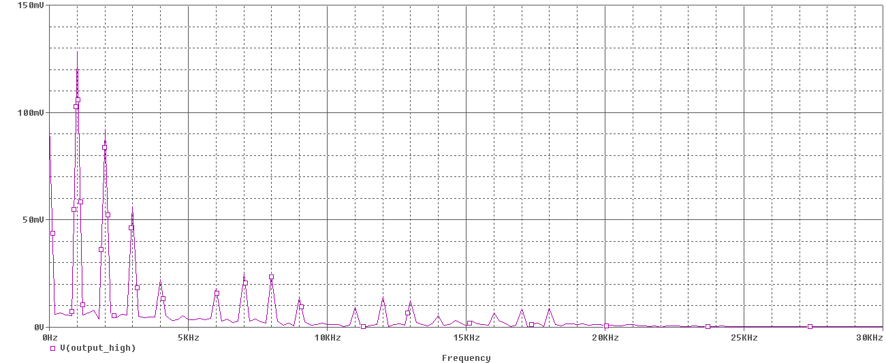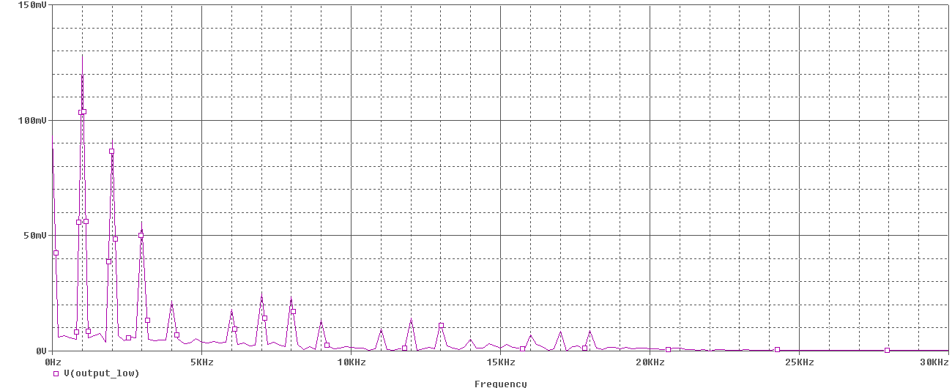
Figure 1r. Output waveform in frequency down of high reference signal after LPF on the left. Output waveform in frequency down of low reference signal after LPF on the right. The voltages of both have frequency components that decrease as time increases and dies out after 20KHz.

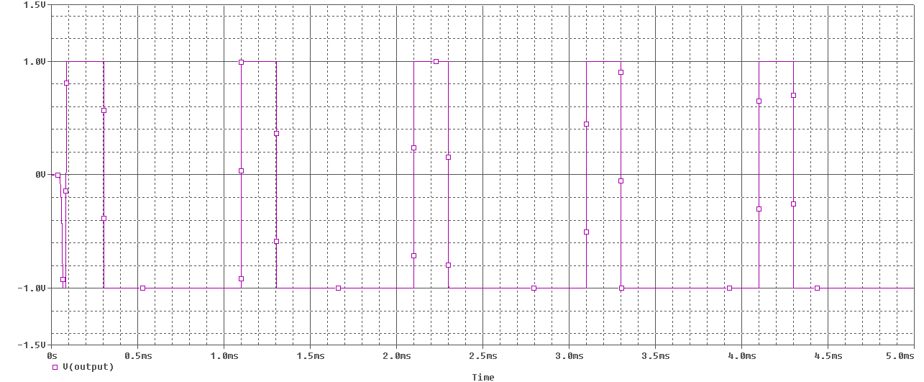
Figure 1s. Output waveform in time domain of the Superheterodyne BPSK System after the outputs from the two correlations go through the differential slicer. What the slicer does is make a decision if the input to the slicer represents a “1” or “0”, in our case, high or low. Here the slicer makes its output a 1 if it is above the threshold and a 0 below it. Here were ever the waveform is at 1V it is equivalent to a logical “1” and “0” if at -1V.
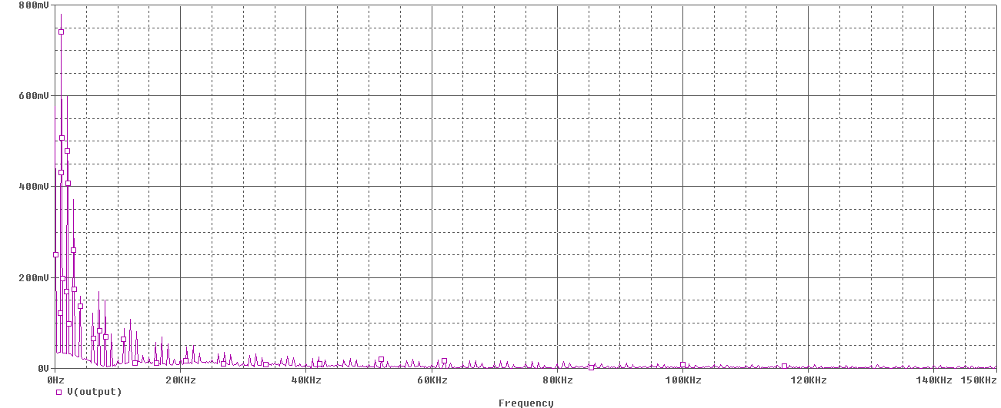
Figure 1t. Output waveform in time domain of the Superheterodyne BPSK System after the outputs from the two correlations go through the differential slicer. Here you can see the waveform’s voltage decrease as frequency increases.

Conclusion:
From the results you can see that comparing the sameness (or difference) of two signals can help you see changes and patterns better. This will increase the pace of understanding signals, which is why correlation plays an important concept. The results show us a great example of what Binary Phase Shifty Keying is like. Binary phase-shift keying is phase-shift keying (PSK) between two phase states, normally 180 degrees apart which we did see in the results of this assignment. There are only two valid states that the system can be in, a 1 and a 0. We definitely saw this with using a differential slicer to give us our desired output.
I’ve have learned a lot from this assignment. It has made the part of the class very simple to understand from seeing how correlation helps us analyze signals. So far I think this assignment has been the easiest to understand, which brings my confidence up a lot in understanding these new concepts. Overall, this assignment is a great introduction to start of Electronic Communications.

