Assignment 7:

ECE 450
Electronic Communications
Spring/Summer 2003
7/31/26

Tatha (Tat) Lohachitkul rattatatat@hotmail.com

Honor Code: I have neither given nor received aid in the preparation of this report.

Tatha (Tat) Lohachitkul



Introduction:

In this assignment we are going to understand the concept of correlation. Correlation is used a lot in digital communications and can be found in demodulators. It is used to determine if some signal is similar to another. We will be looking at a reference signal which will be compared to many other signals in this assignment. Below is the figure of the circuit that we will be analyzing.
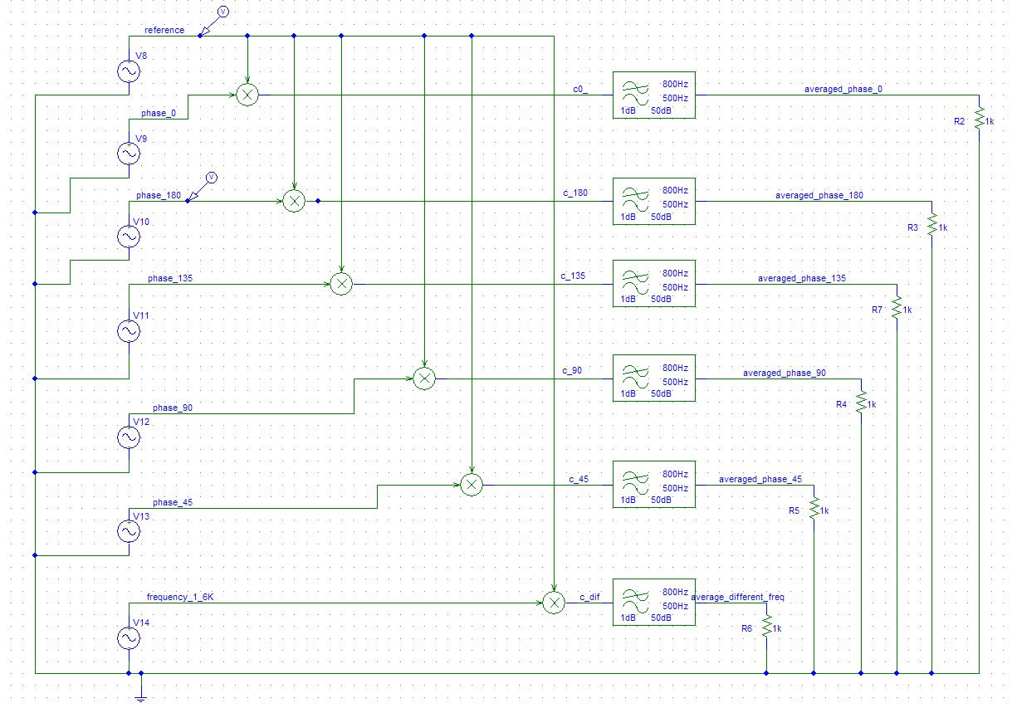
Figure 1a. Design of Correlation in action. There is a reference signal which will be correlated individually with other signals. The other signals will have phase of 0, 180, 135, 90, and 45 from top to bottom. The last signal will have a different frequency of 1.6K and phase of 0. The correlators are the multiplier/LPF pairs. The outputs show the level of correlation between the reference signal and the signal that it is being compared to.

In a simpler description, correlation is the multiplication of two signals together and the local averaging of the result to determine the signal’s similarity in the recent time frame. Here are some examples: If two signals were exactly the same with identical frequencies, amplitudes, and phases and was passed thorough a low pass filter you will get a positive DC signal. If the two signals were 180 degrees out of phase and pass through a low pass filter, you would get a negative DC signal. If the two signals were 90 degrees out of phase and passed through a low pass filter you would get 0 volts DC signal.

Results:
Next we will take a look at the input and output waveforms of the reference and other signals. Note, In order to compute the degree phase shift I used the equation TD * 360 = degree phase shift. Example the 2nd signal of TD = 0.5ms * 360 = 180 degrees phase shift.

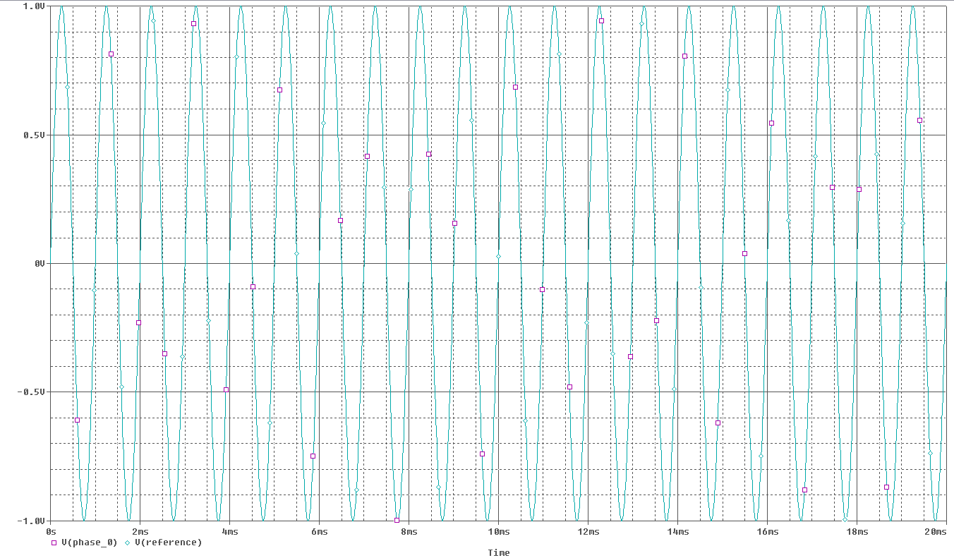
Figure 1b. Input waveform in time domain of the reference signal and the 2nd signal. The reference signal has a frequency of 1KHz and TD of 0. The 2nd signal has a frequency of 1KHz and also a TD value of 0ms. So you can see that the signals are in phase with the same frequencies, amplitudes, and phases. I am predicting that the output will be a positive DC signal after going through the Low Pass Filter.

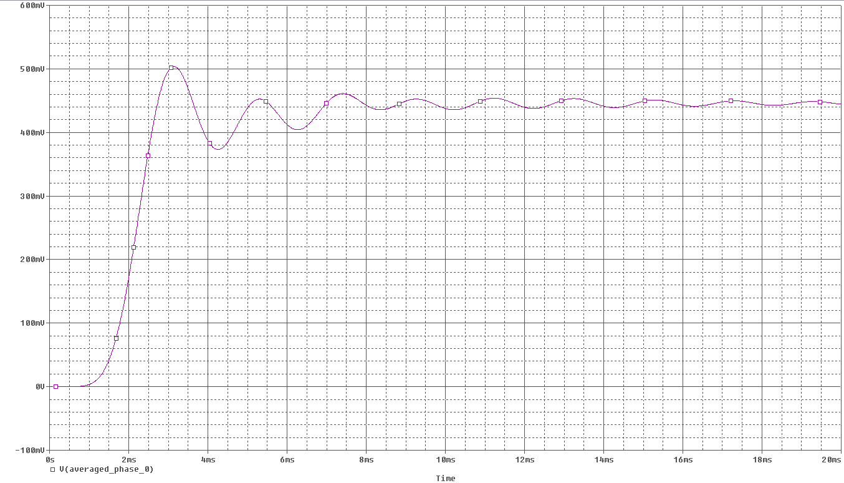
Figure 1c. Output waveform in time domain of the reference signal and the 2nd signal. The reference signal has a frequency of 1KHz and TD of 0. The 2nd signal has a frequency of 1KHz and also a TD value of 0. So you can see that the signals are in phase with the same frequencies, amplitudes, and phases. The waveform was predicted to be a positive DC signal. Here the signal averages to be about 450mV.

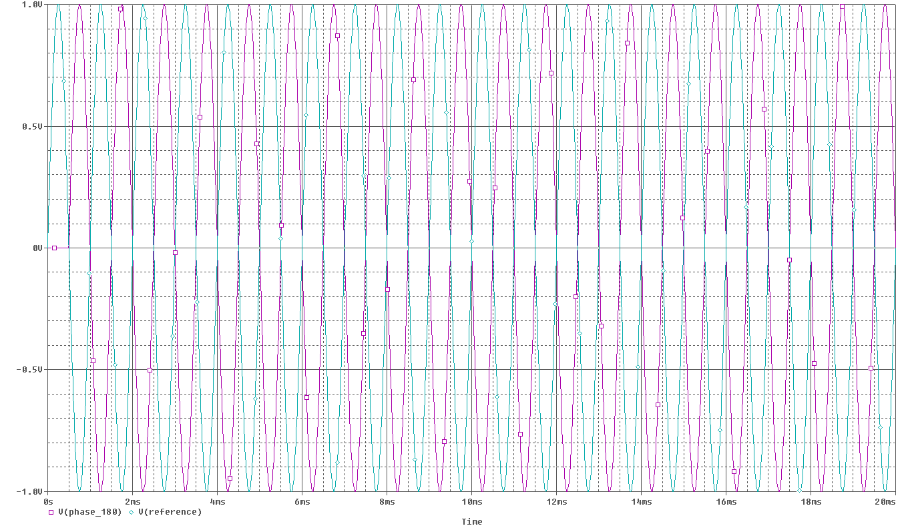
Figure 1d. Input waveform in time domain of the reference signal and the 3rd signal. The reference signal has a frequency of 1KHz and TD of 0. The 3rd signal has a frequency of 1KHz and a TD value of 0.5ms. So you can see that the signals are 180 degrees out of phase but with the same frequencies and amplitudes. I am predicting that the output will be a negative DC signal after going through the Low Pass Filter.

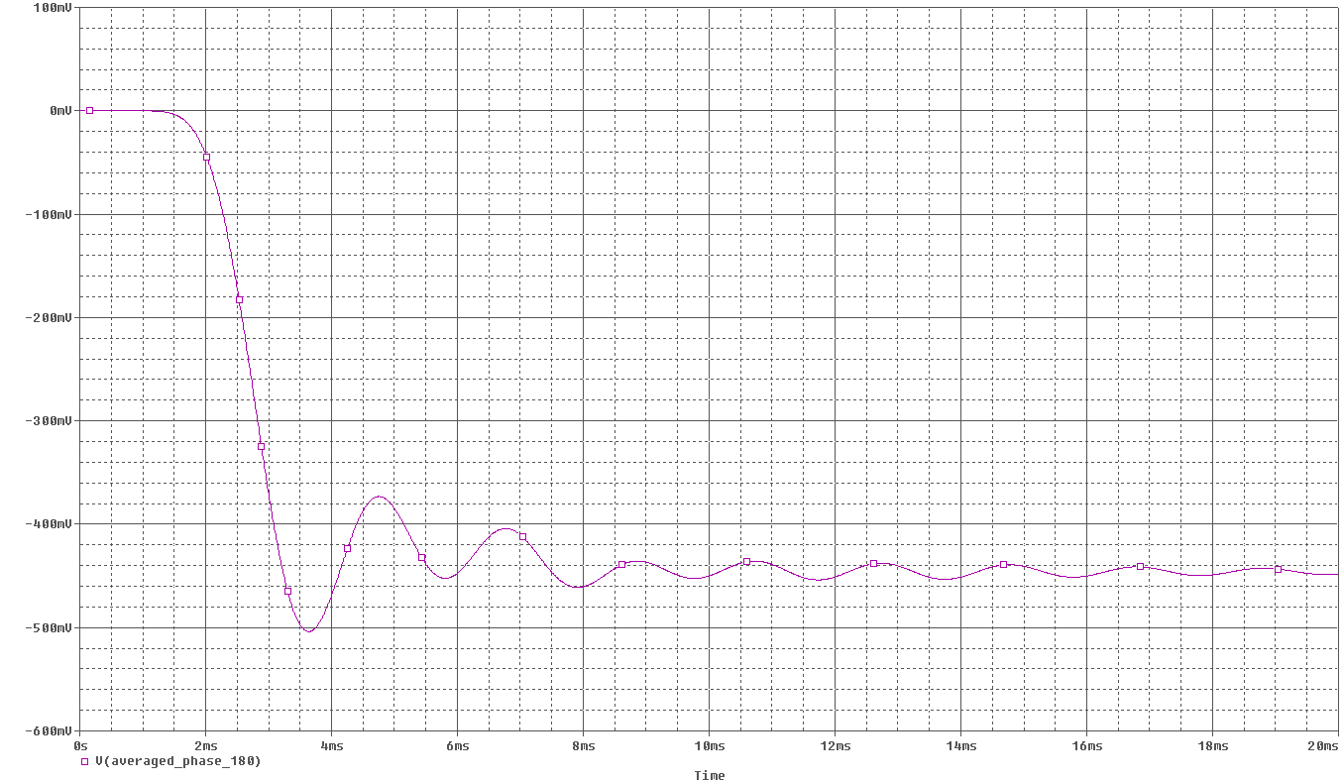
Figure 1e. Output waveform in time domain of the reference signal and the 3rd signal. The reference signal has a frequency of 1KHz and TD of 0. The 3rd signal has a frequency of 1KHz and also a TD value of 0. So you can see that the signals are 180 degrees out of phase and with the same frequencies and amplitudes. The waveform was predicted to be a negative DC signal. Here the signal averages to be about -450mV.

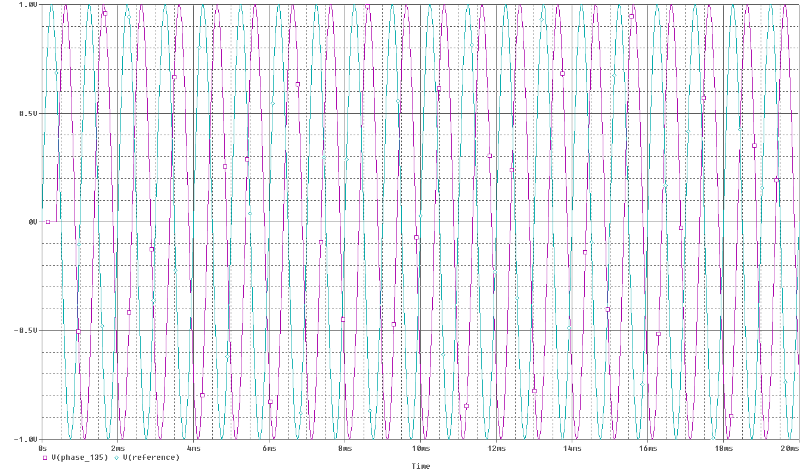
Figure 1f. Input waveform in time domain of the reference signal and the 4th signal. The reference signal has a frequency of 1KHz and TD of 0. The 4th signal has a frequency of 1KHz and a TD value of 0.375ms. So you can see that the signals are 135 degrees out of phase but with the same frequencies and amplitudes. I am predicting that the output will be a negative DC signal and a smaller value after going through the Low Pass Filter.

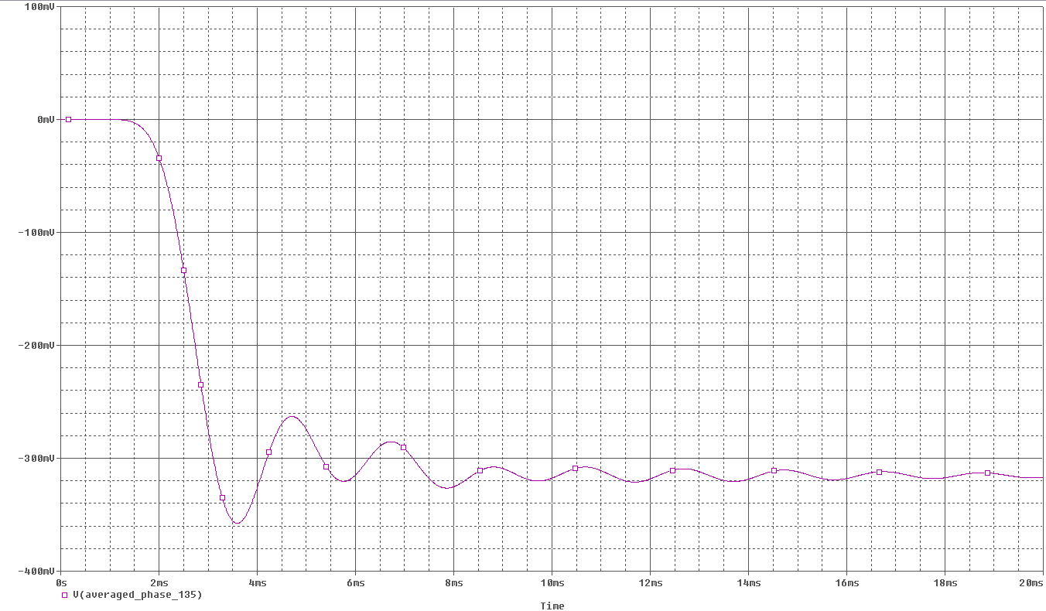
Figure 1g. Output waveform in time domain of the reference signal and the 4th signal. The reference signal has a frequency of 1KHz and TD of 0. The 4th signal has a frequency of 1KHz and also a TD value of 0.375ms. So you can see that the signals are 180 degrees out of phase and with the same frequencies and amplitudes. The waveform was predicted to be a negative DC signal with a smaller value. Here the signal averages to be about -325mV.

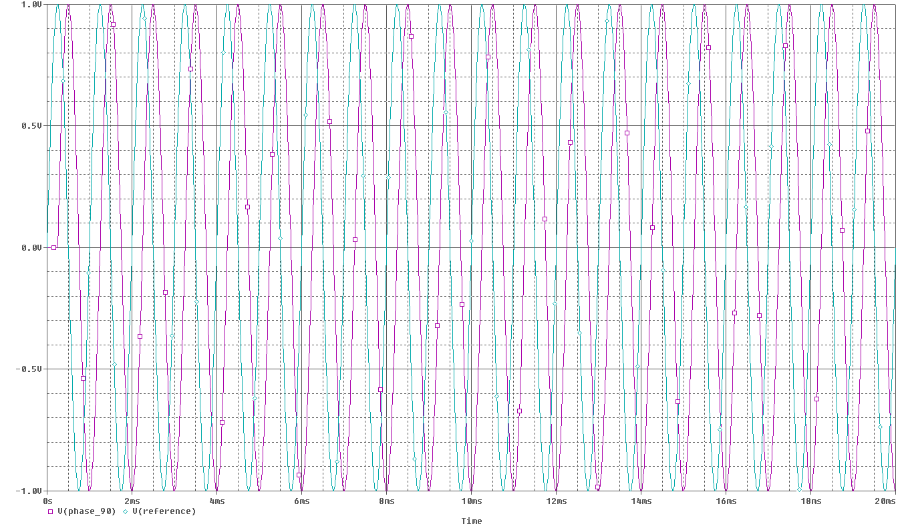
Figure 1h. Input waveform in time domain of the reference signal and the 5th signal. The reference signal has a frequency of 1KHz and TD of 0. The 5th signal has a frequency of 1KHz and a TD value of 0.25ms. So you can see that the signals are 90 degrees out of phase but with the same frequencies and amplitudes. I am predicting that the output will zero DC signal of value 0V after going through the Low Pass Filter.

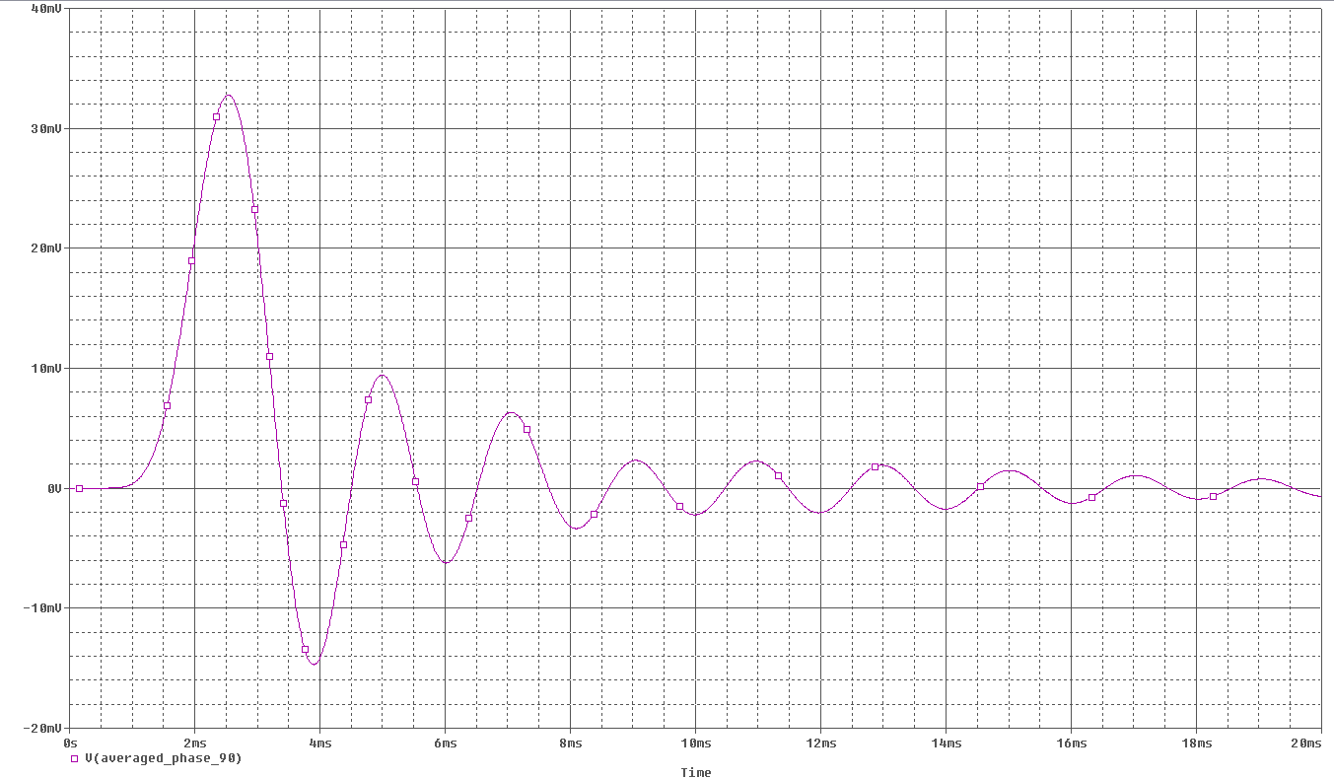
Figure 1i. Output waveform in time domain of the reference signal and the 5th signal. The reference signal has a frequency of 1KHz and TD of 0. The 5th signal has a frequency of 1KHz and also a TD value of 0.25ms. So you can see that the signals are 90 degrees out of phase and with the same frequencies and amplitudes. The waveform was predicted to be a zero DC signal of value 0V. Here the signal averages to be about 0V.

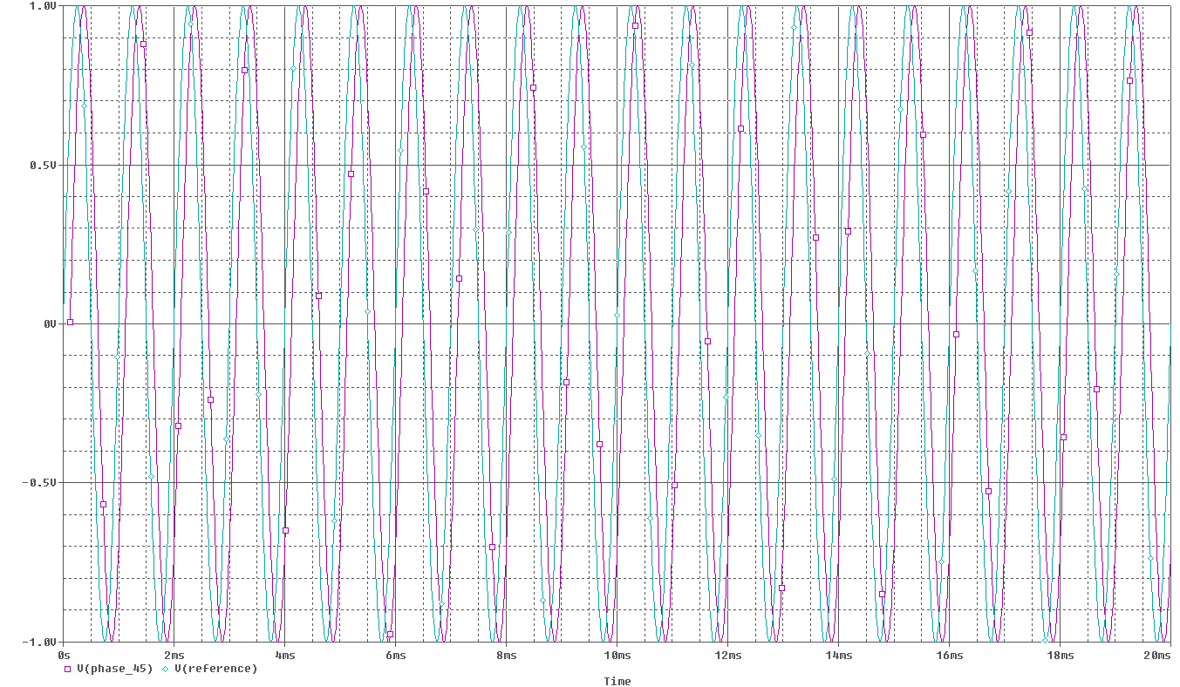
Figure 1j. Input waveform in time domain of the reference signal and the 6th signal. The reference signal has a frequency of 1KHz and TD of 0. The 6th signal has a frequency of 1KHz and a TD value of 0.125ms. So you can see that the signals are 45 degrees out of phase but with the same frequencies and amplitudes. I am predicting that the output will a positive DC signal with a smaller value from the waveform of the 2nd signal after going through the Low Pass Filter.

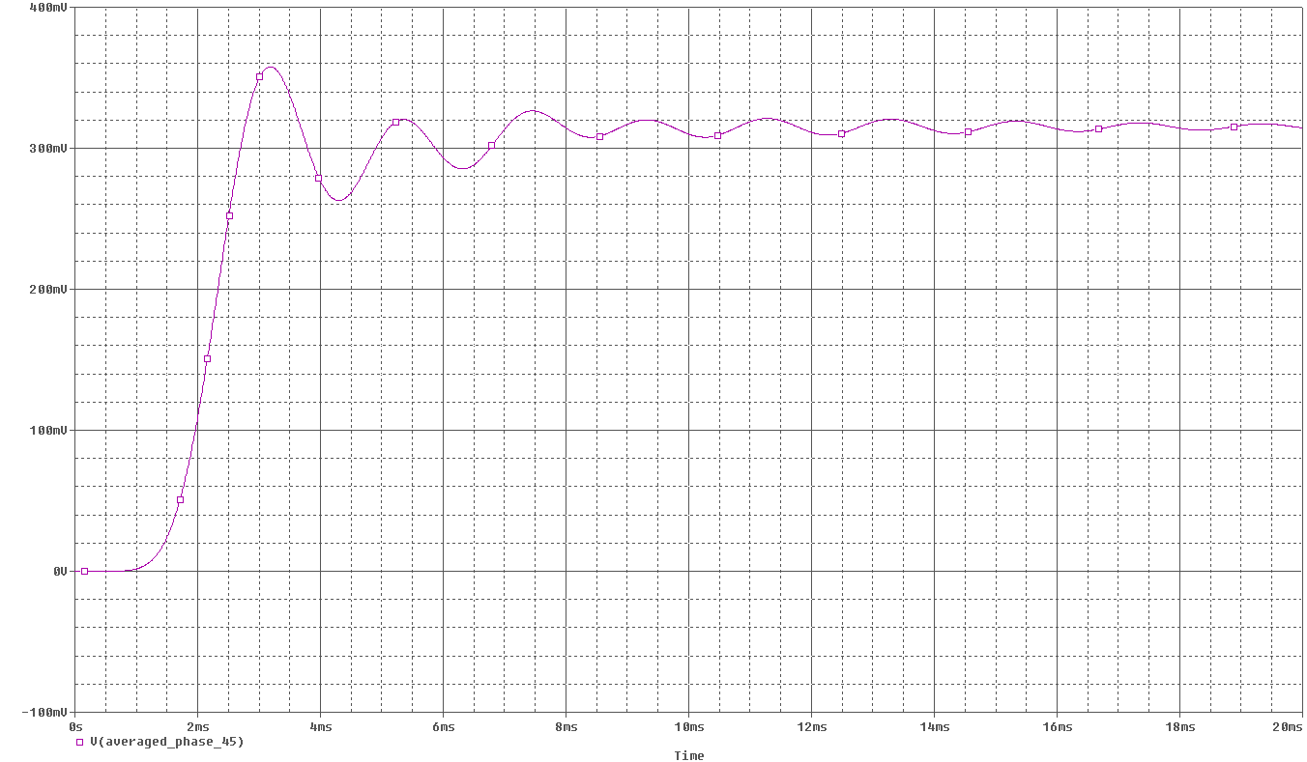
Figure 1k. Output waveform in time domain of the reference signal and the 6th signal. The reference signal has a frequency of 1KHz and TD of 0. The 6th signal has a frequency of 1KHz and also a TD value of 0.375ms. So you can see that the signals are 180 degrees out of phase and with the same frequencies and amplitudes. The waveform was predicted to be a negative DC signal with a smaller value than the output of the 2nd signal. Here the signal averages to be about 325mV.

The next graphs will be of the reference signal and the 7th signal. The 7th signal will have the same attributes but only with a different frequency of 1.6KHz.
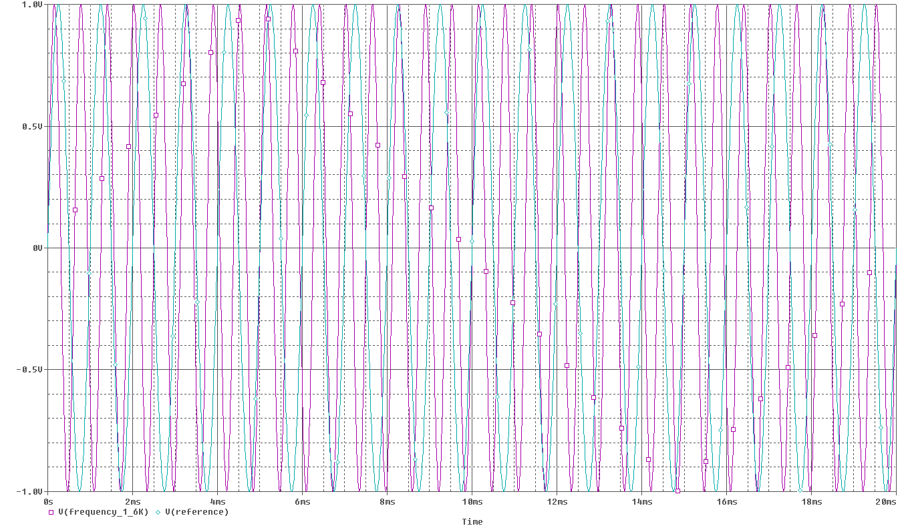
Figure 1l. Input waveform in time domain of the reference signal and the 7th signal. The reference signal has a frequency of 1KHz and TD of 0. The 7th signal has a frequency of 1.6KHz and also a TD value of 0ms. So you can see that the signals not exactly in phase and with the different frequencies. I am predicting that the output will be a positive DC signal after going through the Low Pass Filter.

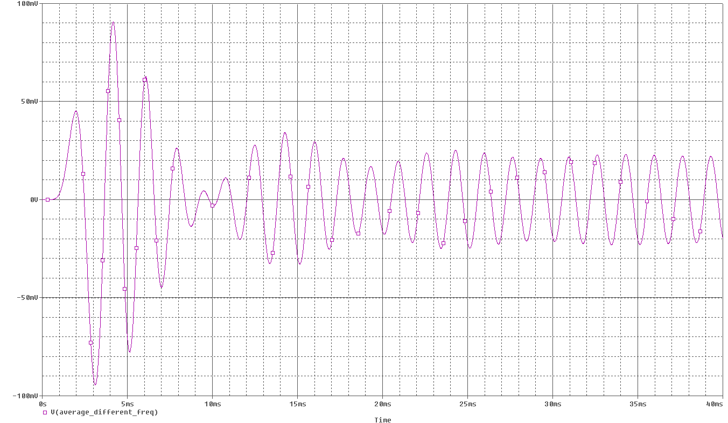
Figure 1m. Output waveform in time domain of the reference signal and the 7th signal. The reference signal has a frequency of 1KHz and TD of 0. The 7th signal has a frequency of 1.6KHz and also a TD value of 0. The waveform was predicted to be a positive DC signal, which was wrong. Here the signal averages to be about between 25mV and -25mV.

Let’s try increasing and decreasing the frequency of the 7th signal and see what happens.
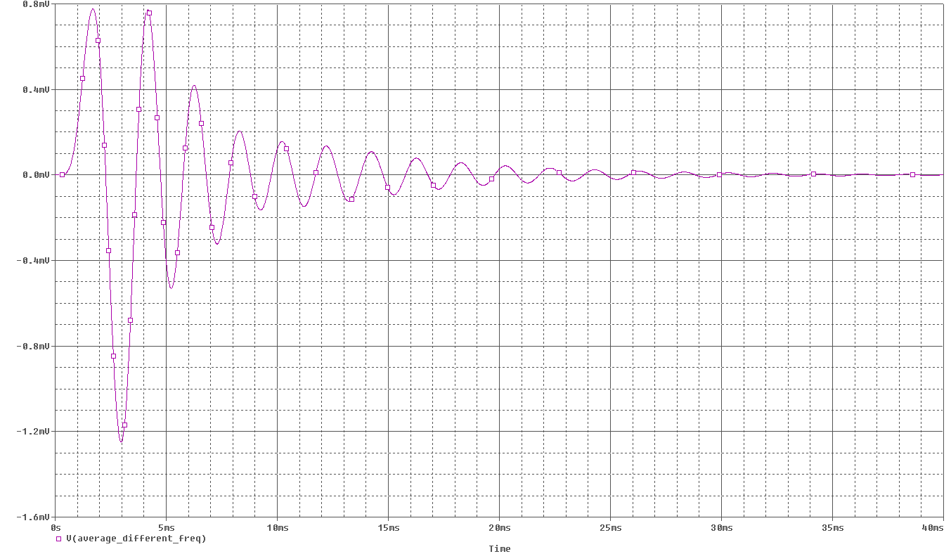
Figure 1n. Output waveform in time domain of the reference signal and the 7th signal. The reference signal has a frequency of 1KHz and TD of 0. The 7th signal has a frequency of 4KHz and also a TD value of 0. The waveform was predicted to be a positive DC signal, which was wrong. Here the signal averages to be 0V.

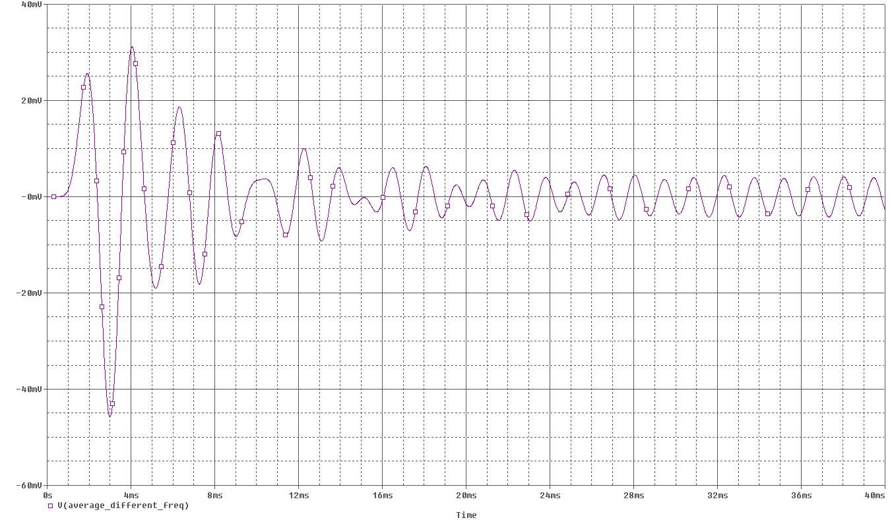
Figure 1o. Output waveform in time domain of the reference signal and the 7th signal. The reference signal has a frequency of 1KHz and TD of 0. The 7th signal has a frequency of 0.3KHz and also a TD value of 0. The waveform was predicted to be a positive DC signal, which was wrong. Here the signal averages to be about between 5mV and -5mV.

Conclusion:

From the results you can see that comparing the sameness (or difference) of two signals can help you see changes and patterns better. This will increase the pace of understanding signals, which is why correlation plays an important concept. The results show us that two signals with the same frequency and with different phase angles will result in a positive, negative, or zero DC signal after passing the signal through a low pass filter that will average the correlation result. As for two signals with different frequencies with the same phases, it seems like the average DC signals comes out to be 0V.
I’ve have learned a lot from this assignment. It has made the part of the class very simple to understand from seeing how correlation helps us analyze signals. So far I think this assignment has been the easiest to understand, which brings my confidence up a lot in understanding these new concepts. Overall, this assignment is a great introduction to start of Electronic Communications.

