Assignment 1: Introduction to fast Fourier transforms and modeling of white noise



ECE 450
Professor: Larry Sieh
Term: Fall 03’

Prepared by:

Brandon Harris
Vladi Gergov

I have neither given nor received aid in the preparation of this report:

_________________________________________________

_________________________________________________

Procedure and Results of Part 1:

The first objective of part 1 was to generate a square wave and a pulse train output by using the summation of sine waves using Orcad. The second objective was to use Orcad to convert the output signal to the frequency domain, by using the function in Orcad called “FFT,” which means fast Fourier transform.

The theory behind this part of the lab is that any periodic signal can be represented by the summation of sines and cosines. The particular Fourier relation for the square wave output is:

G(t) = Sin(100t) + 1/3*Sin(300t) + 1/5*Sin(500t)…

Using the selected value of 8 harmonics, you get a good degree of accuracy for the square wave. The circuit used to realize this is below:

Square Wave Signal

This circuit is comprised of a summing component for the sin waves, a ground, a resistor to drop the voltage across so we can measure the output and of course the sin waves with different frequencies and amplitudes (according to the equation above.)

On the next page, you can see the output of this circuit when you measure the voltage dropped across the 1k resistor and the FFT of the output.

Output of Circuit Simulation for Square Wave Generation

FFT of Circuit Simulation for Square Wave Generation

For the second half of part 1, an impulse train was to be generated. This consists of pulse with a specified amplitude that is occurring periodically. The particular Fourier relation for the pulse train output is:

G(t) = 1 + Cos(100t) + Cos(200t) + Cos(300t) + Cos(400t)…

The circuit used to realize this is below:

Pulse Train Wave Signal

This circuit is similar to the previous one for the square wave, except that all of the amplitudes are the same, the frequencies are not odd, and there is also a 1 V DC source being summed in. This is because the 1 in the equation above for the pulse train represents voltage, DC voltage. The sin functions in the schematic are also voltages, but of varying frequency and voltage.

The output of the circuit simulation and the FFT of the circuit simulation can be seen on the next page:

Output of Circuit Simulation for Pulse Train Wave Generation

FFT of Circuit Simulation for Square Wave Generation

Procedure and results of Part 2:

For part 2, we were to simulate white noise using 100 Gaussian generated values. This was accomplished using Matlab. We specified it to have a standard deviation of 1. After this, we pasted it into an excel column and filled in the time column. For our circuit simulation, we found a voltage source that read inputs from a txt file, voltage and time. We saved this and dropped the load across a 1 k resistor. Running the simulation produced random spikes of voltage, much like what you would see when analyzing white noise. Below you can see the circuit diagram, simulation and FFT.

Circuit Diagram Gaussian Noise Simulation

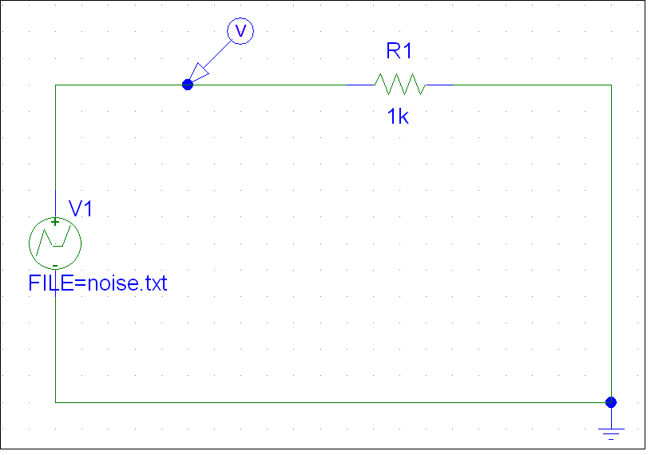

Circuit Simulation for Gaussian Noise Circuit

FFT Graph for Gaussian Noise Circuit

Conclusion:

This lab has taught me how to design a circuit for Square and Impulse waveforms. It has given me a chance to become familiar with the different Fourier waveforms. It was also the first time for me to use a sample from a Gaussian generator with the schematic which was very interesting and knowledgeable. In addition I have gotten to use Pspice more productively during this assignment. Overall, this assignment is a great introduction to start of Electronic Communications. It has acquainted me to many new concepts.

