
ECE 450
Larry Sieh
Fall 2003

Assignment 10:
FSK/FHSS

Vladi Gergov
Brandon Harris

Ken Mayle

We have neither given nor received any unauthorized aid in this graded assignment.

____________________________________________________________________

____________________________________________________________________

____________________________________________________________________

Objective:

To explore FSK systems and FHSS systems.

FSK - Previously, we looked at ASK systems. FSK stands for frequency shift keying. This system involves a FM modulator, noise injection, a superhetrodyne phase, a digital demodulator and the differential slicer. The fsk system is not quite as good as the phase lock loop in terms of noise immunity. This is primarily due to the fact that it does not track the input signal as well. First lets show the input vs. the output to prove that it does work. There is a bit of distortion in the output. You can see the pulse width varies a bit. I am guessing this is due to the reduced noise immunity causing some bit error.
Input baseband vs. output signal

Modulated – The spectral energy at 400 Khz represents a 0 in our signal. The spectral energy at 410Khz represents a 1. This shows that there is more energy at 0. This makes sense being the green graph above spends more time at 0 than 1.

Modulated baseband

IF – This is our demodulated signal. If compared to the diagram for the “Modulated” step above it retains its shape. Note that there is more energy at 90 KHz which is the new spectral band area for our 0’s and then the area around 100khz would be our new spectral area for our 1’s. This was caused by our superhetrodyne processes.
IF

High_Rectified - This next step shows what we’ve extracted by our high pass filter. This is slightly shifted in phase but it is trying to tell us when signal is high. This is illustrated by the green high areas. Otherwise the data is trying to tell us… The signal isn’t high.

High rectified vs. data

Low_Rectifled – This step is showing us after our Low pass filter where the signal thinks our original baseband signal was a zero. Where the green signal is High, it thinks a zero is occurring. Like the Hi_Rectified signal, there is a phase shift due to filters in the circuit.

Low rectified vs. data

Hi and low out – This shows how our two high and low output signals work together. When the high signal is higher than the low signal, they agree that there is a 1 occurring, when the low signal is greater than the high signal, they agree that there is a 0 occurring. They literally both give an answer but whoever is more sure of themselves more shouts louder and is taken to be right.

Hi out vs. low out vs. data

Slicer output – This confirms what we stated above. The slicer is taking and making a –1 be our low state and 1 be our high state.

Output vs. hi out vs. low out

Part 2 – FHSS (frequency hopped spread spectrum)

FHSS uses a method whereby the center frequency is changing randomly. This is called hopping. There are two different types of hopping. Slow and fast. In this lab we will be working with slow hops. This means that we will be sending multiple bits per hop, or change in frequency.

Input vs. output
This shows our hopping code. This is the “orders” for our transmitter which translates into telling when and where to transmit our signal. On the other side we are going to have the same “orders” for the receiver. Not having this situation would be like playing catch with a blind man. He might get lucky and catch the ball but that would be very unlikely. Jedi’s excluded because they’ve got the force and all.

h – This shows our signal as where it has hopped around based on our transmitter hopping code.
Sum of hops – This shows the two signals taking the same airspace imposed on each other. Some of this we don’t care about. It is not in the spectral space we are interested in receiving when we are listening. Some of this however as shown by our transmitter hopping code will overlap. This is bad. This is like getting intimate with your girlfriend but all you can think about is your mother. You simply can’t filter it out of your head.

You’ll be left with a sum of both signals and a limp dick.

To be exact in the spectral space we are listening in between 3 and 4 milliseconds. We see this as a bit error in the output.

The next part goes though what is basically an IF oscillator. However instead we are using the same text file to cut the frequency out that we were modulating with.

Un-hopped – This leaves us with a FSK modulated signal. We are following the first in last out (FILO) scheme where we FSK our signal, then FHSS it, then undo the FHSS then FSK to get back our baseband. Kind of like those drills you’d do in the military where you take a gun apart and put it back together as fast as you can.

The spectral energy around the 40 KHz mark would be our 0’s, around 70 KHz would be 1’s.

“1” bit detection unit – This part of the circuit will take and suck out the energy that is of importance to finding 1’s. It will take and do like in the FSK and make a decision on whether it thinks a one is present or not. There is a slight phase delay. There is also a conflict around 3 – 4 ms due to our overlap in our hop schedule.

This somewhat gives a picture on what the two detection units are trying to decide. There is conflict occurring between 3 – 4 ms. This is caused by both signals being too sure that both are right.

Data source 2:

Now we will tune into the second data source. When you compare the input vs. the output, you will see that there is no data collisions as seen when you tuned into data source1.

Input vs. output

Notice that there is no bit error in 3-4 ms range

Frequency Shift Keying

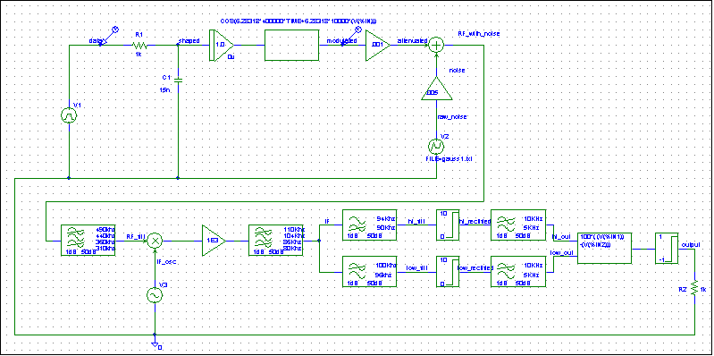

Frequency Hopped Spread Spectrum

