
ECE 450
Larry Sieh
Fall 2003

Assignment 10:
DSSS

Vladi Gergov
Brandon Harris
Ken Mayle

We have neither given nor received any unauthorized aid in this graded assignment.

____________________________________________________________________

____________________________________________________________________

____________________________________________________________________

Part 1:

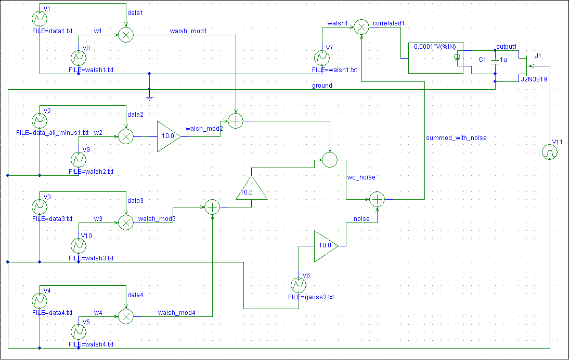

Background:

Direct sequence spread spectrum is a form of modulation and demodulation whereby the signal is spread throughout the spectrum space to the point where it looks like noise. It is encoded with a something called a walsh code.

On the demodulation side, it will only decode something that was encoded with the walsh code. Using this technique, it is possible for different signals to share the same spectrum space. This is a really crazy concept. It basically gets rid of the idea of “channels”. It also is very noise immune due to the key like decoding process.

Below is an example of how the spreading occurs. It is the baseband vs. the modulation with the walsh code. The walsh code in this case is 131 bits, which is a bit confusing to us since we assumed that walsh codes had to be 2^n in length. Anyways, the concentrated signal is spread through out the spectrum.
Data 1 vs. walsh_mod1

All other sources turned off except for walsh1.

This shows how ideally one would recover the baseband signal using the walsh code. The integration is “clean” due to not having any interference in correlating the matching walsh codes. Idealy this wouldn’t matter but we have some undesired correlation between the codes that we will soon see.

With all other gain blocks turned on to 10 – noise included and other 2 walsh modulated signals.

The Squiggle in the ramp can come from other walsh code. Temporarily you have a little bit of correlation in the end, they all cancel out though. For every bit of negative that is offset, there is a similar positive spike on the ramp.
With noise removed, all 3 turned on – We can see here that the noise really doesn’t have much effect on the output, or even the correlation. We were curious on what would happen.

Part 2:

For this section, the goal is to try and produce interference that will prevent the signal from being spread correctly. Our theory is that no matter what we do, crank up the noise, using different data files etc., it is not going to matter because the walsh code is orthogonal to all of the other walsh codes except itself. It will tune out the other signals, while only decoding walsh 1 encoded data.

For our first attempt, we will crank up the gain on all of the gain blocks to 25. This will amplify the other 2 modulated signals and crank up the noise.

As somewhat expected, the output signal will still replicate the baseband signal.

This is with all data_all_minus1.txt files being used on the transmitter.

Yes, this still works out fine. Different data files do not affect anything. The walsh1 code is orthogonal to all of the other walsh codes. However, when you correlate it to itself, you are left with a result of 1. This essentially leaves you with the baseband.

But, what about cranking up ONLY the noise gain? What will that do? Hell if we know, but let’s find out.

It appears that there are bit errors from 30-40ms. It is still having enough time to dump as well, because the capacitor is being fully discharged to 0. We are left with the conclusion that the noise is somehow similar to the walsh code 1 at certain points. Since the noise is so much larger in magnitude, when it is correlated and then integrated, the large magnitude noise will screw up the signal trying to get through. The way the integration works, is that it takes the area underneath the curve. So if you have a baseband signal that is positive, and the large noise value that is negative, when you subtract their areas, the net will be positive even though the baseband signal was supposed to be positive.

This is showing the data_all_minus1 input vs. the output. As you can see, the signal is received as expected. Right before it dumps, it is below zero. All of the integrations represent negative 1.

From what we have found, the only way to screw up the demodulation/dispreading process is by cranking up the gain in front of the noise such that the ratio of noise gain to moduatlion gain is high. For example, leaving the gain blocks at 10 for the modulation processes but cranking up the noise gain. It just so happens that parts of the gauss2.txt file correlate to the walsh code, so when you are decoding it, it mistakenly decodes the noise. When the noise is really high compared to the walsh_mod1, and then it is integrated, the walsh mod will be insignificant next to the noise. So, the noise takes precedent and gives you a false 0 or 1.

Part 3:

The above graph shows data1 and output1. As you can see output1 is correctly demodulated.

The above graph shows data2 and output2. It is again correctly demodulated.

The above graph shows data3 and output3. It is again correctly demodulated.

The above graph shows data4 and output4. It is again correctly demodulated.

When we pump up the gain in front of the noise, take a look below what happens to the output1:

There seems to be an error between 30 and 40 ms. The output is indicating that it should be low. We believe this is happening because the noise is amplified so much, that it over powers the walsh code. The noise is partially correlated at that point, so the integrator takes the area under the curve, (at which the noise is correlated with at this point) and the result is either a false 0 or 1.

Below is further proof that the noise is affecting the dispreading.

The walsh code is different in this case, which makes sense that the noise is correlating in different places this time. You can see that there are errors in different places this time.

Changing the gains for the different walsh code data sources does not affect the received signal because they are orthogonal. No matter how strong the signal of the different walsh code encoded data it still gets canceled out.

