
ECE 450
Larry Sieh
Fall 2003

Assignment 12
What’s the frequency Kenneth?

Vladi Gergov
Brandon Harris
Ken Mayle

We have neither given nor received any unauthorized aid in this graded assignment.

____________________________________________________________________

____________________________________________________________________

____________________________________________________________________
Objective:

In this lab, we are going to examine the DSSS system again. However, we are going to pay close attention to how it works when you have another mod/demod combination sharing the same spectrum space. In our case, it is the AM system for part one. For part two, we will use a FM system. Below is the general schematic for part one.

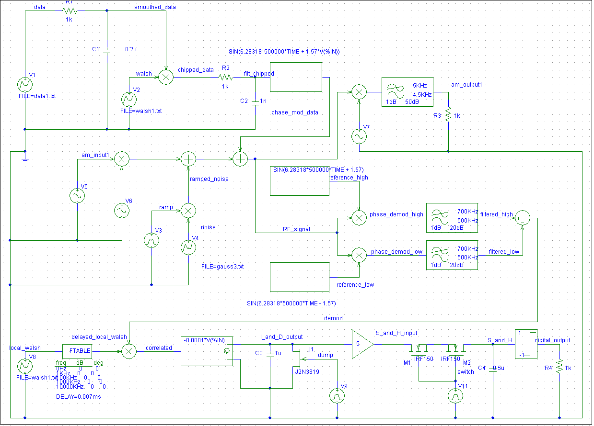

First, let’s take a look at the data signal that we are going to be modulating.

Next, the data sent through a pulse shaper which we have seen many times before. It is then modulated with the walsh signal. You can see this below:

You can see that it is spreading the data throughout the spectral space. The larger the walsh code, the more it will spread the data in the spectrum

Next, it is sent through another pulse shaper, which is not as intense as the prior one. The purpose of the second pulse shaper is to get rid of some of the irrelevant really high frequency harmonics.

Phase Modulation:

Next we have phase modulation. This is two fold. You are multiplying it by 500KHz in order to put it in a certain part in the spectrum. This would be important for cell phones for example. They operate in the GHz range usually. Now, the next part does phase modulation. If the signal is a one, it offsets the signal 1.57 radians (or 90 degrees) and if it is a -1 it is phase modulated in the opposite direction basically. It essentially lets you differentiate between 1s and -1s in the spectral space. You’ll see how this comes into play as you read on.
Below is the phase modulated data:

Notice how there is more spectral energy on the right side. This is because there are more 1s than negative 1s.

Learn to Share:

In this part, we will introduce another mod/demod combo within the same spectral space as the phase modulated signal. The AM signal is being modulated at 495 KHz and then summed with the ramped noise. The phase modulated data is then summed with the ramped noise and modulated AM signal. You can see the result below. We superimposed the phase modulated data on top of this to see how powerful it is in comparison.

You can notice the AM signal center frequency around 495 KHz. It is the large spike. This is due to the amplitude being 3.

To show that we get our AM baseband back... outside of nose, we really didn’t have any problems with the Phase Modulated signal being in the same medium. The tall FFT spikes are the same. There’s noise present but… we expected that.

We simulated the assignment again without noise to better show what was happening at the phase demod stages. This shows as expected we have our spikes at around DC and 1Mhz representing the 1’s and -1’s in our phase demodulation.

With noise we really can’t see or point out anything.

This shows what is happening at the demod and filtered sections in our “Coherent Digital Signal Phase Demodulator”. Once again, we wanted to show our signal with and without noise to help understand what is happening. Even with noise if we sampled it high we would have a hard time getting a good example of a graph.

We are always taking our filtered high signal and subtracting our filtered low. This takes and gives concensus on when a one and zero is occurring. In class we called this “the evidence gatherer”.

This shows our correlation. There are two general states in the correlated signal that signify when the bit is thought to be high or low. The resolution between them is when the overall amplitudes are high, the bit is thought to be high. When the overall amplitude is low, the bit is thought to be low. We showed this without noise so we could demonstrate what was happening. We realize though in the end, this will be okay.

The above figure shows the data and the integrate and dump signal. As we can see it is reconstructing the signal until it reaches 50 ms and then we start to get some bit errors. We think this is due to the repeating ramping noise which is not a good representation of natural Gaussian noise which is orthogonal to our walsh code. The repeating nature of our Gaussian noise file that we used is what causes some of the Gaussian noise at around 50 ms to actually over power the baseband signal and give us some bit errors.
Sample and Hold:

Sampling and holding uses a capacitor with a very small value so it can charge and discharge very rapidly. It takes the last value before the dump and holds it. Then, it magically discharges through the infinite impedance of the gain block. It is controlled with a timer that controls a transistor (in our case two transistors) that allows the capacitor to charge and discharge.

Below is the graph of Sample and Hold vs. the Sample and Hold input:

You can see that it starts to resemble a digital signal.

Final Output:

Next, the sample and hold goes through a 1 to -1 limiter which theoretically should be the base band signal reconstructed.

Below you can see the original data signal vs. the digital output:

You can see that the ramped up repeating Gaussian noise is causing an error in the digital output.

Part 2:

We used an FM modulation/demodulation in the same channel as the DSSS. After we simulated we got the below output.

Which tells us that the FM signal is not interfering with the DSSS signal and hence orthogonal.

The above graph shows the FM modulation channel which is centered at 500KHz which happens to be the same as our DSSS System.

Here is the FM modulated baseband reconstructed successfully. So both modulated signals the FM and the DSSS using the same channel center freq and channel were reconstructed successfully.

