
ECE 450
Larry Sieh
Fall 2003

Another four letter
acronym (AFLA) –

Disclaimer:

Not for unlawful carnal
knowledge. – Van Halen

Vladi Gergov
Brandon Harris
Ken Mayle

We have neither given nor received any unauthorized aid in this graded assignment.

____________________________________________________________________

____________________________________________________________________

____________________________________________________________________
Part 1:

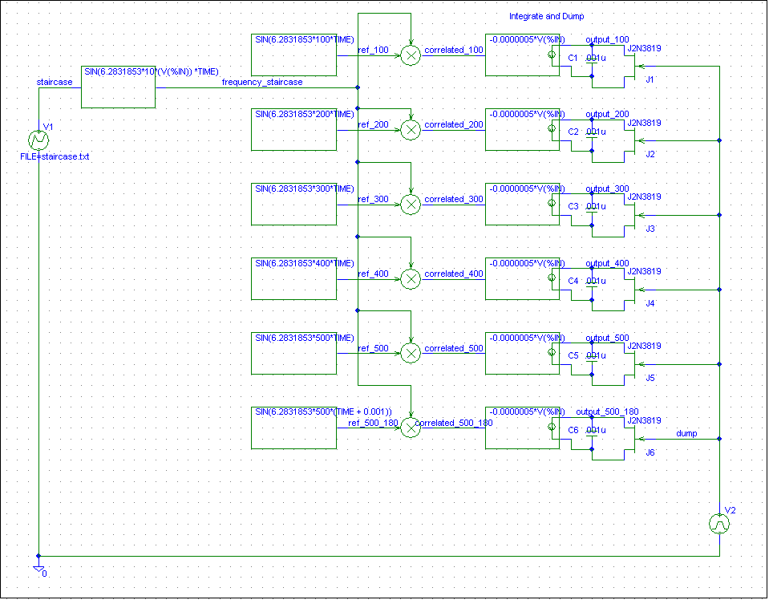

The whole point of this assignment is packing. We want to get as much bits of fudge into some spectral space as possible. For this we use Orthogonal Frequency Division Multiplexing (OFDM).

OFDM basically is our attempt at putting multiple signals in spectal space and exploiting correlation. We take a stair input, which gives us a signal with bit times all equal. Each time the stair “steps” the output signals frequency by integer multiples of the first step’s frequency.

By doing this we kinda break up one signal and can insert during the appropriate bit time data. By doing this, and correlating it to the frequency of the signal in the respected bit time, we’ve got a productive way of distinguishing between bits. So.. multiple signals can talk on the same line at the same time.

A real world example of this would be telephones, cable internet and from what we were told in class certain types of TV broadcasting. This is a very good way of packing a lot of information in a limited amount of spectal space.

Note when the stair voltage increases, the frequency increases by an the next integer multiple.

Outputs

Output of 180 Deg out of phase included

ref_100, correlated_100 and output_100

Note that the high output appears within the 1st 10 ms which is the frequency of our ref_100. After that, everything correlates to zero due to our OFDM principles. That principle is, when the multiplied signals have the same frequency and phase, they will correlate to a postive value. If they are out of phase by 90 they will correlate to zero. When they are 180 degrees out of phase, the result will be a strong negative value.

ref_200, correlated_200 and output_200
ref_300, correlated_300 and output_300

ref_400, correlated_400 and output_400

ref_500, correlated_500 and output_500

ref_500_180, correlated_500_180 and output_500_180

When they are 180 degrees out of phase, the result will be a strong negative value.

Part 2 – OFDM with PSK Modulated by AM

Part 2 deals with analog to digital conversion. We use a relatively basic D – A convert due to that we have node limitations. Had we used the proper part, this would not have stayed within the node/part limit of P-spice.

We are taking an analog signal, then sending it through a A-D converter. Afterwards, we take and pack the signal using OFDM (and PSK with a 180 degree phase shift)

We decide then to show how this could be modulated further using an AM Mod/Demod combo.

On the receiver side, we demodulate the AM then correlate it with reference signals similar to in part 1. Then… based on this we send it through our D-A converter and get a representation of the baseband signal back. The D-A converter is similar to what we have done in ECE414 involving a resistor/op amp array.

Input vs. Output

Sum of OFDM – This is our Multiplexing.

V(AM) – Our signal after passing through an AM Modulation process. This would be a sample of a way we could modulate our signal and transmit it at a higher frequency through RF waves.

Demodulated AM – Note this is our Sum of OFDM above…. Nothing suprising.

DB7 and Dumper 7 – This is where we try and gather evidence on how our MSB or Most Significant Bit is going to influence our signal.

DB2 and Dumper 2 – Shows our Contribution of the LSB (Least Significant Bit).

OFDM7 – DB7 – Where the PSK comes into play. AS PSK would imply when our digital signal is changing state, we go 180 degrees out of phase.

Here we can see that when we are switching from logic 1 to logic 0, the OFDM instantly switches phase to 180 degrees from its previous phase.

Here we can see that OFDM2 OFDM3 OFDM4 are using the same spectrum space and are overlapping this is possible because of the orthogonality of each one due to the integral multiple principle.

The above shows the sum of all the OFDM’s and it shows the energy distributed throughout our spectrum instead of centered in the middle like other techniques this allows for the use of the same channel in short distances since its low power and will not interfere with each other.

This shows the output which is the input signal reconstructed. It has been converted to digital then transmitted and then converted back to digital. This process allows for very good quality of transition and also transmitting data faster because its transmitted in parallel.

