Assignment 2: Introduction to Filters



ECE 450
Professor: Larry Sieh
Term: Fall 03’

Prepared by:

Brandon Harris
Vladi Gergov

I have neither given nor received aid in the preparation of this report:

_________________________________________________

_________________________________________________

Part1: Procedure and Theory

In part 1, we were to calculate the third harmonic frequency for the square wave signal. Since our input signal was 1000 Hz, our third harmonic was 5000 Hz. Then we were to calculate the third harmonic of the pulse train which was 3000 Hz. Once we knew the cutoff frequency, we could simply find the values for L, C and R for the bandpass, LPF and HPF.

LPF and HPF RC filter:

Fc = 1 / ((2*pi) * R * C)

LPF and HPF LR filter:

Fc = R / ((L)*(2*pi))

BPF:

Fo = sqrt ((1/((L)(C) ) )/ ( 2*pi)

By adjusting the R value for the bandpass filter you can adjust the cutoff frequency is.

The signal representation was not perfect because only 8 harmonic frequencies were used.

Part2: Procedure and Theory

This part of the lab demonstrates the amplitude and frequency characteristics of the square wave and pulse train waveforms before and after the signal passes through a low pass, high pass, and band pass filter. The set of filters used for the square wave had a different cutoff frequency than those used for the pulse train as mentioned in the previous section. Both the low pass and high pass filters were passive first order. The band pass was a passive second order since a first order band pass is non-existent.

When the square wave was passed through a low pass filter, the higher frequency components were attenuated. This effect resulted in a square wave with rounded edges and a shallower rise and fall time. However, when the signal was passed through a high pass filter the resulting signal was greatly degraded. This must imply that the lower frequency components have a much greater influence on the basic construction of a square wave signal. They do have the highest amplitude of all the harmonics.

The band pass filter also greatly degraded the input signal when the bandwidth was narrow, but could be adjusted to improve the output signal quality. The band pass filter, being a second order filter inherently had a sharper roll of rate than the first order low and high pass filters.

The pulse train produced different results when passed through the three filters. Both the high and low pass filters had an effect on the pulses amplitude but not on the period. Although degraded somewhat a pulse was produced at the output. The lesser degradation of the signal is probably due to the composition of a pulse. The amplitude of the harmonics are spread out more uniformly across the spectrum, therefore and attenuation of high, low, and middle frequency components don’t have as great of an effect.

Part 1: Results:

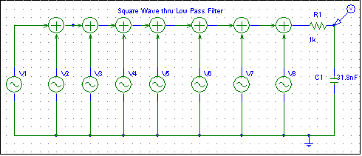

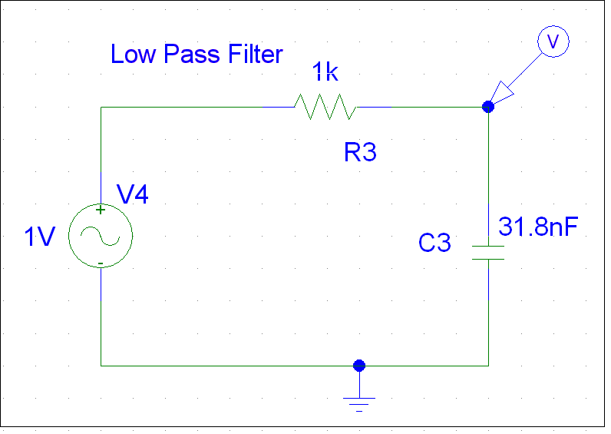

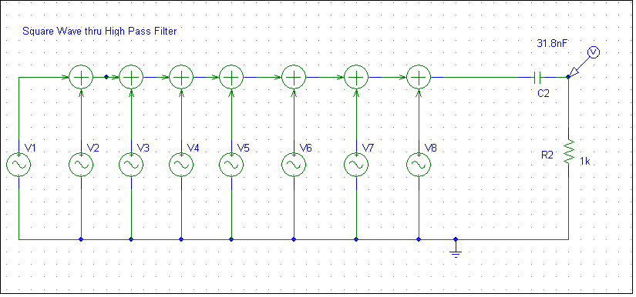

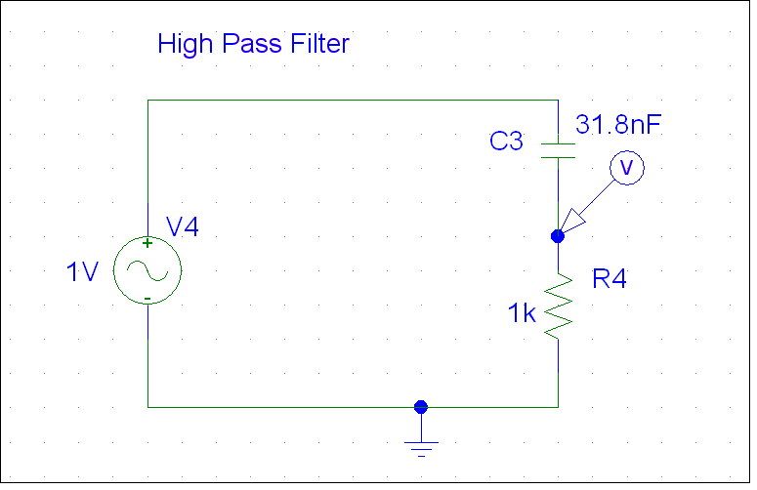

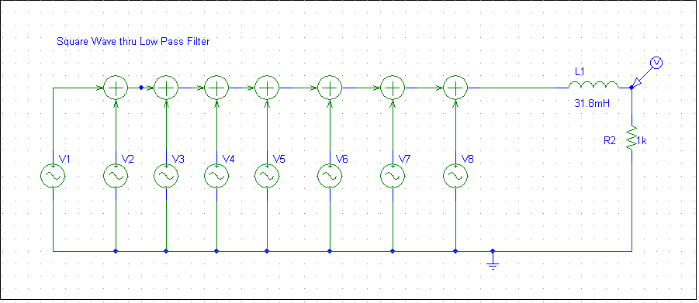

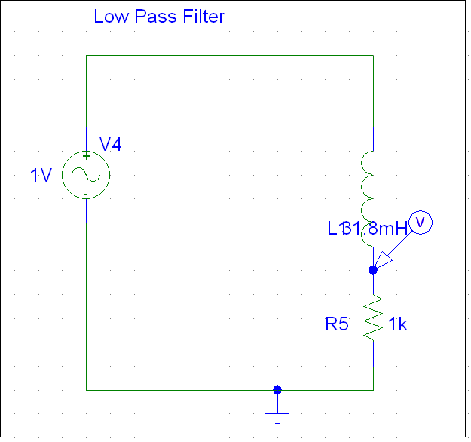

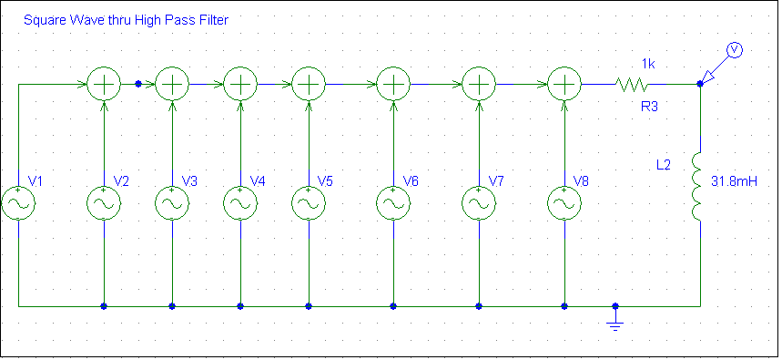

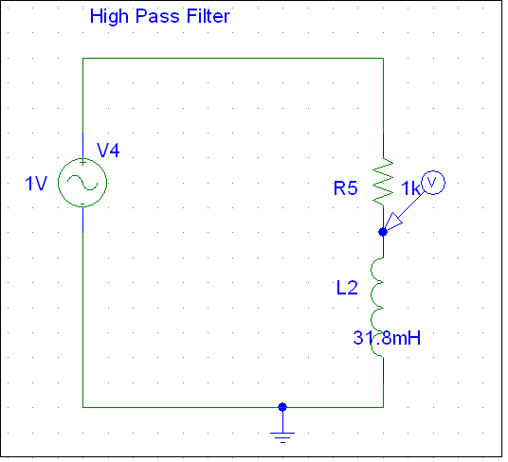

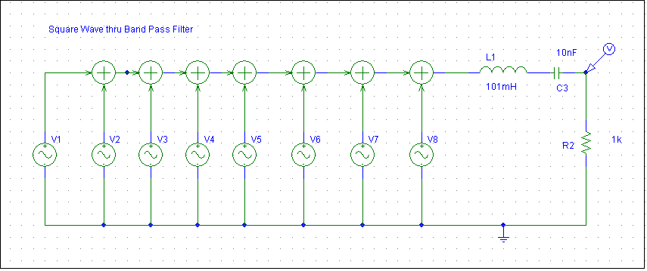

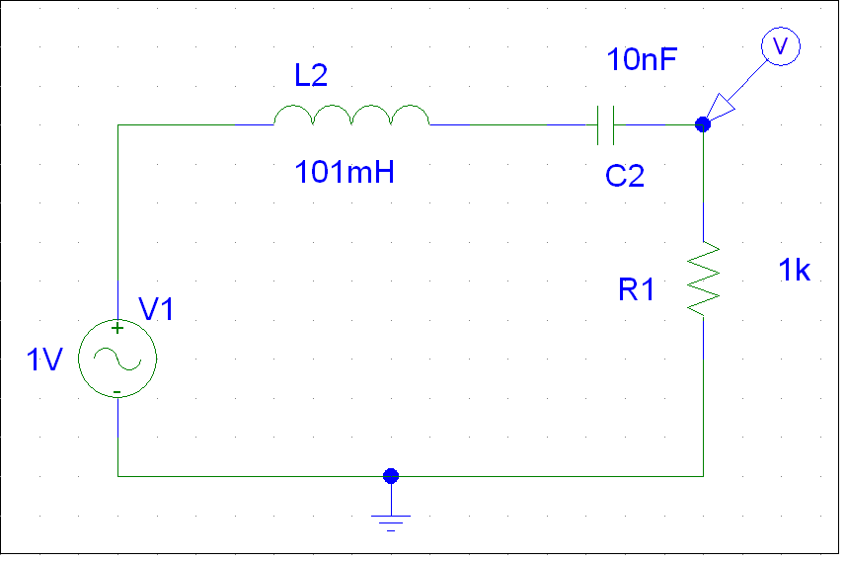

Impulse Train Signal

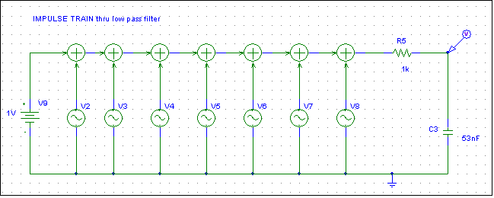

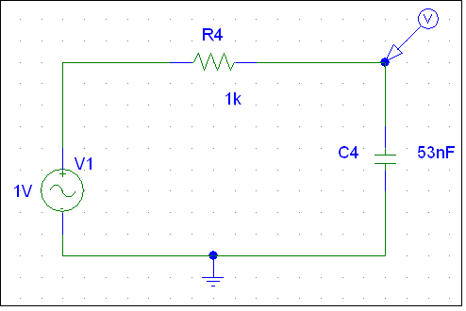

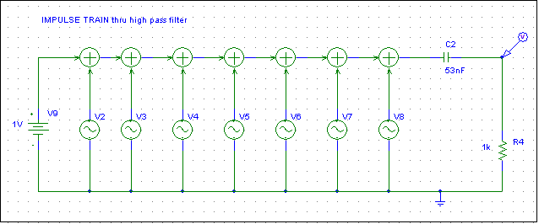

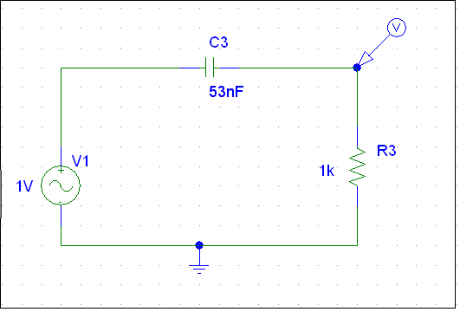

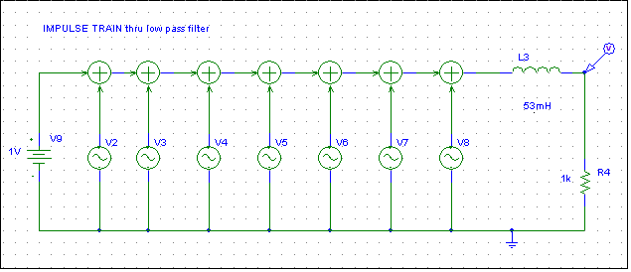

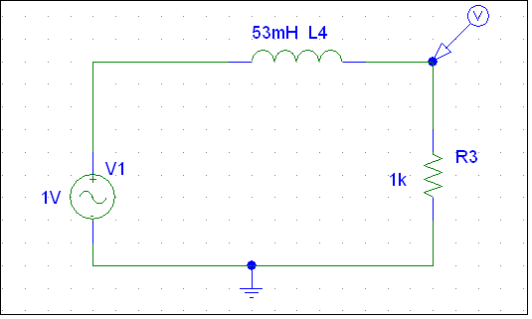

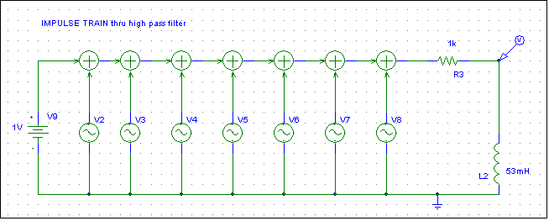

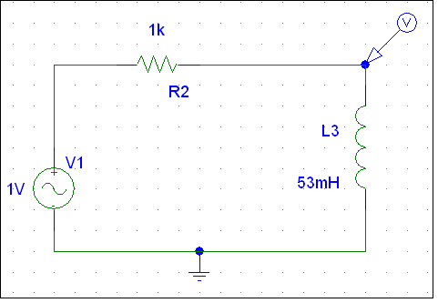

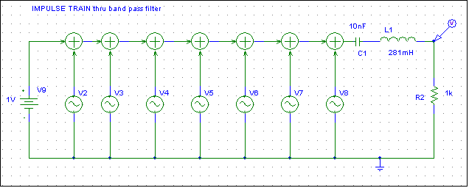

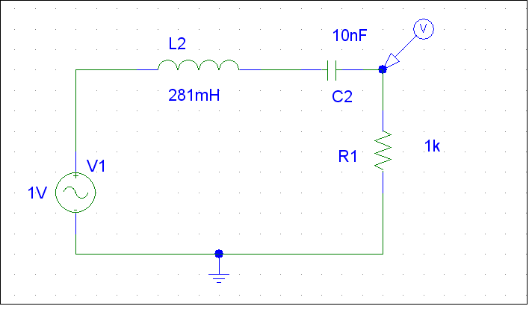

Part 2: Input, Response and Output using all three Filters

Square Wave Input

LPF System Response

Output of Square Wave input through LPF

Square Wave Input

HPF System Response

Output of Square Wave input through HPF

Square Wave Input

BPF System Response

Output of Square Wave input through BPF

Impulse Train Signal

LPF System Response

Output of Impulse Train input through LPF

Impulse Train Signal

HPF System Response

Output of Impulse Train input through HPF

Impulse Train Signal

BPF System Response

Output of Impulse Train input through HPF

