Assignment 3: Exploration of Simple Double Sideband Suppressed Carrier AM



ECE 450
Professor: Larry Sieh
Term: Fall 03’

Prepared by:

Brandon Harris
Vladi Gergov
Ken Mayle

I have neither given nor received aid in the preparation of this report:

_______________________________________________

_______________________________________________

_______________________________________________

Coherent Double Sideband Suppressed Carrier AM modulator-Demodulator Combo

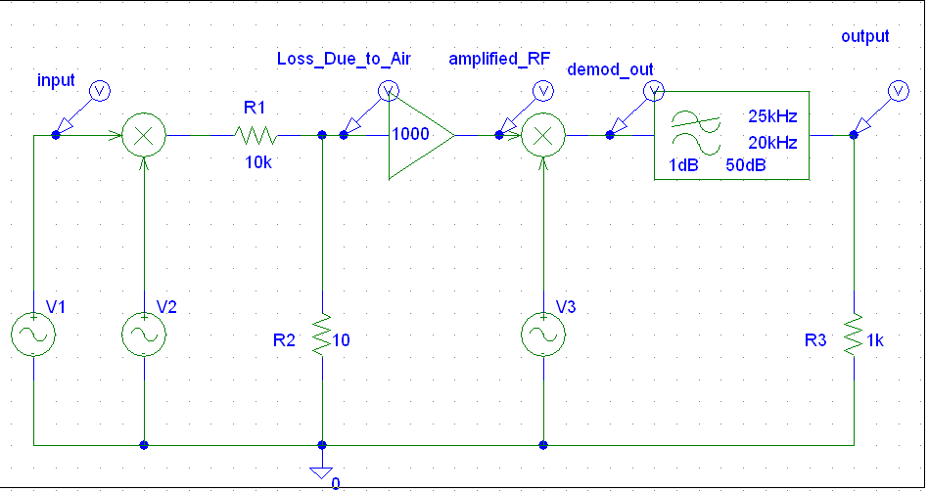

In this device the baseband signal (V1) gets multiplied by the carrier wave (V2). After they are multiplied they are passed through a voltage divider that simulates signal losses due to air. The leftover signal gets amplified with an op-amp which is set with a gain of 1000 to compensate for the Air losses. After which the amplified RF signal gets multiplied with another carrier on which demodulates the signal removing the original carrier wave that can be shown works through trigonometric identities. There is some extra stuff along with the copy of the baseband signal that is twice the frequency of the carrier. After which the parasitic high frequency harmonics are filtered out with a Chebyshev Low pass filter.

It is important that the copy of the carrier on the demodulated side must be phase aligned with the original carrier on the modulated side. If this does not occur then the demodulation does not give as good of a copy of the baseband signal.

Mathematical Identities Used:

Modulated signal: R(t)cos(2πf_{c}t+Ø_{r}); R(t) is the baseband signal.
Local copy of carrier: A₀Cos(2πf_{c}t+Ø₀)

A trig identity used that when examined helps clarify what is occurring is:

cos(x)cos(y)=0.5[cos(x+y)+cos(x-y)]

After multiplying the modulated signal and the local copy of the carrier we get:

V(t)=R(t)cos(2πf_{c}t+ Ø_{r})A₀cos(2πf_{c}t+ Ø₀)

Using the trig identity mentioned earlier we get the equation:

v(t)=1/2 A₀R(t)cos(Ø_{r} - Ø₀) + 1/2 A₀R(t)cos(4πf_{c}t+ Ø_{r} + Ø₀)

If Ø_{r} and Ø₀ are equal (in phase) then (cos(0)=1) and you are left with
1/2 A₀R(t) which is the ½ of the baseband signal times the amplitude of the carrier signal. You still will have some high harmonic noise which is represented by the underline portion above. This ideally occurs at 2 times the carrier frequency. However, we have good methods of filtering this out using a proper low pass filter.

Input baseband signal 100 Hz sinusoid, Amplitude = 1. This could be considered a simple test tone.

After loss due to air- Note this graph shows a mV scale.

Loss due to air up close showing that it is the same frequency as the modulated signal:
Amplification on the RF signal (note we are no longer in mV):

FFT of signal after amplification (note what appears to be a single spike at 150 KHz is actually two sidebands at 150 KHz ±100Hz)

Signal after demodulation shows that the frequency is 100 Hz which means that the baseband has been reconstructed

FFT After the demodulation where we see the baseband signal at 100 Hz and also the other high frequency harmonics that will get filtered out by low pass filter.

Output reconstructed baseband after being put in a low pass filter. It is scaled down approximately by a factor of 1/2. This was expected by the trig identities.

FFT of final reconstructed signal showing that the low pass filter isolated the baseband

Part2 – Now generate two new carriers; once again, one is for the frequency carrier (the one that goes to the modulator) and one that is local carrier (goes to the demodulator). Make it so that they are 90 degrees out of phase.

*Note: This is the same as part one but V3 was given a Phase=90 value.

Input baseband signal 100 Hz sinusoid, Amplitude = 1. This could be considered a simple test tone.

After loss due to air- Note this graph shows a mV scale.
Amplification on the RF signal (note we are no longer in a mV scale):

Demodulated Output before sending through a low pass filter
FFT After the demodulation where we see the baseband signal at 100 Hz and also the other high frequency harmonics that will get filtered out by low pass filter.
Output Signal after low pass filter. Note the micro-volts scale. This is due to the carriers were out of phase.

FFT of Signal after low pass filter – Note the Nano-Volts scale. These spikes could mostly be due to harmonics that our low pass filter did not take out 100%.

To further prove when the carriers get more and more out of phase, this next output was done at a 45 degree phase shift on the demodulating side.

The FFT of the above 45 degree phase shift example above. Our first example (carriers in phase) had a peak a little under .5 Volts. This one at 45 Degrees is somewhere less than .3 Volts demonstrating our claim of a greater phase shift will cause degredation of the copy of the original baseband signal.

Part 3 – Clone your modulator circuit from part to show a result, you should probably show both the time domain and frequency domain representations. Of course, use your judgment on this.

Schematic of alternate audio signal through coherent double sideband suppressed carrier AM modulator-demodulator combo.

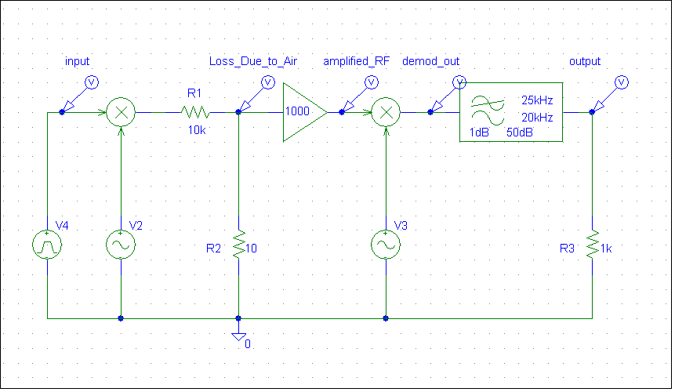

Square Wave test tone input. The signal used is a 5kHz 50% duty cycle V_Pulse generator. This would simulate a square wave that climbed to 1 volt when on, and dropped to -1 Volt when off.

FFT of Input Square Wave – Note the high number of harmonics as one would expect in such a signal.

After loss due to air- Note this graph shows a mV scale.

Amplification on the RF signal (note we are no longer in a mV scale)

Demodulated Output before sending it through a low pass filter. The signal we naturally had many harmonics present. This would be similar to our 8 harmonic square wave in our first assignment but with many more extra sinusoids added in.

FFT of the demodulated signal above showing a high number of harmonics. Note the high strength in the areas around 220kHz as we expected. This would be twice our new 110kHz carrier frequency. We also see the baseband signal at 5000 Hz and also the other high frequency harmonics that will get filtered out by low pass filter.

Output of the system after Chebyshev LPF showing that most of the high frequency harmonics of the square wave have been filtered out. Depending on the cutoff frequency of the LPF the output will look more or less like a square wave.

FFT of the system after LPF showing only two of the square wave harmonics.

