
ECE 450
Larry Sieh
Fall 2003

Assignment 4

Vladi Gergov
Brandon Harris

We have neither given nor received any unauthorized aid in this graded assignment.

____________________________________________________________________

____________________________________________________________________
Amplitude Modulation using envelope detection schematic:

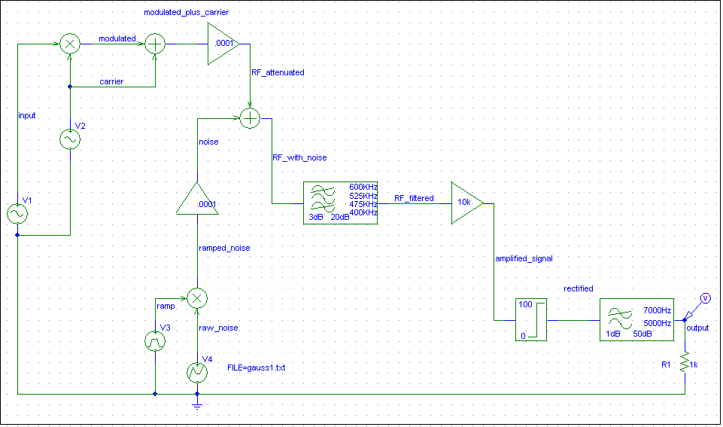

This is the schematic of the amplitude modulation using evelope detection circuit, next we are going to go trace the signal step by step through the circuit and explain each part in detail.

The Input:

The base signal that is being modulated is an 800 MHz sine wave.

The Carrier signal:

The carrier signal is a 500 KHz Oscillator.

Modulation:

Modulation takes the carrier ( A_{c} sin(2πf_{c} t) ) and one plus the base band signal ( m(t) ) and multiplies them together. This takes the carrier and multiples it by the base band signal and also adds a copy of the carrier to the modulated signal. This is archived through a trig identity and yields the following equation for the modulated signal .05 A_{m} A_{c} [sin(2π(f_{c} + f_{m} )t)+ sin(2π(f_{c} - f_{m} )t)] + A_{c} sin(2πf_{c} t). Which means that we have sidebands at f_{C} ± f_{m} and a carrier at f_{c} .

Time domain representation showing the modulated signal.
Frequency domain representation showing the two side bands and the copy of the carrier signal.

Loss due to air:

This is what happens to RF transmissions when they are traveling through the air. We used an amplifier with a gain of .0001 to approximate the loss due to air.

This show the original signal before the attenuation and the attenuated version which is insignificant compared to original.
Gaussian Noise:

In the attempt to simulate noise in the air we used a ramp from 0v to 4v multiplied by the randomly generated Gaussian noise to gradually increase the amount of noise (note: the Gaussian noise voltage source repeats after the file comes to an end ). Then it is scaled with an amplifier and added to the attenuated RF signal.

This figure shows the ramp that is used to gradually amplify the noise.

This figure shows the Gaussian noise that is generated by the input file.

This figure shows the ramp and the noise multiplied together.

This is the final noise that will be added to the attenuated RF signal you can see that the amplitudes have been scaled down a lot by our .0001 gain amplifier.

In this figure you can see how the ramp increases the noise as time moves forward. This is because the farther the signal travels through the air the more noise it encounters.

Here we see the attenuated RF signal and the noise added together and you can see that as time progresses the signal gets more and more distorted.

This figure shows the FFT representation of the above figure, showing the two sidebands and the carrier wave at 500 kHz also some Gaussian noise which later will be mostly eliminated using the band pass filter.

This figure shows the band pass filtered signal. As you can see the noise around the center frequency of the band pass is still present but most of the other frequency noise has been filtered out.

Envelope Detection:

This figure shows the amplified and band pass filtered signal before it passes through the diode. Right now, this contains only the carrier signal and the sidebands around it. Envelope detection requires only the positive portion of the signal in order to get the base band signal out of it.

This is the FFT of the signal before it passes through the diode. It is showing that there is the carrier frequency present along with two side bands and noise throughout the frequency spectrum.

This figure shows how the signal is passed through the diode. The diode rectifies the signal so only the positive part of the signal gets passed through. The reason you need only the positive portion of the signal is because you can reconstruct the base band signal from it. It would not be possible to get the base band out of the signal before it passes through the diode. The many oscillations that appear in the rectified signal are the carrier signal. If you look at the outer shape of the graph, the peak to peak times and calculate the frequency, you would get the base band signal frequency.

This is the FFT of the rectified signal. This shows three important things. On the left, you have the base band signal. In the center, you have the carrier signal with its sidebands and on the right you have what appears to be another copy of the carrier frequency. If you look, you will see that the amplitude of the carrier is halved. The diode is ideal, so it is not because of the voltage drop. This is the reason:

P= I * V

When you rectify the signal, you are essentially halving the voltage. The loss of power is probably radiated as heat through the diode. The spike on the far right of the graph is a bit harder to explain. It should not be there because the bandpass filter should have got rid of that. However, the diode is a non-linear part and there is probably some crazy mathematics that would explain the occurrence of this spike. We are pretty sure that when we rectified the signal through the diode something happened with the negative voltage we cut out to cause this.
Output:

This is the output signal after it goes through the low pass filter. The low pass filter eliminated the carrier signal and the spike that occurred about twice the frequency of the carrier. This signal is still a bit distorted, has a y-offset and is about ¼ the amplitude of the input signal. First, the signal is halved when it is modulated. You can see this with the trig identity below. The modulated signal is represented by this:

G(t) = (1 + h(t))Acsin(2*pi*fc*t) * h(t) is the base band signal

Trig Identity:
sin(x)cos(y) = 0.5[sin(x + y) +sin(x – y)]

Then the signal gets halved again when it is rectified through the diode.

This is the FFT of the output signal. If you look closely you’ll see 3 things. The base band signal at 800 Hz, some noise after that because it was not filtered out from the low pass filter (it had too low of a frequency). The system cannot distinguish between noise and sideband signals. The system is forced to allow all noise in the frequency range of the band pass filter, which is designed to pass the sidebands and the carrier. Even if it was possible to have a brick wall filter at the sideband frequency ranges, you would still have the noise between the two sideband frequencies.

There is also some other type of spike on the left. We are not sure what is causing this. It appears to be some type of DC offset. When you look at the amplitude of the left spike, it is about 250 mV and that is how much the output signal is offset by. This would explain why the output signal is offset on the time domain graph above instead of oscillating around the X – axis. You could remove the spike on the far left by passing this signal through a high pass filter that allows only the base band to go through. Theoretically, you could also filter further by passing it through a low pass (to get rid of noise) or by killing two birds with one stone you could use a band pass filter to get rid of the spike on the left and the noise.

