
ECE 450
Larry Sieh
Fall 2003

Assignment 5

Vladi Gergov
Brandon Harris
Ken Mayle

We have neither given nor received any unauthorized aid in this graded assignment.

____________________________________________________________________

____________________________________________________________________

____________________________________________________________________
Tuning to particular station in noisy environment w/ an AM super-heterodyne receiver:

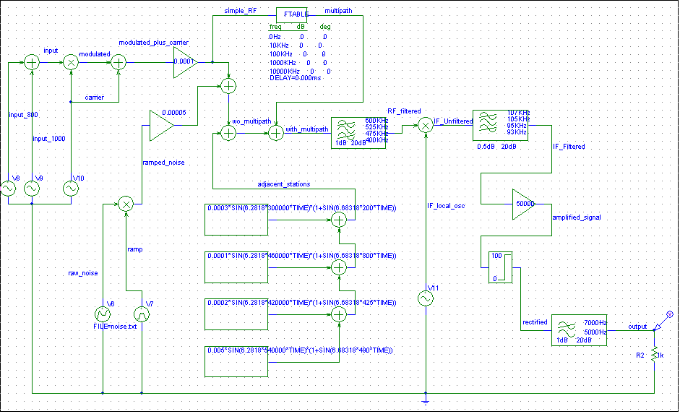

This is the schematic of the tuning to particular station in noisy environment w/ an AM super-heterodyne receiver circuit, next we are going to go trace the signal step by step through the circuit and explain each part in detail.

The Input:

The base signal that is being modulated is two sine waves one at 800 Hz, the other is at 1000 Hz added together.
The Carrier signal:

The carrier signal was mentioned in assignment 4.

Modulation:

Modulation was explained in assignment 4.

Loss due to air:

This was explained in assignment 4.

Gaussian Noise:

This is the same as in assignment 4 with a minor modification of the ramp, which now goes to 10 v.

Multipath:

The multipath module of the circuit adds a delay specified by the user. This delayed signal is then added to the signal before it is received by the receiver which could cause constructive interference (which adds the two signals causing a higher amplitude), destructive interference (which subtracts the two signals and results in total signal loss dude to the phase difference of pi), or something in between.

The graph above shows the input signal vs. the output signal with no delay for the multipath. This is ideally what you want; no interference. Since it is not a perfect world, you do not get perfect results. Below you will see what happens with different types of constructive and destructive interference.

The graph above shows multipath with destructive interference when a phase delay of 0.001 ms is chosen which is offset by pi from the original signal. As you can see the input signal compared to the output is totally maimed. As shown in previous labs, if the signal is out of phase with the carrier the reconstructed base band will be screwed up.

The above is a zoomed in version of the 0.001 ms delay. In this figure we see the phase offset of pi compared to the input.

This graph shows multipath with destructive interference when a phase delay of 0.0012ms is applied. When you have a 0.001 ms delay, it is destructive. So are the odd multiples (i.e. 0.003, 0.005…) When you have 0.002 ms delay and the even multiples (i.e. 0.004, 0.006..) it is constructive. In the case above however, you have something in between.

The above graph shows you the in-between state of multipath. As you can see the waves are offset by a factor close to pi but not enough for complete destructive interference only something in between.

The graph above shows the input signal vs. the output signal with a delay of 0.0015 ms. 0.0015 ms is the midpoint between constructive and destructive. It appears that the amplitude is not affected by much, However, the phase is still affected by about pi/2. The next graph below will illustrate that more. As you can there still appears to be some type of distortion within the first period of the output.

This graph shows the signal before and after multipath is introduced. This again illustrates that the signal is out of phase by approximately pi/2.

Finally, we have a delay of 0.002 ms. This is the graph of the input vs. the output to prove that the baseband is still retained transmitted and demodulated properly. This delay is constructive, which means it will not affect the output by much. We will further illustrate this with the next two graphs. As you can see, it is pretty much the same as the 0 ms delay graph.

This is the graph of the signal before and after the delay. It is delaying it by .002 ms, which is a delay of one period, or 2pi. This will not affect the shape of the output signal.

- There is a definable relationship between the input signal and the output signal. This relation ship is defined as the output signal is the addition of the normal (non delayed) signal and the multipath signal ( delayed signal ).

Super heterodyne:

To illustrate how superhet works we are going to tune to the 500 Hz radio station which rides on a 539.9 KHz carrier wave. To do this we modified the BPF in front of the IF local oscillator to have a center frequency as that of our desired station which was 539.9 KHz. We also modified the cutoff frequency to be 500Hz above and below the center frequency to allow both sidebands to pass through.

The above figure shows the radio station we are tuning.

The figure above shows the radio station we are trying to tune ( all the way to the right ) and the other adjacent radio stations which we want to filter out.

This figure shows the desired station after the gentle roll off BPF has filtered the adjacent stations out.

This figure shows the signal after its been multiplied by the local IF oscillator wave calculated by subtracting the carrier frequency of 539.9KHz minus the intermediate frequency of 100KHz which yields 439.9KHz for the local IF oscillator. The Intermediate Frequency (IF) is a design choice that is between the carrier frequency and the base band frequency, in our case its 100KHz. This is done to get a copy of the signal at the designated center frequency of the sharp roll off BPF which does the “heavy lifting”.

This is a zoomed out view of the above figure showing the other bi-products of the multiplication by the local if oscillator.

This graph shows the IF filtered out by the steep roll off BPF. Notice that the signal at 100Khz is the only one that gets through.

Envelope Detection:

This was explained in detail in assignment 4.

Output:

After envelope detection process is complete we see our 500 Hz signal.

This shows our output of the tuned to 500Hz station with a little distortion from the added noise.

