
ECE 450
Larry Sieh
Fall 2003

Assignment 6

Vladi Gergov
Brandon Harris
Ken Mayle

We have neither given nor received any unauthorized aid in this graded assignment.

____________________________________________________________________

____________________________________________________________________

____________________________________________________________________

Part 1:

Once upon a time, in our previous assignments, we demonstrated AM modulation. AM modulation is ok, but it does not have the noise immunity that FM modulation does. FM stands for frequency modulation while AM stands for amplitude modulation.

As in AM, there are a few different ways to do the modulation/demodulation combo. We will show you one of the most simple ways; the slope detector. Read on as we explain away the magic behind frequency modulation.

To start things off slow, we will demonstrate a simple example of how the modulation occurs.

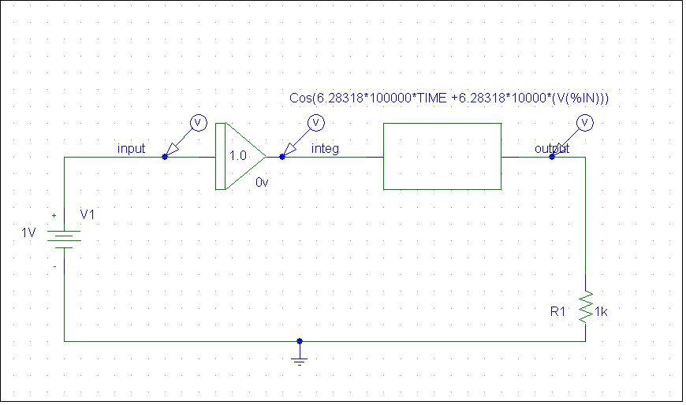

Above is the schematic of the modulation process. Notice that there is no oscillator in FM.

FACT of the DAY: AM cannot be used by the military for secret communication because it is possible for people to detect the oscillator frequency.

The equation below is the backbone of frequency modulation.

Sfm = Ac*Cos [2π*(fc)*t + 2π*(kf) * ∫ 0 to τ of m(τ)d τ

Ac: This is the amplitude of the carrier
Fc: This is the carrier frequency
[2π*(kf) * ∫ 0 to τ of m(τ)d τ]: Varies the signal from the center frequency
M(τ): This is the base band signal
Kf: Kf is an important variable that determines bandwidth. The more bandwidth, the more noise immunity you have. This determines how far away the frequency deviates from the carrier frequency for every volt of input.
So, what will happen when you have 0 VDC offset on the schematic above? There will be no DC offset, so Kf will not offset the carrier frequency of 100KHz.

FFT of 0VDC Modulation with 100KHz Carrier

Now, what will happen when you have a 1 VDC offset with the other remaining parameters staying the same? Since Kf is 10KHz you would see a shift in Fc in the positive direction by one magnitude of Kf. Below is the graph that shows it.

FFT of 1VDC Modulation with 100KHz Carrier

Finally, what will happen if you have a -1VDC offset? Well as you might have guessed it would shift by kf to the left, and the below figure shows just that.
FFT of -1VDC Modulation with 100KHz Carrier

Part 2:
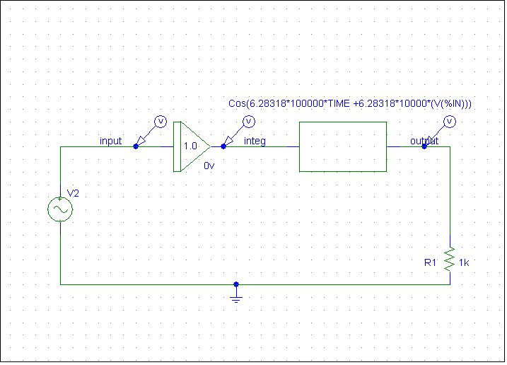

In the schematic above, we switched the DC input with a 4 V amplitude sine wave input. You may be wondering what will happen when you have voltage switch from negative to positive or vice versa when you have a sine wave centered around 0 V. Also, you might want to consider what happens when you change the frequency of the sine wave, or what effect it has on the modulation process.

FFT of the 100 Hz 4 V amplitude sine wave input

Since you have varying voltage from -4 to 4 V, you will have a range of spikes varying from the center frequency by Kf times the voltage range between -4 to 4. If you have your carrier at 100KHz and your Kf value is 10Khz then when you multiply Kf by -4 you will get plus or minus 40Khz from fc which is 100Khz.

IMPORTANT: The instantaneous modulated signal frequency is proportional to the instantaneous baseband voltage. Notice the amplitude is the highest at the upper and lower boundaries. This is because on a sine wave, it reaches its peak voltages (4 and -4 volts). At lower frequencies, the spikes are more evenly distributed throughout the channel width.

FFT of 200 Hz 4 V amplitude sine wave input
If you look at this graph, which is at 200 Hz instead of 100 Hz, you notice a few things. First of all, you notice that there are less spikes throughout the spectrum. The energy is more concentrated on the voltage max and mins of the sine wave due to the higher frequency of the sine wave. In other words, the spikes are not distributed as evenly and it is changing more instantaneously which means that the voltage will be higher throughout the spectrum.

Part3:

Now, we’ve shown what happens when you vary the baseband frequency but let’s show what happens when you vary the Kf.

FFT of 100 Hz baseband and 5000 KHz Kf
When you cut the Kf value down to 5 KHz you lower the channel width as shown in the figure above.

FFT of 100 Hz baseband and 10 KHz Kf
At 10 KHz kf you are increasing the channel width even more then at 5 KHz as shown in the figure above.

FFT of 100 Hz baseband and 20 KHz Kf
At 20 Khz kf the channel width increases again as shown in the figure.

As we can see the pattern is that as you increase the Kf the channel width increases therefore they are proportional.

Part 4:

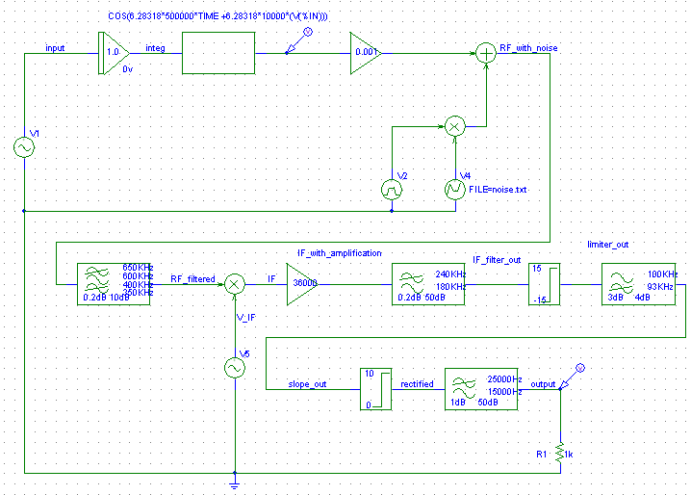

We are going to trace the signal step by step excluding the parts that were already covered in previous assignments. The circuit figure above shows the FM modulator/demodulator combo with a slope detector. In this schematic, the superhet technique is being used in conjunction with FM.

Above we see the input of the system at around 1v amplitude and 400 Hz frequency.

In this circuit, the baseband signal is 4000 Hz. Kf is 10000 KHz and the Fc is 500 KHz. If you take a look below, you’ll see the graph of the modulation output:

FFT of Modulation process

This graph looks different than when the frequencies were much lower. This is due to the non linear behavior of this system.

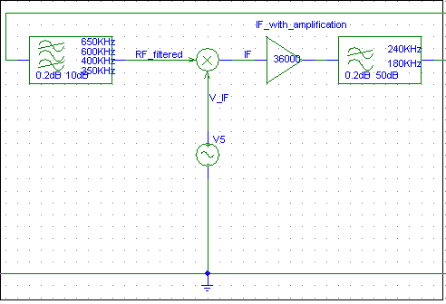

This part of the circuit represents the superhet section of the circuit. Your carrier wave is coming in at 500 KHz, then IF is subtracted (which is 400 KHz) to give you a 100 KHz signal. This was explained in previous labs. It is important to know that the baseband signal is STILL encoded in the 100 KHz carrier. The superhet just gives you a lot of flexibility with the frequencies.

FFT of IF_filter_out

What you’re seeing here is the FFT of the IF filter output. You see the Fc centered around 100 KHz. You see the noise around the harmonics because of the gentle roll off of the filter.

Next, the signal is passed through the limiter. The limiter basically stabilized the signal and removes amplitude discrepancies. This gets rid of any AM components. Look at the comparison below of the amplitudes before and after the limiter.

Above we see the signal after it has passed through the slope detector which is just a strict high pass filter. You want to pass that signal through the very linear region of that HPF. This produces a signal whose envelope is the baseband signal.

Next envelope detection is done and the baseband signal is reconstructed. This was covered in previous assignments.
Part5:

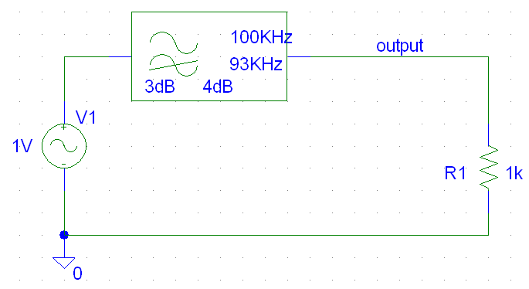
The above schematic shows a simple HPF schematic.

The above shows the frequency response of the HPF. We zoomed into the most linear part we could find and took two sets of points and found the slope. The slope in both cases was approximately .00002 V/Hz. This proves the relative linearity of the slope needed for the FM demodulation process.

THE END….
AND THE BASEBAND LIVED HAPPILY EVER AFTER

