
ECE 450
Larry Sieh
Fall 2003

Assignment 7

Vladi Gergov
Brandon Harris
Ken Mayle

We have neither given nor received any unauthorized aid in this graded assignment.

____________________________________________________________________

____________________________________________________________________

____________________________________________________________________
Part 1:

In the last assignment we showed a simple method of FM modulation and demodulation with the slope detector method. In this assignment we will show the Phase Lock Loop (PPL) demodulation method and why it is inherently better then the slope detection used in AM.

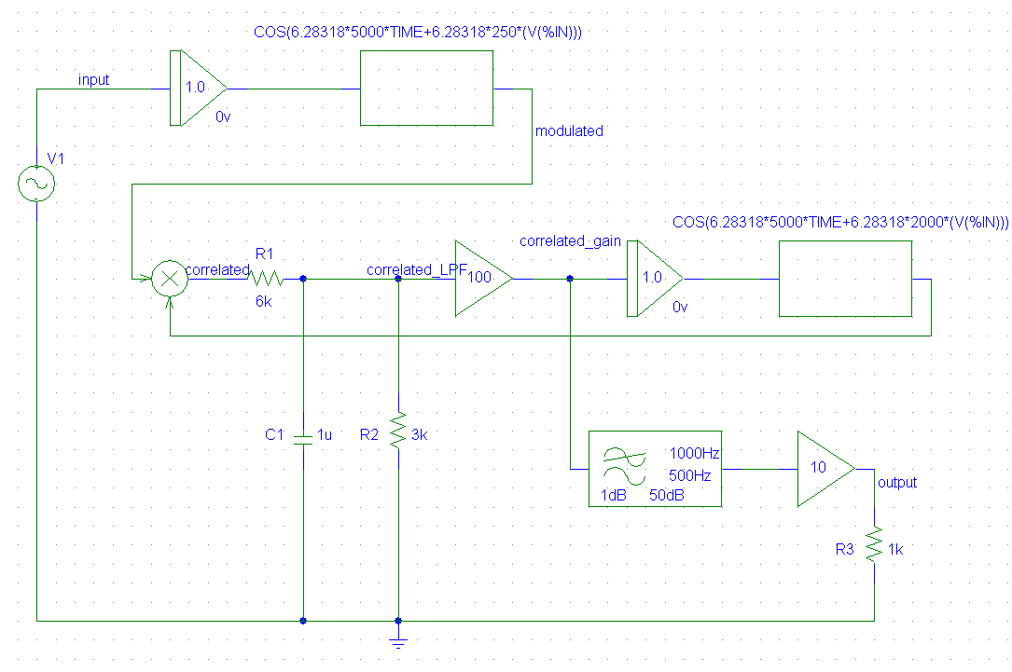

The above is the circuit that we will be examining, it is comprised of the following.

- A FM modulator that modulates the baseband signal.

- A Phase Detector to detect phase differences between two signals.

- A Low pass filter to take the average of the differences. This produces a dc voltage corresponding to the difference in phase.

- An Amplifier to amplify the DC change so it has more strength to drive the Voltage Controlled Oscillator (VCO) which will try to track the baseband signal. This is the part that is described as “a dog chasing it’s tail” due to the baseband signal constantly changing and it never quite catches it.

- Finally a Low pass filter that takes the baseband “byproduct” and filters out high frequencies.

In the above figure we see the two signals before they go into the phase detector, the VCO has not locked to the baseband yet.

In the above graph we see the two signals before they go through the phase detector. They are out of phase by 90 degrees which means that the VCO has locked on to the signal and is tracking it ( trying to keep 0 volt difference ).
The above figure shows the correlated signal while the system is trying to lock on to the baseband. As you can see the dc offset is fluctuating a lot which implies that the VCO is producing a signal which is not matching the phase. This may at first appear to be parasitic however, this discrepancy actually is necessary to regenerate the baseband signal.

After some time the system has locked on to the signal and is now mimicking it closely, as you can see in the little fluctuation in dc of the correlated signal.

The above graph shows the amplified LPF output which is the average voltage of the difference in phase of the two signals.

The phase detector and LPF are designed to output as follows:

1 volts ( positive ) if the phase is 0 degrees (in phase)
0 volts if the phase is 90 degrees out of phase (what the VCO aims for)
-1 volts if the phase is 180 degrees out of phase

This is then amplified so it drives the VCO harder to lock onto the baseband. In the beginning you see there is a lot of “positive” difference and eventually it locks on to the signal since it aims for zero volts (90 degrees out of phase).

For the output filter, you pass the signal from correlated gain through a LPF and an amplifier. So, if you look at the big picture, the phase detector, LPF and VCO is a control system. With control systems, the steady state error is always trying to go to zero. Zero in this case is 90 degrees out of phase. So, based on this principal you’ll get the baseband signal (90 degrees out of phase) as a byproduct of this process when it goes through the LPF before the output stage.

Take a look at the above graph and you’ll get a better understanding of what is going on. It is the input signal vs. the output signal. The initial inconsistencies before it reaches steady state are because the system is trying to lock onto the modulated signal. It finally levels out after a certain amount of time ( when it reaches the steady state ). The output signal may be out of phase, but it is still the same frequency.
Part 2:

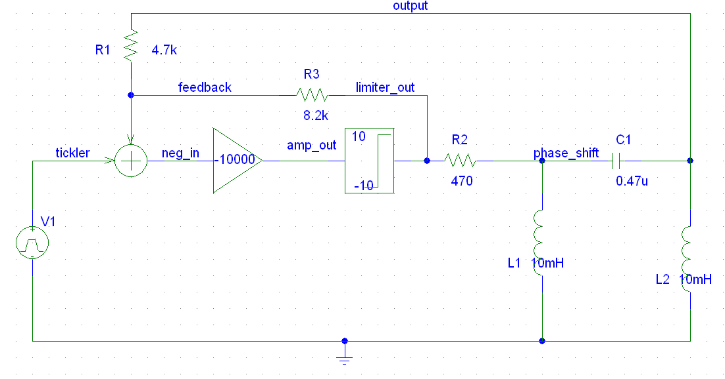
We did some research on the web and found the following quote: “Hartley oscillators are inductively coupled; variable frequency oscillators where the oscillator may be series or shunt fed. Hartley oscillators have the advantage of having one centre tapped inductor and one tuning capacitor. This arrangement simplifies the construction of a Hartley oscillator circuit.” ( From: http://www.electronics-tutorials.com/oscillators/hartley-oscillator.htm )

The figure above shows us how the amplitude increases probably due to the feedback added to the ramp until the limiter kicks in and keeps it at 10 volts.

