
ECE 450
Larry Sieh
Fall 2003

Assignment 9:
BPSK

Vladi Gergov
Brandon Harris
Ken Mayle

We have neither given nor received any unauthorized aid in this graded assignment.

____________________________________________________________________

____________________________________________________________________

____________________________________________________________________
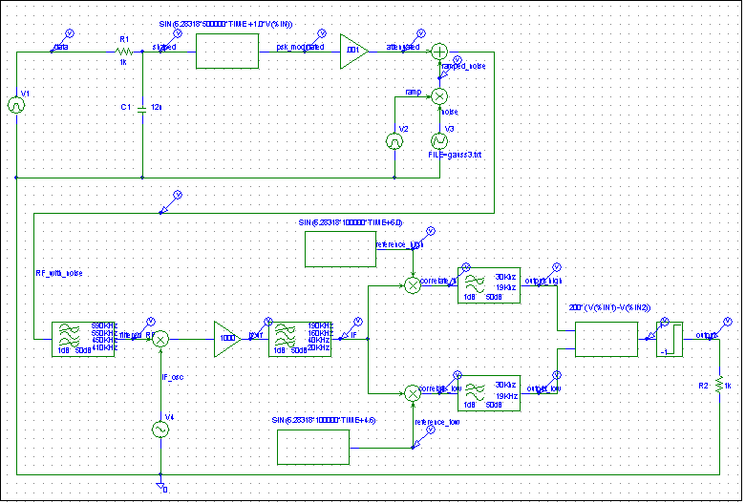

Our Input signal (data and shaped)

As in our last lab, to reduce spectral space used, we remove high harmonics in our square wave. An ideal square wave would have harmonics stretching out to infinity in the frequency domain which we don’t want. Keeping the harmonics that consist most of the strengh of the signal is a good enough tradeoff for the conservation of spectral space.

RF_with Noise and filtered_RF

Our signal has gone through our phase shift keying modulator and has had ramped noise inserted. The red above is after it has been put through a band pass filter removing noise in our signal that has nothing to do with reconstructing it.

IF – if_uf

This shows the superhetrodyne process. There is nothing new here. The red shows after our signal is sent through a band pass filter cutting out the byproduct of the superhetrodyine process. Nothing new to report Captain.

reference_high and reference_low 90 degrees OOF

The two reference signals are mixed with the IF signal with different results. These two results are labeled “correlate_high” and “correlate_lo” on the circuit diagram. These two unique

reference high and psk modulated

reference low and psk modulated.

Correlate High

correlate low

output and initial baseband (data)

