Project II:

COMPENSATOR DESIGN TO IMPROVE A TIME RESPONSE


Winter 2003

Lab Proctor: Lance Slifka

“We have neither given nor received aid in the preparation of this lab report.”
 | Prepared by
Tan Nguyen  tannguyen_79@yahoo.com |  | ____________________________
Trang Pham  annap@umd.umich.edu |  | ____________________________
Nhan Phan  ntphan@umd.umich.edu |  | ____________________________

DESIGN ASSIGNMENT 2:
COMPENSATOR DESIGN TO IMPROVE A TIME RESPONSE

Part 1:

A feedback control system is illustrated in the following block diagram:

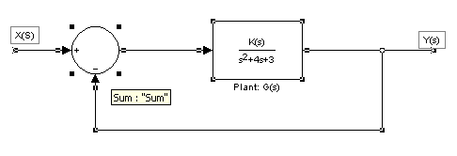
Figure 1: Uncompensated

Problem Statement:

(1) For what value of K will the system’s step response perform with a percent overshoot of 20% and settling time (Ts) of 2 seconds? What is the steady state error?

Design Method:

Original Plant G(s):
figure(1)
num1 = 1;
den1 = [1 4 3];
rlocus(num1,den1)
axis([-5 0.5 -5 5])
title('Root Locus of Uncompensated System (G(s) in feedback formation)');
sgrid(.45,4.444)
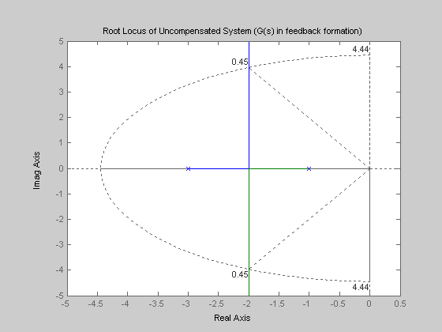

When designing a control system, one must first look at the requirements that are given to determine the variable needed. The canonical for a 2nd order transfer function is shown in Equation 1. To design this control system $ζ$(zeta) and Wn (the natural frequency) must be found.
$\frac{W_{n^{2}}}{S^{2}+2{ξW}_{n}S+W_{n^{2}}}$ (Equation 1)
It was shown that $ζ$ can be found by picking a %OS and solving for equation below. A %OS of %20 was used so that rounding would not be a factor when meeting the requirements. Solving Equation 2 gave a $ζ$=0.4559
$\text{\%}\text{20}=e\hat{−(}\text{ξπ}\sqrt{1−ξ^{2}})∗\text{100}$ (Equation 2)

The next step was to find W_{n} with given value of Ts equal 2 seconds and calculated value of $ζ$ found in Equation 2. Solving Equation 3 gave a W_{n}=4.386 rad/s
$2=\frac{4}{{ξW}_{n}}$ (Equation 3)
Rewrite Equation 3 gave ${ξW}_{n}=2$, this is the real axes intercept. Base on (Equation 2 & 3), the two complex poles can be calculated using Equation 4
$−{ξW}_{n}±{\text{jW}}_{n}(\sqrt{1−ξ^{2}})=−2±j4\text{.}\text{386}(\sqrt{1−0\text{.}{\text{4559}}^{2}})=−2±j3\text{.}\text{904}$ (Equation 4)
Using the two complex poles, an angle from the real axis was determined. Solving for Equation 5 gave $θ=\text{62}\text{.}{\text{87}}^{∘}$
$\text{tan}θ=\frac{3\text{.}\text{904}}{2}$ (Equation 5)
After the two complexes poles and $θ$were found, the new close loop transfer function for the system could be derived using Equation 6.
$H_{\text{new}}(s)=\frac{K}{(S+2+j3\text{.}\text{904})(S+2−j3\text{.}\text{904})}=\frac{K}{S^{2}+4S+\text{19}\text{.}\text{24}}$ (Equation 6)
Mapping the original close loop transfer function to the new close loop transfer function determined K= 16.24.
Original T.F New T.F
$\frac{K}{S^{2}+4S+3+K}≈\frac{K}{S^{2}+4S+\text{19}\text{.}\text{24}}$ (Equation 7)
The last task was to evaluate the steady state error for a step, ramp, and parabolic input. This was not a difficult task because the G(s) was already given, and K was found in Equation 7. We first evaluate the system type k_{p}, k_{v}, and k_{a}. Then the steady errors could be found as below $e_{\text{step}}(∞)=0\text{.}\text{1559},$$e_{\text{ramp}}(∞)=∞,$ and $e_{\text{parabolic}}(∞)=∞\text{.}$
Evaluate $k_{p}=\underset{s→0}{\text{lim}}G(s)=\frac{K}{3}=5\text{.}\text{413}$ and $e(∞)=e_{\text{step}}(∞)=\frac{1}{1+k_{p}}=0\text{.}\text{1559}$
$k_{v}=\underset{s→0}{\text{lim}}\text{SG}(s)=\frac{0∗K}{3}=0$ and $e(∞)=e_{\text{ramp}}(∞)=\frac{1}{k_{v}}=∞$
$k_{a}=\underset{s→0}{\text{lim}}S^{2}G(s)=\frac{0∗K}{3}=0$ and $e(∞)=e_{\text{parabolic}}(∞)=\frac{1}{k_{a}}=∞$

Part 2:
Problem Statement
(2) Simulate this uncompensated feedback control system using MATLAB/Simulink. Discuss the results. Did it meet the specifications? Provide MATLAB plots
a)
Matlab Results
t=[0:0.01:5];
num1 = 16.24;
den1 = [1 4 3];
sys1 = tf(num1,den1)
sys1_feed = feedback(sys1, 1)
ys1 = step(sys1_feed, t);

figure(2)
plot(t, ys1);
title('Plot of Compensated System');
grid on

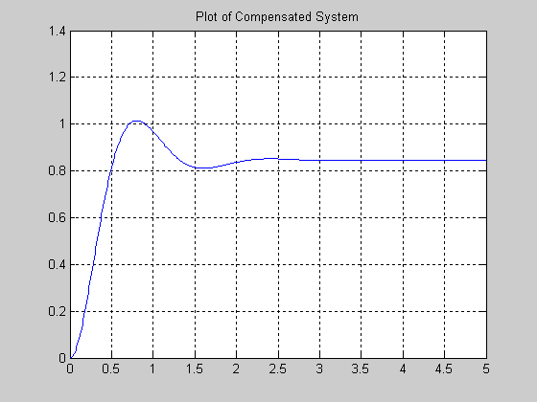
b)
Simulink Result
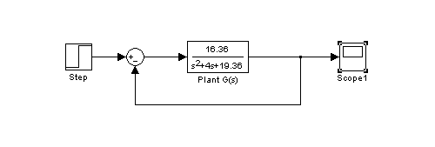
plot(y2a(:,1),y2a(:,2))
grid on
title('Plot of 1st Compensated System')
xlabel('Time')
ylabel('Magnitude')

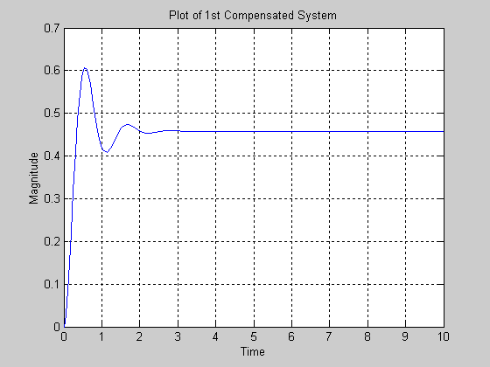
The graph doesn’t look like exactly the Matlab results because the Simulink just only gave us the step response of the Open loop system but in matlab we plot the feedback in series with open loop system.

Part 3:
Problem Statement:
(3) Now, consider the transfer function, G(s), found in part 1 to be the plant. Design a compensator to (i) reduce the plant’s step response settling time to 1 second (ii) reduce the %OS by a factor of 2 and (iii) reduce the steady state error by a factor of 10. What type of compensation is needed in this design? Pick one of the methods (root locus, frequency response) discussed in lecture to complete the design. Note: It is your choice whether to use a cascade or feedback compensator.

Design Method:
Since the %OS is now by a factor of two, which mean 20/2 is 10%. Using Equation 8 below and solve for $ζ$₂=0.5911.
$\text{\%}\text{10}=e\hat{−(}ξ_{2}π\sqrt{1−ξ_{2^{2}}})∗\text{100}$ (Equation 8)
To design a compensator with a plant’s step response settling time reduce to 1 second, the real axis intercept is now ${ξW}_{n2}=4\text{.}$ Solving for Equation 9, W_{n2} =6.766 rad/s
$1=\frac{4}{{ξW}_{n2}}$ (Equation 9)
Base on the above equations (Equation 8 & 9), the new two complex poles can be calculated using Equation 10
$−{ξW}_{n_{2}}±{\text{jW}}_{n2}(\sqrt{1−ξ_{2^{2}}})=−4±j6\text{.}\text{766}(\sqrt{1−0\text{.}{\text{5911}}^{2}})=−4±j5\text{.}\text{457}$ (Equation 10)
After the two complex poles, the new close loop transfer function for the system could be derived using Equation 11.
$H_{2}(s)=\frac{K}{(S+4+j5\text{.}\text{457})(S+4−j5\text{.}\text{457})}=\frac{K}{S^{2}+8S+\text{45}\text{.}\text{779}}$ (Equation 11)
Using the new two complex poles, a new angle from the real axis was determined. Solving for Equation 12 gave $θ_{2}=\text{53}\text{.}{\text{76}}^{∘}$
$\text{tan}θ_{2}=\frac{5\text{.}\text{457}}{4}$ (Equation 12)
To design a compensator, a new block diagram was created. We arbitrary choose a =1 and b=5.
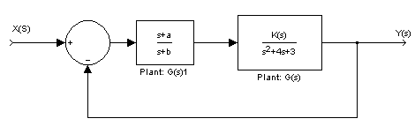
Figure 2: Compensator

Base on Figure 2, the open loop transfer function G_{comp}(s) was determined using Equation 13
$G_{\text{comp}}(s)=\frac{(S+1)K}{(S+5)(S+1)(S+3)}=\frac{K}{(S+3)(S+5)}$ (Equation 13)

Thus, the close loop transfer function for the compensator is derived as

$H_{\text{comp}}(s)=\frac{K}{S^{2}+8S+\text{15}+K}$ (Equation 14)
Mapping Equation 11 and Equation 14 together to determine K=30.779
New T.F. Compensator T.F.
$\frac{K}{S^{2}+8S+\text{45}\text{.}\text{779}}$$=\frac{K}{S^{2}+8S+\text{15}+K}$
Evaluating the new $e_{\text{step}}(∞)=\frac{1}{1+k_{p}}=0\text{.}\text{3276}$, where
$$k_{p}=\underset{s→0}{\text{lim}}G_{\text{comp}}(s)=\frac{\text{30}\text{.}\text{779}}{S^{2}+8S+\text{15}}=2\text{.}\text{052}$$
Since the steady state error is reduce by a factor of ten, which mean 0.1559/10 is 0.01559. The result of $e_{\text{step},\text{new}}(∞)=0\text{.}\text{3276}$ $e_{\text{step},\text{requirement}}(∞)=0\text{.}\text{01559}$. This does not satisfy the steady state error requirement. By recalculated the k_{p,requirement} =63.14 (Equation 15), we were able to satisfy the steady state error requirement. $e_{\text{step},\text{requirement}}(∞)=0\text{.}\text{01559}=\frac{1}{1+k_{p,\text{requirement}}}$ (Equation 15)
Next, using the k_{p,requirement} calculated above and the compensator open loop G_{comp}(s), the ratio of a and b can be determine. Solving for Equation 16 gave $\frac{a}{b}=\text{58}\text{.}\text{322}$
$k_{p,\text{requirement}}=\text{63}\text{.}\text{14}=\underset{s→0}{\text{lim}}\left[\frac{(s+a)}{(s+b)}\frac{\text{16}\text{.}\text{24}}{(s+3)(s+5)}\right]=\left(\frac{a}{b}\right)\left(\frac{\text{16}\text{.}\text{24}}{\text{15}}\right)$ (Equation 16)
Since we want to pick values for a and b that are closest to zero real axis, which will give us a better results on the time response for the compensator, we chose a=0.058322 and b=0.001. Our Final system is shown below

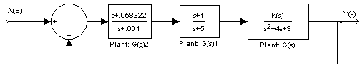
Figure 3: Final system

Then, the final transfer function is
$H_{\text{final}}(s)=\frac{K(s+\text{.}\text{058322})}{(s+\text{.}\text{001})(s+3)(s+5)}$ (Equation17)
Knowing the k_{p,requirement} solved in Equation 15, the K value of the final system can be determined using Equation 18. K=947.1
$k_{p,\text{requirement}}=\text{63}\text{.}\text{14}=\underset{s→0}{\text{lim}}\left[\frac{K}{(s+3)(s+5)}\right]$ (Equation18)

Part 4:
(4) Simulate the feedback system with the controller using MATLAB/Simulink. Did it meet the requirements? Show a superimposed plot of both the uncompensated and compensated responses.
- Matlab Root Locus Results

num2 = 1*poly([-.0587]);
den2 = poly([-3 -5 -0.001]);
rlocus(num2,den2)
axis([-6 0.5 -10 10])
title('Root Locus of Compensated System (D(s) introduced to system)');
sgrid(.591,6.768)

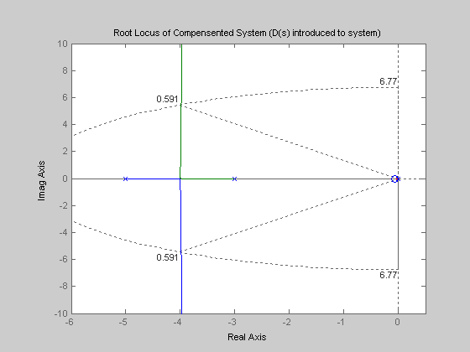

b) Matlab Superimposed plot of both the uncompensated and Compensated response

t=[0:0.01:5];
num1 = 16.36;
den1 = [1 4 3];
sys1 = tf(num1,den1)
sys1_feed = feedback(sys1, 1)
ys1 = step(sys1_feed, t);

num2 = 30.808*poly([-0.0587]);
den2 = poly([-0.0001 -3 -5]);
sys2 = tf(num2,den2)
sys2_feed = feedback(sys2, 1)
ys2 = step(sys2_feed, t);
hold on;
plot(t, ys1);
plot(t, ys2, 'r');
title('Plot of Superimposed of Compensated and Uncompensated System');
xlabel('Time')
ylabel('Magnitude')
grid on
hold off;

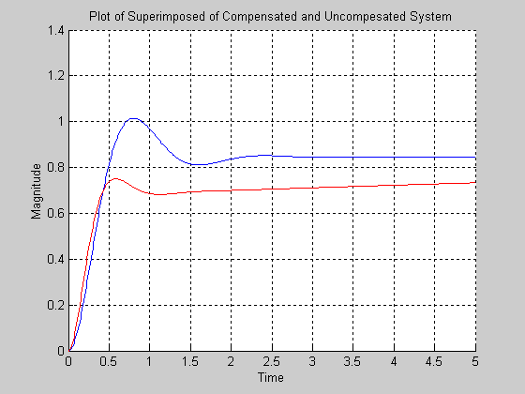

Check for Steady State Error:
t = [0: 0.01: 100];
sys2 = tf(num2,den2)
sys2_feed = feedback(sys2, 1)
ys2 = step(sys2_feed, t);
plot(t, ys2, 'r');
title('compensated system for a time 500 seconds \n (this shows the final value is at range of steady state error')
xlabel('Time')
ylabel('Magnitude')
grid on

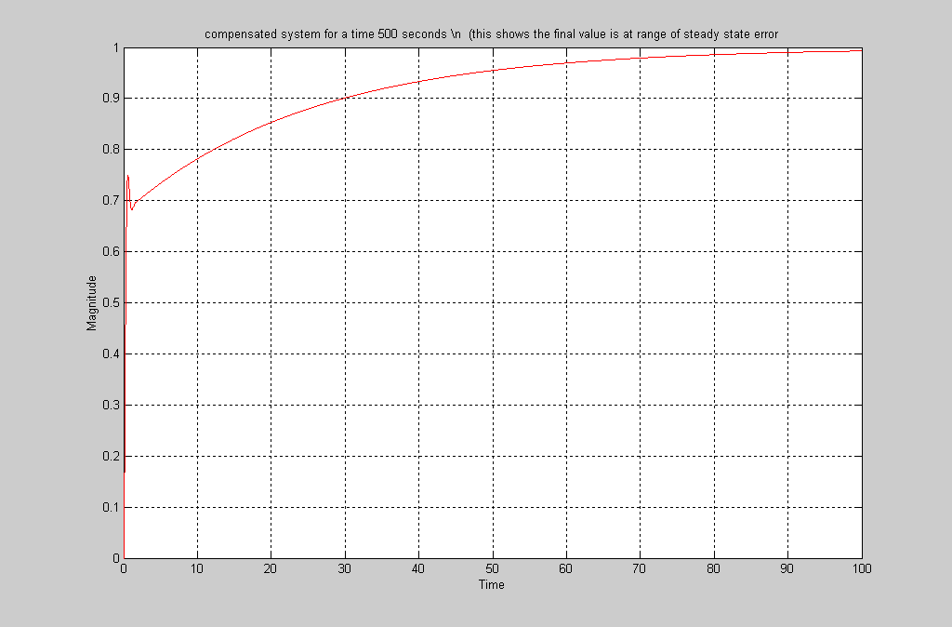

c) Simulink of Compensated and Uncompensated systems:

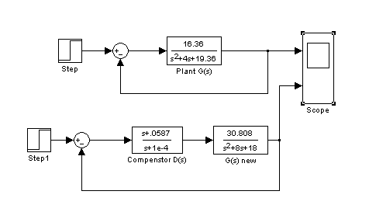

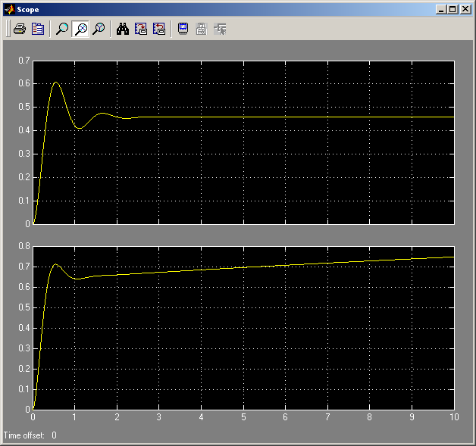

Discussion for part I & II:
Let us first discuss about the requirements for our system, which are: %OS = 20%, Ts = 2sec. We are looking for the K value for our G(s) function; also, we are looking for the steady state error at this K value. We first determine the real axes intercepts by using the formula of settling time (Ts); another word, since we have already known the value for Ts, which is 2sec, we are using it formula to calculate backward to find the real axes intercepts, which is –2 (see attachment for calculation). After that, since we were given with the percent overshoot (%OS) of 20%, from this 20% overshoot we can calculate the damping ratio, which we found to be .4559. We are now completing the equation for our real axes intercepts, which is -2 +/- j3.904. We also found the angle from the real axes to the real axes intercept was 62.87 degree. So far, what we found is shown in the figure below (Please disregard the scale for the imagine axis):

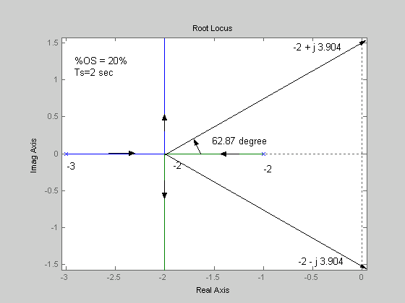

From all the calculation results above, let us move on and calculate the value of K. By matching the new transfer function (from the real axes intercept) with the original transfer function, we have found K is equal to 16.24. Also, we found that steady state error-e step-equal to .1559; e ramp and e parabola is equal to infinity; therefore, we conclude that this system is type O error system.
For the Matlab/simulink part, we have observed that the results from our Matlab is very close to our hand calculating results

Discussion for part III & IV:

In these parts, we are considering the transfer function, G(s), we have found in part (I) and (II) to be plant. However, the settling time Ts is setting for 1 sec, percent overshoot is equal to 10%, and steady state error is setting to .01559 (reduce by factor of 10 from part 1 & 2) as the requirement for our system. Therefore we need to design the compensator for our system, which will meet the three requirements. Similarity as part 1 and 2, we start out with calculating the damping ratio and Wn; after that we found the real axes intercepts to be –4 +/- j5.457. By adjusting the K value by itself we cannot meet all the requirements for our design. So, we have to design the compensator (sub-system) to adjust the original transfer function, G(s), to meet all the requirements of this design. We choose the numerator of our compensator match with the denominator of our original transfer function; the purpose of doing this was to try to cancel out one of the pole in our original G(s). So, we choose a =1 and therefore our b = 5 for our compensator. Now, we are getting a new transfer function G(s), from this G(s) we found the transfer function H(s). By mapping this transfer function (Hnew(s)) with the original transfer function we found our new K to be 30.779. However, we still need to meet the requirement of estep=. 01559, but what we got for our estep from our first compensator is found to be .3276. So, we need to reshape our compensator by design another sub-system that will allow us to meet this particular requirement. We found our Kp from K=30.779 to be 2.052; but since we need our estep to be .01559, we work backward and found the Kp value that will allow us to meet .01559 requirement was to be 63.14. And so, therefore, by mapping this new Kp with the values for our new sub-system for our compensator, which is a/b=58.322. And after testing our system with many different values for a and b accordingly to a/b=58.322 we have found that a=. 058322 and b=. 001 is giving us the best results for our root locus. Please see attachment of calculation to get a better point of view for this part.

Conclusion:

Through this project, we have learned how to design a control system using Root locus to improve the time response. Our Matlab/simulink’s results are very close to our actual hand calculation. Root Locus is helpful to control system when we model something that we never seen it like Black Box in the airplane or any other complex systems in real life.

