Project Design Results of Matlab and Simulink:

Matlab Portion:

%Tan Nguyen, Trang Pham, Nhan Phan
%ECE 460
%WINTER 2003
%Project I
%Part I without a controller D(s)
clc
clear
t=[0:0.01:4];
num=[12.1846];
den=[1 4.127 12.1846];
sys=tf(num,den)
ys=step(sys,t);
plot(t,ys)
title(' Step Response of Part I without the Controller ');
xlabel('Time in second');
ylabel('Magnitude');
grid on
[tp,os,ts]=tposts(t,ys)

Transfer function:
12.18
---------------------
s^2 + 4.127 s + 12.18
tp =
1.1200
os =
0.0999
ts =
1.7000
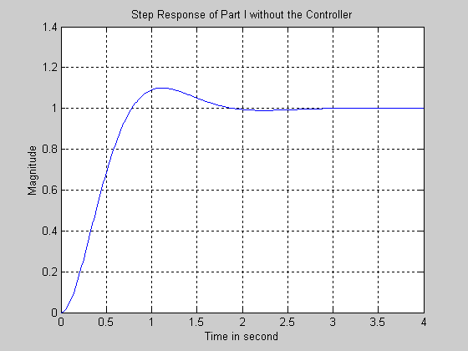

%Tan Nguyen, Trang Pham, Nhan Phan
%ECE 460
%WINTER 2003
%Project I
%Part I without a controller D(s)
clc
clear
t=[0:0.01:4];
num=[12.12];
den=[1 4.127 12.12];
sys=tf(num,den);
ys=step(sys,t);
pzmap(num,den);
title('The Pole-zero Map of Part I without the Controller');
grid on
[p,z]=pzmap(num,den)

p =
-2.0635 + 2.8039i
-2.0635 - 2.8039i

z =
Empty matrix: 0-by-1
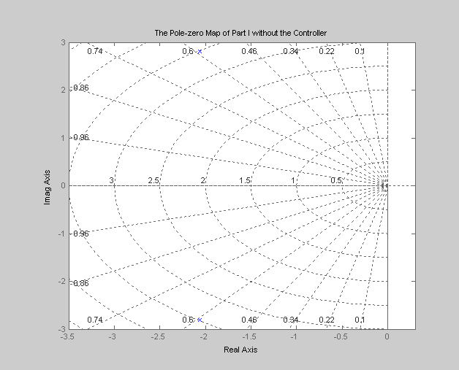

%Tan Nguyen, Trang Pham, Nhan Phan
%ECE 460
%WINTER 2003
%Project I
%Part II with a controller D(s)
clc
clear
t=[0:0.01:2];
num=[80.4184];
den=[1 12.3753 80.4184];
sys=tf(num,den)
ys=step(sys,t);
plot(t,ys)
title(' Step Response of Part II with the Controller D(s)');
xlabel('Time in second');
ylabel('Magnitude');
grid on
[tp,os,ts]=tposts(t,ys)

Transfer function:
80.42
---------------------
s^2 + 12.38 s + 80.42
tp =
0.4800
os =
0.0500
ts =
0.6700
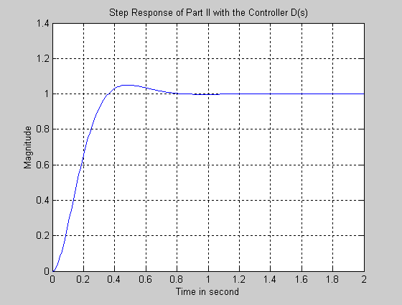

%Tan Nguyen, Trang Pham, Nhan Phan
%ECE 460
%WINTER 2003
%Project I
%Part II with a controller D(s)
clc
clear
t=[0:0.01:2];
num=[80.4184];
den=[1 12.3753 80.4184];
sys=tf(num,den);
pzmap(num,den);
title('The Pole-zero Map of Part II with the Controller D(s)');
grid on
[p,z]=pzmap(num,den)

p =
-6.1876 + 6.4909i
-6.1876 - 6.4909i
z =
Empty matrix: 0-by-1

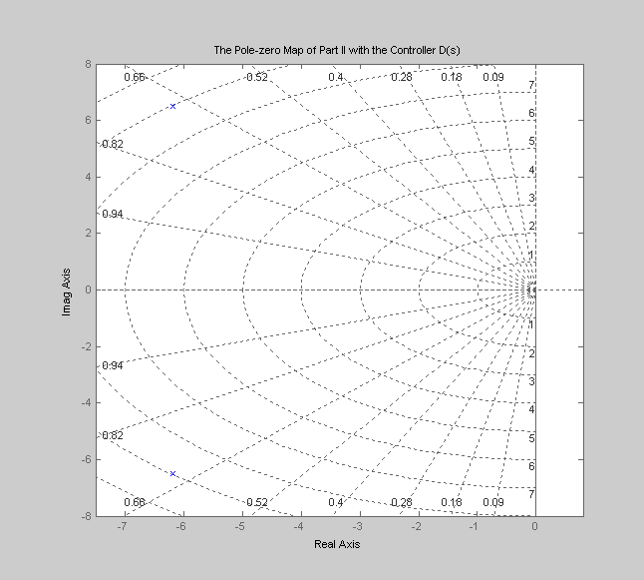

Simulink Portion:
