DESIGN ASSIGNMENT 1: DESIGN FOR A TIME RESPONSE

Part 1:

A control system is illustrated in the following block system diagram:

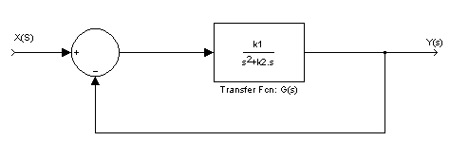

Problem Statement:
(1) Design the transfer function G(s) in the form of $G(s)=\frac{k_{1}}{s(s+k_{2})}$ so that the system’s step response has an overshoot (OS) of exactly 10% and a settling time (Ts) of 2 second. Also, determine the closed loop transfer function. Discuss the location of the closed loop poles and what effects it has on the time response. Evaluate the Steady-state error and system type.

Design Method:

When designing a control system, one must first look at the requirements that are given to determine the variable needed. The canonical for a 2nd order transfer function is shown in Equation 1. To design this control system $ζ$(zeta) and Wn (the natural frequency) must be found.

$\frac{W_{n^{2}}}{S^{2}+2{ξW}_{n}S+W_{n^{2}}}$ (Equation 1)

It was shown that $ζ$ can be found by picking a % OS and solving for equation below. A % OS of %10 was used so that rounding would not be a factor when meeting the requirements. Solving Equation 2 gave a $ζ$=0.591155.

$\text{\%}\text{10}=e\hat{−(}\text{ξπ}\sqrt{1−ξ^{2}})∗\text{100}$ (Equation 2)

The next step was to find W_{n} with given value of Ts equal 2 seconds and calculated value of $ζ$ found in Equation 2. Solving Equation 3 gave a W_{n}=3.490656 rad/s

$2=\frac{−\text{ln}(\text{.}\text{02}\sqrt{1−ξ^{2}})}{{ξW}_{n}}$ (Equation 3)

After Wn and $ζ$ were found, the close loop transfer function for the system could be derived using Equation 4. The step response for this equation was then graph in Matlab. The calculated Matlab results, m-file, and graph are on the attached sheets.

$H(s)=\frac{W_{n^{2}}}{S^{2}+2{ξW}_{n}S+W_{n^{2}}}≈\frac{k_{1}}{S^{2}+k_{2}S+k_{1}}=\frac{\text{12}\text{.}\text{1846}}{S^{2}+4\text{.}\text{127}S+\text{12}\text{.}\text{1846}}$ (Equation 4)

The last task was to evaluate the steady state error for a step, ramp, and parabolic input. This was not a difficult task because the G(s) was already given, and k₁ and k₂ were already found. We first evaluate the system type k_{p}, k_{v}, and k_{a}. Then the steady errors could be found as below $e_{\text{step}}(∞)=0,$$e_{\text{ramp}}(∞)=0\text{.}\text{3387},$ and $e_{\text{parabolic}}(∞)=∞,$ which indicated the system is type 1.

Evaluate $k_{p}=\underset{s→0}{\text{lim}}G(s)=\frac{k_{1}}{0}=∞$ and $e(∞)=e_{\text{step}}(∞)=\frac{1}{1+k_{p}}=0$

$k_{v}=\underset{s→0}{\text{lim}}\text{SG}(s)=\frac{k_{1}}{k_{2}}=2\text{.}\text{952}$ and $e(∞)=e_{\text{ramp}}(∞)=\frac{1}{k_{v}}=0\text{.}\text{3387}$

$k_{a}=\underset{s→0}{\text{lim}}S^{2}G(s)=\frac{0}{k_{2}}=0$ and $e(∞)=e_{\text{parabolic}}(∞)=\frac{1}{k_{a}}=∞$

Part 2: Matlab & Simulink Portion

I. Matlab/Results

%Tan Nguyen, Trang Pham, Nhan Phan
%ECE 460
%WINTER 2003
%Project I
%Part I without a controller D(s)
clc
clear
t=[0:0.01:4];
num=[12.1846];
den=[1 4.127 12.1846];
sys=tf(num,den)
ys=step(sys,t);
plot(t,ys)
title(' Step Response of Part I without the Controller ');
xlabel('Time in second');
ylabel('Magnitude');
grid on
[tp,os,ts]=tposts(t,ys)

Transfer function:
12.18
---------------------
s^2 + 4.127 s + 12.18
tp =
1.1200
os =
0.0999
ts =
1.7000
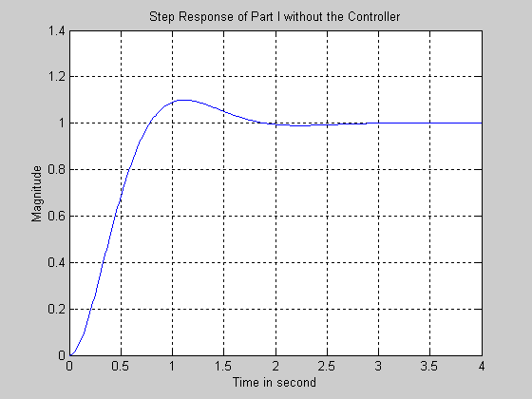

%Tan Nguyen, Trang Pham, Nhan Phan
%ECE 460
%WINTER 2003
%Project I
%Part I without a controller D(s)
clc
clear
t=[0:0.01:4];
num=[12.12];
den=[1 4.127 12.12];
sys=tf(num,den);
ys=step(sys,t);
pzmap(num,den);
title('The Pole-zero Map of Part I without the Controller');
grid on
[p,z]=pzmap(num,den)

p =
-2.0635 + 2.8039i
-2.0635 - 2.8039i

z =
Empty matrix: 0-by-1
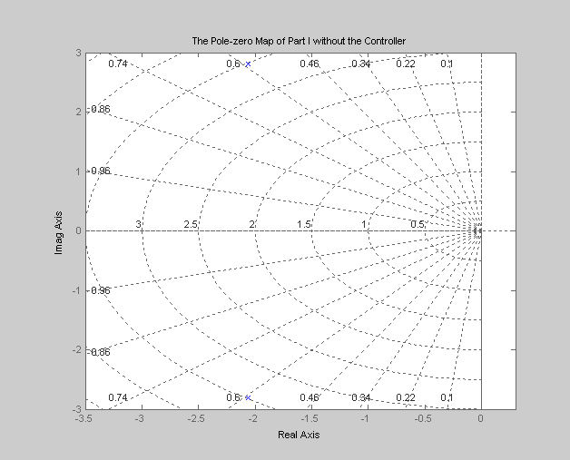

II. Simulink/Results

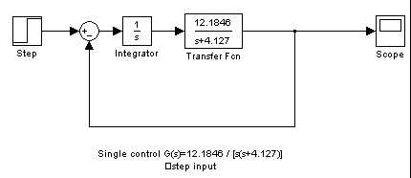

Go to school simulate the Simulink for this and plot it then copy the plot paste it into here.

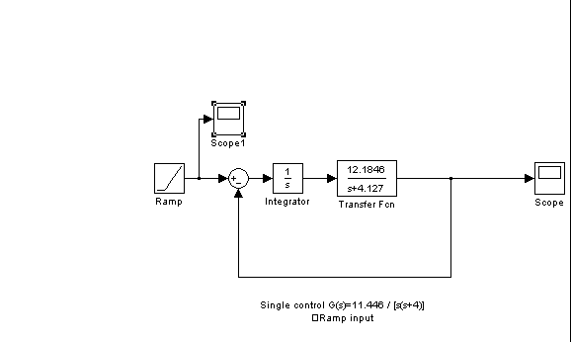

Go to school simulate the Simulink for this and plot it then copy the plot paste it into here. NB: Using orginal and output to comare them(Scope 1 and scope 2 plot) for E ramp comparison.

Discussion:

Part 1&2:

With the control system of %OS equal 10 and settling time is 2 seconds; we were able to find the close loop transfer function. To determine if our overshoot and settling time value were accurate, the Matlab function tposts was used. Our Matlab result of overshoot value is 9.9% which is very close to theoretical value. However, the settling time result in Matlab is 1.78 seconds, which is a little off. The cause for this discrepancy was when the transfer function is evaluated in Matlab; it only takes the first four significant numbers and rounds the least significant of the four. Please see our Matlab/Simulink of part 2 for result. From the transfer function found in equation 4, G(s) was easily determine and was used to evaluate the and steady state errors of step, ramp, and parabolic input. The result of steady state error indicated the system is Type 1. Base on Equation 4, the poles of this system are two complex poles ( -2.0635+j2.815, -2.0635-j2.815), which indicated the system is Underdamped responses. The damped sinusoid with exponential envelope whose time constant is equal to the reciprocal of the pole’s real part (-2.0635). The radian frequency of the sinusoid, the damped frequency of oscillation, is equal to the imaginary part of the poles (j2.815, -j2.815). Since our (damping ratio) $ζ$=0.591155, a constant value and constant overshoot (10%). The time response would look exactly the same, except for their speed. This mean as the two complex poles increased or the farther the poles are from the origin, the more rapid the response.

Part 3:
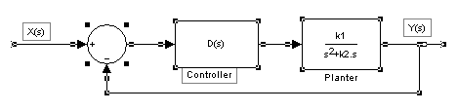

Problem Statement:

Now consider a second system show above. The transfer function, G(s), cannot be changed. To improve the time response, a controller, D(s), is added in series and takes the form $D(s)=\frac{6\text{.}6(s+k_{2})}{(s+p)}$ where the k₂ is the same from part 1. Find the pole location that will reduce the %OS by a factor of two and the settling time by a factor of 3 in the step response. What is the new close loop transfer function? Discuss the location of the new poles and how they improve the time response. What is the system type? Evaluate steady state error?

Design Method:

To form the new design block system above G₁(s) was created as such:

G₁(s) =D(s) G(s) = $\frac{6\text{.}6(s+k_{2})}{s+p}$*$\frac{k_{1}}{s(s+k_{2})}$=$\frac{6\text{.}6k_{1}}{S^{2}+\text{pS}}$ . Notice that we cancelled out the two identical zero and pole of (s+k₂) in order to have a new G₁(s) system.

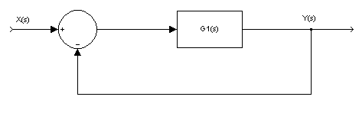
Since the system is a negative feed back, the transfer function can be found using Equation 5
$H_{\text{new}}(s)=\frac{Y(s)}{X(s)}=\frac{6\text{.}6k_{1}}{s(s+p)+6\text{.}6k_{1}}$ (Equation 5)

Since the %OS is now by a factor of two, which mean 10/2 is 5%. Using Equation 6 below and solve for $ζ$_{new}=0.690.
$\text{\%}5=e^{−}(\text{ξπ}\sqrt{1−ξ^{2}})∗\text{100}$ (Equation 6)

Again, the next step is to find W_{n(new).} With the new settling time of Ts= (2/3) second, solving for Equation 7 gave W_{n (new)} =9.20707

$(2/3)=\frac{−\text{ln}(\text{.}\text{02}\sqrt{1−ξ^{2}})}{{ξW}_{n(\text{new})}}$ (Equation 7)

Taking variables found in Equation 5 to 7, we now can find the new pole (p). Solving Equation 8 gave p=12.7058.

$ξ=\frac{a}{2W_{n(\text{new})}}=\frac{p}{2W_{n(\text{new})}}$ (Equation 8)

Finally, the new close loop transfer function of second order system can be derive using Equation 9

$H_{\text{new}}(s)=$$\frac{W_{n_{(\text{new})}^{2}}}{S^{2}+2{ξW}_{n(\text{new})}S+W_{n_{(\text{new})}^{2}}}=\frac{\text{84}\text{.}\text{7701}}{S^{2}+\text{12}\text{.}\text{7058}S+\text{84}\text{.}\text{7701}}$ (Equation 9)

From the result of Equation 9, G₁(s) can be found using Equation 10

G₁(s) =$\frac{6\text{.}6k_{1}}{S^{2}+\text{pS}}$ $=\frac{\text{84}\text{.}\text{7701}}{S^{2}+\text{12}\text{.}\text{7058}S}$ (Equation 10)

The next step is to evaluate steady state error, for a step, ramp, and parabolic input as show below. Similar to part 1, we first evaluate the system type k_{p}, k_{v}, and k_{a}. Then the steady errors gave $e_{\text{step}}(∞)=0,$$e_{\text{ramp}}(∞)=0\text{.}\text{1499},$ and $e_{\text{parabolic}}(∞)=∞,$ which indicated the system is type 1.

$k_{v}=\underset{s→0}{\text{lim}}G(s)=\frac{\text{84}\text{.}\text{7701}}{0}=∞$ and $e(∞)=e_{\text{step}}(∞)=\frac{1}{1+k_{p}}=0$
$k_{v}=\underset{s→0}{\text{lim}}\text{SG}(s)=\frac{\text{84}\text{.}\text{7701}}{\text{12}\text{.}\text{7058}}=6\text{.}\text{6718}$ and $e(∞)=e_{\text{ramp}}(∞)=\frac{1}{k_{v}}=0\text{.}\text{1499}$
$k_{a}=\underset{s→0}{\text{lim}}S^{2}G(s)=\frac{0}{\text{12}\text{.}\text{7058}}=0$ and $e(∞)=e_{\text{parabolic}}(∞)=\frac{1}{k_{a}}=∞$

Part 4: Matlab & Simulink Portion

I. Matlab/Results

%Tan Nguyen, Trang Pham, Nhan Phan
%ECE 460
%WINTER 2003
%Project I
%Part III with a controller D(s)
clc
clear
t=[0:0.01:2];
num=[80.4184];
den=[1 12.3753 80.4184];
sys=tf(num,den)
ys=step(sys,t);
plot(t,ys)
title(' Step Response of Part III with the Controller D(s)');
xlabel('Time in second');
ylabel('Magnitude');
grid on
[tp,os,ts]=tposts(t,ys)

Transfer function:
80.42
---------------------
s^2 + 12.38 s + 80.42
tp =
0.4800
os =
0.0500
ts =
0.6700
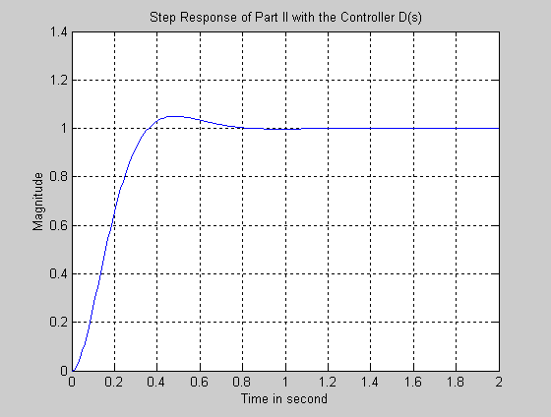

fix the title of this graph in the matlab m-files by copying the above file then simulate it okie Part III instead of Part II

%Tan Nguyen, Trang Pham, Nhan Phan
%ECE 460
%WINTER 2003
%Project I
%Part III with a controller D(s)
clc
clear
t=[0:0.01:2];
num=[80.4184];
den=[1 12.3753 80.4184];
sys=tf(num,den);
pzmap(num,den);
title('The Pole-zero Map of Part III with the Controller D(s)');
grid on
[p,z]=pzmap(num,den)

p =
-6.1876 + 6.4909i
-6.1876 - 6.4909i
z =
Empty matrix: 0-by-1

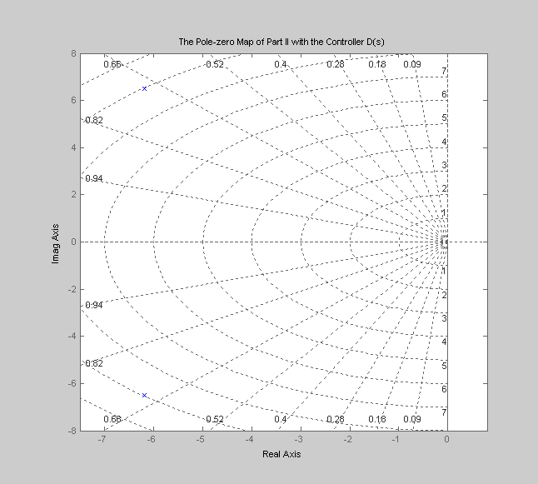
Fix the title of this one also Part III instead of part II

II. Simulink/Results
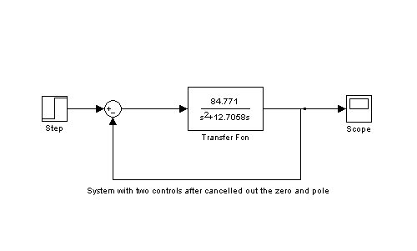

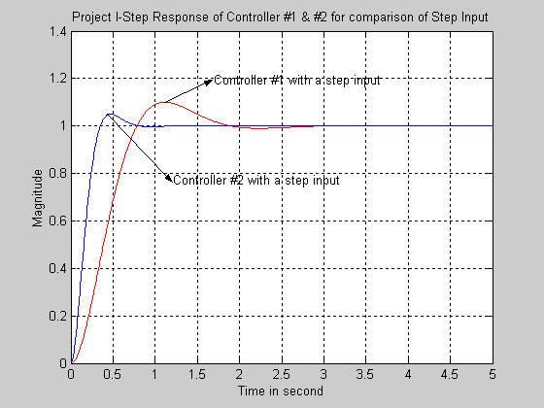

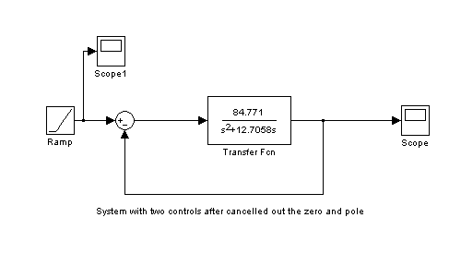

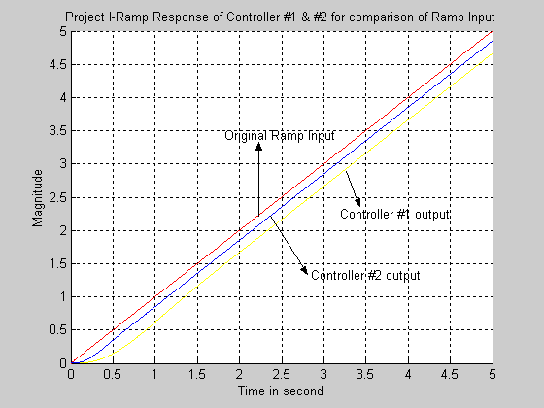
fix this figure in Simulink then replot then copy and paste it into here Only orginal and output of controller #2 plot can be put it here

Discussion:

Part 3&4:

A controller is now added to the system to improve the time response. Using the new requirements of %OS equal 5 and settling time is 2/3 seconds gave us a new close loop transfer function in Equation 9. Similar to Part 1&2 above, we used Matlab function tposts to compare experiment results to theoretical result. Our Matlab result of overshoot and settling time value are exactly the same to theoretical value. This indicated our system work perfectly. Please see the Matlab/Simulink of part 4 above to clarify this result. From the Equation 10, G₁(s) was used to evaluate the steady state errors of step, ramp, and parabolic input. Since the control system has the specification K_{v}=6.6718, we can draw several conclusion. The system is stable and is of Type 1, because only Type 1 systems have K_{v}’s that are finite constants. A ramp input is the test signal since the steady state error for a ramp input is inversely proportional to K_{v}. The steady error of the ramp input is now 0.1499, which is an improvement or much less error compare to steady sate error in Part 1&2 of ramp input [$e_{\text{ramp}}(∞)=0\text{.}\text{3378}$ ]. Base on Equation 9, the poles of this system are two complex poles (-6.353+j6.664, -6.353- j6.664), which indicated the system is Underdamped responses. Since our complex poles has increased compare to previous system in Part 1&2, the poles are now farther away from the origin, which cause the time response reached to steady state more rapid and faster than in the control system of Part 1&2.

Conclusion:

In this time response project, we had learned how to design the feedback control system with given specific parameters of overshoot and settling time. On the basis of a system configuration and a group of selected test signals, namely steps, ramps, and parabolas, we can analyze or design for the system’s steady state error performance. We also learned that the steady-state error of ramp input in Part 3&4 is smaller than the steady-state error of ramp input in Part 1&2. The reason for this was due to smaller %OS and smaller settling time in Part 3&4 compared to Part 1&2. Also, since the two complex poles in Part 3&4 had increased compare two complex poles in Part 1&2, the time it take the time response to reach steady state is quicker.

