ECE 460 |  |  | 21 January 2003
Lab 1:
Introduction to Matlab


Winter 2003

Lab Proctor: Lance Slifka

“We have neither given nor received aid in the preparation of this lab report.”
 | Prepared by
Tan Nguyen  tannguyen_79@yahoo.com |  | ____________________________
Trang Pham  annap@umd.umich.edu |  | ____________________________
Nhan Phan |  | ____________________________

Theory:

MATLAB is a high performance language for technical computing. It integrates computation, visualization and programming in an easy-to-use environment where problems and solutions are expressed in familiar mathematical notation. It is particularly convenient for modeling, simulation, analysis, and design of dynamic control systems.

Objective:
To give the student a quick introduction to MATLAB, enable students to use the software from the very beginning of the Control systems course.

Procedure/Results:
Part A: Examples of Command line entries:
In the command window, Matlab commands are extended as soon as the return key is pressed. The following is a sequence of possible command line entries.

%Report Item #1
%To get started with MATLAB recreate the following transactions and save them (in %diary) for the report.
%Example 1- Scalars, vectors and matrices
>> %Example 1- Scalars, vectors and matrices
a=2.5 %Assigns a scalar value to the variable "a"
a=[1 2 3] % "[]" signify a vector or a matrix
a=[1, 2, 3] % both "," and "bland space" act as delimiters; extra spaces are ignored
a=[1 2 3;4 5 6;7 8 10] % a ";" signifies end of a row of the matrix
f=a(2,1) %The element in Row 2 and Column 1 of matrix "a"
g=a(2:3,2) %Will assign elements in row2 to 3 and column 2 of "a" to the variable "g"
h=a(2,2:3) %Will assign elements in row 2 and columns 2 to 3 of "a" to the variable "h"
b=[1 2;3 4]; % The semicolon after ] suppresses printing on screen of the value of "b"
d=inv(b) %Matlab will compute the inverse of matrix "b" and assign it to "d" and print it.

a =
2.5000
a =
1 2 3
a =
1 2 3
a =
1 2 3
4 5 6
7 8 10
f =
4

g =
5
8
h =
5 6
d =
-2.0000 1.0000
1.5000 -0.5000
************************************************************************
%Example 2- Plotting graphs and repetitive computations.
t=[0: 0.1:20]'; % "t" is a column vector with elements 0,.1,.2,...,20 - a total of 201 elements
for i= 1:1:201
x(i)=sin(t(i))*(t(i)^2);
end
y=sin(t).*(t.^2); % alternate approach. Note that x=y=t^2sin(t). Second method is more efficient
% The column vectors x and y are identical vectors of dimension 201. y is generated by using
%array operators, an efficient way of performing repetitive computations.
plot(t,x)
%This command plots a x vs. t graph. With the graph window active, the plot can be printed
%(just use the print command in the File menu). Next plot y vs. t for comparison.
plot(t,y)
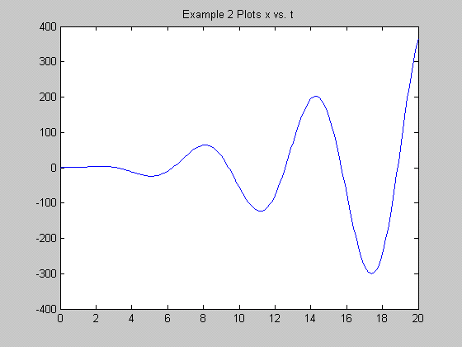
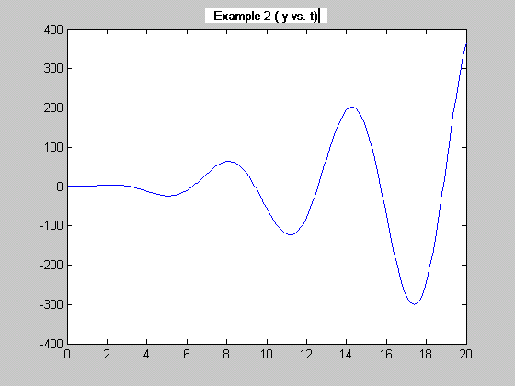

************************************************************************
%Example 3-Complex Arithmetic
z=1+2i %Assigns a complex value to z;
r=abs(z) %absolute value or magnitude of z
theta=angle(z) %angle of z in radians; multiply by (180/pi) for angle in degrees
fz=(z+1)/(z*(z^2-4*z+5)*(z-1)); %Evaluating complex expression;
%F(z)=(z+1)/z(z^2-4z+5)(z-1)
fz
z =
1.0000 + 2.0000i
r =
2.2361
theta =
1.1071
fz =
0.1400 + 0.0200i
************************************************************************
%Example 4-Factoring Polynomials
%F(s)=s^3+6s^2+11s+6. We want to factor this polynomial.
%In Matlab polynomials are defined as row vectors of the polynomial coefficients.
pol1=[1 6 11 6];
rt1=roots(pol1); % computes the roots and store the result in rl1 without
%printing on screen.
rt1
pol2=[1 4 4]; rt2=roots(pol2) % We may have more than one command
%(statement) in a line.
%Note: no ";' at the end of rt2 statement. If there is no ';'
%Matlab prints the value of the variable
pol3=[1 1 1]; rt3=roots(pol3)
f1=poly(rt1); %Given the roots, this will compute the polynomial coeffs.
f1

rt1 =
-3.0000
-2.0000
-1.0000
rt2 =
-2
-2
rt3 =
-0.5000 + 0.8660i
-0.5000 - 0.8660i
f1 =
1.0000 6.0000 11.0000 6.0000
************************************************************************
%Example 5- Partial Fraction Expansion.
%Given a ratio of polynomials, G(s)=(3s+7)/(s^3+6s^2+11s+6), determine the
%corresponding PFE.
%This is done by first defining the numerator and denominator polynomials
num1=[3 7];
den1=[1 6 11 6];
[r,p,k]=residue(num1,den1);
%r is the vector of PFE coefficients; p is the vector of roots of den1;
%and k=0 if the degree of num1 < the degree of den1.
r
p
k

r =
-1.0000
-1.0000
2.0000
p =
-3.0000
-2.0000
-1.0000
k =
[]

%Example 6 - Plotting functions revisited.
%Generate and plot the function; f(t)=1-2e^(-0.24t)cos(2t)
t=[0:0.1:20];
f=1-2*exp(-.24*t).*(cos(2*t));
% Array operator ".*" is needed to multiply two vectors element by element
plot(t,f)
xlabel('The t axis')
ylabel('The f axis')
title('The plot of f versus t')
grid on
diary off % the file lab1.txt is closed

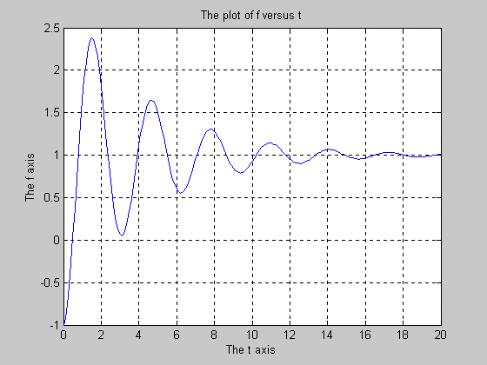

Part B: MATHLAB Programming:
Files that contain MATHLAB language code are called M-files can be functions that accept arguments and produce output, or they can be scripts that execute a series of MATHLAB statements. We create M-files using a text editor, then use them as any other MATHLAB function of command.

%Report Item #3
% Rework example 6 Generate and plot the function : f(t)=1-2e^(-.24t) cos(2t)
t=[0:0.1:20];
f=1-2*exp(-.24*t).*(cos(2*t)); % .* multiply 2 vectors element by element
plot(t,f)
hold on % holds the graph for superimposed plots
plot(t,(1+2*exp(-0.24*t)),'--') % gives a dashed line plot
plot(t,(1-2*exp(-0.24*t)),'--') % ""
xlabel(' The t axis')
ylabel(' The f axis')
title('The plot of f versus t by second method')
grid on;
hold off; % removes the hold for future plots
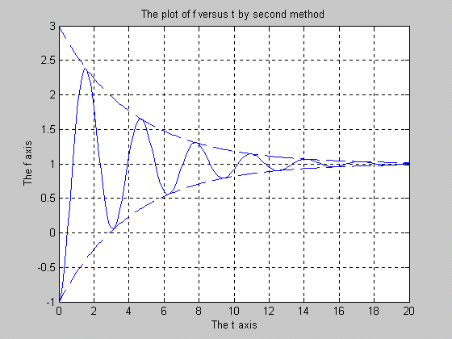

************************************************************************
% Report Item #4. Write function m-file prompts user for a positive
% integer input, and return the sum of integer from 1 to n.
%function m-file int_sum.m
function y=int_sum(x) %first line of a function m-file must be the function statement
n=input('Type an integer and hit return: ') % prompting for an input
if ((n-abs(round(n)))~=0) %check if input is not a positive integer
error('Input is not a positive integer') %if so, give error message
else s=sum(1:n) % evaluate and print the sum
end

%Report Item #5
%Determine the roots of the following polynomials using MATLAB roots function:
%a) P1(s)=s^3+6s^2+11s+6
pol1=[1 6 11 6];
rt1=roots(pol1);
rt1
f1=poly(rt1); %Reconstruct the polynomials using the poly function
f1
%b) P2(s)=s^4+s^3-3s^2-s+2
pol2=[1 1 -3 -1 2];
rt2=roots(pol2);
rt2
f2=poly(rt2); %Reconstruct the polynomials using the poly function
f2
%c)P3(s)=s^6+s^5-2s^4-3s^3-7s^2-4s-4
pol3=[1 1 -2 -3 -7 -4 -4 ];
rt3=roots(pol3);
rt3
f3=poly(rt3); %Reconstruct the polynomials using the poly function
f3
%d)P4(s)=2s^4+4s^3+8s^2+8s+4
pol4=[2 4 8 8 4];
rt4=roots(pol4);
rt4
f4=poly(rt4); %Reconstruct the polynomials using the poly function
f4

rt1 =
-3.0000
-2.0000
-1.0000
f1 =
1.0000 6.0000 11.0000 6.0000
rt2 =
-2.0000
-1.0000
1.0000
1.0000
f2 =
1.0000 1.0000 -3.0000 -1.0000 2.0000
rt3 =
2.0000
-2.0000
-0.0000 + 1.0000i
-0.0000 - 1.0000i
-0.5000 + 0.8660i
-0.5000 - 0.8660i
f3 =
Columns 1 through 5
1.0000 1.0000 -2.0000 -3.0000 -7.0000
Columns 6 through 7
-4.0000 -4.0000
rt4 =
-0.2571 + 1.5291i
-0.2571 - 1.5291i
-0.7429 + 0.5291i
-0.7429 - 0.5291i
f4 =
1.0000 2.0000 4.0000 4.0000 2.0000
************************************************************************
%Report Item #6
%Find partial fraction expansion for the following ratios of
%polynomials with pencil and paper, and verify the results using MATLAB.
%a) F1(s)=(s+3)/(s+1)(s+2)
num1=[1 3];
den1=[1 3 2];
[r,p,k]=residue(num1,den1);
%r is the vector of PFE coefficients; P is the vector of roots of den1;
% and k=0 if the degree of num1< the degree of den1;
r
p
k
%b) F2(s)=(5s+3)/(s^3+6s^2+11s+6)
num2=[5 3];
den2=[1 6 11 6];
[r,p,k]=residue(num2,den2);
%r is the vector of PFE coefficients; P is the vector of roots of den1;
% and k=0 if the degree of num1< the degree of den1;
r
p
k
%c) F3(s)=(2s+12)/(s^2+2s+5)
num3=[2 12];
den3=[1 2 5];
[r,p,k]=residue(num3,den3);
%r is the vector of PFE coefficients; P is the vector of roots of den1;
% and k=0 if the degree of num1< the degree of den1;
r
p
k
%d) F4(s)=(s^2+2s+3)/(s+1)^3
num4=[1 2 3];
den4=[1 3 3 1];
[r,p,k]=residue(num4,den4);
%r is the vector of PFE coefficients; P is the vector of roots of den1;
% and k=0 if the degree of num1< the degree of den1;
r
p
k

r =
-1
2
p =
-2
-1
k =
[]
r =
-6.0000
7.0000
-1.0000
p =
-3.0000
-2.0000
-1.0000
k =
[]
r =
1.0000 - 2.5000i
1.0000 + 2.5000i
p =
-1.0000 + 2.0000i
-1.0000 - 2.0000i
k =
[]
r =
1.0000
0.0000
2.0000
p =
-1.0000
-1.0000
-1.0000
k =
[]

************************************************************************
%Report Item #7
% Compute and plot the following functions on the same page using subplot command.
%Be sure to include labels, tile, and grid for each plot. Use t2=[0:0.1:99]'.
%Use a script m-file to do this exercise.
%a) x(t2)=(12t2^2+2.3t2+5)e^(-.1t2) vs. t2
t2=[0:0.1:99]';
x=(12*(t2.^2)+2.3*t2+5).*exp(-0.1*t2);
subplot(2,2,1); plot(t2,x)
xlabel(' The t2 axis')
ylabel(' The x(t2) axis')
title('The plot of x(t2) versus t2 ')
grid on

%b)y(t2)=(12t2^2+2.3t2+5)e^(-0.1t2 vs. t2
y=1-exp(-0.04*t2).*(cos(0.2*t2)+(0.19*sin(0.2*t2)));
subplot(2,2,2); plot(t2,y)
xlabel('The t2 axis')
ylabel('The y(t2) axis')
title(' The plot of y(t2) versus t2')
grid on

%c)h(t2) vs. g(t2) where g(t2) =2t2cos(0.2t2) and h(t2)= t2sin(0.2t2).
h=t2.*(sin(0.2*t2));
g=2*t2.*(cos(0.2*t2));
grid on
subplot(2,2,3); plot(g,h)
xlabel('The g(t2) axis')
ylabel('The h(t2) axis')
title('The plot of h(t2) versus g(t2)')
grid on

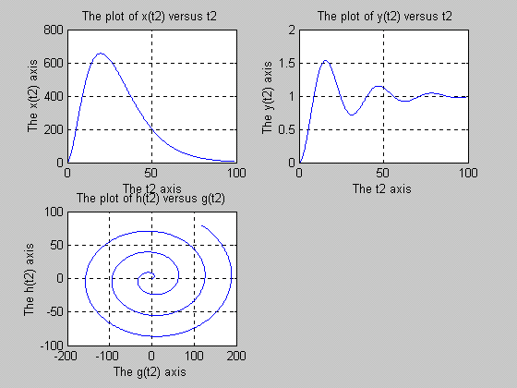

Part C: Explore other MATHLAB commands and functions

Explore help command by simply entering help in command window. Then use the help command to explore other commands and functions, such as, format, load, save, real, imag, atan2, etc.

Report Item #8:
Briefly describe the commands format, load, and save.

Format:
MATLAB performs all computations in double precision. Use the format function to control the output format of the numeric values displayed in the Command Window. The format function affects only how numbers are displayed, not how MATLAB computes or save them. The specified format applies only to the current session. To maintain a format across sessions, use MATLAB preferences. Format by itself, changes the output format to the default type, short, which are 5-digit scaled, fixed-point values.

Load:
Loads all the variables from the MAT-file matlab.mat, if it exists, and returns an error if it doesn't exist. Load filename loads all the variables from filename given a full pathname or a MATLABPATH relative partial pathname. If filename has no extension, load looks for file named filename or filename.mat and treats it as a binary MAT-file. If filename has an extension other than .mat, load treats the file as ASCII data.

Save:
Save by itself, stores all workspace variables in a binary format in the current directory in a file named matlab.mat. Retrieve the data with load. MAT-files are double-precision, binary, MATLAB format files. They can be created on one machine and later read by MATLAB on another machine with a different floating-point format, retaining as much accuracy and range as the different formats allow. They can also be manipulated by other programs external to MATLAB. Save filename stores all workspace variables in the current directory in filename.mat. To save to another directory, use the full pathname for the filename. If filename is the special string stdio, the save command sends the data as standard output.

