ECE 473 - Embedded Systems
Homework #2

Solutions

Chapter 7 Questions:

Problem 1

a. ASCII "9" : hexadecimal $39: binary 00111001
ASCII "A" : hexadecimal $41: binary 01000001

s 0 1 2 3 4 5 6 7 p s s 0 1 2 3 4 5 6 7 p s

b. Bandwidth = (number of information bits/frame) / (total number of bits/frame) * baud rate
Bandwidth = (8/11)*9600 = 6981.8 baud

Problem 2

a. SCI transmit process

transmit

TxD=0

Wait 16 clock times
end

n=0
Wait 16 clock times

TxD=bn
Wait 16 clock times
n=n+1

TxD=1

Wait 16 clock times
n<=7?
yes
no
TxD=T8

b. SCI receive process

receive
end
RxD=1?
yes
Wait 8 clock times
RxD=1?
yes
no
n=0
Wait 16 clock times
Bn=RxD
n=n+1
n<=7?
yes
Wait 16 clock times
R8=RxD
Wait 16 clock times
RxD=0?
FE=1
yes
no
no

Problem 3

SPI run faster than SCI because it is a synchronous protocol, both devices operate the same clock that allows higher bandwidth, while SCI is asynchronous protocol, the devices have two separate clocks.

Problem 4

RS485 operates faster than RS232 and over longer distances because it is a balanced differential lines protocol, that uses 2 wires per signal, while RS232 is single ended.

Chapter 8 Questions:

Problem 1

IIL=1 mA
IIH=0.1 mA

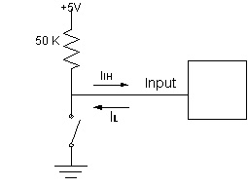
R = 5/IIH = 5 /0.0001 = 50 K

Problem 2

Algorithm:
Initialization:
- Disable interrupts
- Set PC7-PC4 as outputs
- Set PC3-PC0 as inputs
- Set PORTC to be open collector (CWOM=1)
- Enable STRA interrupt
- Enable interrupts
IRQ ISR Logic:
- Select a row by setting its corresponding output pin to a low state
- Read columns and check if 0 to see if key pressed
- Store all switches that have been pressed
- GOTO 1

Problem 3

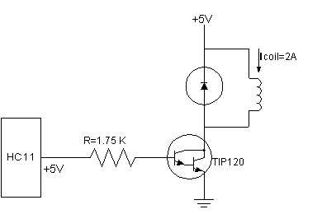

Ic=2A
hfe=1000
Ic=βIb=2A ; Ib=2/1000=2mA

5V-2*0.7V=R*Ib
0.002R=5-1.4=3.6V
R=3.6/0.002=1.8K

