
ECE 473 PROJECT
Professor Shaout
Winter 2003

Fan Controller

Nick Sitarski
Vladi Gergov

We have neither given nor received any unauthorized aid in this graded assignment.

____________________________________________________________________

_____________________________________________________________________

Requirement \Specifications:

- Input temperature value from sensor circuit ( Figure 1 ).
- Convert analog to digital value via table lookup to degrees Celsius ( Figure 2 ).
- Print to terminal sample of temperature every 20 ms.
- Check to see if the critical temperature has been reached and output warning to terminal.

Design:

Computers today operate at a high frequency and cooling the CPU can be a big challenge, especially in lap top computers. While wanting to keep the CPU cool, conservation of battery life is important. The objective of this project was to create a temperature monitor while at the same time dynamically controlling a fan (to conserve energy) and checking for dangerously high temperatures.

Note: See figures 3 through 6 to see the approach used when writing the code.

Hardware Used In Design:

- HC11 Microcontroller
- Thermistor
- Transistors
- Resistors
- Terminal Display

Implementation:

This project consisted of three threads listed below:

- The first thread does an analog to digital conversion and calculates the corresponding temperature using a look up table.
- The second thread waits a set time then prints the temperature to the screen.
- The third thread does a check to see if the temperature is above a set limit. If so a warning is sent to the screen.

Every time that an interrupt is triggered (from the PWM) a new thread is scheduled and all registers are saved to the stack for that thread. Scheduling different threads in an interrupt is another element that makes this project a real time operating system.

The deadlines are dynamic in nature because they change with temperature. The duty cycle consists of two parts, an on-time and an off-time. The on-time plus the off-time equals 20,000 cycles, 20,000 cycles is one duty cycle. When the motor is on and we go to an interrupt, along with scheduling the next thread, the motor is turned off and the time until the next interrupt is set. The higher the temperature, the longer the on-time portion of the duty cycle will run. When the motor is off and we go to an interrupt, the motor is turned on and the time is set until the next interrupt. The starting speed of the motor is a 50% duty cycle meaning the on-time cycle equals the off-time cycle at 10,000 cycles a piece. When the temperature goes up the on-time portion goes up and the off-time portion goes down. A dynamic time slice approach is used because each thread is given a set amount of time, however, this time (awarded to each thread) changes with temperature. A routine calculated all 256 analog to digital temperatures in the main routine. In the temperature thread, the temperature was looked up in a temperature array. Calculating analog to digital temperature values once in the beginning of the program and storing them in an array, saves time from calculating the temperature values every time the tread needs a new value. It is much quicker to look a temperature up from an array than to try to calculate the temperature every time.

When the temperature goes up the analog to digital reading goes down. However, it would be good to have the voltage go up as the temperature goes up. To correct this situation take 255 (the highest analog to digital voltage) and subtract the voltage read by the analog to digital converter. Also, multiplying the resulting voltage by a constant will give more of a spread in on-time and off-time than the 0 to 255 values given by the analog to digital converter. The last thing that is done to the on-time is and the starting 10,000 cycles. For calculating the off-time simply subtract on-time from 20,000. The following formulas were used to calculate on-time and off-time:

The ICC compiler was used to compile the C code. Header files used are located in the attached commented C code. The code was made to run in buffalo but can easily be transferred to EEPROM with steps described in documentation section.

On-time =( (256 – Analog to Digital) *30)+10,000
Off-time = 20,000 – On-time

Figure 1 - We used a thermistor in series with a 14.6 K resistor to create the voltage needed for the analog to digital conversion. To power the motor we use 2 NPN transistors along with a 4.7 K resistor. The circuitry is shown below. To calculate the value of the resistor used, use the following formula:
(5V-1.4V)/R < .8mA = 4.7K
With this resistor value the transistor will be biased in forward active – mode. When the transistors are in forward – active mode, enough current will be supplied for the motor at the collectors. If no transistors were used the HC11 would reset because it can not supply the required current by the motor.

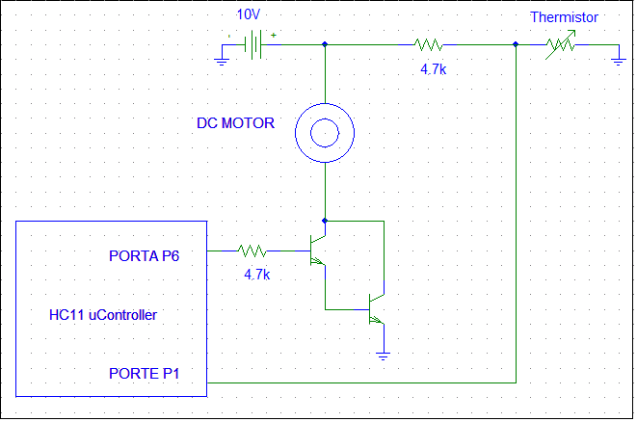
Figure 2 - As the temperature sensor readings decrease, the analog to digital voltage increased. Each voltage corresponds to a temperature shown in the below graph.

The final formula for the temperature is:

Temperature = 81.994-ln(Voltage*.019531)
Where .019531 is 5(volts) / 256(A/D Values)

Flow Charts: Figure 3 - Main Program / Scheduler

Initialize
Set PC Pointer
Set PWM Time
Go To Interrupt
Save SP

Schedule Next Thread
Motor On?
Set Next Interrupt Time
Turn Off Motor
Turn On Motor
Time For Next Interrupt?
YES
NO

NO
YES
Figure 4 -Thread 1 - Analog to Digital Conversion

Read A/D
Calculate On-time
Calculate Off-time
Calculate Temperature
At any time the scheduler can interrupt the above thread. After other threads are serviced this thread will pick up where it left off.

Figure 5 -Thread 2 - Printing Temperature Sample

Wait Over?

Print Temperature
YES
NO
At any time the scheduler can interrupt the above thread. After other threads are serviced this thread will pick up where it left off.
Figure 6 -Thread 3 - Critical Temperature Check

Temperature Too High?
Print Warning To Screen
NO
YES
At any time the scheduler can interrupt the above thread. After other threads are serviced this thread will pick up where it left off.

Testing:
To test this system run the system and measure the temperature of the thermistor and be sure that the temperature on the computer screen is within 1 degree C of the temperature on the temperature gun. As the temperature increases make sure that the voltage across the motor increases, this ensures that the on-time duty cycle is increasing as temperature goes up.

Documentation:
BUFFALO: (this assumes buffalo is on EEPROM )
- Establish communications of the HC11 to a terminal emulator window on a pc.
- Push the Reset button on the HC11
- Type in “l <space> t” in the prompt of the terminal window.
- Load the project.s19 file.
- Type “c <space> 2000” in the terminal window after loading of project.s19 has finished.

EEPROM:
- Establish communications of the HC11 to the axiom software included with the axiom HC11.
- Install JP1 and JP2
- Load project.s19 file.
- Uninstall JP1 and JP2
- Push the reset button on the HC11 board

Conclusion:

The project was a success. The temperature sensor worked as well as the fan controller. A 16 bit processor would have given us a more accurate temperature and a faster clock would have made the motor less jumpy. The biggest problem was making the scheduler, since none of the group members had a class on structures, however this was overcome with a little reading of the text book. After the scheduler was conquered problems with the calculation of temperatures taking to long were encountered. The method of overcoming the time to calculate temperature, an array was used (described in implementation section). Although not the most complicated real time operating system, all goals and project requirements were met.

Note:
Due to time constraints and the nature of this project we did not actually replace buffalo with our own scheduler. If this were going to be an actual system that needed to be started automatically on power up of the hc11 board we would have replaced buffalo in the above described matter.
Note:
The original signed design proposal was lost, however, an unsigned copy of the original proposal is attached.

Final Project Proposal:

In any PC it is very important to have proper cooling so that the CPU or any other heat emitting component does not overheat. For our project we would like to have our HC11 control the speed at which a fan rotates in relation to temperature sensor readings.

In our system we will simulate different temperatures by using a heat gun to blow on temperature sensors connected to the HC11. Our board will continuously monitor the temperatures and adjust the fan speed accordingly. To adjust the fan speed we will output a digital signal to an external power supply. This power supply will control the output voltage to the fan. This system will simulate the system that you have in a computer or any other place where a fan speed needs to be controlled.

