ECE 473 - Embedded Systems
Lab #2: Serial and Parallel Interfacing
Due Oct. 28, 2002
Lab Purpose:
- To implement SPI communication between two HC11 boards
- To interface switches, LEDs and motors to an HC11
Administrative Details:
- You may work with one other person on this lab.
- All code must be written in C and demonstrated on an HC11 / HC12 board.
- You must turn in a short lab report as well as your source code.
Task:
As shown in the figure below, the lab will consist of two parts: HC11 Board A and HC11 Board B.
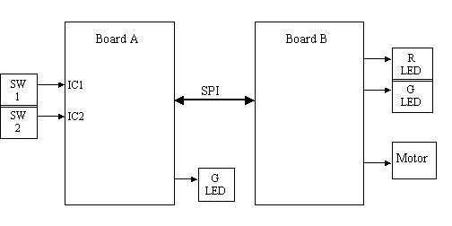
Hardware Notes:
- The ECE department will provide the motor. Its Jameco part number is 177498, and the specifications are: 177498 Motor Specifications
- You are responsible for locating and buying any other components that you need, including a general purpose NPN transistor capable of driving the motor, push-button switches, LEDs, general logic, diodes and resistors.
- Make sure your circuit does not require more than about 0.8mA from the HC11 output pin.
- The components you need should be available at most electronic stores. If you prefer the web, several good places to buy components are:
  - www.digikey.com
  - www.jameco.com
Board A:
This board will be the master in the SPI configuration and will have two push-button switches as inputs. The outputs will be one green LED and the SPI bus. Its behavior will be as follows:
- Button 1: Each time the button is pressed it should generate an IC1 interrupt on HC11 board A. Board A should then command board B (via SPI) to reduce the motor PWM duty cycle by 5%.
- Button 2: Each time the button is pressed it should generate an IC2 interrupt on HC11 board A. Board A should then command board B (via SPI) to increase the motor PWM duty cycle by 5%.
- Green LED: This should turn on for one second every other second to show that the system is running (i.e. on for 1 second, off for 1 second, on for 1 second, etc.).
Note: Regardless of how long either button stays depressed, it should only affect the duty cycle by 5%. The button must be released before it can function again. (Be careful of switch bouncing!)
Board A's main loop:
- Initialize the system:
  - LED output
  - One second counter, SPI message flags (decrease duty cycle, increase duty cycle)
  - SPI configuration
  - Interrupt flags for RTI, IC1, IC2
  - TCTL2 register (to set input capture edge directions)
  - Interrupt masks for RTI, IC1, IC2
  - other?
- Go into an infinite loop that
  - Checks "decrease duty cycle" flag - If set, it sends the "decrease duty cycle" SPI message
  - Checks "increase duty cycle" flag - If set, it sends the "increase duty cycle" SPI message
Note: Use gadfly method to wait for SPI messages to complete.
Board A's RTI ISR:
• Checks for "1 second expired" - If so, it toggles the green LED
Board A's IC1 ISR:
- Sets a flag indicating that the "decrease duty cycle" message should be sent
Board A's IC2 ISR:
- Sets a flag indicating that the "increase duty cycle" message should be sent
Board B:
This board will be the slave in the SPI configuration and will have two LEDs (red and green) and a motor as its outputs. Its behavior will be as follows:
Board A's main loop:
• Initialize the system:
- LED outputs (both off)
- Motor on with PWM duty cycle at 50%
- SPI configuration
- OC1 interrupt flag and mask (for PWM)
• Go into an infinite loop that
- Waits for a SPI message - then increments or decrements the duty cycle by 5%
- Turns on the red LED if the duty cycle was decreased (and turns off green LED)
- Turns on the green LED if the duty cycle was increased (and turns off red LED)
Note: Use gadfly method to wait for SPI messages.
Board B's OC1 ISR:
• Turn motor output on or off (if it is on, turn it off, etc.)
• Reschedule OC1 for ONTIME (if the motor has been turned on) or OFFTIME (if the motor has been turned off).

