Nick Sitarski
Vladi Gergov
ECE 473
Professor Shaout
Winter 2003
Final Project


We have neither given nor received any unauthorized aid in this graded assignment.

____________________________________________________________________

_____________________________________________________________________
Objective:

Computers operate at a high frequency and cooling the CPU can be a challenge, especially in lap top computers. While wanting to keep the CPU cool, conservation of battery life is important. The objective of this project was to create a temperature monitor while at the same time controlling a fan (to conserve energy) and checking for dangerously high temperatures.

Meeting Project Specifications:

The project must be a real time operating system. A real time operating system contains deadlines that must be met. If the deadlines are not met, severe consequences will occur. This project meets the objective of having deadlines. The deadlines are dynamic in nature because they change with temperature. The duty cycle consists of two parts, an on-time and an off-time. The on-time plus the off-time equals 20,000 cycles, 20,000 cycles is one duty cycle. When the motor is on and we go to an interrupt, along with scheduling the next thread, the motor is turned off and the time until the next interrupt is set. The higher the temperature, the longer the on-time portion of the duty cycle will run. When the motor is off and we go to an interrupt, the motor is turned on and the time is set until the next interrupt. The starting speed of the motor is a 50% duty cycle meaning the on-time cycle equals the off-time cycle at 10,000 cycles a piece. When the temperature goes up the on-time portion goes up and the off-time portion goes down. A dynamic time slice approach is used because each thread is given a set amount of time, however, this time (awarded to each thread) changes with temperature.

When the temperature goes up the analog to digital reading goes down. However, it would be good to have the voltage go up as the temperature goes up. To correct this situation take 255 (the highest analog to digital voltage) and subtract the voltage read by the analog to digital converter. Also, multiplying the resulting voltage by a constant will give more of a spread in on-time and off-time than the 0 to 255 values given by the analog to digital converter. The last thing that is done to the on-time is and the starting 10,000 cycles. For calculating the off-time simply subtract on-time from 20,000. The following formulas were used to calculate on-time and off-time:
On-time =( (256 – Analog to Digital) *30)+10,000
Off-time = 20,000 – On-time

The project must also contain thread. This project consisted of three threads listed below:
- The first thread does an analog to digital conversion and calculates the corresponding temperature using a look up table.
- The second thread waits a set time then prints the temperature to the screen.
- The third thread does a check to see if the temperature is above a set limit. If so a warning is sent to the screen
Every time that an interrupt is triggered (from the PWM) a new thread is scheduled and all registers are saved to the stack for that thread. Scheduling different threads in an interrupt is another element that makes this project a real time operating system.
Circuitry:
We used a thermistor in series with a 14.6 K resistor to create the voltage needed for the analog to digital conversion. To power the motor we use 2 NPN transistors along with a 4.7 K resistor. The circuitry is shown below.

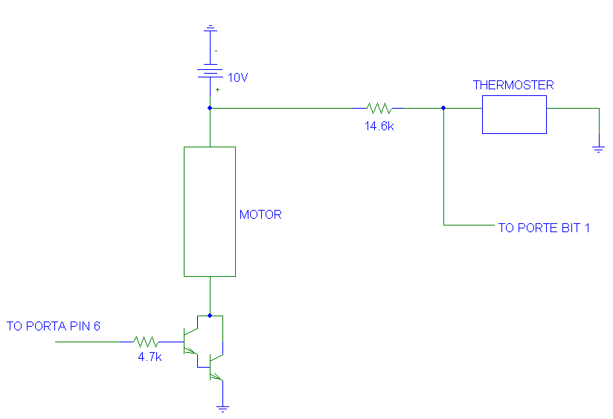

Temperature Calculation:
As the temperature sensor readings decrease, the analog to digital voltage increased. Each voltage corresponds to a temperature shown in the below graph.

The final formula for the temperature is:
Temperature = 81.994-ln(Voltage*.019531)
Where .019531 is 5(volts) / 256(A/D Values)

Flow Chart: Main Program & ISR Scheduler

Initialize
Set PC Pointer
Set PWM Time
Go To Interrupt
Save SP

Schedule Next Thread
Motor On?
Set Next Interrupt Time
Turn Off Motor
Turn On Motor
Time For Next Interrupt?
YES
NO

NO
YES
Thread 1 Analog to Digital Conversion

Read A/D
Calculate On-time
Calculate Off-time
Calculate Temperature
At any time the scheduler can interrupt the above thread. After other threads are serviced this thread will pick up where it left off.

Thread 2 Printing Temperature

Wait Over?

Print Temperature
YES
NO
At any time the scheduler can interrupt the above thread. After other threads are serviced this thread will pick up where it left off.
Thread 3 High Temperature Check

Temperature Too High?
Print Warning To Screen
NO
YES
At any time the scheduler can interrupt the above thread. After other threads are serviced this thread will pick up where it left off.

Conclusion:
The project was a success. The temperature sensor worked as well as the fan controller. A 16 bit processor would have given us a more accurate temperature and a faster clock would have made the motor less jumpy. The biggest problem was making the scheduler, since none of the group members had a class on structures, however this was overcome with a little reading of the text book. Although not the most complicated real time operating system all goals and project requirements were met.

