

Final Project: Design of A Band Equalizer

Tan Nguyen

Hung Nguyen

Minh Le

Dr. Selim Awad

Due date: 08/12/03

SPRING/SUMMER 2003

University of Michigan – Dearborn

HONOR CODE:

We have neither received nor given aid in the presentation of this report.

Signatures:

Table of Contents

Table of Contents 2
Objective: 3
Theory 3
Overview 3
Recording a Wave File 4
Continuous-to-Discrete Converter 4
Bandpass Filters 5
Discrete-to-Continuous Converter 5
Wave File and Matlab 7
Continuous-to-Discrete Converter 7
Anti-Aliasing Lowpass Filter 7
A/D Converter 8
Bandpass Filters 9
Discrete-to-Continuous Converter 10
D/A Converter 10
Reconstruction Lowpass Filter 10
Conclusion 14
Appendix: M-Files 16

Objective:

The purpose of this project is to design a system to modify the magnitude spectra of specific bands of speech signals. Four frequency bands, covering the range from 200 Hz up to 3200 Hz, will be considered. For each frequency range (band), the user should be able to control independently its magnitude spectrum. The bandwidth of each band will be twice that of the preceding band. Thus, if the first bandwidth is BW1, the second will be Bw2 = 2 Bw1, etc. Also, A/D and D/A converters with 16-bits in conjunction with the anti-aliasing (LPF) and reconstruction (LPF) filter are used.

Theory

Overview

This equalizer system is designed to filter a continuous-time signal and convert it to a discrete-time signal through proper sampling. The discrete-time signal is then passed through four different digital bandpass filters whose frequency bands range from 200 Hz to 3200 Hz. The user controls the bandpass filters’ independent gains provided that they are less than 1. The sum of the bandpass filter outputs is converted back to a continuous-time signal when it is passed through a reconstruction filter. The system block diagram is shown in the next page.
Figure 1: Equalizer System Block Diagram

Recording a Wave File

Before designing the equalizer system, a wave file is created. Microsoft Sound Recorder is used to record speech and transform it into an array that can be manipulated by Matlab. When recording speech, the PCM 22050Hz, 16-Bit, Mono format was used. This means that the sampling frequency is 22,050 Hz and that the number of bits per sample used to encode the data is 16.

Continuous-to-Discrete Converter

The continuous-to-discrete (C/D) Converter consists of an Anti-Aliasing Lowpass Filter and an Analog-to-Digital (A/D) Converter.
Before the continuous-time signal is sampled, it needs to pass through an anti-aliasing lowpass filter. Theoretically, this LPF should have a gain of 1 and a cut-off frequency that is less than half the sampling frequency. Since the specified digital sampling frequency, f_{samp}, is 10 kHz, the LPF cut-off frequency, f_{p}, should be 5 kHz.
The A/D Converter takes a continuous-time signal and converts it into a discrete-time signal. The A/D converter in this case is bipolar and the voltage swing of the input signal is selected to range between the Vref values of ±10. Theoretically, the converter consists of a Sampler, Quantizer, and Encoder. The Sampler samples the amplitude of the filtered analog signal at the rate of 10 kHz, the specified sampling frequency. The Sampler holds or keeps the value constant so that the sample can pass through the Quantizer and Encoder. The Quantizer approximates the level of the sampled amplitude, choosing from 2¹⁶ discrete levels (16 since the A/D Converter specification is 16-Bits). The Encoder assigns a word for each discrete input from the Quantizer.

Bandpass Filters

From the system specifications, four bandpass filters with the frequency ranges 200 Hz to 400 Hz, 400 Hz to 800 Hz, 800 Hz to 1600 Hz, and 1600 Hz to 3200 Hz are used. Each of the four BPF gain, which can range from 0 to 1, is controlled by the user. The outputs of all four BPF’s are added and the sum is passed on to the next stage.

Discrete-to-Continuous Converter

The discrete-to-continuous (D/C) Converter consists of a Digital-to-Analog (D/A) Converter and a Reconstruction Filter. The D/C Converter converts the sum of the bandpass filters, a discrete-time signal, into a continuous-time signal.
The D/A Converter consists of the Quantizer. This has the same parameters as the Quantizer of the A/D Converter.
The Reconstruction Filter has exactly the same parameters as the Anti-Aliasing Filter of the C/D Converter. It is a lowpass filter with a gain of 1 and the same cut-off frequency as the anti-aliasing filter, which in this case is 5 kHz. The output of the reconstruction filter is ultimately the output of the equalizer system.
System Implementation and Results:
The equalizer system implementation in Matlab Simulink is shown below:
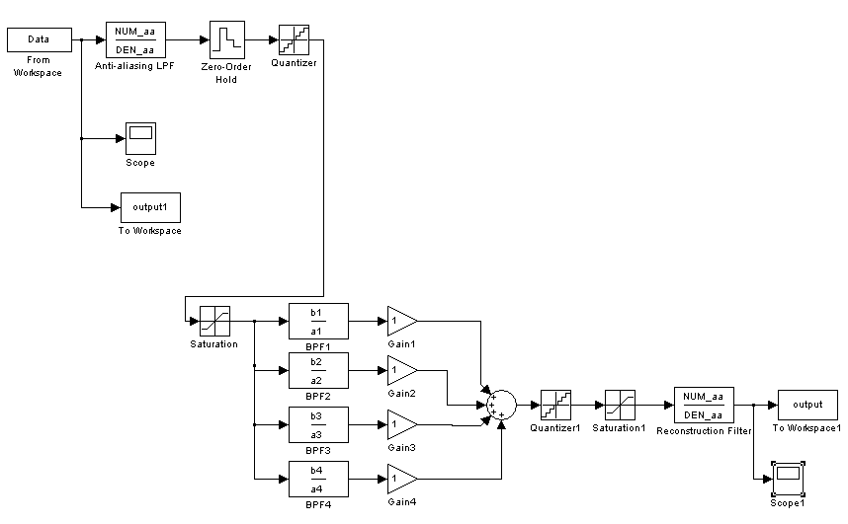
Figure 2: Equalizer System Implementation in Matlab Simulink

Wave File and Matlab

As explained in the theory section, a wave file was created using the Microsoft Sound Recorder software with a PCM 22050Hz, 16-Bit, Mono format. The wave file created in this case is called voice1.wav. Matlab converts this file into an array using the command waveread(’filename’). This command imports the data, sampling frequency and the number of bits from the wave file and into Matlab for display or plotting, playback, or data manipulation. To play a vector signal using Matlab, the command sound is used. This command sends the array into the sound card, which would make corresponding sounds. It should be noted that the sampling frequency used when using the sound command should be the same as the sampling frequency during the recording of the sound.

Continuous-to-Discrete Converter

Anti-Aliasing Lowpass Filter

As mentioned in the theory, the anti-aliasing lowpass filter needs a gain of 1 and a cut-off frequency less than 5 kHz. In the implementation of the LPF, the chosen passband frequency, f_{p_aa}, is 4.8 kHz while the chosen stopband frequency, f_{s_aa}, is 5 kHz. The selected passband attenuation, called a_{p_aa}, is 0.44553 dB while stopband attenuation, called a_{s_aa}, is 26.02 dB. An elliptic filter is the type of filter chosen to implement this LPF since elliptic filters are more efficient than Butterworth or Chebyshev filters; lower-order elliptic filters give the same results as higher-order Butterworth and Chebyshev filters. The anti-aliasing lowpass filter magnitude response is shown below in linear scale and in the next page shown in attenuation scale.
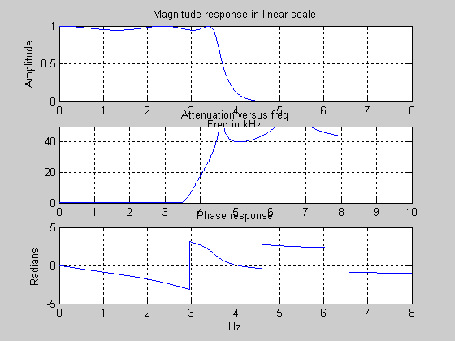
Figure 3: Magnitude Response of the Anti-Aliasing Lowpass Filter and Magnitude Response of the Anti-Aliasing Lowpass in Attenuation Scale, and the phase response

A/D Converter

In Matlab Simulink, the A/D Converter is made up of the Zero-Order Hold, Quantizer and Saturation blocks. The Zero-Order Hold samples the signal every 0.1 msec (1/f_{samp}=1/10kHz) and keeps the amplitude constant until the signal passes through the quantizer and saturation blocks. The Quantizer approximates the signal into 2¹⁶ levels. The Saturation block acts as a limiter and makes sure that the approximation does not exceed the limits, L1 and L2.

Bandpass Filters

In the implementation of the bandpass filters, the selected passband attenuation, a_{p}, is 0.5 dB while the selected stopband attenuation, a_{s}, is 40 dB. These parameters give the bandpass filters a gain of 1. Blocks controlling the BPF gains, which are labeled G1, G2, G3, and G4, are placed after the bandpass filters. Changing the BPF gains changes the sound output.
The passband and stopband frequencies of each BPF are specified in the table below.
Table 1
With these parameters, Matlab is used to prewarp the digital filters and design the analog Elliptic bandpass filters. Again, Elliptic filters is chosen over Butterworth and Chebyshev filters because lower-order elliptic filters give the same approximations as higher-order Butterworth or Chebyshev filters. In Matlab, the first step in designing the elliptic BPF is to find the order of the filter by using the command ellipord and the specifications mentioned above. The next step is to find the transfer function of the analog elliptic filter using the command ellip. Then Bilinear Transformation is applied to the analog transfer function using the command bilinear. The last step is obtaining the transfer function of the digital filter using the freqz command.

Discrete-to-Continuous Converter

D/A Converter

The D/A Converter is implemented with the Quantizer and Saturation blocks. The A/D and D/A converters are very similar; they have the same blocks except that the D/A converter does not have the Sampler or Zero-Order Hold block. The quantizer and saturation block in both converters have the same parameters.

Reconstruction Lowpass Filter

As mentioned before, the Reconstruction Filter has the exact same parameters as the Anti-Aliasing Lowpass Filter. So in Matlab Simulink, the block for the anti-aliasing filter is copied and used as the reconstruction filter. The output is then transported back to the Matlab Workspace, where it may be plotted and played back to the speakers, by using the To-Workspace block.
In the next page are plots of the voice1.wav file and the output of the equalizer system when G1 = G2 = G3 = G4 = 1.
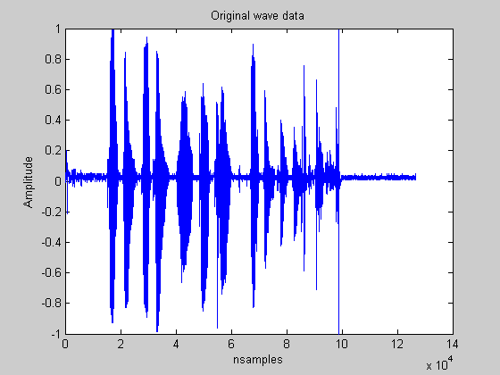
Figure 4: original "voice1" waveform, unfiltered
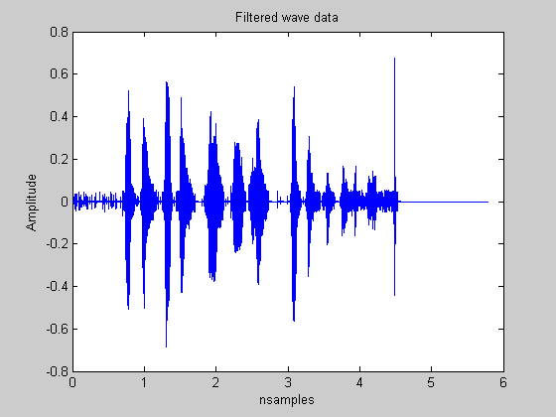
Figure 5: G1, G2, G3, and G4 gains set to 1.
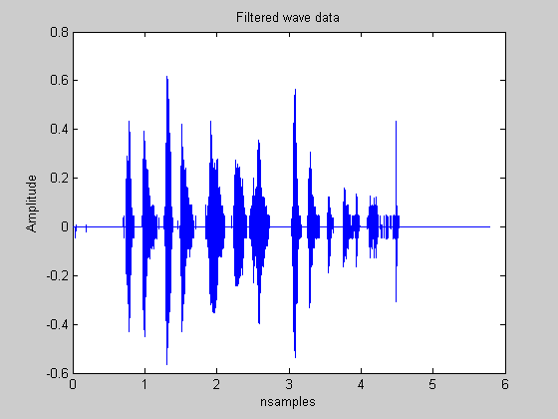
Figure 6: G1, G2 set to 1; G3,G4 gains set to 0.

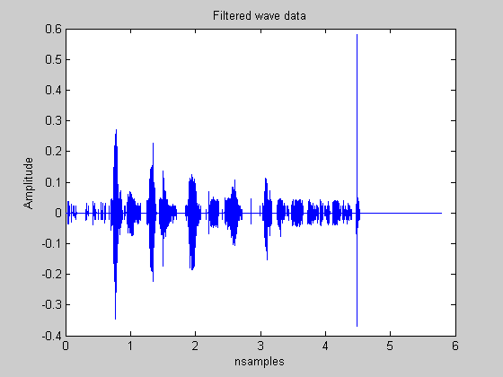
Figure 7: G1, G2 set to 0; G3,G4 gains set to 1.
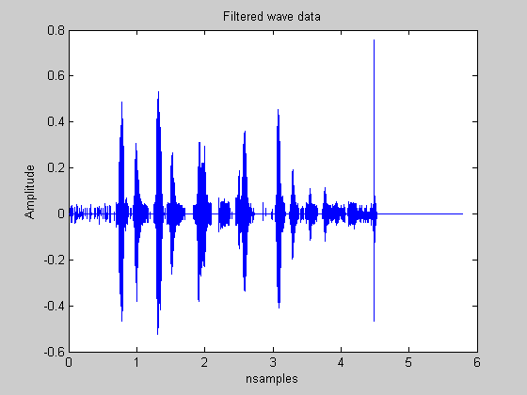
Figure 8: G1 set to 0; G2,G3,G4 gains set to 1.

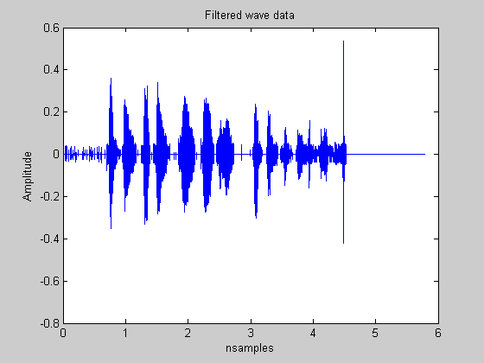
Figure 9: G2 set to 0; G1,G3,G4 gains set to 1.

Conclusion

The equalizer system was built in accordance to the specifications. The system uses both analog and digital filters. The equalizer system involves filtering a continuous-time signal using an anti-aliasing lowpass filter, sampling the filtered continuous-time signal and converting it into a discrete-time signal, processing the discrete-time signal with bandpass filters, and converting the output back into a continuous-time signal.
The important thing to note is that there are two sampling frequencies. The analog frequency (FS), which is equal to 22,050 Hz, is the sampling frequency used when recording speech using the Microsoft Sound Recorder. The digital frequency (f_{samp}), which is 10 kHz, is the sampling frequency of the digital filters. Another important thing to note is that the Anti-Aliasing and Reconstruction filters should have the cut-off frequency less than half of the digital sampling frequency, f_{samp}, and not half the 22,050 Hz analog sampling frequency. The last important thing to note is that the sample-time parameter of the To-Workspace block, which transports the system output signal back to Matlab Workspace be played back to the speaker, should be 1/FS and not 1/f_{samp}. This is because the signal is already in the analog domain and should therefore use the analog sampling frequency.
Final observations while evaluating the voice1.wav; we made adjustments to the various gain nodes to see the effect on the waveform. When filters 3 and 4 were zeroed (figure 6), the signal could still be heard and understood. There were some subtle changes to the output but the speech was clear enough to understand. When filters 1 and 2 were zeroed (figure 7), the signal was completely filtered out. All that remained was a faint static sound. This means that the signal is primarily contained in the lower half of our frequency spectrum. Now leaving the first filter at zero gain (figure 8), the signal could barely be heard. If the listener did not know what the sound was supposed to be, the sound would be understood. The level of the sound was very low, meaning most of the signal is likely to be contained in the 2nd Bandpass’s bandwidth. We performed a final test to prove this, (figure 9). The results surprised us. The signal could not be clearly understood. It is apparent that both lower bandpass filter are required to active in order for the listener to understand the output.
Other wave files were tested with this project. The files contained sentences as opposed to single syllables. When the zero gain was distributed, only various areas of the input sound file were heard at the output.

Appendix: M-Files
%480 Final Project
%Spring/Summer 2003
clear;
clc;
g1=1; %gain 1
g2=1; %gain 2
g3=1; %gain 3
g4=1; %gain 4
fsamp= 1e4; %digital sampling
t=1/fsamp; %digital period
T=2; %peroid for warping and prewarping

%stop bands in format filter 1..4 frequency 1
f11=150;
f21=350;
f31=750;
f41=1550;

%stop bands in format filter 1..4 frequency 2
f12=450;
f22=850;
f32=1650;
f42=3250;

%-pass bands in format filter 1..4 frequency lo
f1lo=250;
f2lo=450;
f3lo=850;
f4lo=1650;

%-pass bands in format filter 1..4 frequency up
f1hi=350;
f2hi=750;
f3hi=1550;
f4hi=3150;

%att in dB
ap= 0.5;
as= 40;

%converting analog into dital
filt1=[f11, f1lo, f1hi, f12]*2*pi/fsamp;
filt2=[f21, f2lo, f2hi, f22]*2*pi/fsamp;
filt3=[f31, f3lo, f3hi, f32]*2*pi/fsamp;
filt4=[f41, f4lo, f4hi, f42]*2*pi/fsamp;

%prewarping
T=2;
filter_a1= 2/T*tan(filt1/2);
filter_a2= 2/T*tan(filt2/2);
filter_a3= 2/T*tan(filt3/2);
filter_a4= 2/T*tan(filt4/2);

%here come the filters
[N1, wn1] = ellipord (filter_a1(2:3), filter_a1(1:3:4),ap,as,'s');
[N2, wn2] = ellipord (filter_a2(2:3), filter_a2(1:3:4),ap,as,'s');
[N3, wn3] = ellipord (filter_a3(2:3), filter_a3(1:3:4),ap,as,'s');
[N4, wn4] = ellipord (filter_a4(2:3), filter_a4(1:3:4),ap,as,'s');
%note for bandpass fitlers

[B1,A1]=ellip(N1, ap, as, wn1, 's');
[B2,A2]=ellip(N2, ap, as, wn2, 's');
[B3,A3]=ellip(N3, ap, as, wn3, 's');
[B4,A4]=ellip(N4, ap, as, wn4, 's');

%frequency response of the four filters
freqs(B1,A1)
title('Frequency Response of 1st BPF');
figure(2)
freqs(B2,A2)
title('Frequency Response of 2nd BPF');
figure(3)
freqs(B3,A3)
title('Frequency Response of 3rd BPF');
figure(4)
freqs(B4,A4)
title('Frequency Response of 4th BPF');

figure(5)
%here is the filter conversion form analog to digital using the bilinear transform
[b1,a1]=bilinear(B1,A1,1/T);
[b2,a2]=bilinear(B2,A2,1/T);
[b3,a3]=bilinear(B3,A3,1/T);
[b4,a4]=bilinear(B4,A4,1/T);
disp('Band pass filters complete')

%test to see if filters work correctly**************************************
disp('test start')

f=[0:.1:5e3]';
omega = 2*pi*f/fsamp;
H1=freqz(b1,a1,omega);
H2=freqz(b2,a2,omega);
H3=freqz(b3,a3,omega);
H4=freqz(b4,a4,omega);

dB_H1=20*log10(abs(H1));
dB_H2=20*log10(abs(H2));
dB_H3=20*log10(abs(H3));
dB_H4=20*log10(abs(H4));

subplot(2,2,1)
plot(f, dB_H1)
grid on;
axis([0,500,-45,1]);
xlabel('Frequency in Hertz');
ylabel('Magnitude in dB');
title('Mag response of digital BPF 1');

subplot(2,2,2)
plot(f, dB_H2)
grid on;
axis([0,900,-45,1]);
xlabel('Frequency in Hertz');
ylabel('Magnitude in dB');
title('Mag response of digital BPF 2');

subplot(2,2,3)
plot(f, dB_H3)
grid on;
axis([0,1700,-45,1]);
xlabel('Frequency in Hertz');
ylabel('Magnitude in dB');
title('Mag response of digital BPF 3');

subplot(2,2,4)
plot(f, dB_H4)
grid on;
axis([0,3300,-45,1]);
xlabel('Frequency in Hertz');
ylabel('Magnitude in dB');
title('Mag response of digital BPF 4');

figure(6)
subplot(2,2,1)
plot(f, -dB_H1)
grid on;
axis([0,500,-1,45]);
xlabel('Frequency in Hertz');
ylabel('Att in dB');
title('Att of digital BPF 1');

subplot(2,2,2)
plot(f, -dB_H2)
grid on;
axis([0,900,-1,45]);
xlabel('Frequency in Hertz');
ylabel('Att in dB');
title('Att of digital BPF 2');

subplot(2,2,3)
plot(f, -dB_H3)
grid on;
axis([0,1700,-1,45]);
xlabel('Frequency in Hertz');
ylabel('Att in dB');
title('Att of digital BPF 3');

subplot(2,2,4)
plot(f, -dB_H4)
grid on;
axis([0,3300,-1,45]);
xlabel('Frequency in Hertz');
ylabel('Att in dB');
title('Att of digital BPF 4');
figure(7)
disp('test complete')
%******************************************************************************
%continus to digital
fs = 4500;
fp = 3500;
[N,Wn] = ellipord(2*pi*fp, 2*pi*fs, ap, as, 's');
[NUM_aa, DEN_aa] = ellip(N, ap, as, Wn, 's'); %finding the transfor coeff
f=[0:1:8e3];
H= freqs(NUM_aa, DEN_aa, 2*pi*f);

subplot(3,1,1)
plot(f/1e3, abs(H));
xlabel ('Freq in kHz');
ylabel ('Amplitude');
title('Magnitude response in linear scale');
grid on;

att= -20*log10(abs(H)); %Att in Db
subplot(3,1,2)
plot(f/1e3 , att)
title ('Attenuation versus freq')
axis([0,10,0,50]);
grid on;

subplot(3,1,3)
plot(f/1e3,angle(H))
xlabel('Hz');
ylabel('Radians')
title('Phase response');
grid on;

figure

%***********************************************************************
%ad and da converter values
nb = 8;%**********************number of bits
vref= 5;
delta = (2^(1 -nb))*vref;
l1 = vref - delta;
l2 = -vref;
%wave**************************
wavfile = 'voice1';
[Y, FS, BITS]=wavread(wavfile);
plot(Y)
title ('Original wave data')
xlabel('nsamples')
ylabel('Amplitude')
figure
wavplay(Y, FS);

Time=[0:length(Y)-1]'*1/FS;
plot(Time,Y);
Data=[Time,Y];

figure
plot(OUTPUT(:,1),OUTPUT(:,2));
title ('Filtered wave data')
xlabel('nsamples')
ylabel('Amplitude')
wavplay(OUTPUT)

