

ECE-480 Design Project

Assignments 1 and 2

Matlab Operations on Wave Files and Energy / Zero-Crossings of Signals

Blaine Thompson

Nick Sitarski

Brandon Harris

ECE - 480

Due date: 5/2/04

Dr. S. Awad
Winter 2004

Objective

Record and save the phrase “We were away”. Say it drawn out enough so that the vowel /IY/ in “We” and diphthong /eI/ in “away” have a significant duration. Use Sound Recorder with the following properties:

Format = Pulse Code Modulation
Sampling Rate = 22,050 Hz
Bits per Sample = 16
Recording Mode = Mono

Assignment 1

Part 1

A wave file was recorded using Windows Sound Recorder with the settings as describe in the objective.

Open the wave file in Matlab. Create a labeled plot of the signal versus samples. How many samples are in this signal?

The number of samples contained in this signal is 104747.

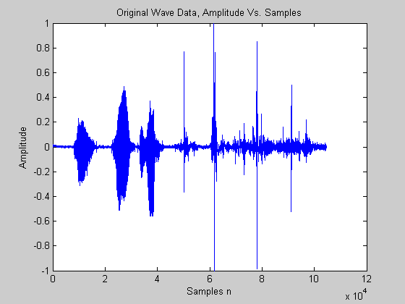

Matlab Code for Part 1

%Part 1 %Plot Original signal vs. samples.
wavfile = 'male_part1';
sampfreq=22050;
[Y,FS,BITS] = wavread(wavfile);
sound(Y,FS,BITS);
figure,plot(Y), title('Original Wave Data, Amplitude Vs. Samples'), xlabel('Samples n'), ylabel('Amplitude');
sample_size=size(Y) %Sample Size = 104747 samples

Part 2

Create a labeled plot of signal versus time. What is the duration of this signal?

As you can see the duration of the signal is 4.7504 Seconds.

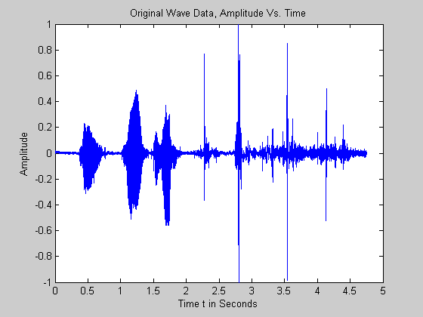

Matlab Code for Part 2

%Part 2
t=[0:1/sampfreq:(sample_size-1)/sampfreq];
figure,plot(t,Y), title('Original Wave Data, Amplitude Vs. Time'), xlabel('Time t in Seconds'), ylabel('Amplitude');
duration = max(t) %Duration = 4.7504 Seconds

Part 3

Alter the signal so that the new sample rate is 11,025 Hz. There are 52,374 samples in this signal. How many samples are in this signal? There are 52,374 samples in this signal.

Matlab Code for Part 3

%Part 3
Z = decimate(Y,2);
FSdec = FS/2;
sound(Z,FSdec,BITS);
sample_size_dec = size(Z) %dec sample size = 52374 samples

Part 4

Explain why a sampling rate of 11,025 is still acceptable for this signal and what type of sounds or signals might this sampling rate not be appropriate.

This signal is a recording of speech, which has maximum frequency of approximately 5 KHz. To meet the requirements of the Nyquist criteria a sampling rate of only twice that frequency is required. This sampling rate would not be appropriate for recording music.

Part 5

Edit the signal and remove any background-noise, pause, silence or clicks before and after the signal. Include a labeled plot of the edited signal versus samples. How many samples are in the signal? There are 17,558 samples in the shorted signal.

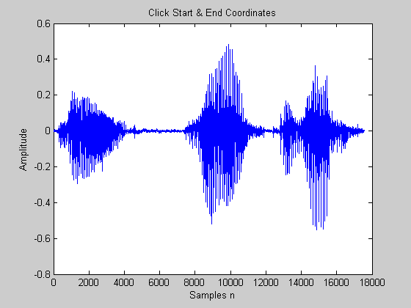

Matlab Code for Part 5

%Part 5
figure,plot(Z), title('Wave Data sampled at 11,025 Hz, Amplitude Vs. Samples'), xlabel('Samples n'), ylabel('Amplitude');,
phrase = 'Click Start & End Coordinates, Original Wave Data';
display(phrase);
title(phrase);
[xcoord, ycoord] = ginput(2);
xcoord = round(xcoord);
xcoord = sort(xcoord);
X=Z(xcoord(1):xcoord(2));
figure,plot(X), title('Shortened Wave Data Sampled at 11,025 Hz'), xlabel('Samples n'), ylabel('Amplitude');
Shortened_Sample_Size = size(X) %Shortened Sample size = 17,558 samples
sound(X,FSdec,BITS);

Part 6

Save the edited 11,025 Hz signal to a new wave file. Play the signal back and compare the sound quality of the 11,025 Hz wave file to the original 22,050 Hz wave file. Explain what attributes have changed and how well you can perceive the differences with your ears.

There are no noticeable changes to the attributes of the signal sampled at 11,025 Hz versus 22,050 Hz. One member in our group claimed the signal sampled at 22,050 Hz sounds better in general.

Matlab Code for Part 6

%Part 6
file = 'assign1_par6.wav';
wavwrite(X,FSdec,BITS,file);

Part 7

From the 11025 Hz “We were away” wave file, extract the utterance /IY/ from “We”. Plot the utterance versus samples. How many samples are in this signal?

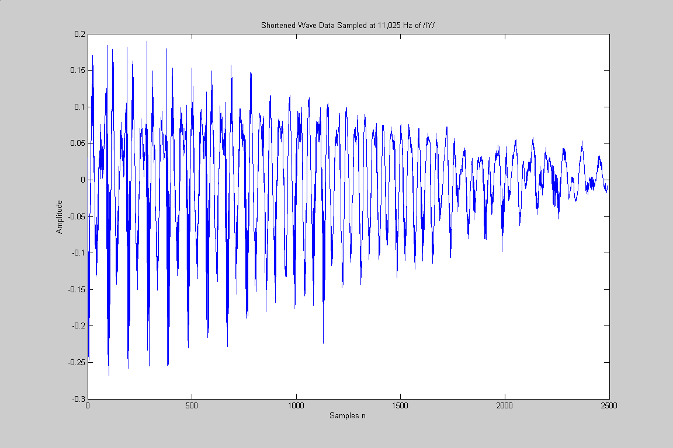

There are approximately 2,490 samples in this utterance of the sound “We”.

Part 8

Zoom in on the /IY/ utterance. Does the signal look quasi-periodic? Plot two ‘periods’ of the signal. What is the approximate duration of one period in samples and seconds?

The time period is approximately 8.7 ms

What frequency does this correspond to?

114.93 Hz.

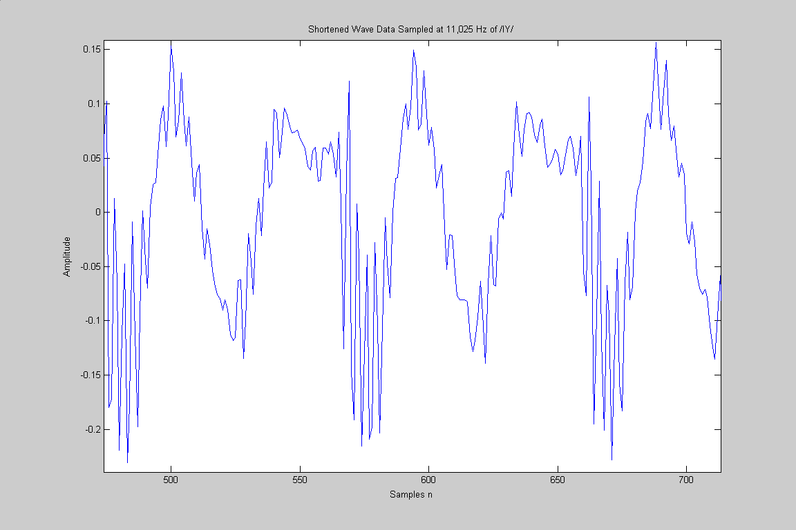

Matlab Code for Part 7-8

%Part 7-8
figure,plot(X), title('Wave Data sampled at 11,025 Hz, Amplitude Vs. Samples'), xlabel('Samples n'), ylabel('Amplitude');,
phrase = 'Click Start & End Coordinates';
display(phrase);
title(phrase);
[xcoord, ycoord] = ginput(2);
xcoord = round(xcoord);
xcoord = sort(xcoord);
A=X(xcoord(1):xcoord(2));
figure,plot(A), title('Shortened Wave Data Sampled at 11,025 Hz of /IY/'), xlabel('Samples n'), ylabel('Amplitude');
Shortened_Sample_Size = size(A) %Shortened Sample size = 2,490 samples
sound(A,FSdec,BITS);
%96 samples in a period, 8.7 ms, 114.93 Hz

Part 9

From the 11,025 Hz “We were away” wave file, extract the utterance /eI/ from “away”. Plot the utterance versus samples. How many samples are in this signal?

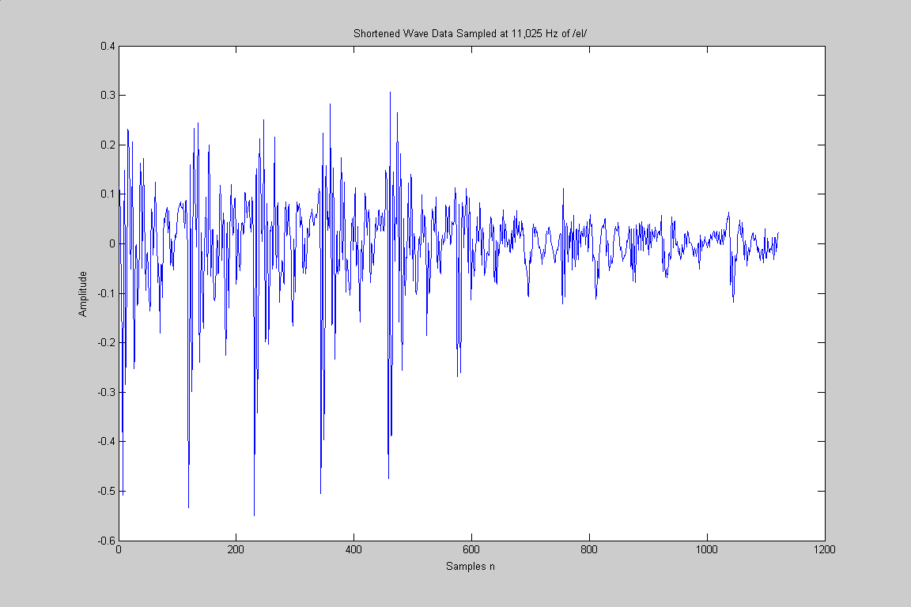

There are approximately 1,121samples in this utterance.

Part 10

Zoom in on the /eI/ utterance. Does the signal look quasi-periodic? Plot four ‘periods’ of the signal. What is the approximate duration of one period in samples and in seconds? What frequency does this correspond to?

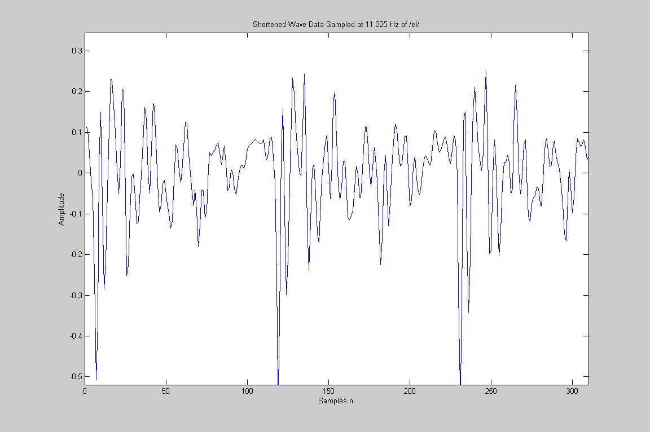

The signal is quasi-periodic two periods are displayed above. There are 1,121samples the period is 10.2 ms and the corresponding frequency is 97.5Hz.

Matlab Code for Part 9-10

%Part 9-10
figure,plot(X), title('Wave Data sampled at 11,025 Hz, Amplitude Vs. Samples'), xlabel('Samples n'), ylabel('Amplitude');,
phrase = 'Click Start & End Coordinates';
display(phrase);
title(phrase);
[xcoord, ycoord] = ginput(2);
xcoord = round(xcoord);
xcoord = sort(xcoord);
B=X(xcoord(1):xcoord(2));
figure,plot(B), title('Shortened Wave Data Sampled at 11,025 Hz of /eI/'), xlabel('Samples n'), ylabel('Amplitude');
Shortened_Sample_Size = size(B) %Shortened Sample size = 1,121samples
sound(B,FSdec,BITS);
%113 samples, 10.2 ms, 97.5Hz

Part 11

Resample the original 22,050 Hz “We were away” wave file in Matlab using 8-bits. Compare the sound quality of the 8-bit signal to that of the 16-bit quality. Explain what attributes have changed and how much you can perceive the differences with your ears.

No noticeable changes could be perceived from the lower bit quality. For the learning value, we tried lowering the bits until the signal could not longer be heard. The perceived changes were a decrease in the dynamic range of the sound. The voice had a tinish characteristic to it.

Matlab Code for Part 11

%Part 11
file = 'assign1_par11.wav';
c = Y;
wavwrite(c,FS,8,file);
sound(c,FS,8);

Conclusion for Assignment 1

In this assignment students explored techniques for importing and exporting wave files in Matlab. Tools were used to extract parts of speech for time and frequency analysis. Different recording resolutions were compared for quality and attributes. This exercise also demonstrates how speech can be represented with less resource requirements that that of other audio information such as music. Speech doesn’t need a high bandwidth, sample rate, or bits per sample greater than 8.

Objective

This project assignment will introduce some fundamental DSP concepts that are used to process speech signals. You will segment (window) a speech signal into sections and develop procedures to calculate the average energy and zero-crossings for each segment. These procedures will be used I the final design project.

Assignment 2

Part 1

Record and save the phrases “We were away” and “She is aware”. Speak the phrases drawn out enough so that the voiced and unvoiced portions of the speech are apparent. Use Sound Recorder with the following properties:

Format = Pulse Code Modulation
Sampling Rate = 11,025 Hz
Bits per Sample = 16
Recording Mode = Mono

Open the “She is Aware” file in Matlab. Extract the word “She” and create a labeled plot of the signal versus time.

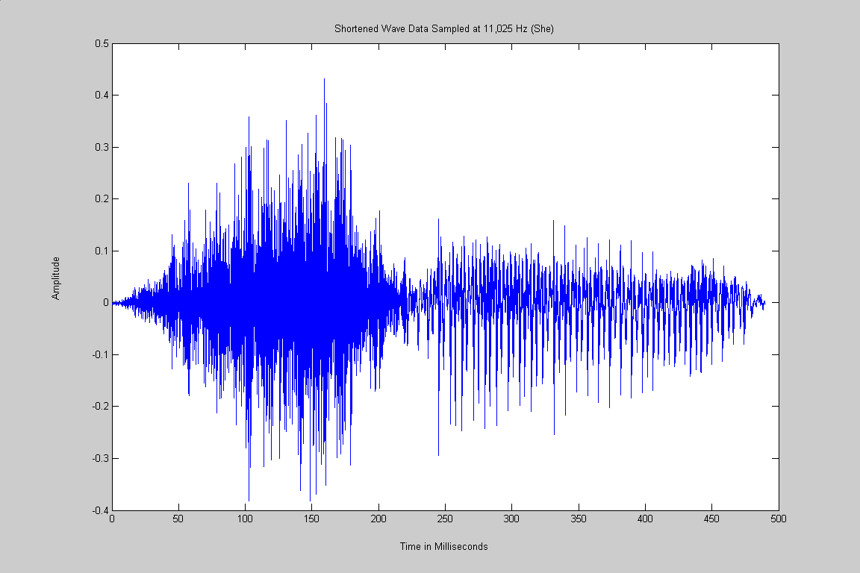

Matlab Code for Part 1

%Part 1 %Plot data and extract valued data
wavfile = 'male_part2';
sampfreq=11025;
[Y,FS,BITS] = wavread(wavfile);
sound(Y,FS,BITS);

figure,plot(Y),title('Wave Data sampled at 11,025 Hz, Amplitude Vs. Samples'), xlabel('Samples n'), ylabel('Amplitude');,
phrase = 'Click Start & End Coordinates to Extract She, Original Wave Data';
display(phrase);
title(phrase);
[xcoord, ycoord] = ginput(2);
xcoord = round(xcoord);
xcoord = sort(xcoord);
X=Y(xcoord(1):xcoord(2));
figure,plot(X), title('Shortened Wave Data Sampled at 11,025 Hz (She)'), xlabel('Samples n'), ylabel('Amplitude');
Shortened_Sample_Size = size(X)
sound(X,FS,BITS);

tspch=[1:length(X)]/FS; %Time vector for speech in seconds
tspch = tspch*1000; %speech time vector in milliseconds
figure,plot(tspch,X),title('The Word She'),xlabel('Time in Milliseconds'),ylabel('Amplitude');

Part 2

Verify mathematically that 220 samples should be used to represent 20 msec of speech sampled at 11,025 Hz.

Sample_time = Sample_size/ F_sample = 220 / 11,025 Hz = .02 Sec (20 msec)

Part 3

Create a function, avg_energy, to calculate the average energy for an array, where:

[ENERGY} =avg_energy(ARRAY, WINLENGTH)

ENERGY is the Average Energy output array.
ARRAY is the input vector
WINLENGTH is the length of the moving window (even number of points)

Use a Hamming window to filter each analysis frame before calculating the energy. Move the window by WINLENGTH /2. If the length of the array is greater than a constant times WINLENGTH, ignore the extra samples at the end of the array (as shown in example code).

Include the Matlab code for your function. Test the function on the “She” speech signal with a window size of 220 samples. Include labeled subplots of “She” and the average energy versus time.

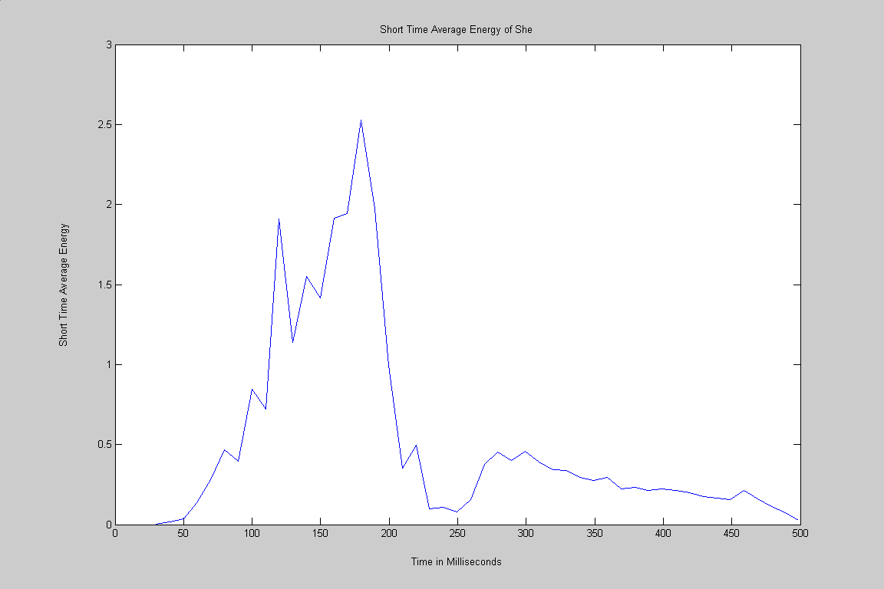

Matlab Code for Part 3

%Average Energy Function
%This function will take a signal, and window length
%it will return the energy vector
%also it will plot energy vs time in milliseconds

function energy = avg_energy(ARRAY,WINLENGTH)
%This Function will work for a sampling frequency of 11,025 HZ
%energy is output
%Array is vector input, Winlength is window size (samples)
fs=11025; %sets sampling frequency to 11,025
movewin = WINLENGTH/2; %Number of samples to move window
winstart = 1; %Start of first window
winend = WINLENGTH; %End position of first window
endspeech = length(ARRAY); %last speech position
wn = hamming(WINLENGTH); %create hamming window
index = 1; %start index for energy array
while (winend<endspeech) %AVGEnergy = sum mag^2
xn = ARRAY(winstart:winend); %Extract a section of speech
yn = xn.*wn; %Multiply by hamming window
energy(index)=sum(yn.^2); %Sum energy squared
winstart = winstart+movewin; %move window
winend = winstart+WINLENGTH-1; %Preserve Window Length
index=index+1; %move to next energy length
end

tspch=[1:endspeech]/fs; %Time vector for speech in seconds
tspch = tspch*1000; %speech time vector in milliseconds
tenergy=[1:length(energy)]; %Get number of samples for energy
tenergy = (WINLENGTH+tenergy*movewin)/fs;
tenergy = tenergy*1000; %energy time vector in milliseconds
figure,plot(tenergy,energy),xlabel('Time in Milliseconds'),ylabel('Short Time Average Energy');

%Part 3
avgenergy=avg_energy(X,220);

Part 4

Create a function to calculate the average magnitude where:

[ENERGY] = avg_magnitude(ARRAY, WINLENGTH)

Use the same specifications as in 3 except ENERGY is the Average Magnitude.

Include the Matlab code for your function. Test the function on the “She” speech signal with a window size of 220 samples. Include labeled subplots of “She” and the average magnitude versus time.

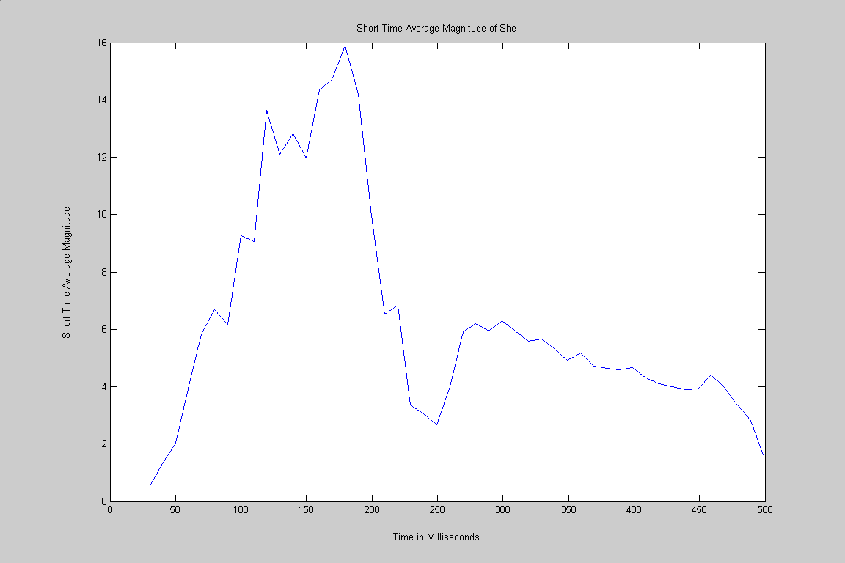

Matlab Code for Part 4

%Average Energy Function
%This function will take a signal, and window length
%It will return the average magnitude vector
%Also it will plot magnitude vs. time in milliseconds

function energy = avg_magnitude(ARRAY,WINLENGTH)
%This Function will work for a sampling frequency of 11,025 HZ
%energy is output
%Array is vector input, Winlength is window size (samples)
fs=11025; %sets sampling frequency to 11,025
movewin = WINLENGTH/2; %Number of samples to move window
winstart = 1; %Start of first window
winend = WINLENGTH; %End position of first window
endspeech = length(ARRAY); %last speech position
wn = hamming(WINLENGTH); %create hamming window
index = 1; %start index for energy array

while (winend<endspeech) %AVGmag = sum of abs of magnitude
xn = ARRAY(winstart:winend); %Extract a section of speech
yn = abs(xn).*wn; %Multiply by hamming window
energy(index)=sum(yn); %Sum energy squared
winstart = winstart+movewin; %move window
winend = winstart+WINLENGTH-1; %Preserve Window Length
index=index+1; %move to next energy length
end

tspch=[1:endspeech]/fs; %Time vector for speech in seconds
tspch = tspch*1000; %speech time vector in milliseconds
tenergy=[1:length(energy)]; %Get number of samples for energy
tenergy = (WINLENGTH+tenergy*movewin)/fs;
tenergy = tenergy*1000; %energy time vector in milliseconds
figure,plot(tenergy,energy),xlabel('Time in Milliseconds'),ylabel('Short Time Average Magnitude');
%Part 4
avgmagnitude = avg_magnitude(X,220);

Part 5

Comment on the difference between the results of the average energy and magnitude calculations. Which algorithm is faster? Comment on the scales of the amplitude. In your opinion, which algorithm “better” describes the amplitude properties of the signal? Define your criteria and explain why you choose this algorithm.

The energy algorithm squares the amplitude of the signal, which requires extra processing time since it uses multiplication, so it is therefore slower. The magnitude gives more information with respect to the relationship of one signal to the other; since it is a more linear representation.
Part 6
Create a function to calculate the zero crossings where:

[CROSSINGS] = zero_crossings(ARRAY, WINLENGTH)
CROSSINGS is the Number of Zero-Crossings output array
ARRAY is the input vector
WINLENGTH is the length of the moving window (even number of points)

Use a rectangular window to filter each analysis frame before calculating the zero-crossings. Move the window by WINLENGTH /2. If the length of the array is greater than a constant times WINLENGTH, ignore the extra samples at the end of the array (as shown I the example code).

Include the Matlab code for your function. Test the function on the “She” speech signal. Include labeled subplots of “She” and the zero-crossing versus time.

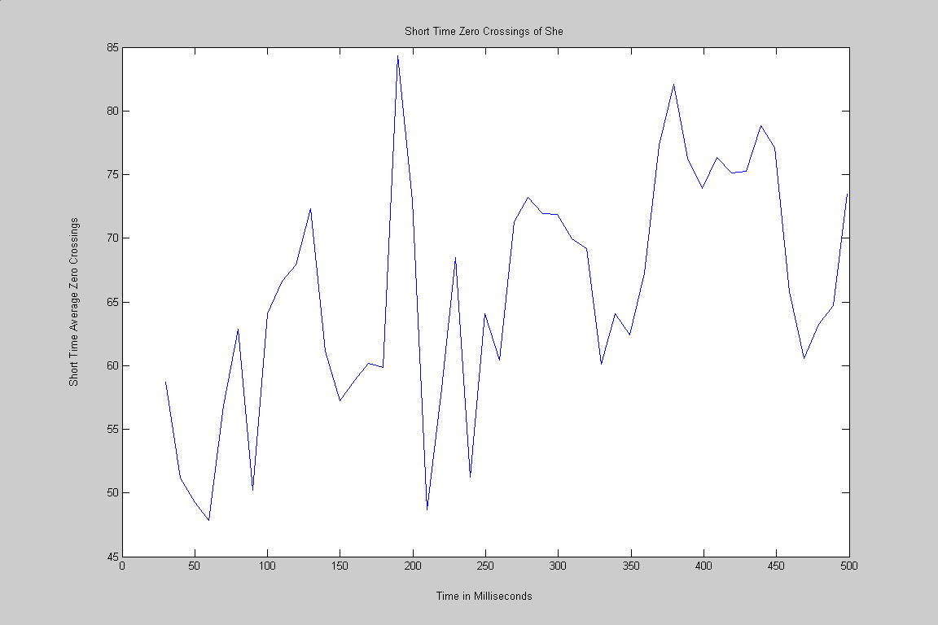

Matlab Code for Part 6

%Zero Crossings Function
%This function will take a signal, and window length
%it will return the zero crossings
%also it will plot crossings vs time in milliseconds

function crossings = avg_magnitude(ARRAY,WINLENGTH)
%This Function will work for a sampling frequency of 11,025 HZ
%energy is output
%Array is vector input, Winlength is window size (samples)

fs=11025; %sets sampling frequency to 11,025
movewin = WINLENGTH/2; %Number of samples to move window
winstart = 1; %Start of first window
winend = WINLENGTH; %End position of first window
endspeech = length(ARRAY); %last speech position
wn = hamming(WINLENGTH); %create hamming window
index = 1; %start index for energy array
xnprev = 0;

while (winend < endspeech)
xn = ARRAY(winstart:winend);
yn = (abs(sign(xnprev) - sign(xn)) / 2) .* wn; %chcking for sign change
crossings(index) = sum(yn); %summing crossings
winstart = winstart+movewin;
winend = winstart+WINLENGTH-1;
index=index+1;
xnprev = xn;
end

tspch=[1:endspeech]/fs; %Time vector for speech in seconds
tspch = tspch*1000; %speech time vector in milliseconds
tcrossings=[1:length(crossings)]; %Get number of samples for crossings
tcrossings = (WINLENGTH+tcrossings*movewin)/fs;
tcrossings = tcrossings*1000; %crossings time vector in milliseconds
figure,plot(tcrossings,crossings),xlabel('Time in Milliseconds'),ylabel('Short Time Average Zero Crossings');

%Part 6
zerocrossing = zero_crossing(X,220);

Part 7

Edit the file “She is aware” and remove any noise, pause, or clicks before and after the signal. Create subplots of the following signals versus time:

- The speech signal
- The average energy of the speech signal
- The zero crossing of the speech signal.

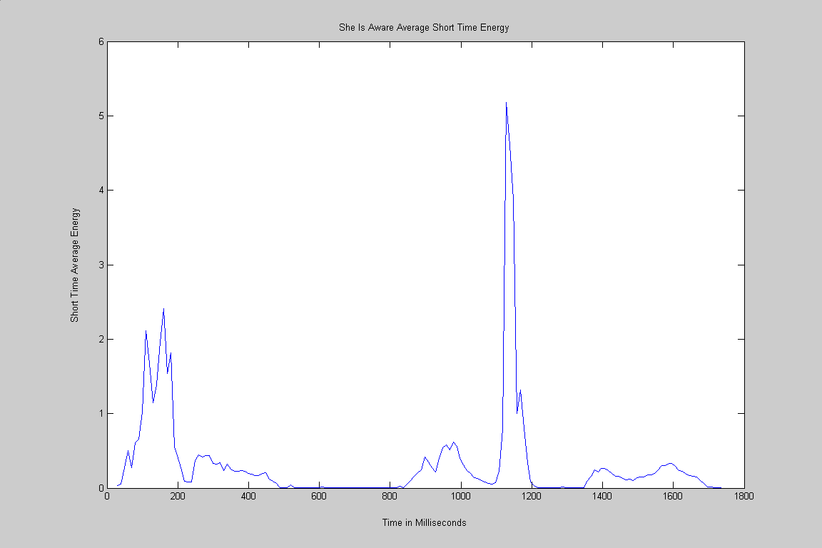

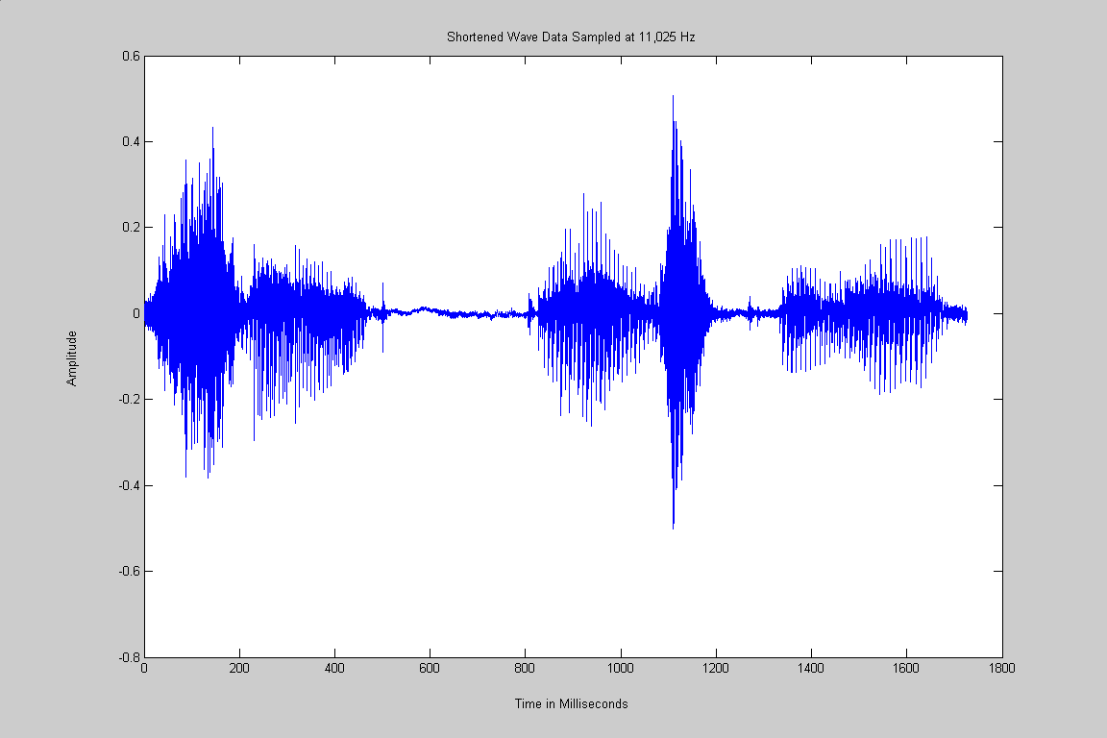

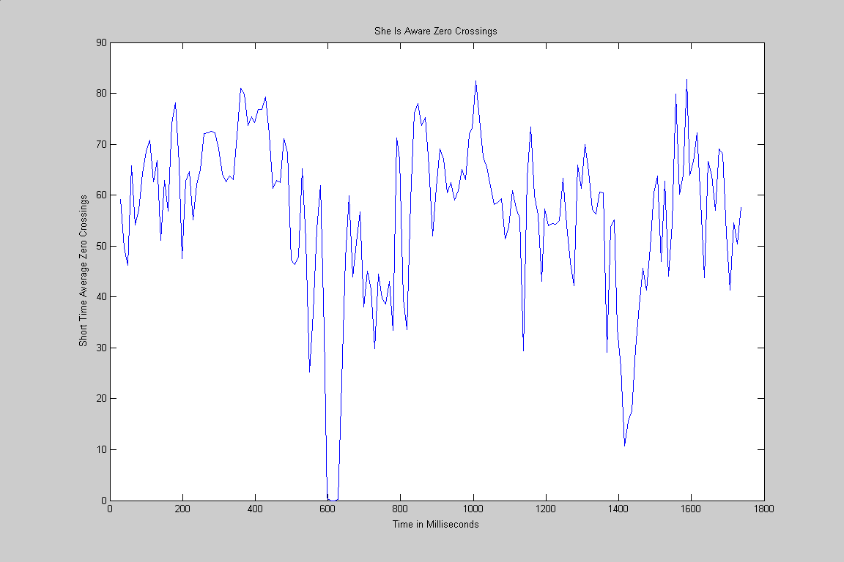

Matlab Code for Part 7

%Part 7
figure,plot(Y),title('Wave Data sampled at 11,025 Hz, Amplitude Vs. Samples'), xlabel('Samples n'), ylabel('Amplitude');,
phrase = 'Click Start & End Coordinates to Extract She, Original Wave Data';
display(phrase);
title(phrase);
[xcoord, ycoord] = ginput(2);
xcoord = round(xcoord);
xcoord = sort(xcoord);
Z=Y(xcoord(1):xcoord(2));
figure,plot(Z), title('Shortened Wave Data Sampled at 11,025 Hz'), xlabel('Samples n'), ylabel('Amplitude');
Shortened_Sample_Size = size(Z)
sound(Z,FS,BITS);

tspch=[1:length(Z)]/FS; %Time vector for speech in seconds
tspch = tspch*1000; %speech time vector in milliseconds
figure,plot(tspch,Z),title('Shortened Wave Data Sampled at 11,025 Hz'),xlabel('Time in Milliseconds'),ylabel('Amplitude');

avgenergy=avg_energy(Z,220);
avgmagnitude = avg_magnitude(Z,220);
zerocrossing = zero_crossing(Z,220);

Part 8

Edit the file “We were away” and remove any noise, pause, or clicks before and after the signal. Create subplots of the following signal versus time:

- The speech signal “We were away”
- The Average energy of the speech signal
- The zero-crossing of the speech signal

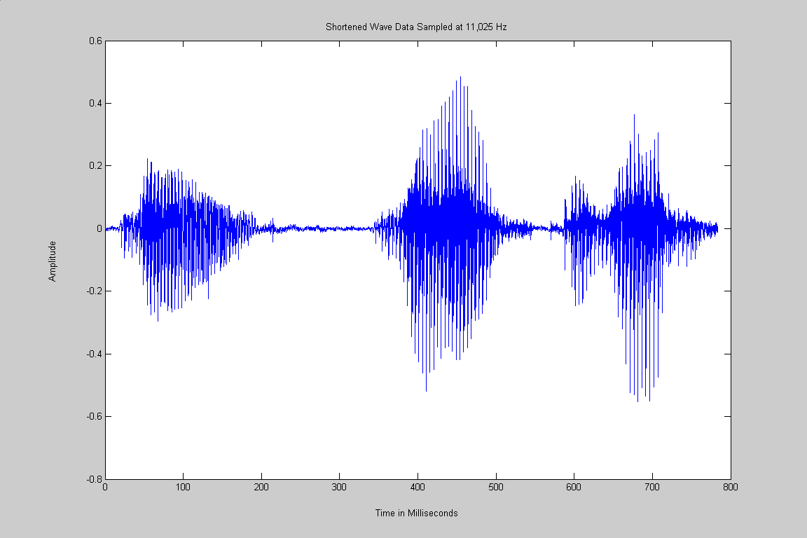

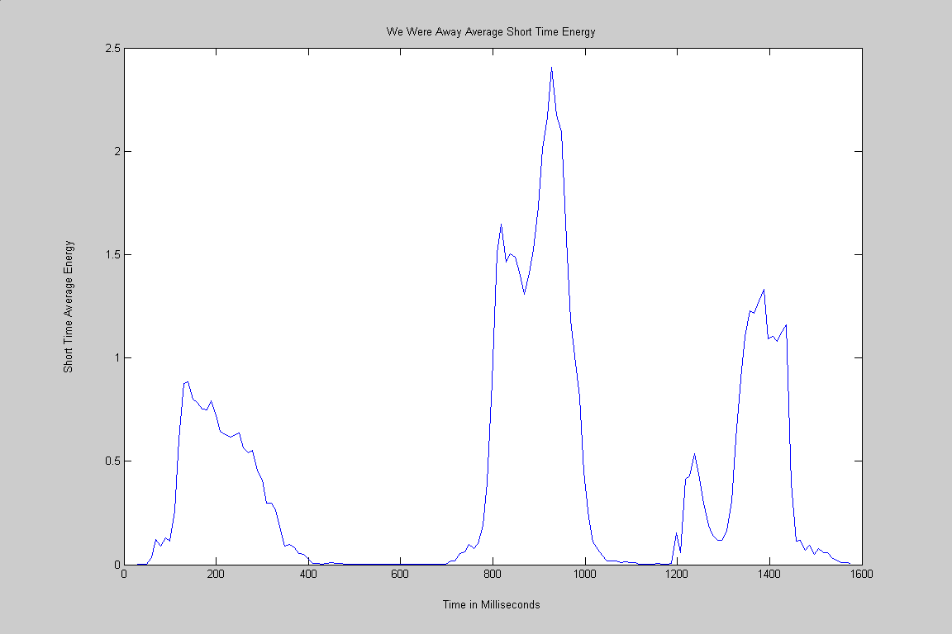

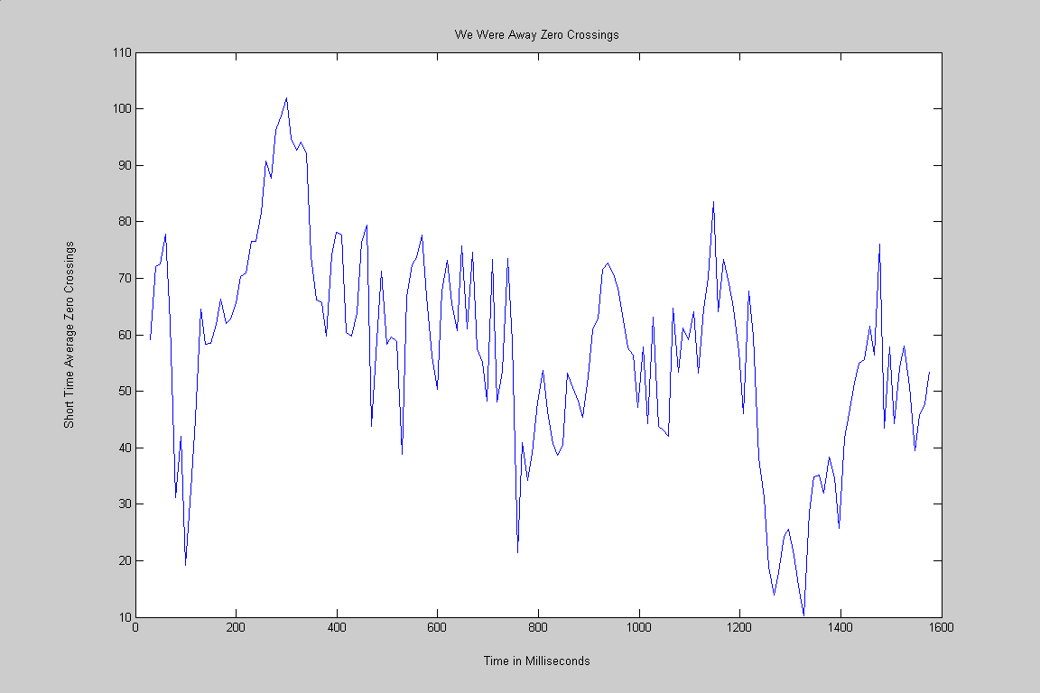

Matlab Code for Part 8

%Part 8 Read in wave file, must change frequency since it was recorded at
%a higher frequency than 11,025 Hz
wavfile = 'male_part1';
sampfreq=22050;
[S,FS,BITS] = wavread(wavfile);
Q = decimate(S,2);
FSdec = FS/2;
figure,plot(Q), title('Wave Data sampled at 11,025 Hz, Amplitude Vs. Samples'), xlabel('Samples n'), ylabel('Amplitude');,
phrase = 'Click Start & End Coordinates, Original Wave Data';
display(phrase);
title(phrase);
[xcoord, ycoord] = ginput(2);
xcoord = round(xcoord);
xcoord = sort(xcoord);
R=Q(xcoord(1):xcoord(2));

figure,plot(R), title('Shortened Wave Data Sampled at 11,025 Hz'), xlabel('Samples n'), ylabel('Amplitude');
Shortened_Sample_Size = size(R)
sound(R,FSdec,BITS);

tspch=[1:length(R)]/FS; %Time vector for speech in seconds
tspch = tspch*1000; %speech time vector in milliseconds
figure,plot(tspch,R),title('Shortened Wave Data Sampled at 11,025 Hz'),xlabel('Time in Milliseconds'),ylabel('Amplitude');

avgenergy=avg_energy(R,220);
avgmagnitude = avg_magnitude(R,220);
zerocrossing = zero_crossing(R,220);

Part 9

From your results in 7 and 8, describe how the energy and zero-crossings are related to voiced and unvoiced speech utterances.

The relationship is that the unvoiced sounds are closely related to noise and are generated by forcing of air through the mouth, which results in a lot of zero crossings. The voiced sounds are generated by vibration of the vocal chords, which produce a higher energy signal that is quasi-periodic.

Conclusion for Assignment 2

In this assignment students explored techniques for analyzing speech components within wave files in Matlab. Tools were used to extract parts of speech for analysis. The speech signals were decomposed into their basic components. These components have unique qualities with respect to energy and zero crossings. The voiced components rely on vocal chord vibrations while thrusting air through the mouth generates the unvoiced components. These unique parameters allow speech analysis software to decompose these signals for applications such as voice recognition and digital signal processing.

