Assignment 1: Introduction to discrete-time signals



ECE 480
Professor: Selim Awad
Term: Winter 04

Prepared by:

Chris Musser
Ken Mayle
Vladi Gergov

I have neither given nor received aids in the preparation of this report:

_________________________________________________

_________________________________________________

_________________________________________________

Lab Overall Objectives:

- To familiarize students with Matlab and the basic discrete-time signals.
- Matlab is used as a tool to achieve this purpose.

Objective 1
Consider the curve y=$\sqrt{\frac{2−2x}{2+2x^{2}}}$
What is the range of the variable x, which makes y real? Sketch the curve and estimate the global maximum. Find the value of this maximum and the corresponding value of x at the maximum.

For range of x:

-∞ ≤ x ≤1

% Chris Musser, Ken Mayle, Vladi Gergov
%ECE 480 Lab 1

x=[-100:.1:100]'; %Set x parameter
y1=(2-2*x)./(2+2*x.^2);
y2=sqrt(y1); %y=
plot(x,y2) %plot x vs. y2

[ymax,indy]=max(y2) %find y max

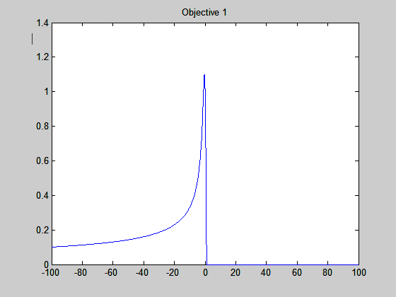
xm=x(indy) %find x at y max

%Matlab command screen
%>> max =
% 1.0986
% indy =
% 997
%
%xm =
% -0.4000

Objective 2

Plot the following functions on the same graph. Take the interval
0 < t < 30 and choose a suitable δελτα(t) (e.g., 0.01 s).
y1(t)=1.25e^{-t}
y2(t)=2.02e^{-0.03t}
y3(t)=2.02e^{-0.3t} cos(0.554t+pi/4)+1.25e^{-t}

Limit the Y-axis to -15 and 15 and the X-axis to 0 and 20. Also determine the
following values for y3(t ) at t = 0, t = 8, and y3(t) min.

% Chris Musser, Ken Mayle, Vladi Gergov
%ECE 480 Lab 1 Problem 2

t=[0:.01:30]'; %Establish duration

%Set up functions

y1=1.25*exp(-t);
y2=2.02*exp(-.3*t);
y3=2.02*exp(-.3*t).*cos((.554*t)+(pi/4))+1.25*exp(-t);

y=[y1, y2, y3]; %Save the 3 functions in an array
plot(t,y); grid on; %Plot the 3 functions on the same set of axis
xlabel('Time in secs')
ylabel('Amplitude')
axis([0 20 -15 15]) %Set axis values
legend('Y1', 'Y2', 'Y3'); %Set legend
y3_0=y3(t==0)
y3_8=y3(t==8)
[ymin,indy]=min(y3) %find y min

% y3_0 =
% 2.68
% y3_8 =
% 0.09
% ymin =
% -0.61
% indy =
% 352.00
% ans =
% -0.61

Objective 3

Generate and plot the following sequences:

(a) x1(n) = 0. 5 δ(n + 4) -12 < n < 10
(b) x2(n) = δ (n - 330) 300 < n < 350
(c) x3(n) = 4.5 δ (n + 4) - 1.6 δ (n -2) -12 < n < 4
(d) x4(n) = u(n) – u(n – 12) -5 < n < 20

How many samples do we have for each sequence (see end of matlab code)? (later we realized we could do stem with subplots).

% Chris Musser, Ken Mayle, Vladi Gergov
%ECE 480 Lab 1 Problem 3 Part A

%Set up ranges
n1=[-12:1:10]';
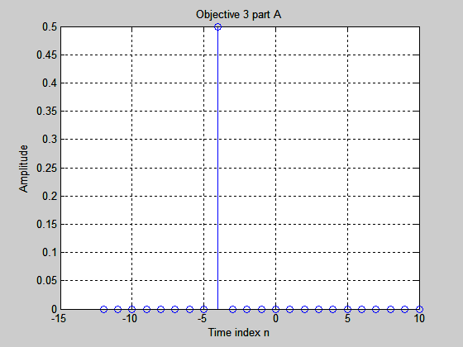
x1=zeros(size(n1)); %Make x1 the same size as n1
ind=find(n1==-4); %Make the index look at -4
x1(ind)=.5; %Set the index value to .5

stem(n1,x1); %Plot n1 vs. x1
xlabel('Time index n')
ylabel('Amplitude')
grid on;
%There is only one non zero sample for x1.

n2=[300:1:350]';
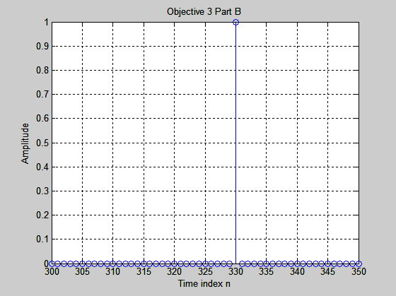
x2=zeros(size(n2)); %Make x2 the same size as n2
ind=find(n2==330); %Make the index look at 330
x2(ind)=1; %Set the index value to 1

stem(n2,x2); %Plot n2 vs. x2
xlabel('Time index n')
ylabel('Amplitude')
grid on;
%There is only one non zero sample for x2.

n3=[-12:1:4]';
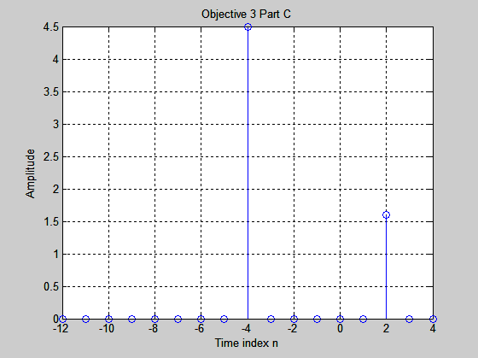
x3=zeros(size(n3)); %Make x3 the same size as n3
ind1=find(n3==-4); %Make the index look at -4
ind2=find(n3==2); %Make the index look at 2
x3(ind1)=4.5; %Set the index value to 4.5
x3(ind2)=1.6; %Set the index value to 1.6

stem(n3,x3); %Plot n3 vs. x3
xlabel('Time index n')
ylabel('Amplitude')
grid on;

n3=[-12:1:4]';

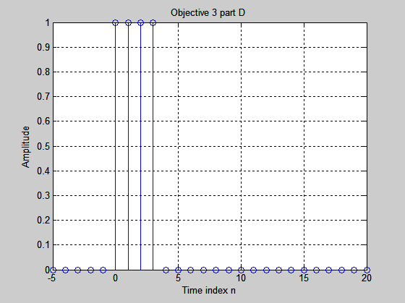
x3=zeros(size(n3)); %Make x3 the same size as n3
ind1=find(n3==-4); %Make the index look at -4
ind2=find(n3==2); %Make the index look at 2
x3(ind1)=4.5; %Set the index value to 4.5
x3(ind2)=1.6; %Set the index value to 1.6

stem(n3,x3); %Plot n3 vs. x3
xlabel('Time index n')
ylabel('Amplitude')
grid on;

Objective 4

Plot each of the following sequences. Determine which of them is
periodic. Find the period for the periodic sequences. For the sequence of
part (c) give a simpler formula.

(a) x1(n) = sin ($\frac{2π}{\text{14}}n+π/3$) -20 < n < 60
(b) x2(n) = sin ($\frac{π}{\text{15}}n+π/3$) -50 < n < 50

(c) x3(n) = sin (3πn + π/2) -10 < n < 10
(d) x4(n) = cos ($\frac{2π}{\sqrt{\text{68}}}n$) -10 < n < 50

(e) x5(n) = sin ( $\frac{π}{3}n$)-2cos($\frac{π}{4}n+π/4$) -40 < n < 40

(f) x5(n) = 2 cos ( $\frac{π}{3}n$)*sin($\frac{π}{4}n+π/4$) -40 < n < 40

% Chris Musser, Ken Mayle, Vladi Gergov
%ECE 480 Lab 1 Problem 4

% Part A
w1=2*pi/14; %Define w1
n1=[-20:1:60]'; %Define n1
x1=sin(w1*n1+(pi/3));
subplot(3,2,1)
stem(n1,x1) %Plot n1 vs. x1
xlabel('Time index n')
ylabel('Amplitude')
grid on;

%Check to see if it is Periodic
w1/(2*pi)
%Matlab Command Screen
%ans =
% 0.0714 Since this is a rational number the series is periodic.
% The period is 14.

% Part B
w2=pi/15; %Define w1
n2=[-50:1:50]'; %Define n2
x2=sin(w2*n2-(pi/3));
subplot(3,2,2)
stem(n2,x2) %Plot n2 vs. x2
xlabel('Time index n')
ylabel('Amplitude')
grid on;

%Check to see if it is Periodic
w2/(2*pi)
%Matlab Command Screen
%ans =
% 0.0714 Since this is a rational number the series is periodic.
% The period is 30.

% Part C
w3=3*pi;
n3=[-10:1:10]';
x3=sin(w3*n3+(pi/2));
subplot(3,2,3)
stem(n3,x3)
xlabel('Time index n')
ylabel('Amplitude')
grid on;

%Check to see if it is Periodic
w3/(2*pi)
%Matlab Command Screen
%ans =
% 1.5000 Since this is a rational number the series is periodic.
% The period is 2.
%Since sin(wn+(pi/2))=cos(wn) and cos(3pi)=cos(pi); a simpler formula for this
%series is cos(pi*n).
%check:
x3a=cos(pi*n3);
stem(n3,x3a)

% Part D
w4=2*pi/(sqrt(68));
n4=[-10:1:50]';
x4=cos(w4*n4);
subplot(3,2,4)
stem(n4,x4)
xlabel('Time index n')
ylabel('Amplitude')
grid on;

%Check to see if it is Periodic
w4/(2*pi)
%Matlab Command Screen
%ans =
% 0.1213 Since this is a rational number the series is periodic.
% The period is sqrt(68)= 8.2462.

% Part E
w5a=pi/3;
w5b=pi/4;
n5=[-40:1:40]';
x5=sin(w5a*n5)-2*cos(w5b*n5+(pi/4));
subplot(3,2,5)
stem(n5,x5)
xlabel('Time index n')
ylabel('Amplitude')
grid on;

%Check to see if it is Periodic
w5a/(2*pi)
w5b/(2*pi)
%Matlab Command Screen
%ans =
% 0.1667
%ans =
% 0.1250
%Since these two are rational numbers the series is periodic.
% The period is found by:
N1=6; N2=8; %N1 is period of first sinusoid and N2 is the period of the second.
N=lcm(N1,N2) %N will give you the period of the series.
%N = 24

% Part F
w6a=pi/3;
w6b=pi/4;
n6=[-40:1:40]';
x6=2*cos(w6a*n6).*sin(w6b*n6-(pi/4));
subplot(3,2,6)
stem(n6,x6)
xlabel('Time index n')
ylabel('Amplitude')
grid on;

%Check to see if it is Periodic
w6a/(2*pi)
w6b/(2*pi)
%Matlab Command Screen
%ans =
% 0.1667
%ans =
% 0.1250
%Since these two are rational numbers the series is periodic.
% The period is found by:
N1=6; N2=8; %N1 is period of first sinusoid and N2 is the period of the second.
N=lcm(N1,N2) %N will give you the period of the series.
%N = 24
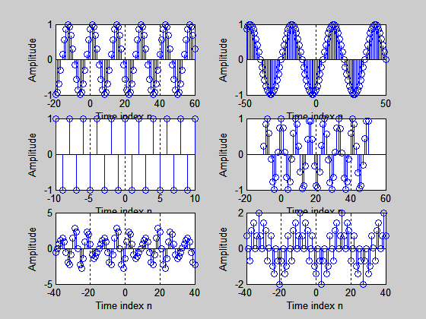

Objective 5

Generate a sampled sinusoid with the following data:
Signal frequency 0.6 kHz, sampling freq. = 8 kHz,
Initial phase = 30 deg.,
starting time = 0 sec.,
Amplitude = 2,
Ending time = 14.667 msec.

Make two plots of the resulting signal: one as a function of time (in msec),
and the other as a function of the sample Index n used in tn = nt. Determine
the length of the resulting discrete-time signal and the number of periods of
the sinusoid included in the signal vector.

% Chris Musser, Ken Mayle, Vladi Gergov
%ECE 480 Lab 1 Problem 5

f=0.6e3;
fsamp=8e3;
T=1/fsamp;
theta=30*pi/180;
time=[0:T/10:14e-3]';
amp=2;
xa=amp*sin(2*pi*f*time+theta);
subplot(2,1,1)
plot(time*1e3,xa,'r')
title('Lab1-Plot of #5');
xlabel('Time in msec');
ylabel('Amplitude');
grid on

tsamp=[0:T:14e-3]';
xb=amp*sin(2*pi*f*tsamp+theta);
n=tsamp/T;
subplot(2,1,2)
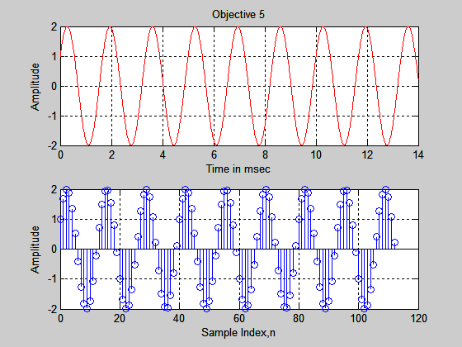
stem(n,xb,'b');
xlabel('Sample Index,n');
ylabel('Amplitude');
grid on

N=max(tsamp)/T
period=1/f
num_periods=max(time)/period

N =
112
period =
0.0017
num_periods =

8.4000

Objective 6

Plot the discrete-time exponential signal
x(n) = 2(-0.7)^{n} over the range n = 0,1,2,...,10
Find the sum of the sequence. Verify using the closed form:
$Σ_{n=0}^{L−1}a^{n}=\frac{1−a^{L}}{1−a}\text{for}$ a ≠ 1

% Chris Musser, Ken Mayle, Vladi Gergov
%ECE 480 Lab 1 Problem 6

n=[0:10]';
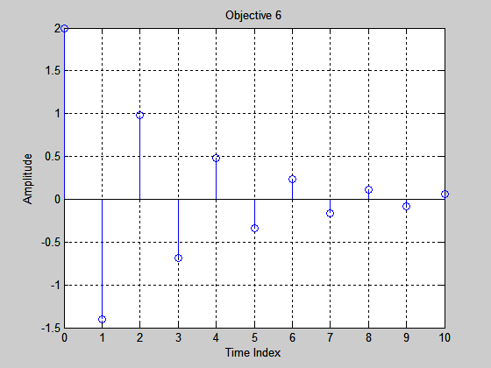
x=2*(-0.7).^n;
stem(n,x);
title('Objective 6');
xlabel('Time Index');
ylabel('Amplitude');
grid on
xm=sum(x)
xm =
1.20

Objective 7

Consider the difference equation given as follows:
y(n) = 0.5 y(n-1) + x(n), n > 0 and y(n) = 0 for n < 0.
Find and plot y(n) for the following cases:
(a) x(n) = δ (n)
(b) x(n) = u(n-2)
(c) x(n) = u(n) – u(n – 7)

% Chris Musser, Ken Mayle, Vladi Gergov
%ECE 480 Lab 1 Problem 7a

n=[-5:10]';
x=zeros(size(n));
ind=find(n>=0);
x(ind(1))=1;
subplot(2,1,1)
stem(n,x);
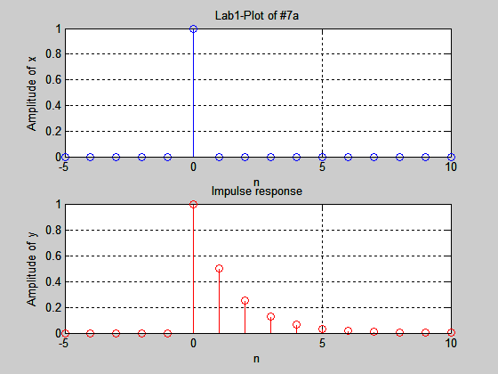
title('Lab1-Plot of #7a');
xlabel('n');
ylabel('Amplitude of x');
grid on

y=zeros(size(n));
indnz=ind(1);
for i=indnz:length(x)
y(i)=0.5*y(i-1)+x(i);
end
subplot(2,1,2)
stem(n,y,'r');
title('Impulse response');
xlabel('n');
ylabel('Amplitude of y');
grid on
pause

% Chris Musser, Ken Mayle, Vladi Gergov
%ECE 480 Lab 1 Problem 7b

n=[-5:10]';
x=zeros(size(n));
ind=find(n>=2);
x(ind)=1;
subplot(2,1,1)
stem(n,x);
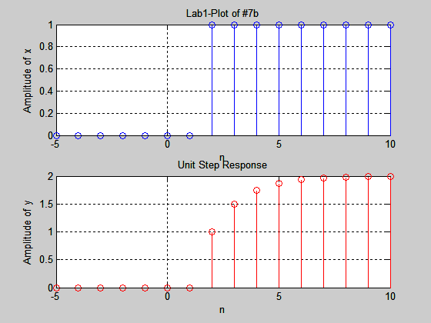
title('Lab1-Plot of #7b');
xlabel('n');
ylabel('Amplitude of x');
grid on

y=zeros(size(n));
indnz=ind(1);
for i=indnz:length(x)
y(i)=0.5*y(i-1)+x(i);
end
subplot(2,1,2)
stem(n,y,'r');
title('Unit Step Response');
xlabel('n');
ylabel('Amplitude of y');
grid on
pause

% Chris Musser, Ken Mayle, Vladi Gergov
%ECE 480 Lab 1 Problem 7c

n=[-5:10]';
x=zeros(size(n));
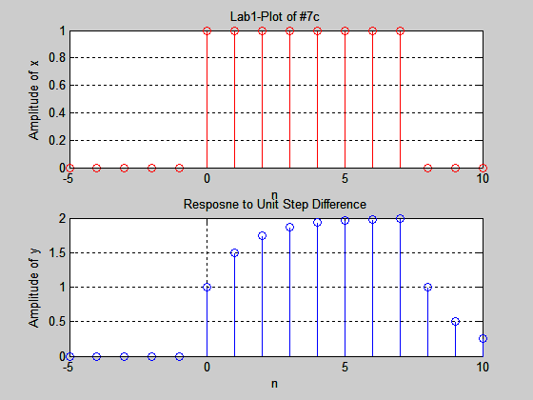
ind=find(n>=0 & n<=7);
x(ind)=1;
subplot(2,1,1)
stem(n,x,'r');
title('Lab1-Plot of #7c');
xlabel('n');
ylabel('Amplitude of x');
grid on

y=zeros(size(n));
indnz=ind(1);
for i=indnz:length(x)
y(i)=0.5*y(i-1)+x(i);
end
subplot(2,1,2)
stem(n,y);
title('Resposne to Unit Step Difference');
xlabel('n');
ylabel('Amplitude of y');
grid on

Objective 8

For the same difference equation given as of part (7), namely
y(n) = 0.5 y(n-1) + 2x(n), n > 0, find y(n) for the following
conditions:
• y(-1) = 4 (initial condition)
• x(n) = u(n).

% Chris Musser, Ken Mayle, Vladi Gergov
%ECE 480 Lab 1 Problem 8

clc
clear
n=[-10:15]';
x=zeros(size(n));
ind=find(n>=0);
x(ind)=1;
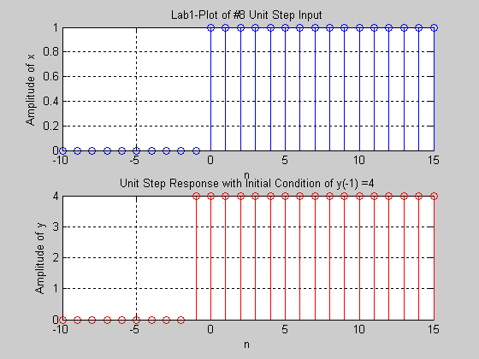
subplot(2,1,1)
stem(n,x);
title('Lab1-Plot of #8 Unit Step Input');
xlabel('n');
ylabel('Amplitude of x');
grid on

y=zeros(size(n));
index_int_cond=find(n==-1);
y(index_int_cond)=4;

indnz=ind(1);
for i=indnz:length(x)
y(i)=0.5*y(i-1)+2*x(i);
end
subplot(2,1,2)
stem(n,y,'r');
title('Unit Step Response with Initial Condition of y(-1) =4');
xlabel('n');
ylabel('Amplitude of y');
grid on



