ECE 480
Winter 2003
COMPUTER-BASED ASSIGNMENT # 4
Introduction to the simulation of signals and systems

Objective:

The objective of this lab is two fold. First, the student will get familiar with Simulink as a tool to simulate discrete-time and continuous-time signals and systems. Second, some typical systems will be simulated and the results will be analyzed using Matlab.

Exercise #1

Use Simulink to simulate the system shown in Fig. 1 The system is composed of a sampled sine wave of unity amplitude, frequency f1 Hz, and initial phase shift of p/3 radians. The signal will be displayed on the scope. Assume that the sampling frequency (fsamp) is 10 kHz.

a) If f1 = 1.5 kHz, simulated the system with a time equivalent to 5 periods of the sine wave. Display the waveform on the scope and also export the data of the output to the Matlab workspace to plot the amplitude (discrete-time versus time in msec). Also, plot the amplitude versus the time index, n.

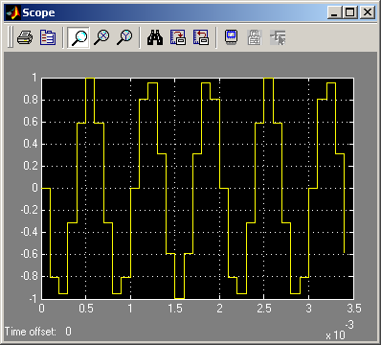
Matlab Code:

freq = 1500;
fsample = 10000;
T = 1/fsample;
time = output_1c(:,1);
n = time*fsample;
amplitude = output_1c(:,2);

subplot(2,1,1)
stem(time, amplitude)
grid on
xlabel('Time in msec');
ylabel('Amplitude');
subplot(2,1,2)
stem(n,amplitude)
grid on
xlabel('Time index');
ylabel('Amplitude');
Figure 1

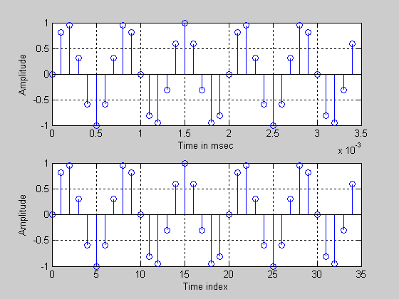
Figure 2 – Discrete time and time index (f1 = 1.5kHz)

b) Change the f1 to 11.5 kHz and investigate the output signal. Compare to part a) and comment.

The output is the same as the input, the reason is that 11.5 kHz is an alias for 1.5kHz. This will be further discussed in part ‘d’. The code is the same as part ‘a’ but with the frequency changed to 11.5kHz instead of 1.5kHz.

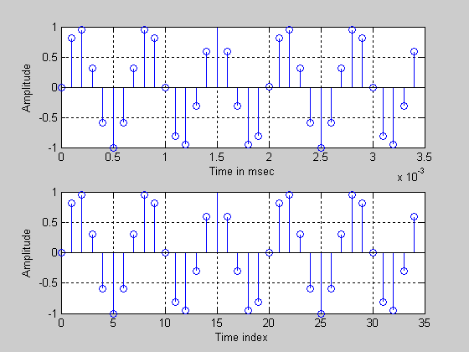
Figure 3 – Discrete time and time index (f1 = 11.5kHz)
c) What is the apparent frequency of the output if f1 = 8.5 kHz?. Compare to part a) and comment.

The output of this signal is the same but has a pahse reversal; this will be discussed further in part ‘d’. The code for this part of the lab is the same as in part ‘a’ but with the frequency changed to 8.5kHz

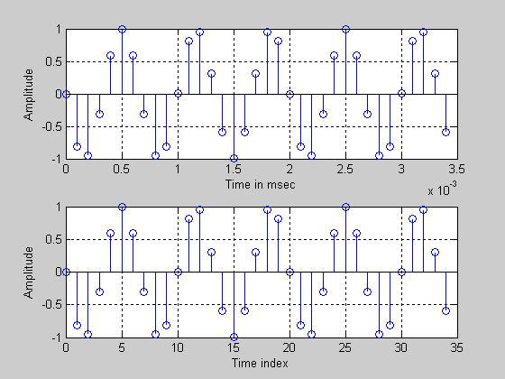
Figure 4 – Discrete time and time index (f1 = 8.5kHz)

d) For the above cases, give the digital frequencies and indicate if they have aliases in the range 0 < f < 5 kHz.

(2*π*1,500) = .3 π Initial signal
10,000
(2*π*11,500) = 2.3π = 2π + .3 π = .3π Aliased signal of 1.5kHz
10,000
(2*π*8,500) = 1.7π = 2π - .3 π Aliased signal of 1.5kHz with phase reversal
10,000
Exercise #2
Consider the digital filter given by the:

y(n) = 1.8 cos(p/16) y(n-l) - 0.81 y(n-2) + x(n) + 0.5 x(n-1)

- Using Simulink, assuming fsamp =10 kHz, and a simulation time of 2 msec, find the step response.

For this exercise the digital filter with difference equation y(n) = 1.8 cos(p/16) y(n-l) - 0.81 y(n-2) + x(n) + 0.5 x(n-1) was added to the system. Simulink was used to finding the step response of the system. This was accomplished by first constructing the system seen in figure 8. fsamp was declared to be 10kHz and a simulation time of 2 msecs was selected. These parameters were set by choosing start time =0, stop time =20*T, where T=1/fsamp in the simulation parameters box. Figure 1 show’s the system set up in simulink. Figure 2 shows the graph of the step response.

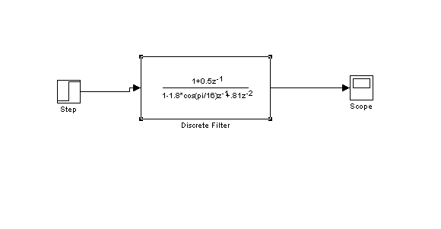
Figure 1

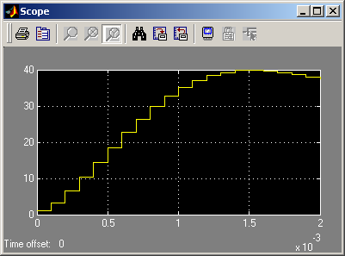
Figure 2

- Determine the steady-state value, Go. Hence, plot the transient response, ytran. Hint: use the model shown in Fig. 2

This part of the lab finds the steady state value of the system, and then plots the transient response, which is the total system output less the steady state value. The steady state of this system was found by running the system again, then using matlab command G0 = outputs(end, 2);. This returned the final value of the data saved to the workspace from the simulation. The steady state value of 33.65 was then subtracted from the total response by using a summer in the simulink workspace. The value of the constant was set to the value of the steady state response. What is left over is the transient response, and is plotted vs. time and the time index n. This plot can be seen in figure 4.

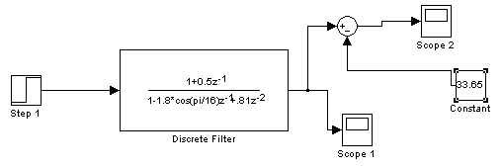
Figure 3

G0 = 33.65

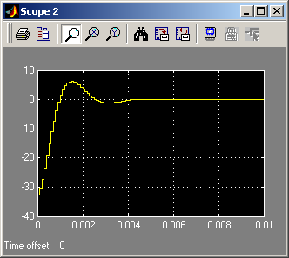
Figure 4

- If an input is a pulse equivalent to x(n) = u(n) – u(n-14), find the pulse duration in msec, and hence determine the pulse response. Hint: use the model shown in Fig. 3

This section uses an input x(n)=u(n)-u(n-14), and requires that the pulse duration in milliseconds be found as well as determine that pulse responses to the system. The system used for this exercise is shown in figure 5. The first step function in the system is set up to be a typical step input, and the second pulse called “step 1” has parameters set to: step time=14*T, initial value=0, final value= 1, and sample time=T. The simulation was then ran and data saved to the workspace. Code was used to find the duration of the pulse in msecs, which turned out to be pulse_duration_in_msec = 7.1 which can be observed in figure 6.

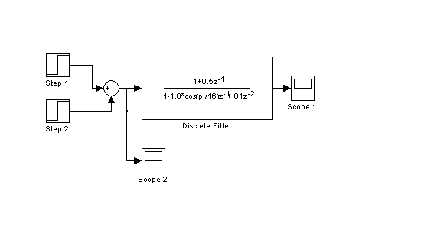
Figure 5

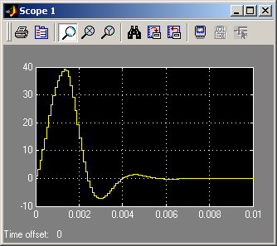
Figure 6

- For a input which is a sine wave of unity amplitude, frequency 1.4 kHz and phase of p/3, as in part b), find the transient and steady-state.

In order to plot the transient resonse the steady state response had to be found first since Ytr = Y-Yss. The steady state response was found by finding the magnitude and phase response using the freqz command, then the steady state was determined by Yss =|H(e^jw)|*A*sin(Ω+θ+<H(e^jw)). This signal was then subtracted from the total response and shown on the scope. Figure 7 shows the complete system and figure 8 shows the total response. Figure 9 shows the transient response of the system.

Figure 7

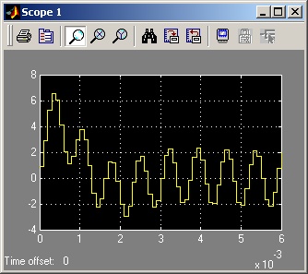
Figure 8

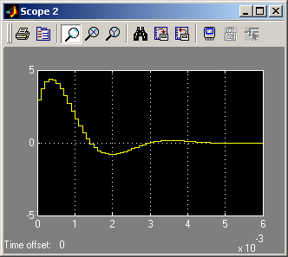
Figure 9

Matlab Code:

n=[0:200];
a0=1;
a1=-1.8*cos(pi/16);
a2=.81;

b0=1;
b1=.5;
b2=0;

a=[a0, a1, a2];
b=[b0, b1, b2];

w=[0, .32*pi];
H=freqz(b,a,w);
mag=abs(H);
phase=angle(H);

Exercise #3

It is required to design an anti-aliasing lowpass filter to filter out frequencies in the frequency band f > 5 kHz. The requirements are as follows:

The stop-band frequency, fs = 5 kHz and (stop-band attenuation) as = 40 dB.
The passband attenuation, ap = 1 dB
Order of filter, n, cannot exceed 7.

a) Choose the approximation that gives the best results.

(a) The approximation that gives the best results is an elliptic filter. This is based on order/simplicity. If based on performance, it would be Butterworth would give the best results.

b) Determine the passband frequency fp.

(b) The pass band frequency that keeps the order 7 or under is 4700Hz.

fp =

4700

N =

7

Wn =

2.9531e+004

c) Find the transfer function and hence plot the magnitude and phase responses of your design.

(c) Elliptic produced 7 orders
Butterworth produced 103 orders
Chebychev I/II produced 19 orders
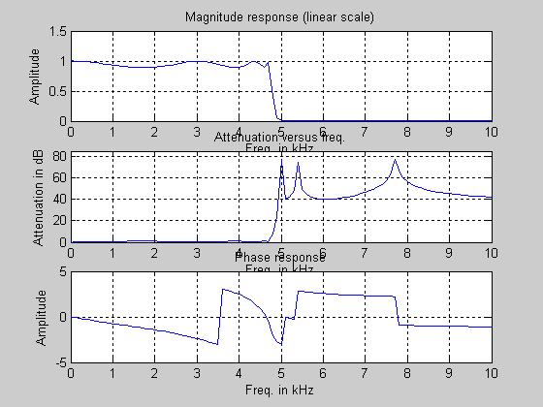

fp=4700; % pass band frequency edge
fs=5e3; % stop band frequcy edge
ap=1; % attenuation in passband
as=40; % attenuation in stopband

%Gives the parameters of the equivalent elliptic filter
[N,Wn]=ellipord(2*pi*fp, 2*pi*fs, ap, as, 's')

%Echo's and meanings
%N is the order of the elliptic filter
%wn is the passband edge in radians/sec
%Finding the transfer coefficients

[Num,Den]=ellip(N,ap,as,Wn,'s')
f=[0:100:10e3]'; % frequency range 0 to 10kHz
H=freqs(Num,Den,2*pi*f); % finding the frequency response
att=-20*log10(abs(H)); % Find the attenuation in dB

%Butterworth filter approximation method
[Nbutter,Wnbutter]=buttord(2*pi*fp,2*pi*fs,ap,as,'s')

%Echo's and their meanings
%Nbutter is the order
%Wnbutter is the passband edge in radians/sec

%Chebyshev filter approximation method
[Ncheby,Wncheby]=cheb1ord(2*pi*fp,2*pi*fs,ap,as,'s')

%Echo's and their meanings
%Ncheby is the order
%Wncheby is the passband edge in radians/sec

subplot(3,1,1)
plot(f/1e3,abs(H));
xlabel('Freq. in kHz');
ylabel('Amplitude');
title('Magnitude response (linear scale)');
grid on;

subplot(3,1,2)
plot(f/1e3,att);
xlabel('Freq. in kHz');
ylabel('Attenuation in dB');
title('Attenuation versus freq.');
axis([0,10,0,85]);
grid on;

subplot(3,1,3)
plot(f/1e3,angle(H));
xlabel('Freq. in kHz');
ylabel('Amplitude');
title('Phase response');
grid on;

d) For your design, what will be the order of the filter you designed if Butterworth, Chebychev or Elliptic filter approximations are used?

d)
Butterworth approximation is 92nd order.
Chebychev approximation is 18th order.
Elliptic approximation is 7th order.

e) In order to test the anti-aliasing lowpass filter, construct the model shown in Fig. 4, which represents a part of a data acquisition system. Assume that the digital filter is given by the following difference equation:
y(n) = 0.53353 y(n-1) -0.7265 y(n-2) + 0.136728{ x(n) - x(n-2)}.

What is the type of this digital filter? Test for stability. Plot the magnitude and phase responses.

e) This is a band pass filter. It is stable, the poles lie within the unit circle.
Amplitude and phase response in Radians
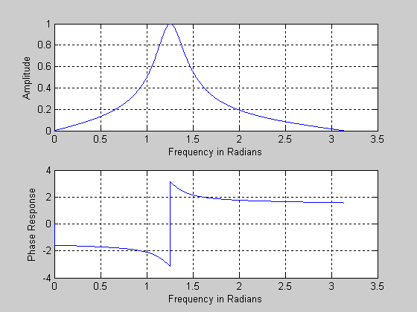
Amplitude and phase response in Hertz.
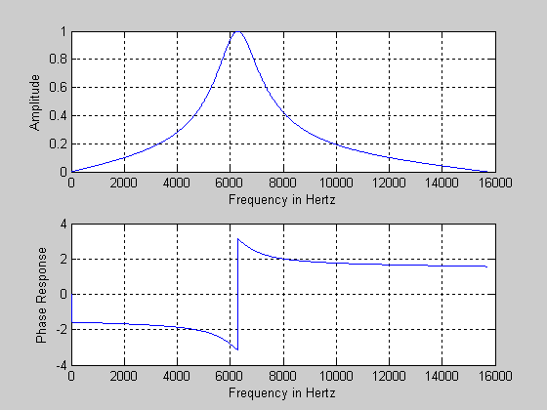

f) Simulate the model using Simulink for input frequencies f = 1 kHz, 2, KHz, 4 kHz, 6 kHz and 8 kHz. Verify that there is no aliasing. Investigate the different waveforms seen on the screen of the scopes and comment.

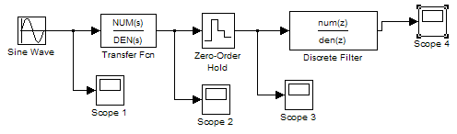

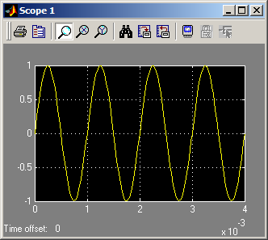
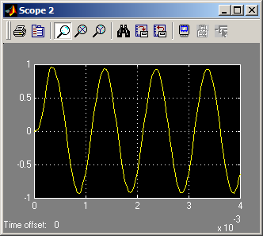

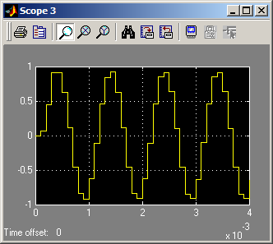
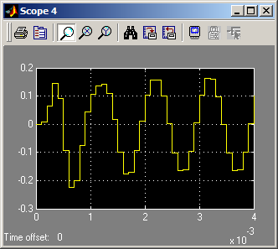
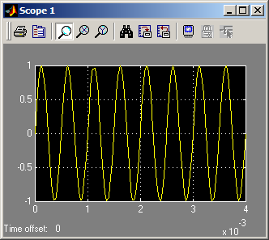
This Figure shows the scopes when the sine wave is at 1kHz. 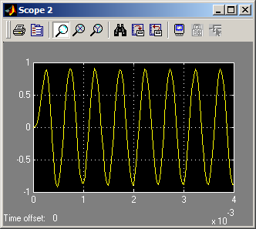

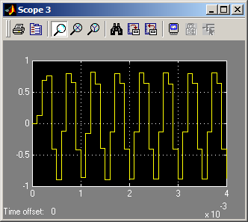
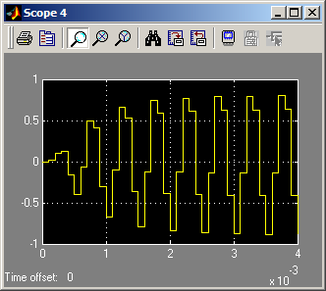

This Figure shows the scopes when the sine wave is at 2kHz.

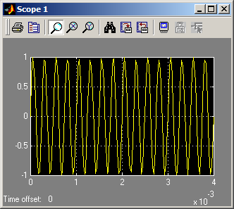
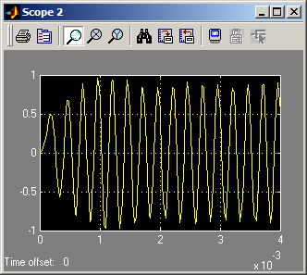

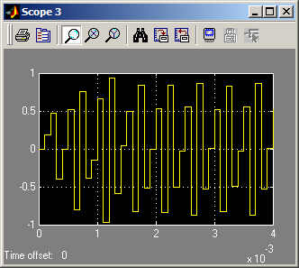
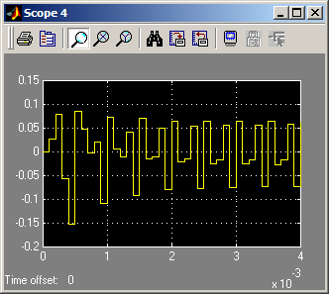

This Figure shows the scopes when the sine wave is at 4kHz.
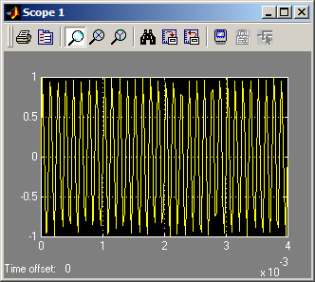

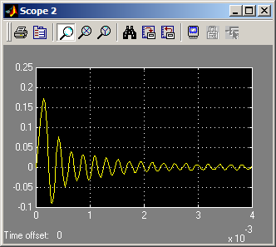
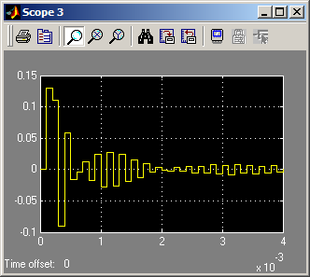
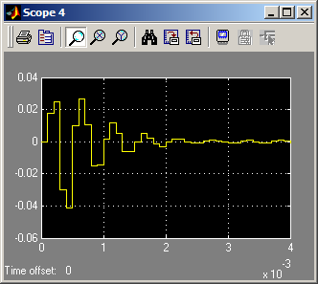

This Figure shows the scopes when the sine wave is at 8kHz.

Exercise #4
In this exercise we would like to model an A/D converter with the following parameters:
- Number of bits is nb
- Full scale-level isVref = 5 volts (this means that the maximum range is + Vref)
- Sampling frequency of 10 kHz.
The model is shown in fig. 5.

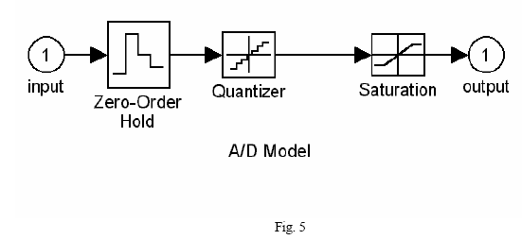
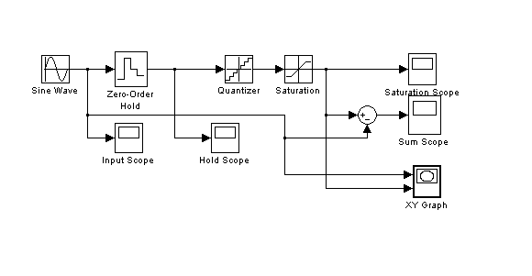
Figure 1

a) For the following values values of the parameters model the A/D converter and plot the transfer charact\ertics. Hint: Use one period of a low frequency signal (1 Hz).
- nb = 3 bits
- nb = 8 bits.

Figure 2 shows nb=3 bits transfer characteristics and Figure 3 shows nb=8 bits transfer characteristics.

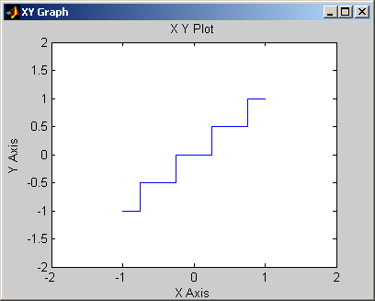
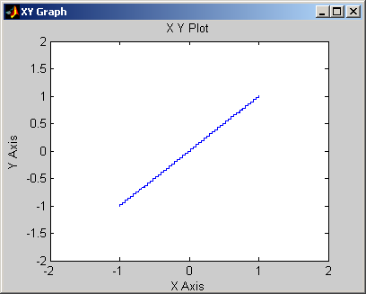Figure 3
Figure 2

Notice that figure 3 has more steps. That is because the delta (quantization step size) is smaller.

Δ= 2*Vref
2^nb

Bits = 3:
2*5 =10 =5
2^3 8 4

Bits = 8:
2*5 =10 = 5
2^8 256 128

Matlab Code:
Fsamp=10e3;
T=1/Fsamp;
NB=3; %or NB=8;
Vref=5;

delta=(2^(1-NB))*Vref;

L1=Vref-delta;
L2=-Vref;

f1=1;
amp=Vref-delta;

b) For an analog input sine wave of frequency 10 Hz and amplitude = Vref –(quantization step), plot the output and the quantization noise signals for both cases of part a).

The output scope and noise scope for NB=3 bits is shown in Figure 4 and NB=8 bits is shown in Figure 5.

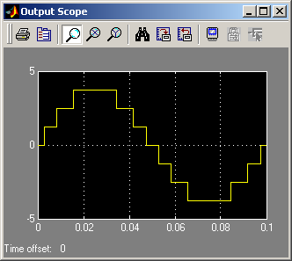
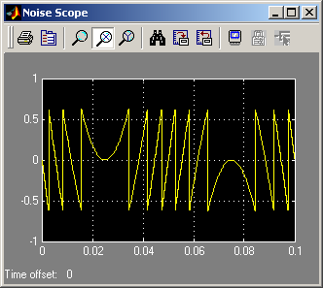

Figure 4

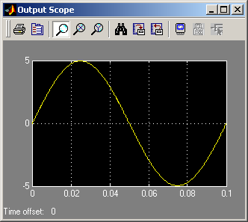
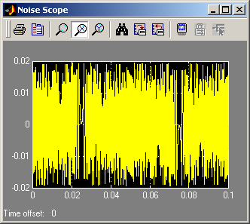

Figure 5

c) Calculate the quantization average power and hence the S/N ratio of the output signals.
Hint: Use about 5 cycles of the sine wave in order to calculate the average power.

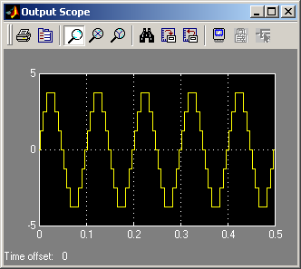

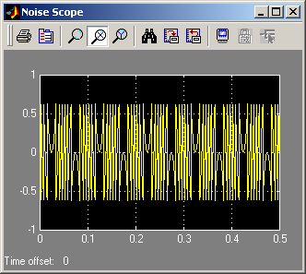

Figure 1: 5 Cycles (3bits)
Matlab Code:
Fsamp=10e3;
T=1/Fsamp;
NB=3; %or NB=8;
Vref=5;

delta=(2^(1-NB))*Vref;

L1=Vref-delta;
L2=-Vref;

f1=10;
amp=Vref-delta;
Pinput=((Vref^2)/2)
Pnoise=mean(noise(:,2).*noise(:,2))
Poutput=mean(output(:,2).*output(:,2))
SNR_in_DB=10*log10(Poutput./Pnoise)

Pinput =

12.5000

Pnoise =

0.1125

Poutput =

7.4391
SNR_in_DB =

18.2052

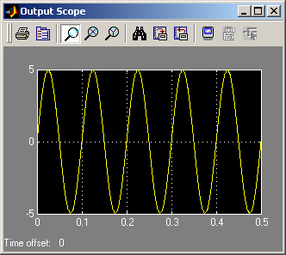
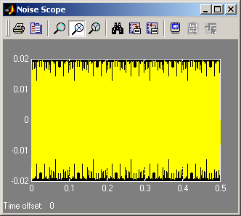
Figure 2 (8bits)
Fsamp=10e3;
T=1/Fsamp;
NB=8;
Vref=5;

delta=(2^(1-NB))*Vref;

L1=Vref-delta;
L2=-Vref;

f1=10;
amp=Vref-delta;
Pinput=((Vref^2)/2)
Pnoise=mean(noise(:,2).*noise(:,2))
Poutput=mean(output(:,2).*output(:,2))
SNR_in_DB=10*log10(Poutput./Pnoise)

Pinput =

12.5000

Pnoise =

1.2358e-004

Poutput =

12.3052

SNR_in_DB =

49.9813

Conclusion:

This lab proved to be an excellent introduction to Simulink and its ability to cross-reference with Matlab. Each portion of the lab touched on different ideas covered throughout the semester. This tool will be useful in the future as an aid in the simulation of electronic systems.

