

LAB#1:Introduction to Discrete-Time Signal

Hung Nguyen

Tan Nguyen

Minh Le

Dr. Selim Awad

Due date: 05/19/03
SPRING/SUMMER 2003

University of Michigan – Dearborn

HONOR CODE:

We have neither received nor given aid in the presentation of this report.

Signatures:

Objective:

- To familiarize students with Matlab and the basic discrete-time signals.
- Matlab is used as a tool to achieve this purpose.

Procedure/Result(s):

(1) Consider the curve y=$\sqrt{\frac{4−2x}{4+x^{2}}}$
What is the range of the variable x, which makes y real? Sketch the curve and estimate the global maximum. Find the value of this maximum and the corresponding value of x at the maximum.
Y = $\sqrt{\frac{4−2x}{4+x^{2}}}$ ⇒ Y = $\frac{4−2x}{4+x^{2}}≥0$ ⇒ $4+x^{2}≠0$ ⇒ $\frac{4−2x}{4+x^{2}}≥0$
$$\begin{aligned}4−2x≥0 \\ −2x≥−4 \\ x≤2\end{aligned}$$
Therefore, -∞ ≤ x ≤2

Matlab Code:

x=[-5:0.01:2]';
y=sqrt((4-2.*x)./(4+x.^2));
plot(x,y);
title('Plot of #1');
xlabel('X-Axis');
ylabel('Y-Axis');
grid on
[ymax,indy]=max(y)
xm=x(indy)

ymax=1.0987
indy=418
xm=-0.8300

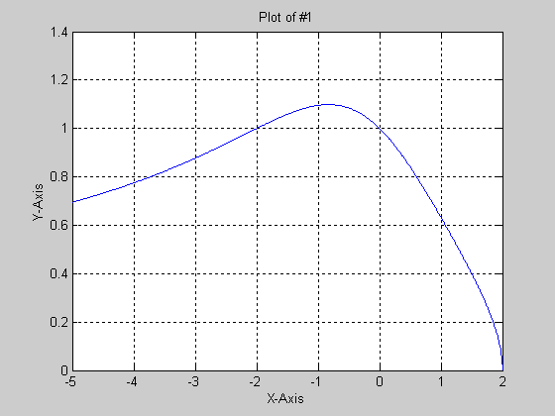
(2) Plot the following functions on the same graph. Take the interval
0 < t < 30 and choose a suitable .t (e.g., 0.01 s).
y1(t)=1.25e^{-t}
y2(t)=2.02e^{-0.03t}
y3(t)=2.02e^{-0.3t} cos(0.554t+45π/90)+1.25e^{-t}

Limit the Y-axis to - 4 and 5 and the X-axis to 0 and 18. Also determine the
following values for y3(t ) at t = 0, t = 5, and y3(t) min.

Matlab Code:

t=[0:0.01:30]';
y1=1.25*exp(-t);
y2=2.02*exp(-0.3*t);
y3=y2.*cos(0.554*t+(45*pi)/90)+y1;
y=[y1,y2,y3];
plot(t,y)
title('Plot of #2');
xlabel('Time in second');
ylabel('Amplitude');
grid on
legend('y1','y2','y3');
v=[0,18,-4,5]
axis(v);
y3_0=y3(t==0) =1.2500
y3_5=y3(t==5) =-0.1522
y3_min=min(y3) = -0.8436

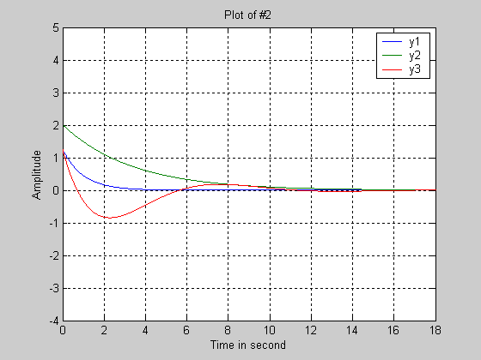

(3) Generate and plot the following sequences:

(a) x1(n) = 0. 8 δ(n + 5) -12 < n < 10
(b) x2(n) = δ (n - 335) 300 < n < 350
(c) x3(n) = 4.5 δ (n + 4) - 1.5 δ (n -3) -12 < n < 4
(d) x4(n) = u(n) – u(n – 10) -5 < n < 20
How many samples do we have for each sequence?

Matlab Code:

%3a)
n=[-12:10]';
x=zeros(size(n));
ind=find(n==-5);
x(ind)=0.8
stem(n,x);
num_samples=length(x)
title('Lab1-Plot#3a')
xlabel('Time-index,n');
ylabel('Amplitude');
grid on
num_samples =23

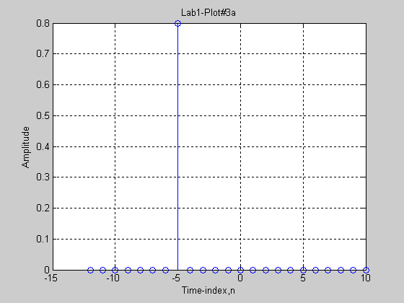

%3b
n=[300:350]';
x=zeros(size(n));
ind=find(n==335);
x(ind)=1
stem(n,x);
num_samples=length(x)
title('Lab1-Plot#3b')
xlabel('Time-index,n');
ylabel('Amplitude');
grid on

num_samples =51

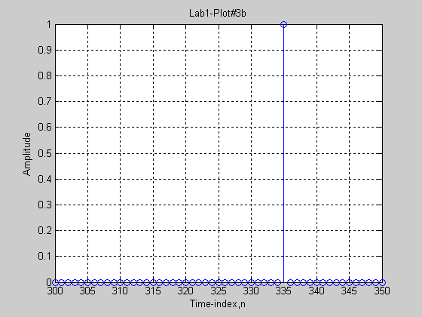

%3c

n=[-12:4]';
x1=zeros(size(n));
x2=zeros(size(n));
ind1=find(n==-4);
ind2=find(n==3);
x1(ind1)=4.5;
x2(ind2)=-1.5;
x=x1+x2;
stem(n,x)
num_samples=length(x)
title('Lab1-Plot #3c')
xlabel('Time-index,n');
ylabel('Amplitude');
grid on

num_samples = 17

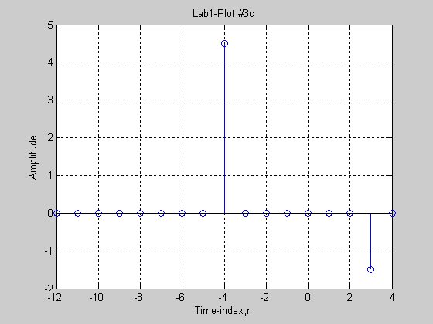

%3d
n=[-5:20]';
x=zeros(size(n));
ind=find(n>=0 & n<=9);
x(ind)=1;
stem(n,x)
num_samples=length(x)
title('Lab1-Plot #3d');
xlabel('Time-index,n');
ylabel('Amplitude');
grid on

num_samples = 26

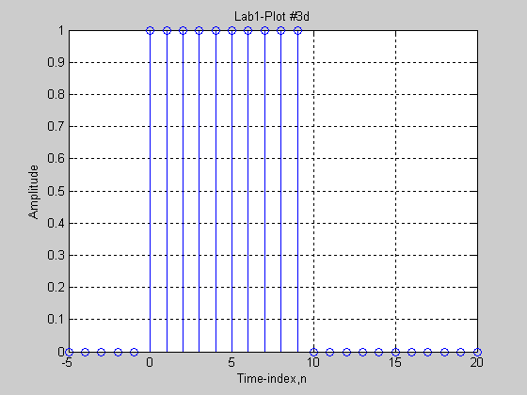

(4) Plot each of the following sequences. Determine which of them is
periodic. Find the period for the periodic sequences. For the sequence of
part (c) give a simpler formula.
(a) x1(n) = sin ($\frac{2π}{\text{14}}n+π/3$) -20 < n < 70
(b) x2(n) = sin ($\frac{π}{\text{15}}n+π/3$) -60 < n < 60

(c) x3(n) = sin (3πn - π/2) -10 < n < 10
(d) x4(n) = cos ($\frac{2π}{\sqrt{\text{68}}}n$) -10 < n < 50

(e) x5(n) = cos ( $\frac{π}{3}n$)+2sin($\frac{π}{4}n+π/4$) -40 < n < 40

(f) x5(n) = 2 cos ( $\frac{π}{3}n$3)*sin($\frac{π}{4}n+π/4$) -40 < n < 40

Ματλαβ Χοδε:
%#4α
να=[−20:70]∋;
ωα=(2∗πι)/14;
φορ ι=1:λενγτη(να)
ψα(ι)=σιν(ωα∗(ι)+πι/3);
ενδ
συβπλοτ(6,1,1)
στεμ(να,ψα);
τιτλε(∋Λαβ1−Πλοτ#4α∋);
ξλαβελ(∋Ξ−αξισ∋);
ψλαβελ(∋Ψ−αξισ∋);
γριδ ον

%#4β
νβ=[−60:60]∋;
ωβ=πι/15;
φορ ι=1:λενγτη(νβ)
ψβ(ι)=σιν(ωβ∗(ι)−πι/3);
ενδ
συβπλοτ(6,1,2)
στεμ(νβ,ψβ);
τιτλε(∋Λαβ1−Πλοτ#4β∋);
ξλαβελ(∋Ξ−αξισ∋);
ψλαβελ(∋Ψ−αξισ∋);
γριδ ον

%#4χ
νχ=[−10:10]∋;
ωχ=3∗πι;
φορ ι=1:λενγτη(νχ)
ψχ(ι)=σιν(ωχ∗(ι)−πι/2);
ενδ
συβπλοτ(6,1,3)
στεμ(νχ,ψχ);
τιτλε(∋Λαβ1−Πλοτ#4χ∋);
ξλαβελ(∋Ξ−αξισ∋);
ψλαβελ(∋Ψ−αξισ∋);
γριδ ον

%4δ
νδ=[−10:50]∋;

ωδ=(2∗πι)/σθρτ(68);
φορ ι=1:λενγτη(νδ)
ψδ(ι)=χοσ(ωδ∗(ι));
ενδ
συβπλοτ(6,1,4)
στεμ(νδ,ψδ);
τιτλε(∋Λαβ1−Πλοτ#4δ∋);
ξλαβελ(∋Ξ−αξισ∋);
ψλαβελ(∋Ψ−αξισ∋);
γριδ ον

%4ε
νε=[−40:40]∋;
ωε1=πι/3;
ωε2=πι/4;
φορ ι=1:λενγτη(νε)
ψε(ι)=χοσ(ωε1∗(ι))+2∗σιν(ωε2∗(ι)+ωε2);
ενδ
συβπλοτ(6,1,5)
στεμ(νε,ψε);
τιτλε(∋Λαβ1−Πλοτ#4ε∋);
ξλαβελ(∋Ξ−αξισ∋);
ψλαβελ(∋Ψ−αξισ∋);
γριδ ον

%4φ
νφ=[−40:40]∋;
ωφ1=πι/3;
ωφ2=πι/4;
φορ ι=1:λενγτη(νφ)
ψφ(ι)=2∗χοσ(ωφ1∗(ι)).∗σιν(ωφ2∗(ι)+ωφ2);
ενδ
συβπλοτ(6,1,6)
στεμ(νφ,ψφ);
τιτλε(∋Λαβ1−Πλοτ#4ε∋);
ξλαβελ(∋Ξ−αξισ∋);
ψλαβελ(∋Ψ−αξισ∋);
γριδ ον

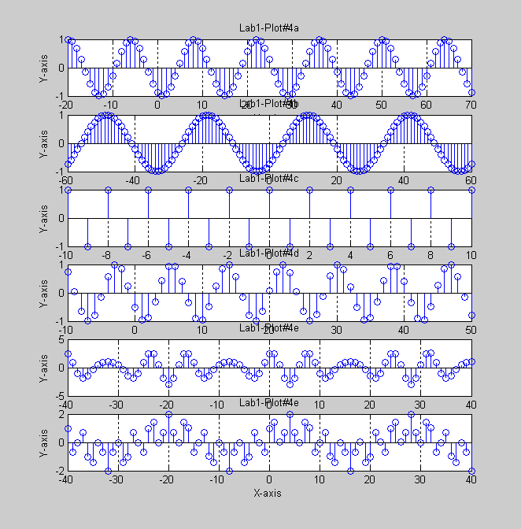

Answer: The period of each sequence is:
a) $\frac{w1}{2π}=\frac{1}{\text{14}}$; This is a rational number therefore, x1(n) is a periodic with a period of 14

b) $\frac{w2}{2π}=\frac{1}{\text{30}}$; This is a rational number therefore, x2(n) is a periodic with a period of 30

c) This sequence has a simpler form: sin ($3π−\frac{π}{2})=\text{sin}(πn+2πn−\frac{π}{2})=−\text{cos}(πn)$
$\frac{w3}{2π}=\frac{3}{2}$; This is a rational number therefore, x3(n) is periodic with a period of 2
d) $\frac{w4}{2π}=\frac{1}{\sqrt{\text{68}}}$; This is Not a rational number therefore, x4(n) is not periodic

e) $\frac{w5a}{2π}=\frac{1}{6}$and $\frac{w5b}{2π}=\frac{1}{8}$; It is a rational number therefore, x5(n) is periodic with a period of 34 (the least common multiple of the period of the two frequencies).

(5) Generate a sampled sinusoid with the following data:
Signal frequency 0.6 kHz, sampling freq. = 8 kHz,
Initial phase = 30 deg.,
starting time = 0 sec.,
Amplitude = 2,
Ending time = 14 msec.
Make two plots of the resulting signal: one as a function of time (in msec),
and the other as a function of the sample Index n used in tn = nt. Determine
the length of the resulting discrete-time signal and the number of periods of
the sinusoid included in the signal vector.

Matlab Code:

%#5
f=0.6e3;
fsamp=8e3;
T=1/fsamp;
theta=30*pi/180;
time=[0:T/10:14e-3]';
amp=2;
xa=amp*sin(2*pi*f*time+theta);
subplot(2,1,1)
plot(time*1e3,xa,'r')
title('Lab1-Plot of #5');
xlabel('Time in msec');
ylabel('Amplitude');
grid on

tsamp=[0:T:14e-3]';
xb=amp*sin(2*pi*f*tsamp+theta);
n=tsamp/T;
subplot(2,1,2)
stem(n,xb,'b');
xlabel('Sample Index,n');
ylabel('Amplitude');
grid on

N=max(tsamp)/T
period=1/f
num_periods=max(time)/period

N = 112
period = 0.0017
num_periods = 8.4000

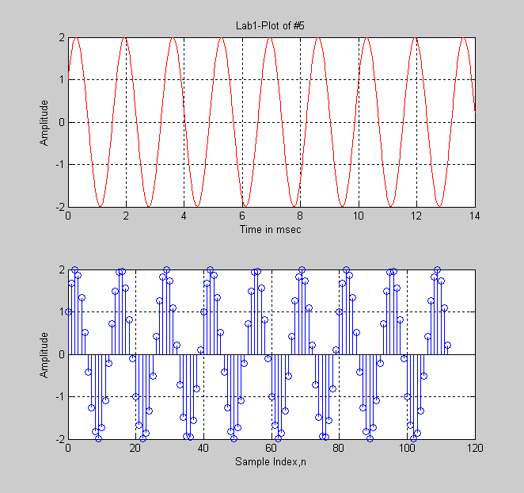

(6) Plot the discrete-time exponential signal
x(n) = 2(-0.6)^{n} over the range n = 0,1,2,...,19
Find the sum of the sequence. Verify using the closed form:
$Σ_{n=0}^{L−1}a^{n}=\frac{1−a^{L}}{1−a}\text{for}$ a ≠ 1

%6
n=[0:18]';
x=2*(-0.6).^n;
stem(n,x);
title('Lab1-Plot of #6');
xlabel('Time Index');
ylabel('Amplitude');
grid on
xm=sum(x)

xm = 1.2501

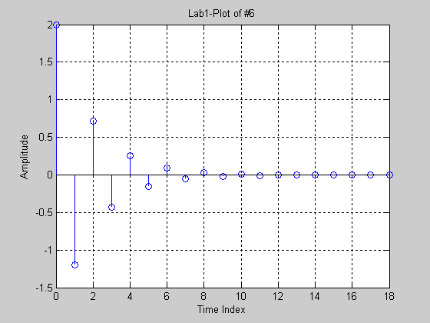

$Σ_{n=0}^{L−1}a^{n}=\frac{1−a^{L}}{1−a}$= 2$\left[\frac{1−a^{\text{20}}}{1−a}\right]=2\left[\frac{1−(−0\text{.}6)^{\text{19}}}{1−(−0\text{.}6)}\right]=$1.25008

This is identical to the Matlab result.

(7) Consider the difference equation given as follows:
y(n) = 0.25 y(n-1) + x(n), n > 0 and y(n) = 0 for n < 0.
Find and plot y(n) for the following cases:
(a) x(n) = ™(n)
(b) x(n) = u(n-2)
(c) x(n) = u(n) – u(n – 4)

%7a
n=[-5:10]';
x=zeros(size(n));
ind=find(n>=0);
x(ind)=1;
subplot(2,1,1)
stem(n,x);
title('Lab1-Plot of #7a');
xlabel('n');
ylabel('Amplitude of x');
grid on

y=zeros(size(n));
indnz=ind(1);
for i=indnz:length(x)
y(i)=0.25*y(i-1)+x(i);
end
subplot(2,1,2)
stem(n,y,'r');
title('Impulse response');
xlabel('n');
ylabel('Amplitude of y');
grid on

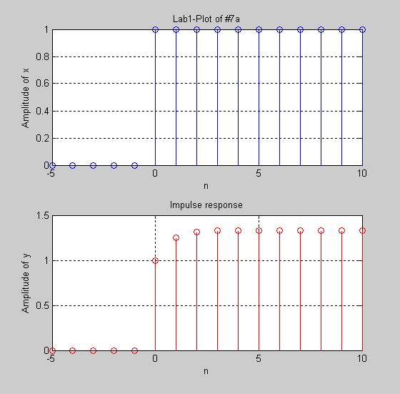

%7b
n=[-5:10]';
x=zeros(size(n));
ind=find(n==2);
x(ind)=1;
subplot(2,1,1)
stem(n,x);
title('Lab1-Plot of #7b');
xlabel('n');
ylabel('Amplitude of x');
grid on

y=zeros(size(n));
indnz=ind(1);
for i=indnz:length(x)
y(i)=0.25*y(i-1)+x(i);
end
subplot(2,1,2)
stem(n,y,'r');
title('Unit Step Response');
xlabel('n');
ylabel('Amplitude of y');
grid on

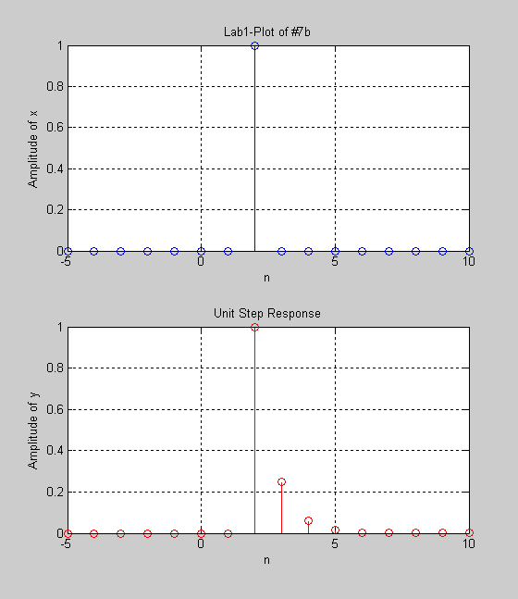

%7c
n=[-5:10]';
x=zeros(size(n));
ind=find(n>=0 & n<=4);
x(ind)=1;
subplot(2,1,1)
stem(n,x,'r');
title('Lab1-Plot of #7c');
xlabel('n');
ylabel('Amplitude of x');
grid on

y=zeros(size(n));
indnz=ind(1);
for i=indnz:length(x)
y(i)=0.25*y(i-1)+x(i);
end
subplot(2,1,2)
stem(n,y);
title('Resposne to Unit Step Difference');
xlabel('n');
ylabel('Amplitude of y');
grid on

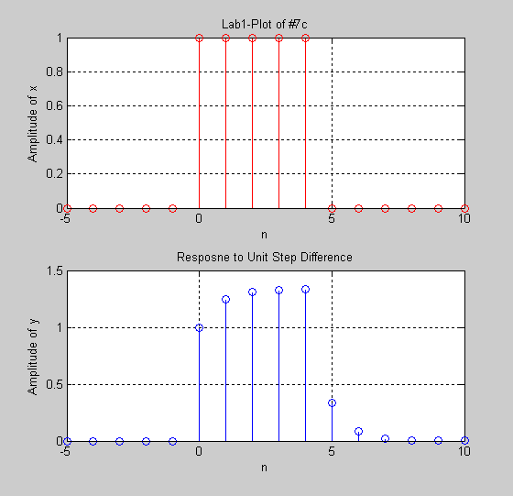

(8) For the same difference equation given as of part (7), namely
y(n) = 0.25 y(n-1) + x(n), n > 0, find y(n) for the following
conditions:
• y(-1) = 4 (initial condition)
• x(n) = u(n).

%8
clc
clear
n=[-10:15]';
x=zeros(size(n));
ind=find(n>=0);
x(ind)=4;

subplot(2,1,1)
stem(n,x);
title('Lab1-Plot of #8 Unit Step Input');
xlabel('n');
ylabel('Amplitude of x');
grid on

y=zeros(size(n));
index_int_cond=find(n==-1);
y(index_int_cond)=4;

indnz=ind(1);
for i=indnz:length(x)
y(i)=0.25*y(i-1)+x(i);
end
subplot(2,1,2)
stem(n,y,'r');
title('Unit Step Response with Initial Condition of y(-1) =4');
xlabel('n');
ylabel('Amplitude of y');
grid on

